题目6-16声明一个int 型变量 a,一个 int 型指针 p,一个引用r,通过 p把 a的值改为 10,通过r把a的值改为5。
答：源代码
#include<iostream>
using namespace std;

int main()
{
int a;
int* p = &a;
*p = 10;
cout << "通过p把a改为：" << a << endl;
int& r = a;
r = 5;
cout << "通过r把a改为：" << a << endl;
return 0;
}
执行结果：
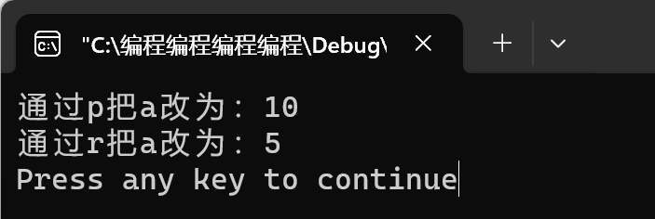

题目6-21编写一个函数,统计一条英文句子中字母的个数,在主程序中实现输人输出。

答：源代码
#include<iostream>
#include <string>
using namespace std;

int main()
{
string str;
int sum = 0;
cout << "请输入一句英文:";
getline(cin, str, '\n');
int length = str.length();
for (int i = 0; i < length; i++)
{
if (((str[i] >= 'a') && (str[i] <= 'z')) || (str[i] >= 'A' && str[i]<= 'Z')) {
sum++;
}
}
cout << "有" << sum << "个单词" << endl;
return 0;
}
执行结果：
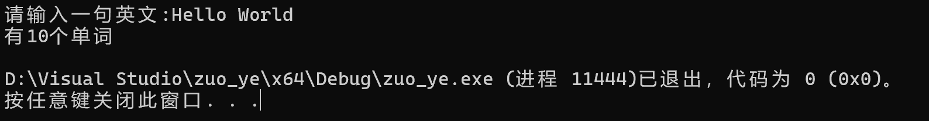

题目6-22编写函数 void reverse(string &s),用递归算法使字符串s倒序。
答：源代码：
#include<iostream>
#include<string>
using namespace std;
void reverse(string& s, int len, int i)
{
if (i < len / 2) {
char temp;
temp = s[i];
s[i] = s[len - i - 1];
s[len - i - 1] = temp;
reverse(s, len, i + 1);
}
}
int main()
{
string s;
cout << "请输入一个字符串：";
cin >> s;
int len = s.length();
int i = 0;
reverse(s, len, i);
cout << "这个字符串倒过来是：" << s << endl;
return 0;
}
执行结果：
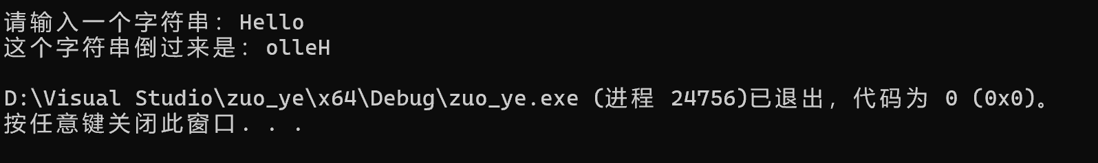

题目6-23设学生人数N=8,提示用户输人 N个人的考试成绩,然后计算出他们的平均值并显示出来。
答：源程序
#include<iostream>
using namespace std;
int main()
{
int a[8];
double average;
double sum = 0;
for (int i = 0; i < 8; i++)
{
cout << "请输入第" << i + 1 << "个学生的考试成绩:";
int score;
cin >> score;
a[i] = score;
}
for (int n = 0; n < 8; n++) {
sum = sum + a[n];
}
average = sum / 8;
cout << "这八名同学的平均成绩是" << average << endl;
return 0;
}

执行结果：
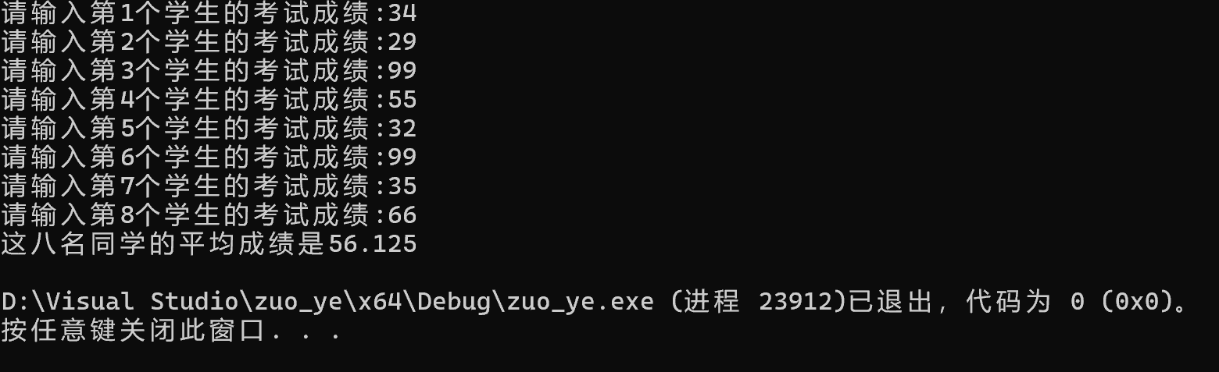

题目6-26编写一个矩阵转置的函数，矩阵的行数和列数在程序中由用户输入。
答：源代码
#include<iostream>
using namespace std;

void transposeMatrix(int row, int col, int a[][100], int transposed[][100]) {
for (int i = 0; i < row; ++i) {
for (int j = 0; j < col; ++j) {
transposed[j][i] = a[i][j];
}
}
}

int main() {
int row, col;
int yjz[100][100];
int transposed[100][100];

cout << "请输入矩阵的行数和列数：";
cin >> row >> col;

cout << "请输入矩阵的元素：";
for (int i = 0; i < row; i++) {
for (int j = 0; j < col; j++)
cin >> yjz[i][j];
}

cout << "原矩阵为：" << endl;
for (int i = 0; i < row; i++) {
for (int j = 0; j < col; j++)
cout << yjz[i][j] << " ";
cout << endl;
}

transposeMatrix(row, col, yjz, transposed);

cout << "转置后矩阵为：" << endl;
for (int i = 0; i < col; i++) {
for (int j = 0; j < row; j++)
cout << transposed[i][j] << " ";
cout << endl;
}

return 0;
}
执行结果：
