11-6定义一个 Dog类,包含体重和年龄两个成员变量及相应的成员函数。声明一个实例 dog1，体重为5,年龄为 10,使用I/O 流把 dog1的状态写入磁盘文件。再声明另一个实例 dog2，通过读文件把 dog1的状态赋给 dog2。分别使用文本方式和二进制方式操作文件,看看结果有何不同；再看看磁盘文件的 ASCII码有何不同。
答：源代码
#include <iostream>
#include <fstream>
#include <string>

using namespace std;

class Dog {
public:
int weight;
int age;

Dog(int w = 0, int a = 0) : weight(w), age(a) {}

friend ostream& operator<<(ostream& os, const Dog& d) {
os << d.weight << " " << d.age;
return os;
}

friend istream& operator>>(istream& is, Dog& d) {
is >> d.weight >> d.age;
return is;
}
};

int main() {
Dog dog1(5, 10);

ofstream textFile("dog.txt");
if (textFile.is_open()) {
textFile << dog1;
textFile.close();
}

ofstream binaryFile("dog.bin", ios::binary);
if (binaryFile.is_open()) {
binaryFile.write(reinterpret_cast<char*>(&dog1), sizeof(Dog));
binaryFile.close();
}

Dog dog2;
ifstream textIn("dog.txt");
if (textIn.is_open()) {
textIn >> dog2;
textIn.close();
}

Dog dog3;
ifstream binaryIn("dog.bin", ios::binary);
if (binaryIn.is_open()) {
binaryIn.read(reinterpret_cast<char*>(&dog3), sizeof(Dog));
binaryIn.close();
}

cout << "狗1: 体重 = " << dog1.weight << ", 年龄 = " << dog1.age << endl;
cout << "狗2: 体重 = " << dog2.weight << ", 年龄 = " << dog2.age << endl;
cout << "狗3: 体重 = " << dog3.weight << ", 年龄 = " << dog3.age << endl;

return 0;
}
执行结果：
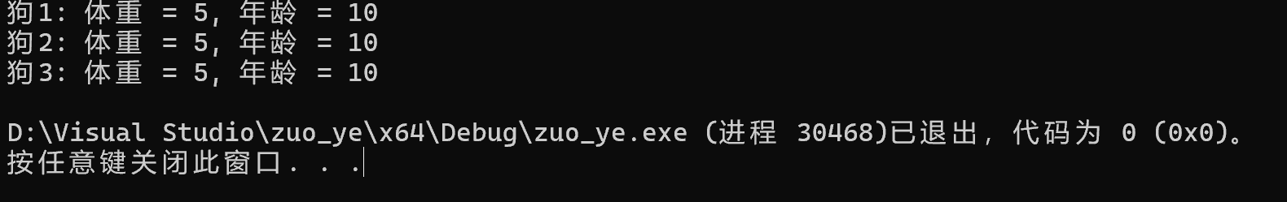
生成bin与txt文件
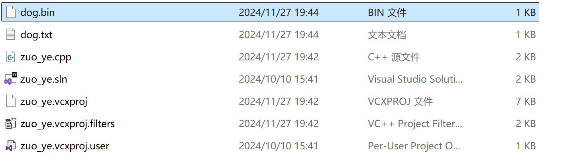
Txt文件：
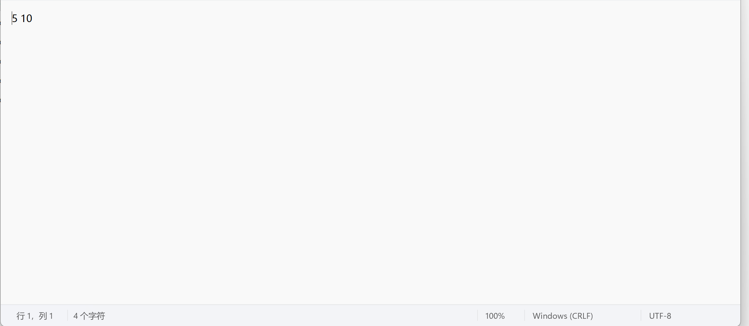
Bin文件:
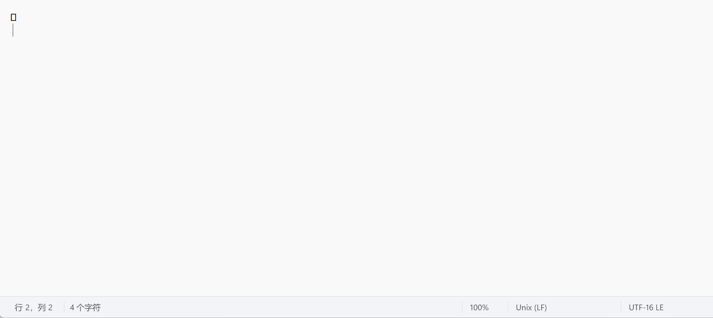
11-9编写程序实现如下功能:打开指定的一个文本文件,在每一行前加行号后将其输出到另一个文本文件中。

答：源代码
#include <iostream>
#include <fstream>
#include <string>

using namespace std;

int main() {
ifstream inputFile("input.txt");
ofstream outputFile("output.txt");

if (!inputFile || !outputFile) {
cout << "文件打开失败" << endl;
return 1;
}

string line;
int lineNumber = 1;
while (getline(inputFile, line)) {
outputFile << lineNumber << " " << line << endl;
++lineNumber;
}

inputFile.close();
outputFile.close();

cout << "处理完成" << endl;
return 0;
}
执行结果：
