第四章
书上例子补充：
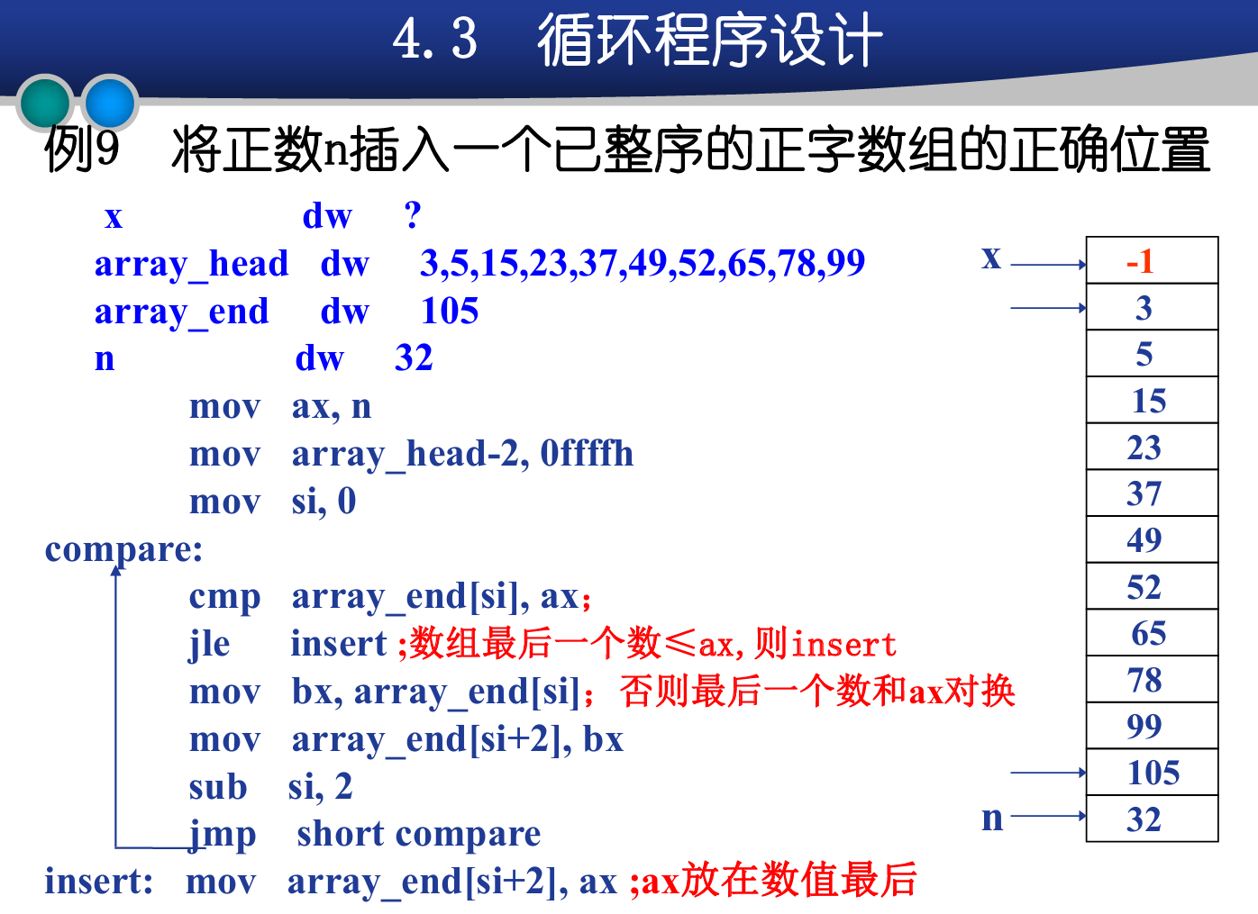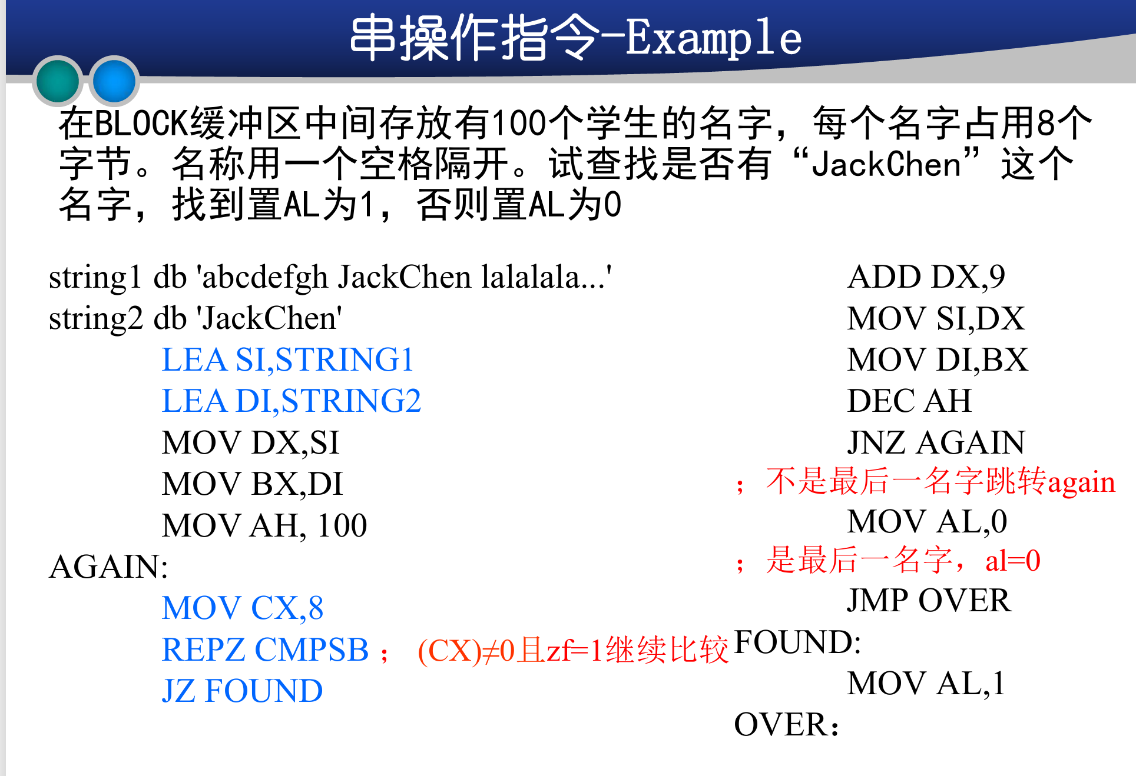
子程序设计：
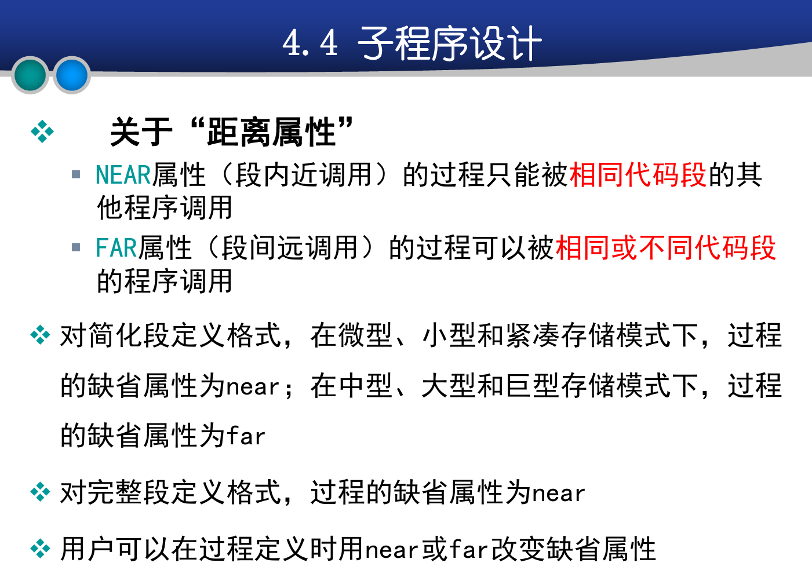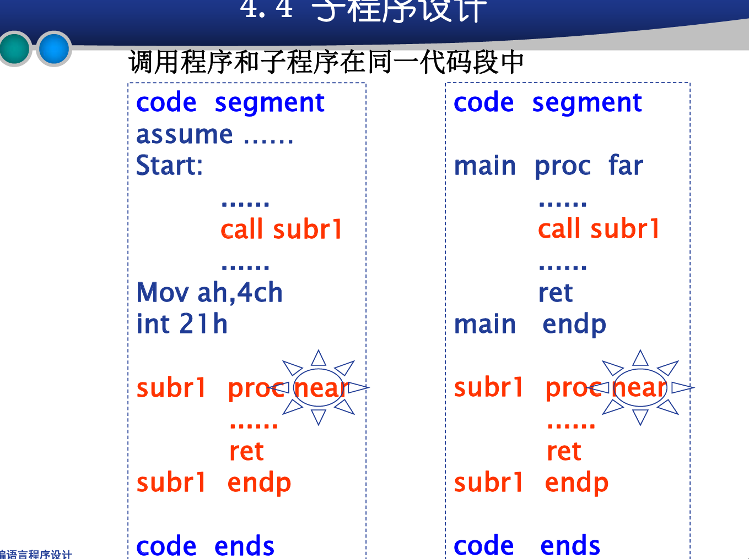
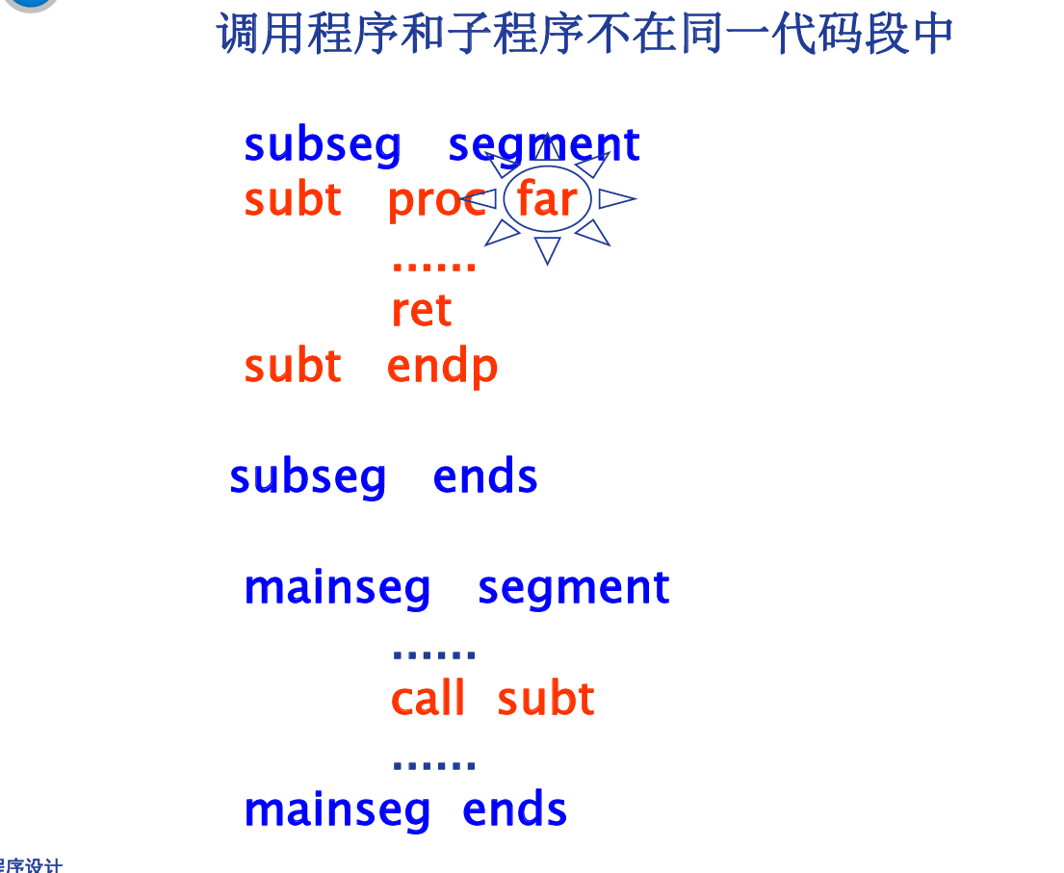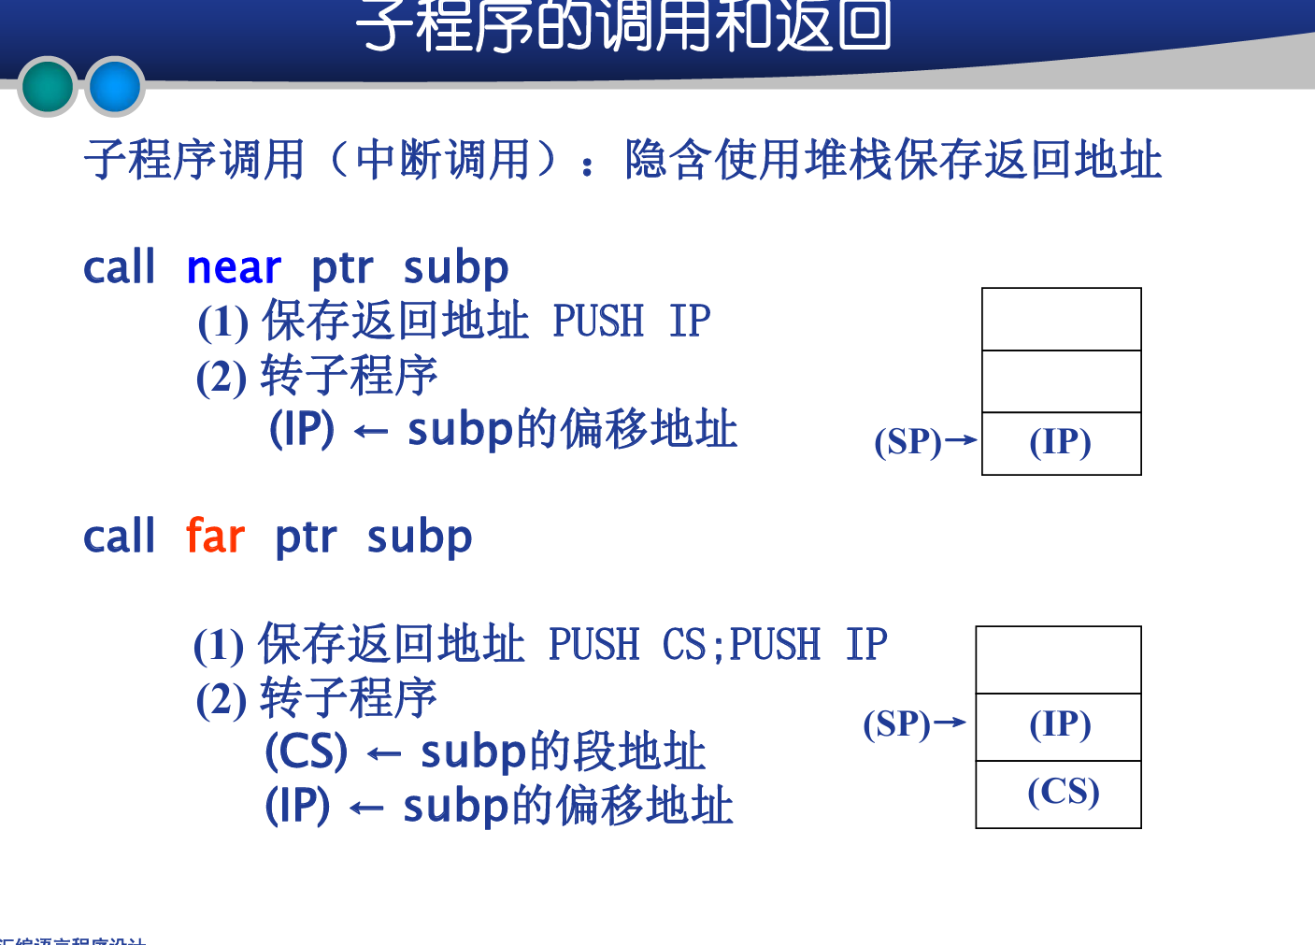
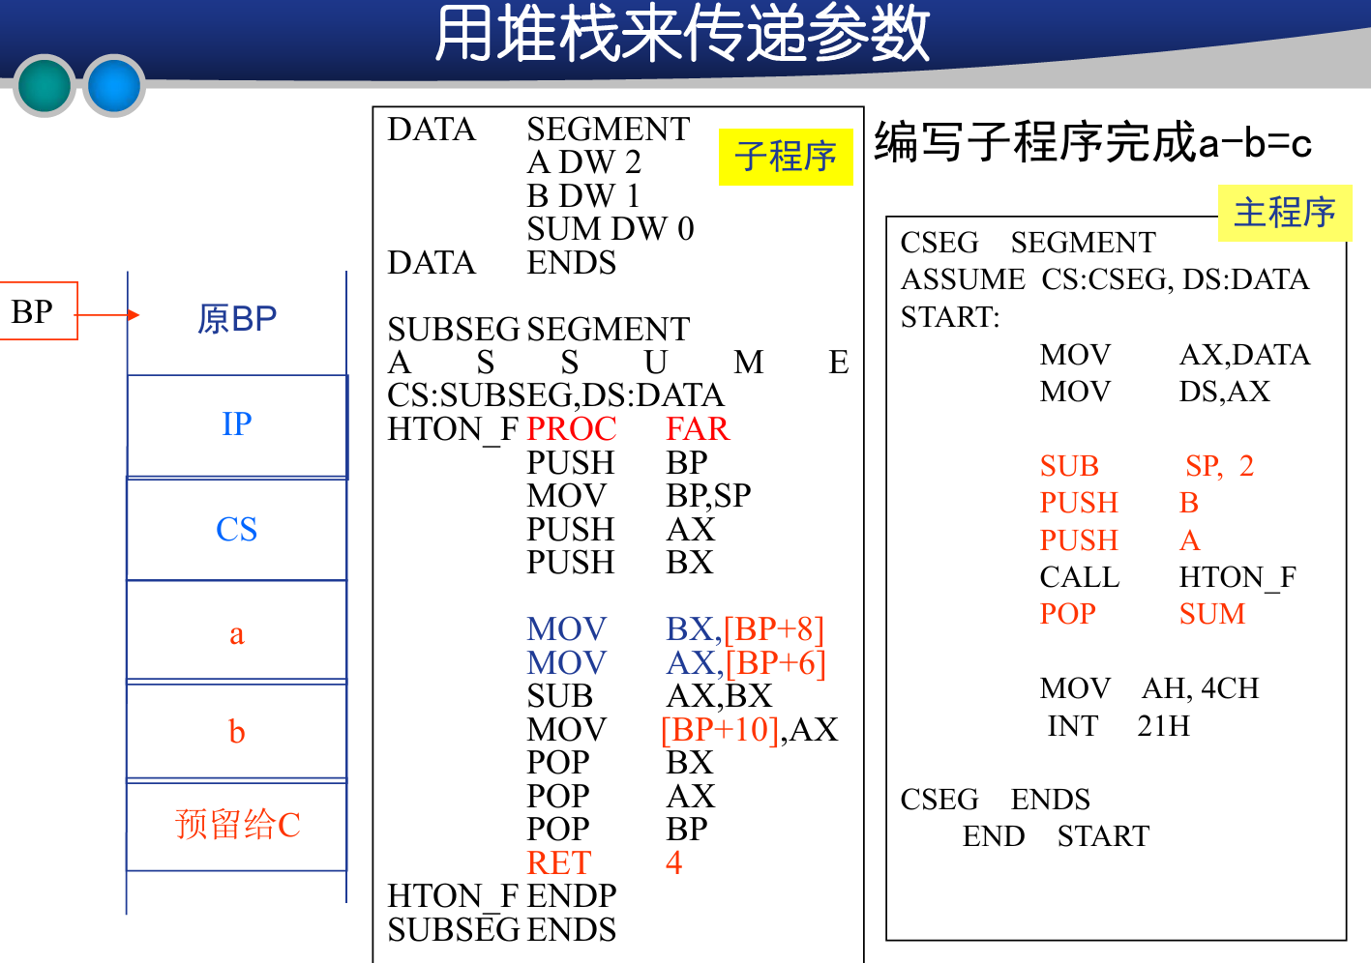
子程序应用扩展：
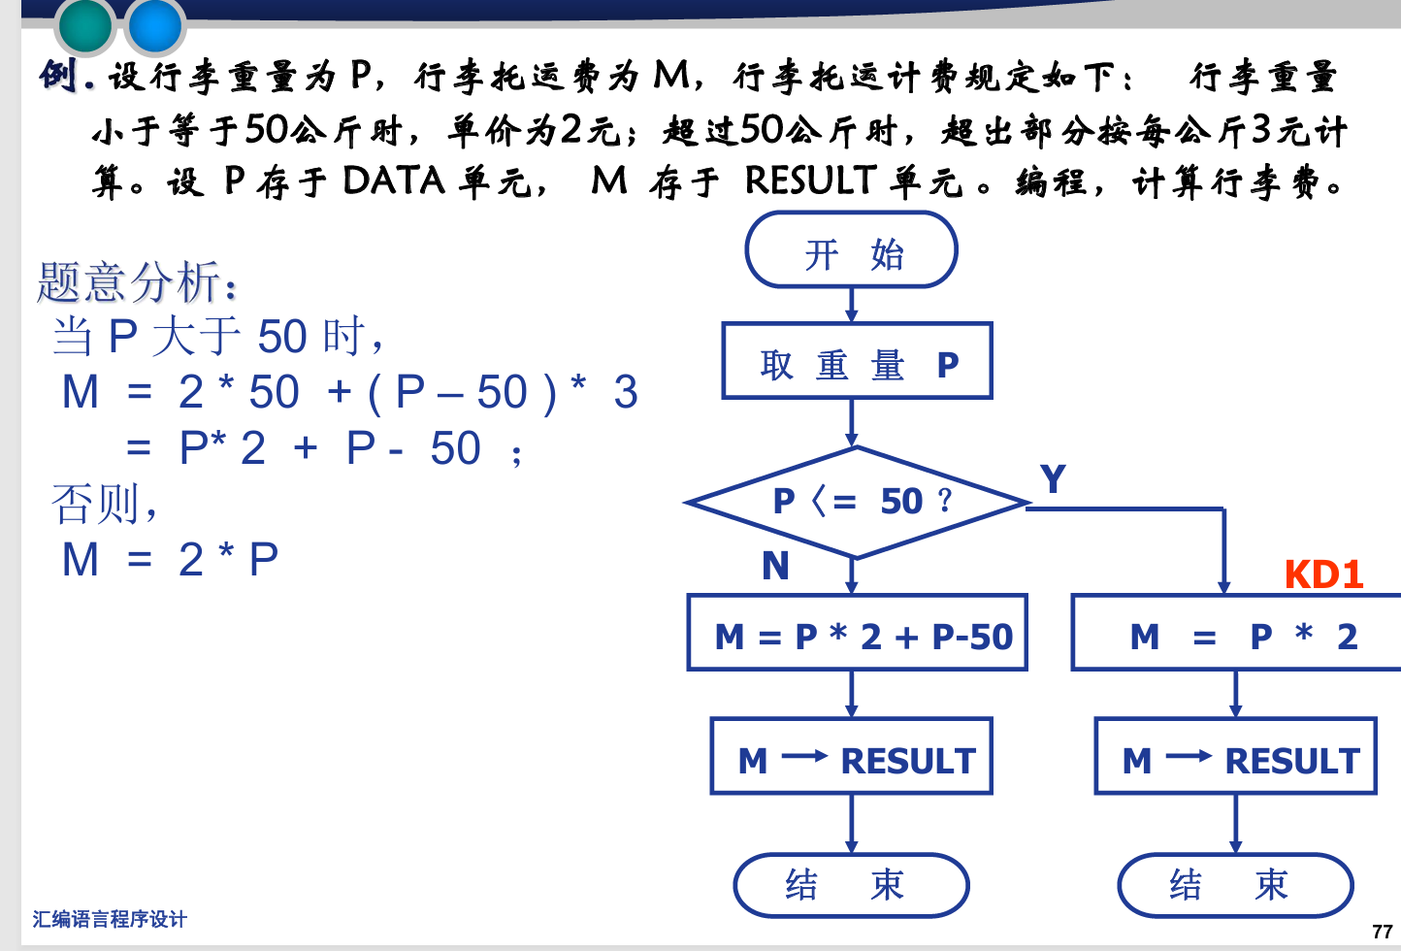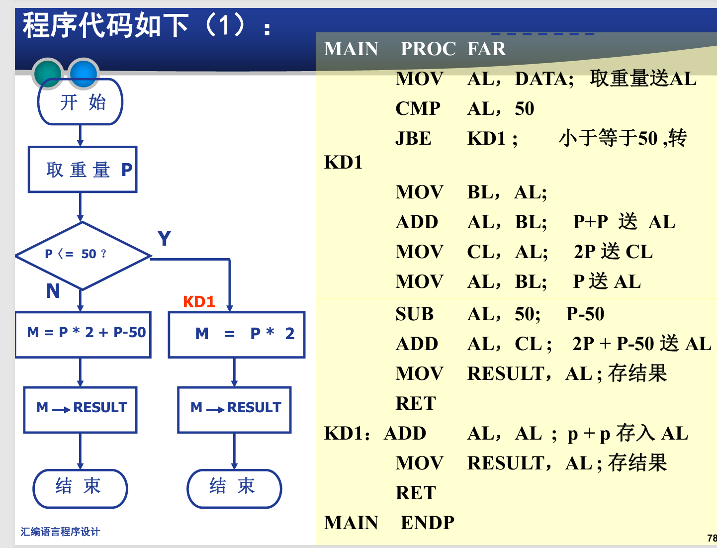
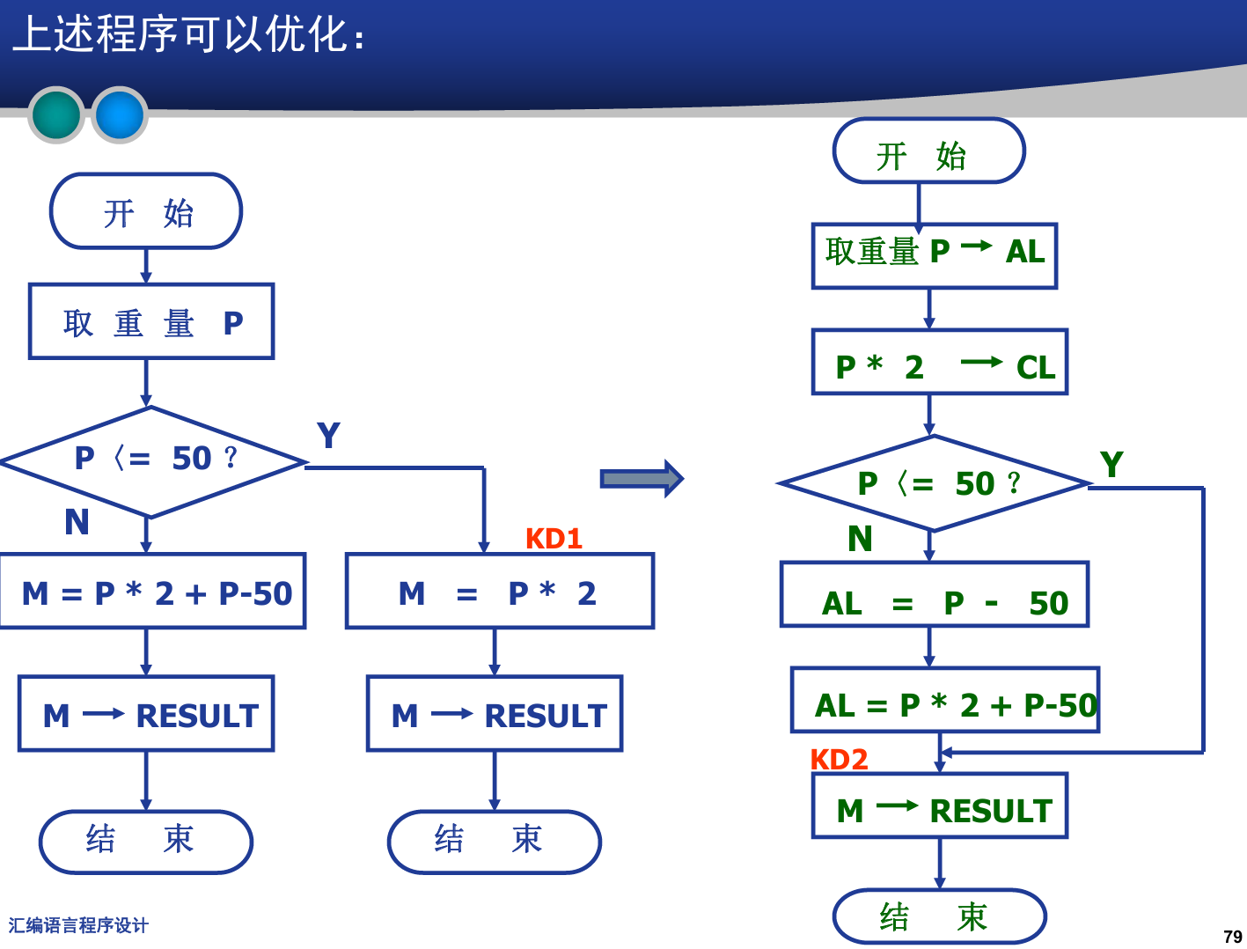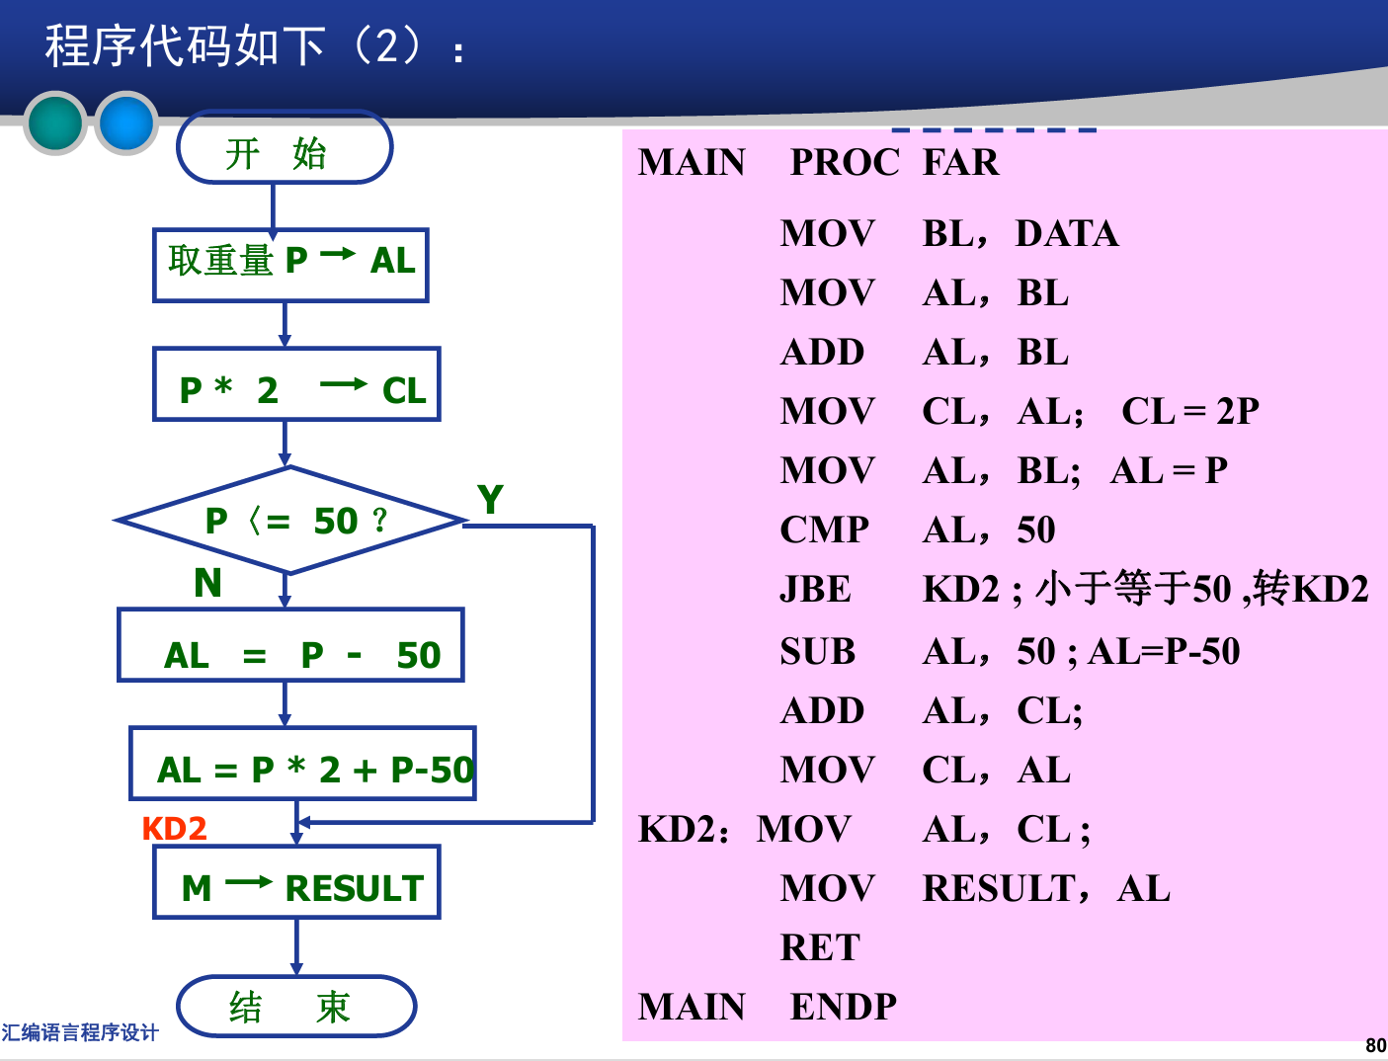
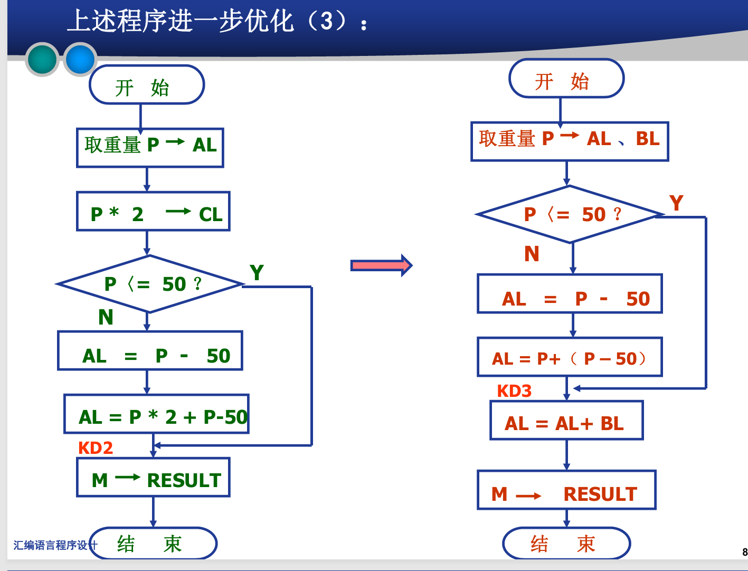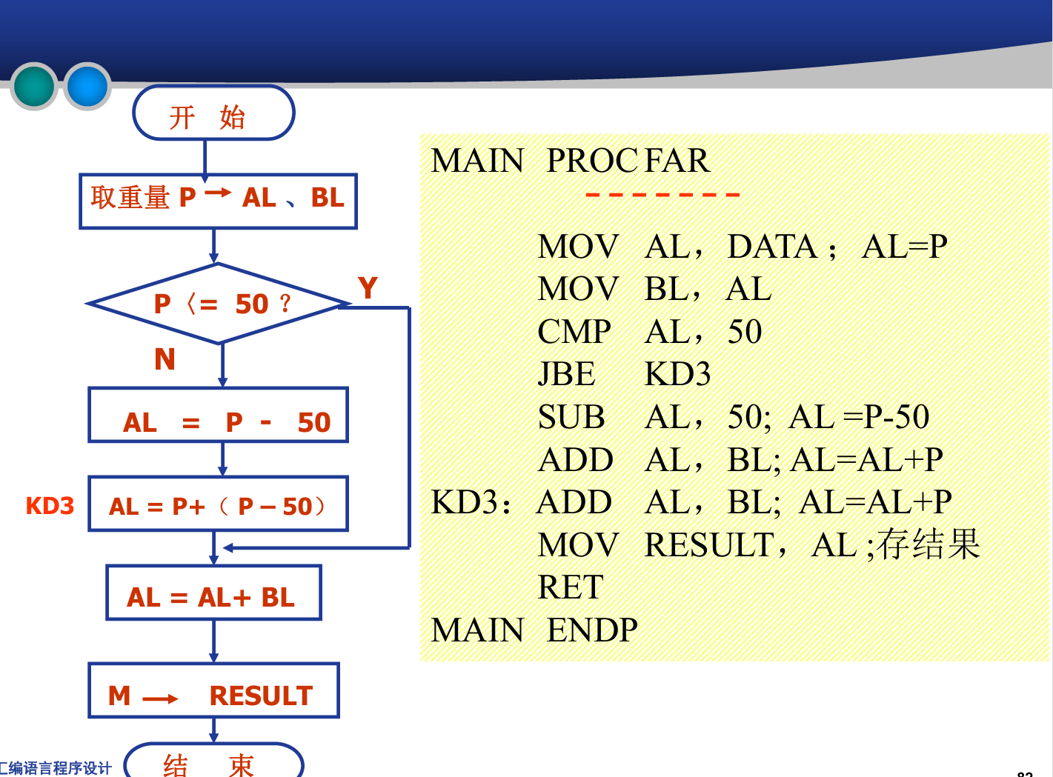
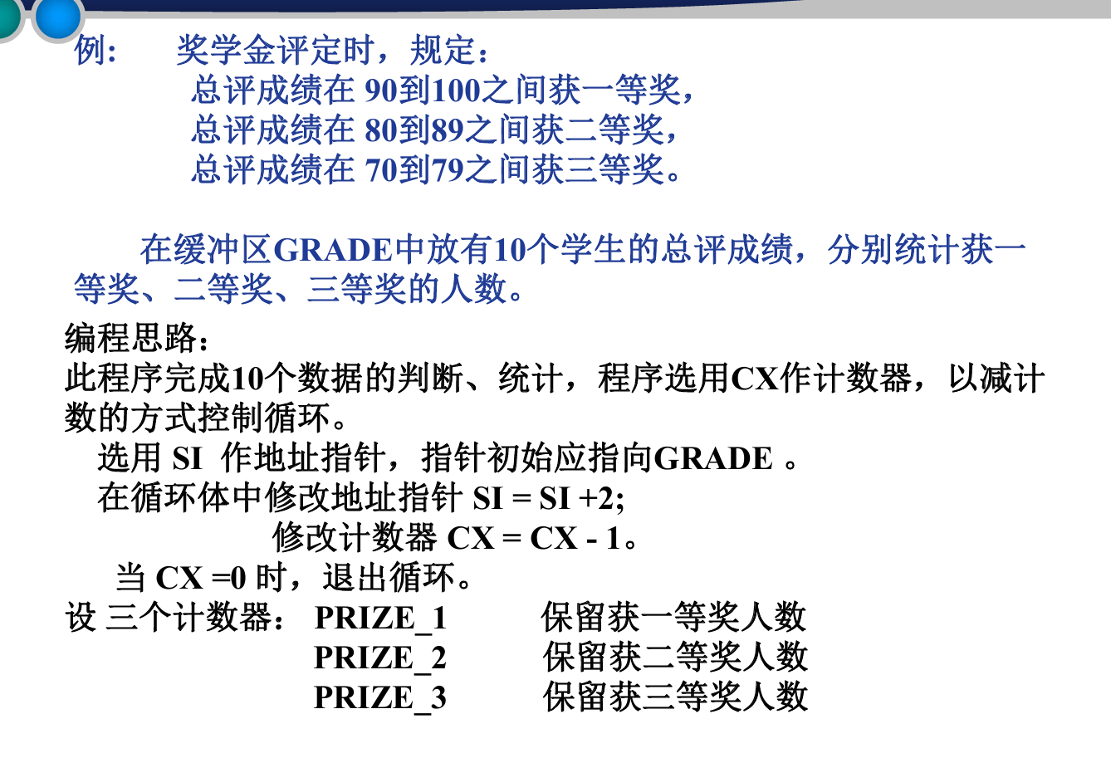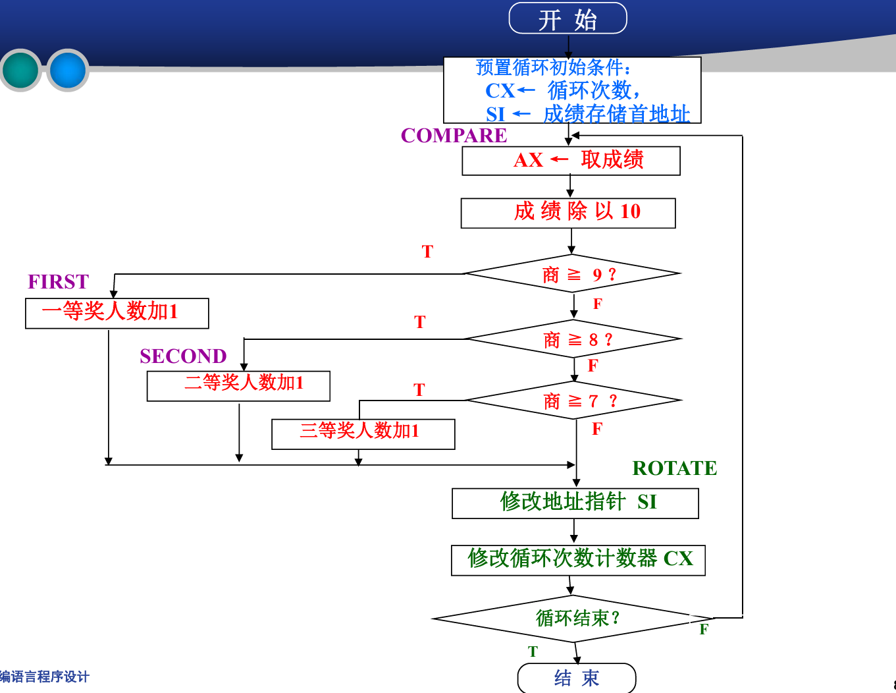
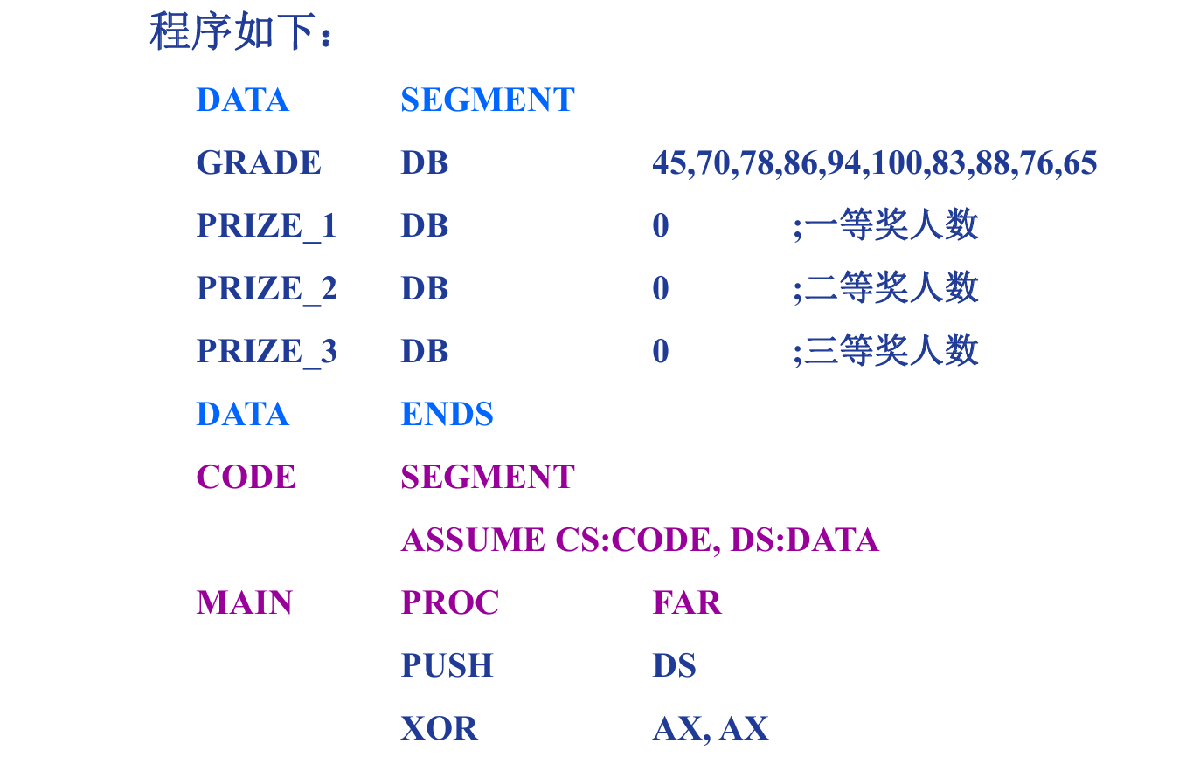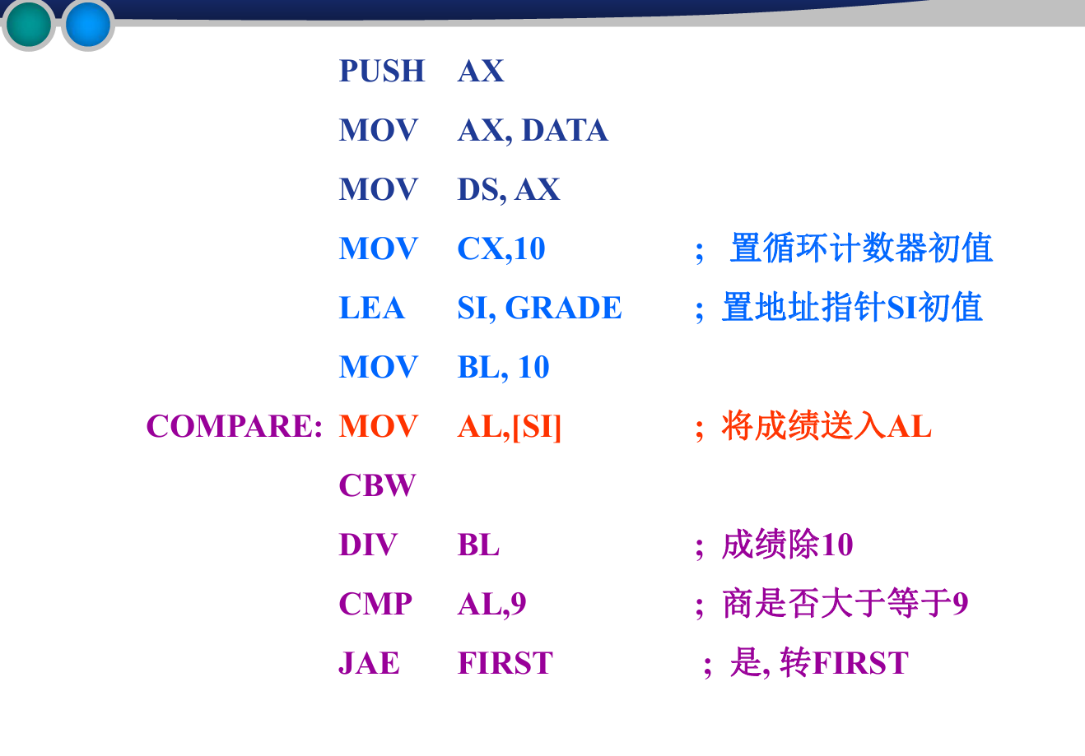
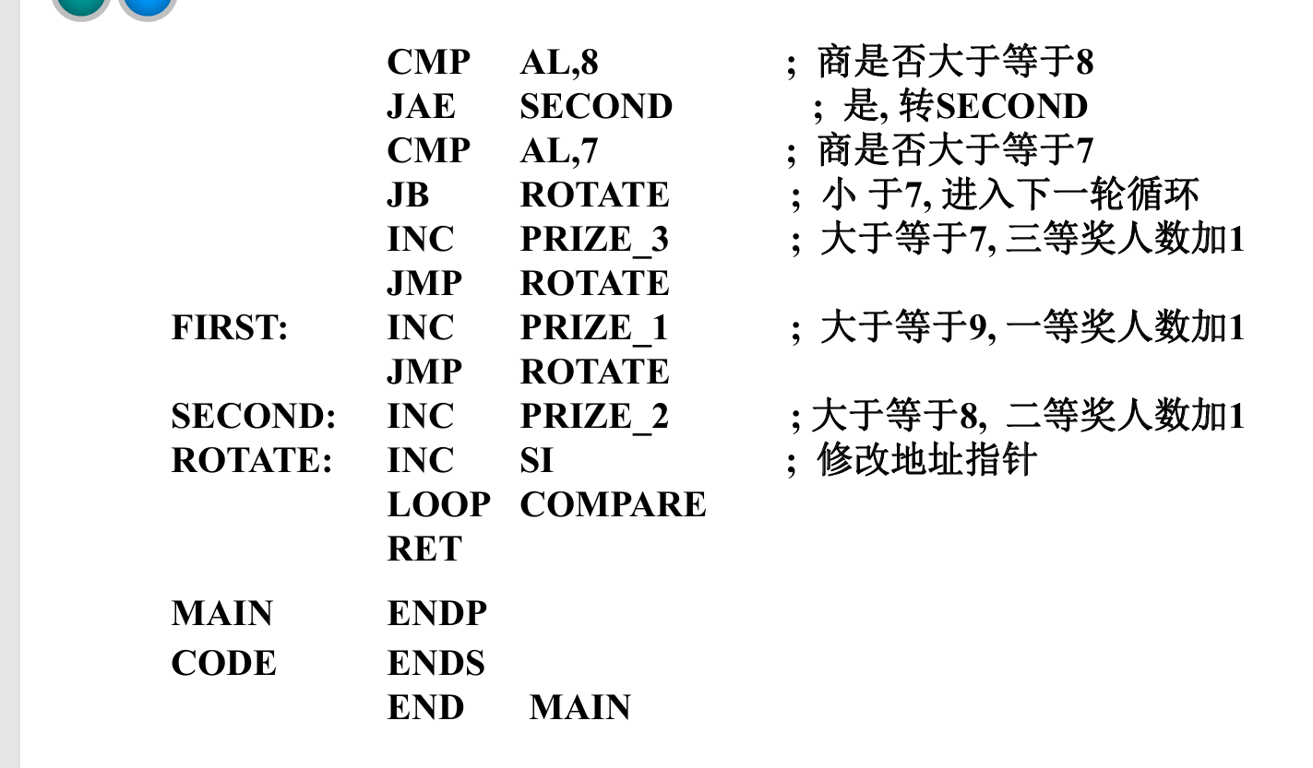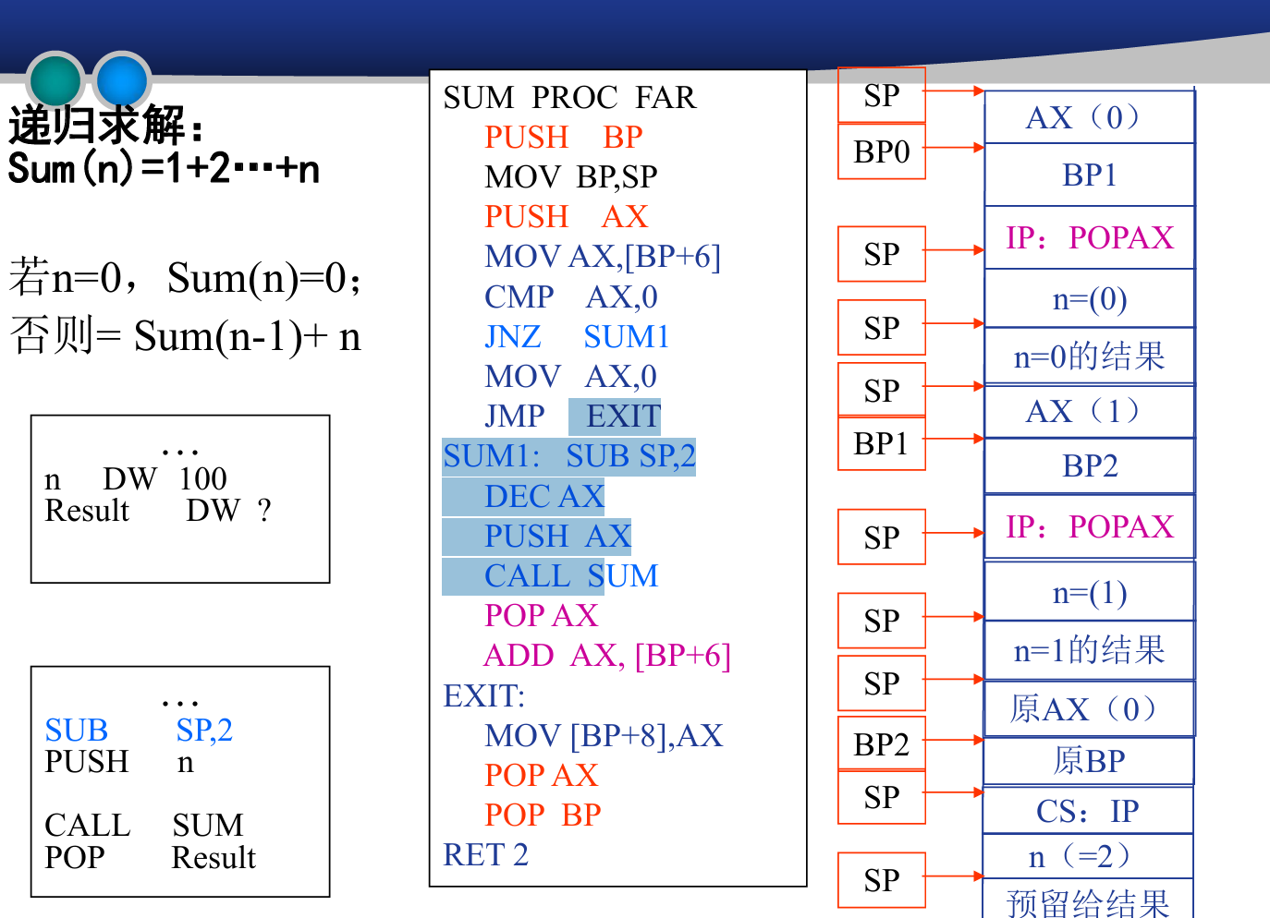

第五章
宏汇编：
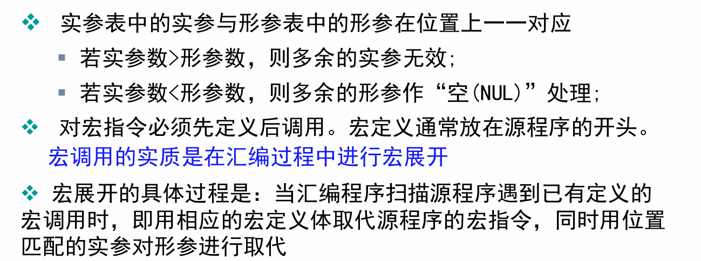
I/O端口:
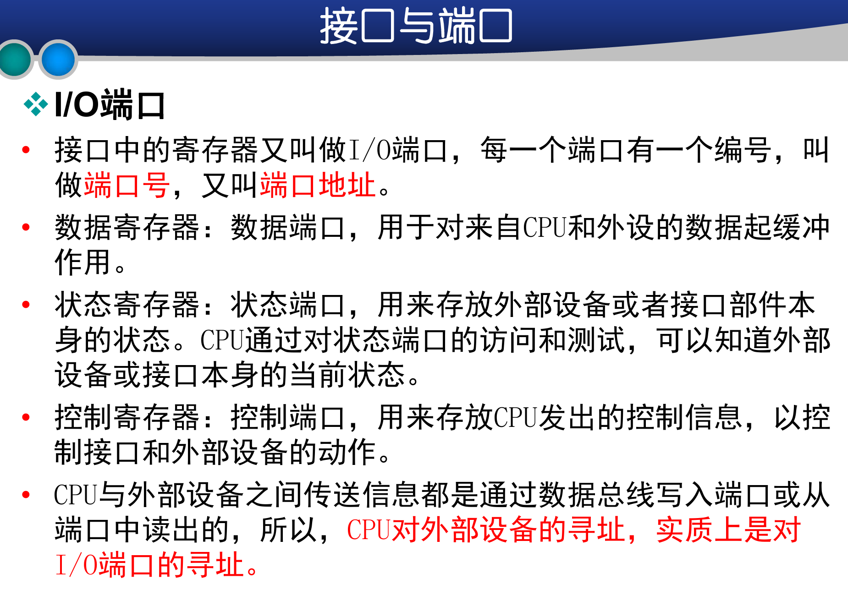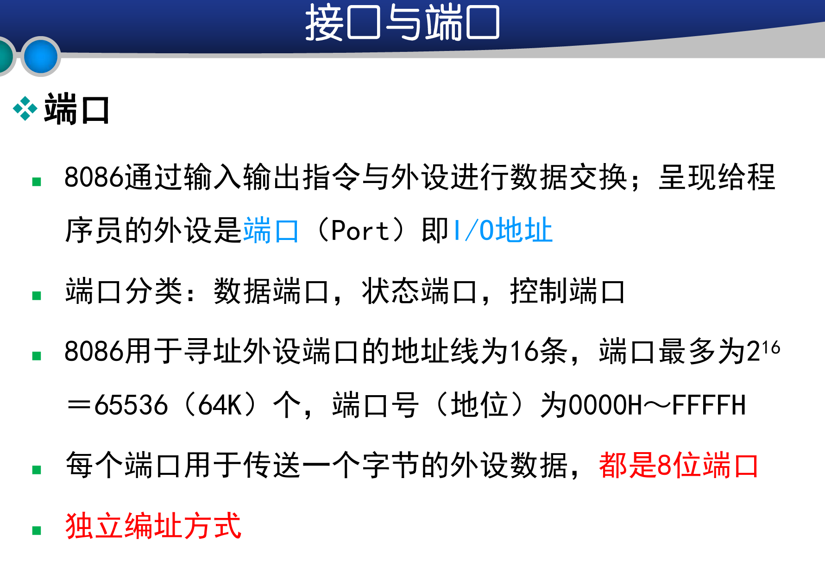
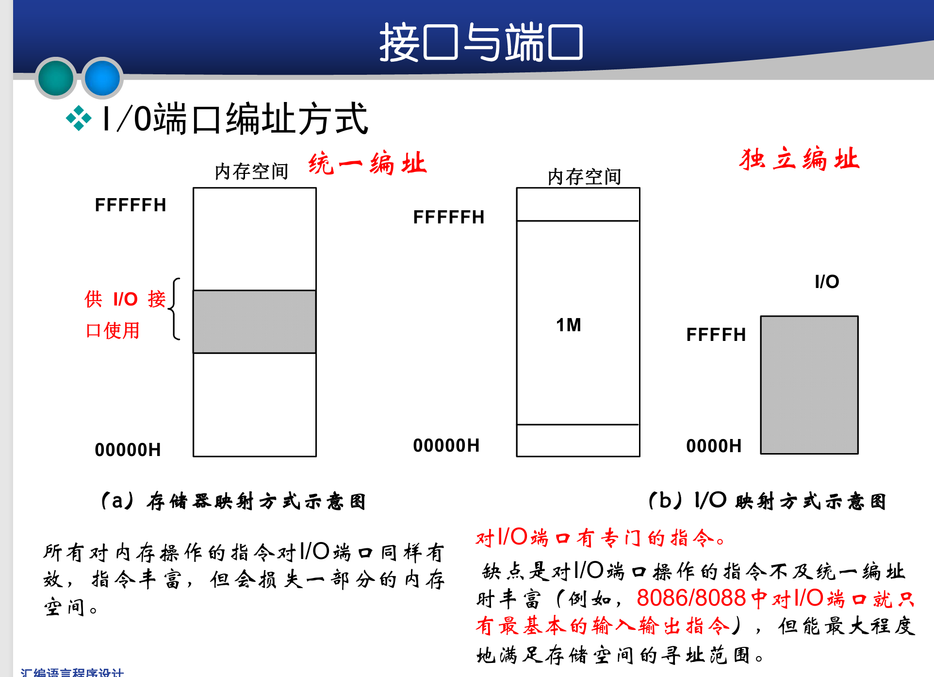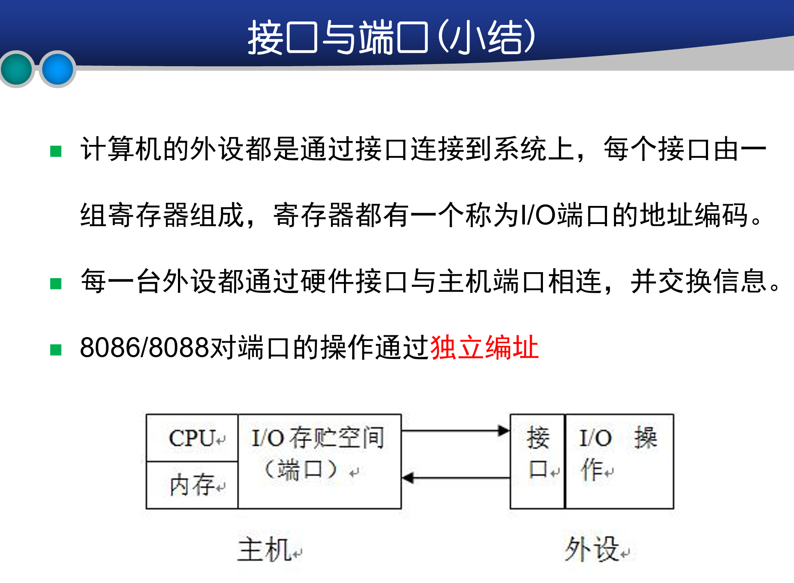
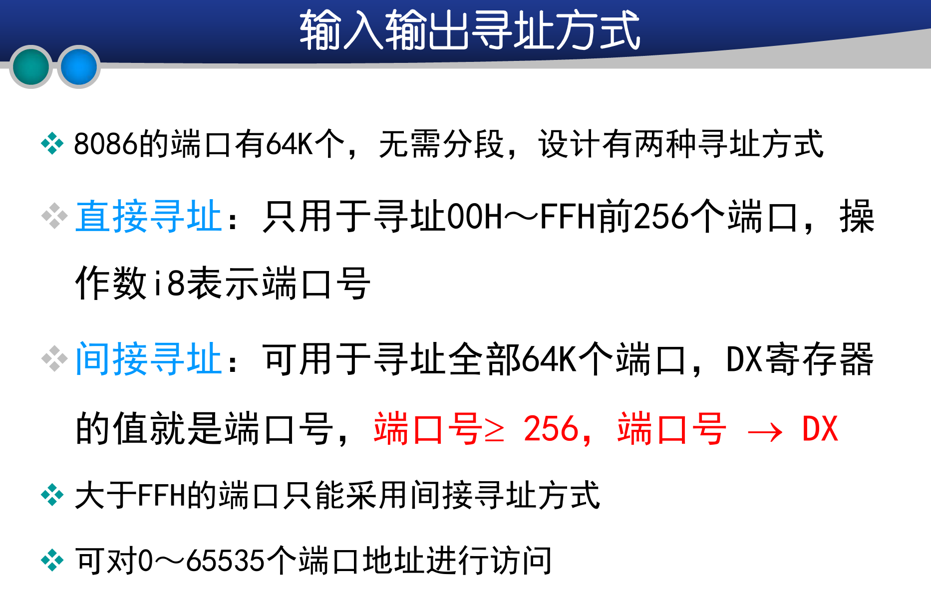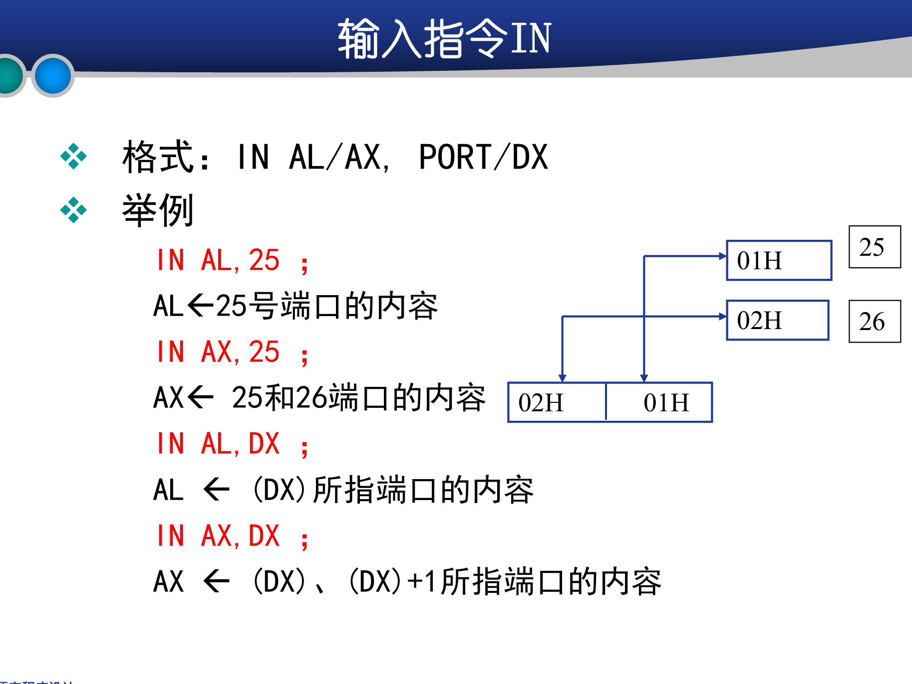
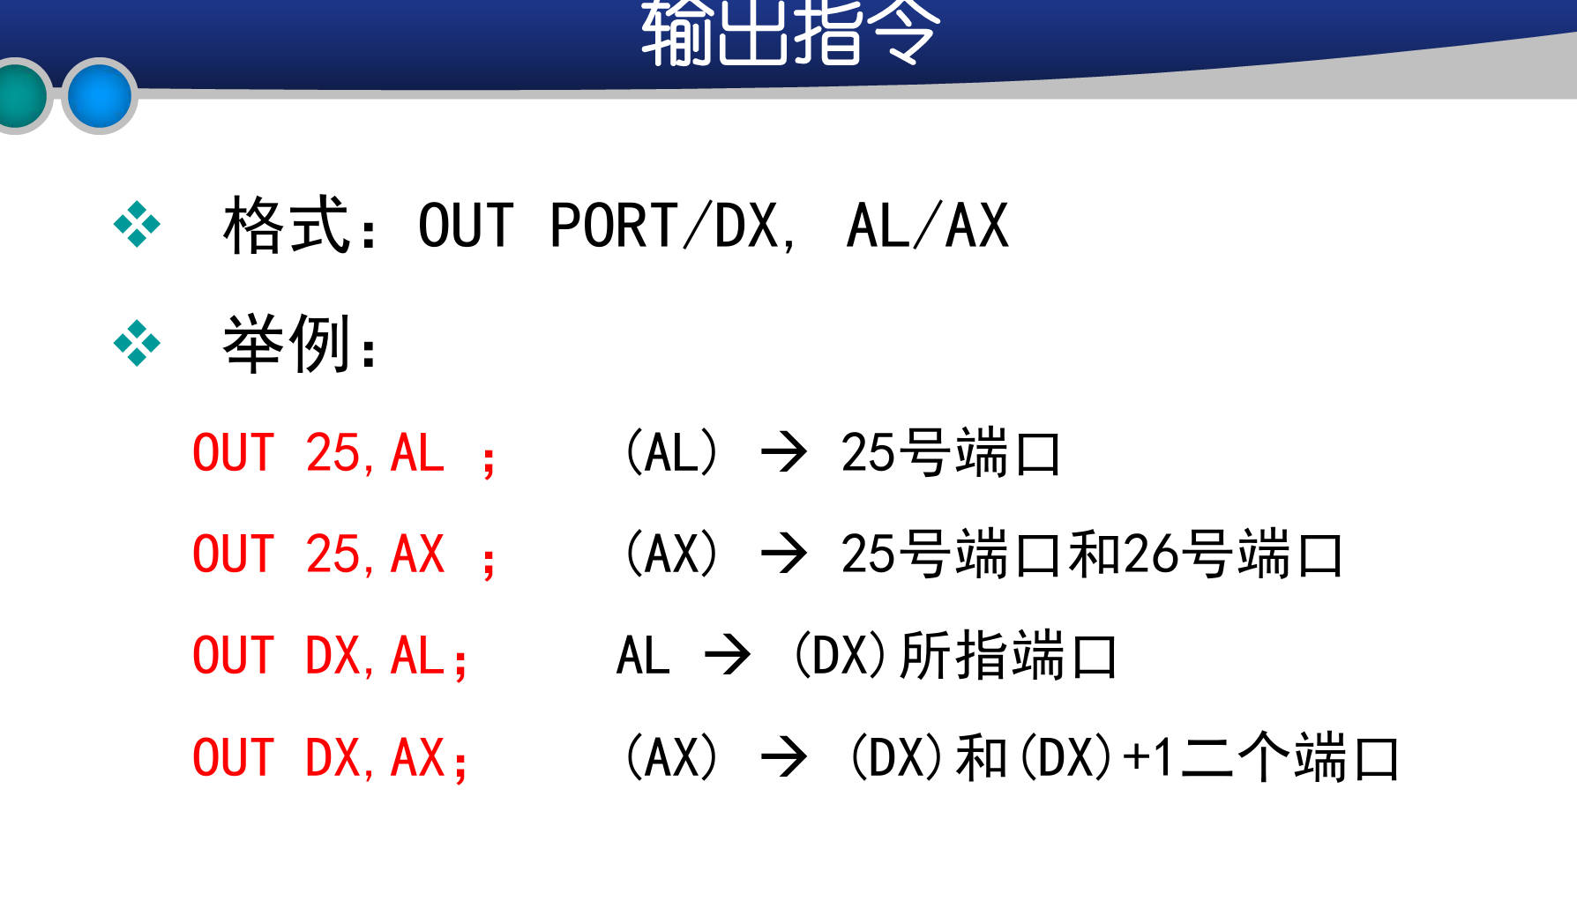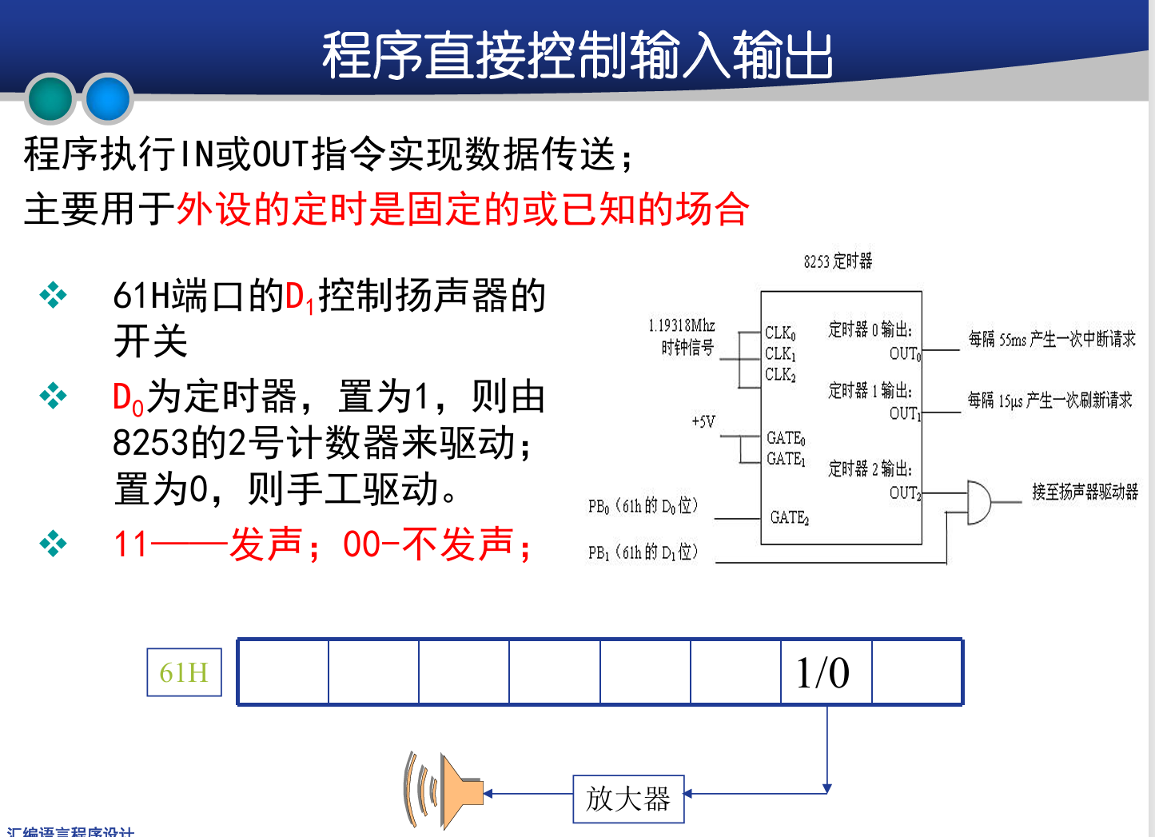
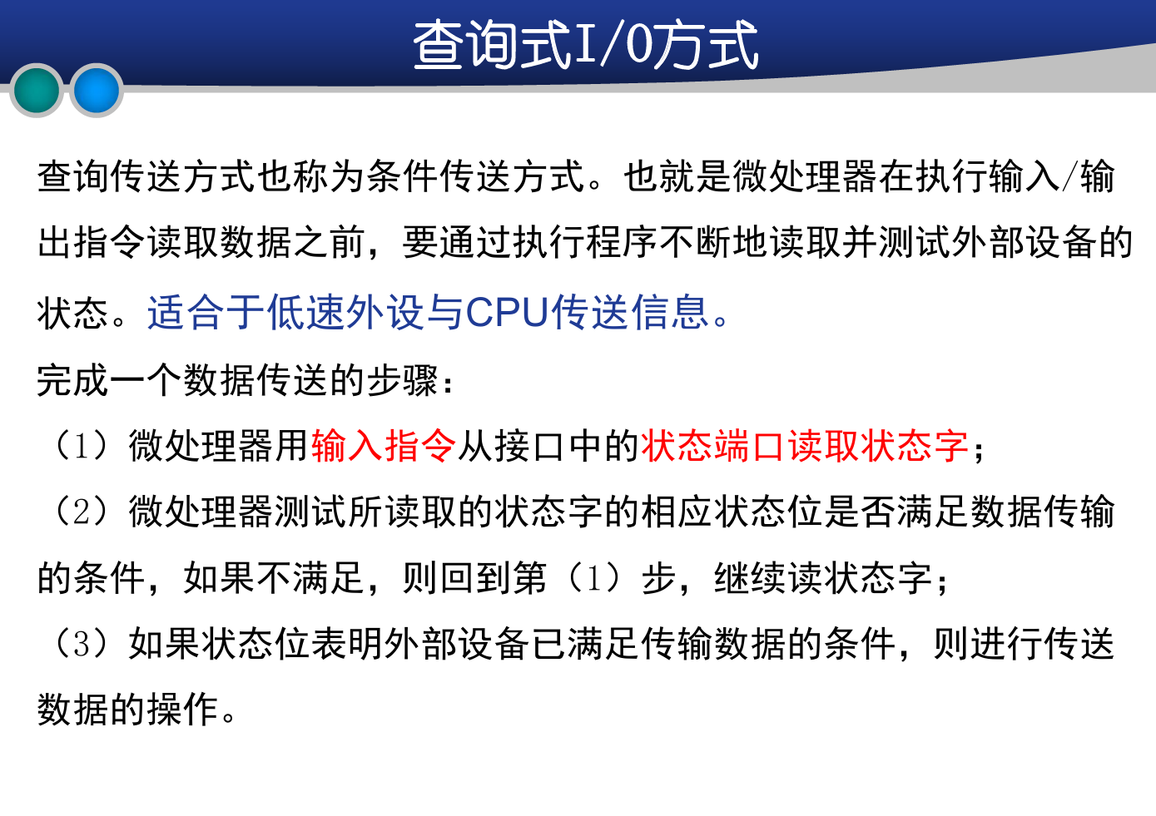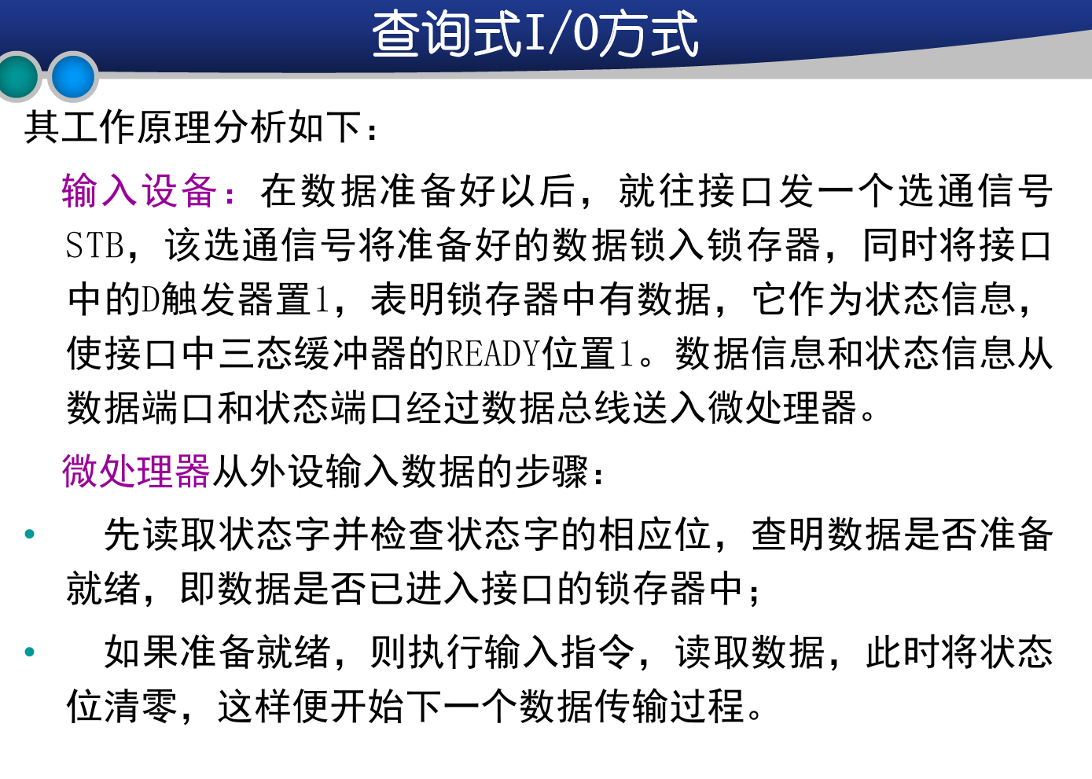
中断：
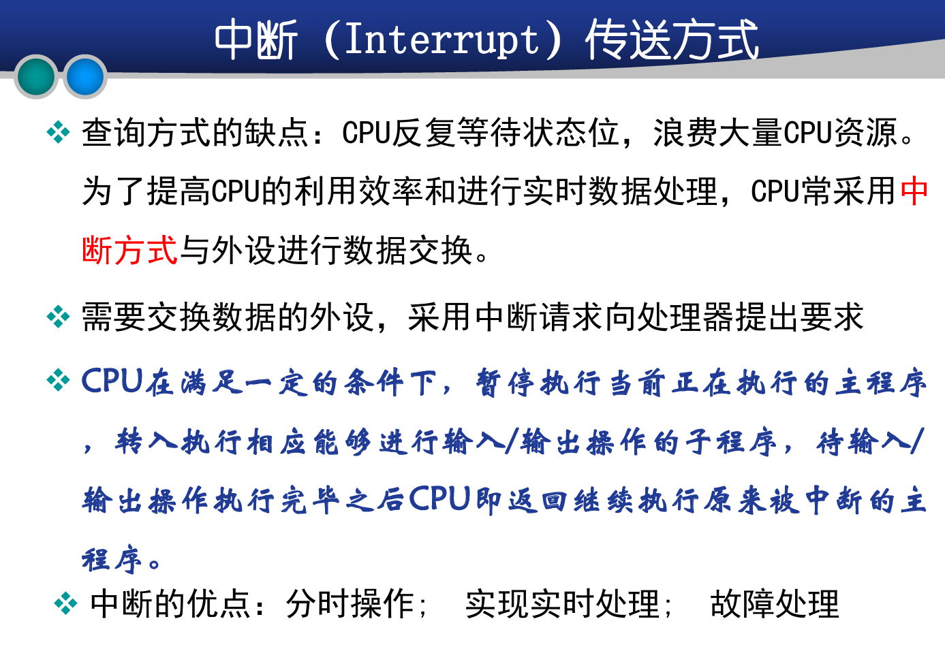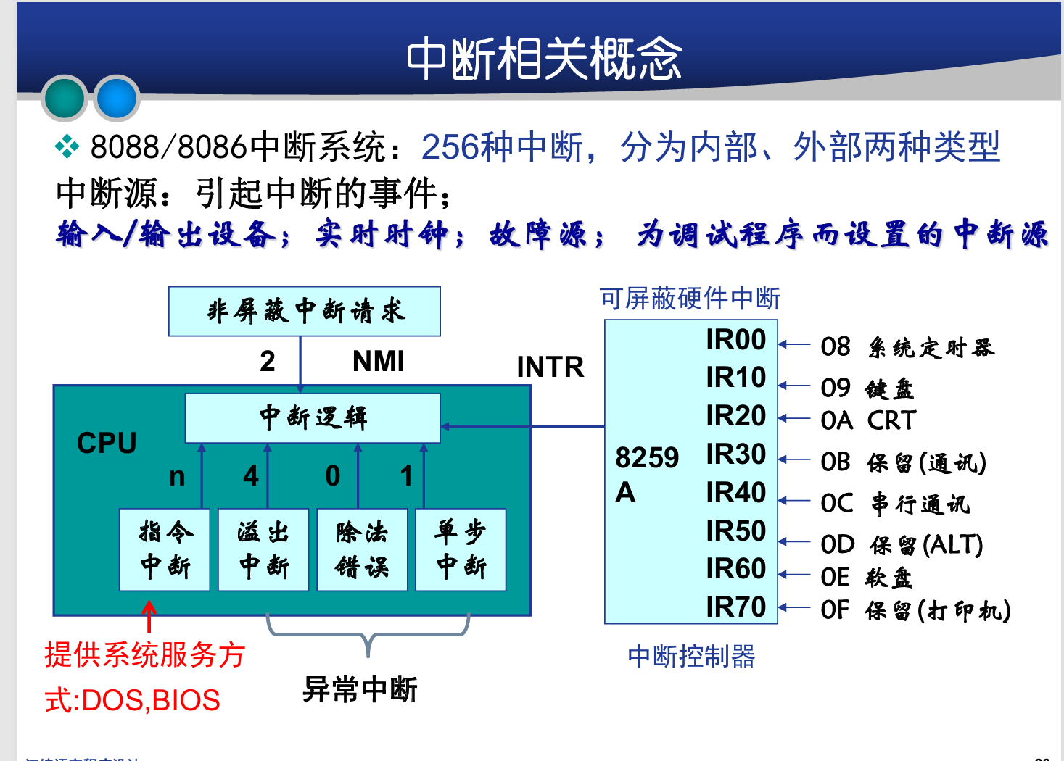
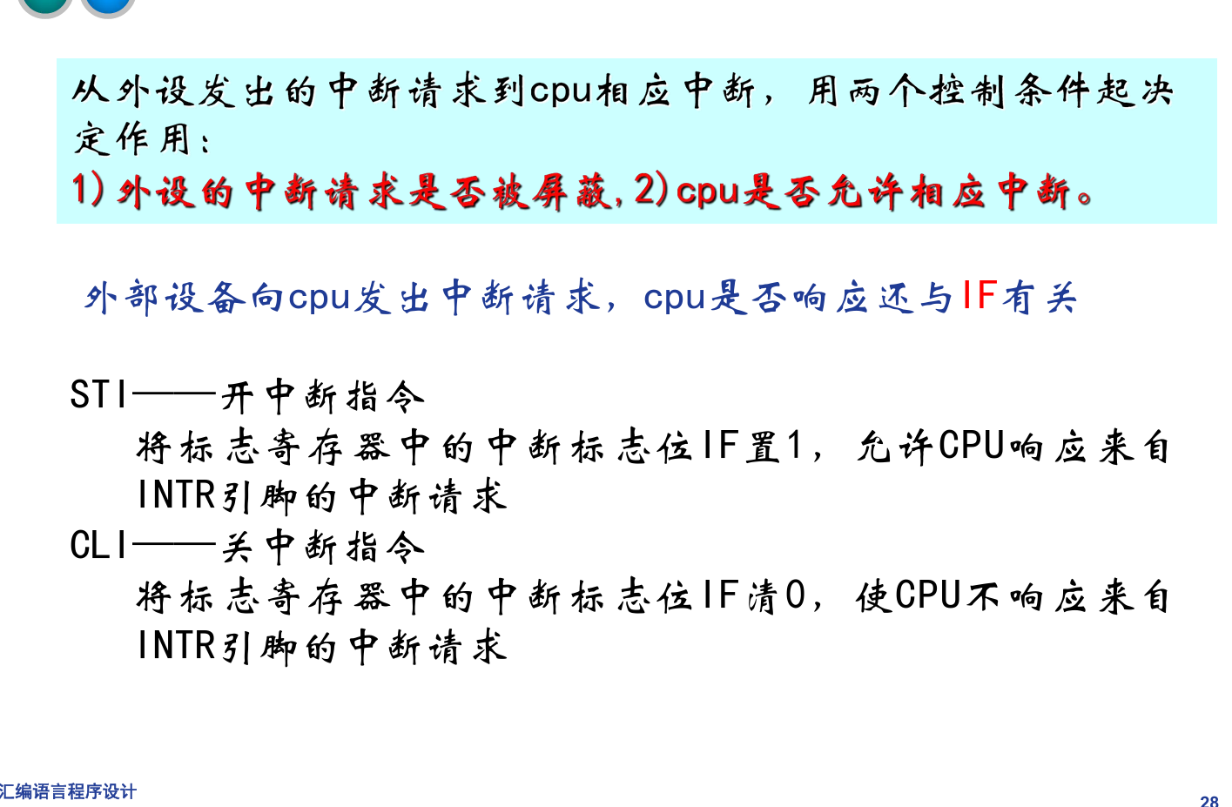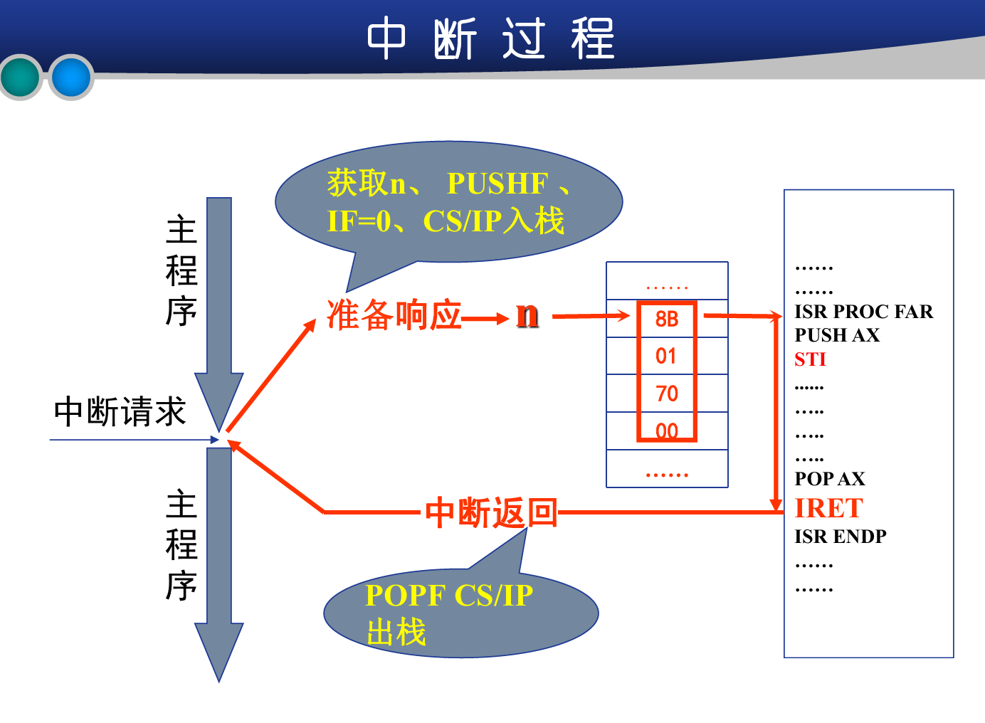

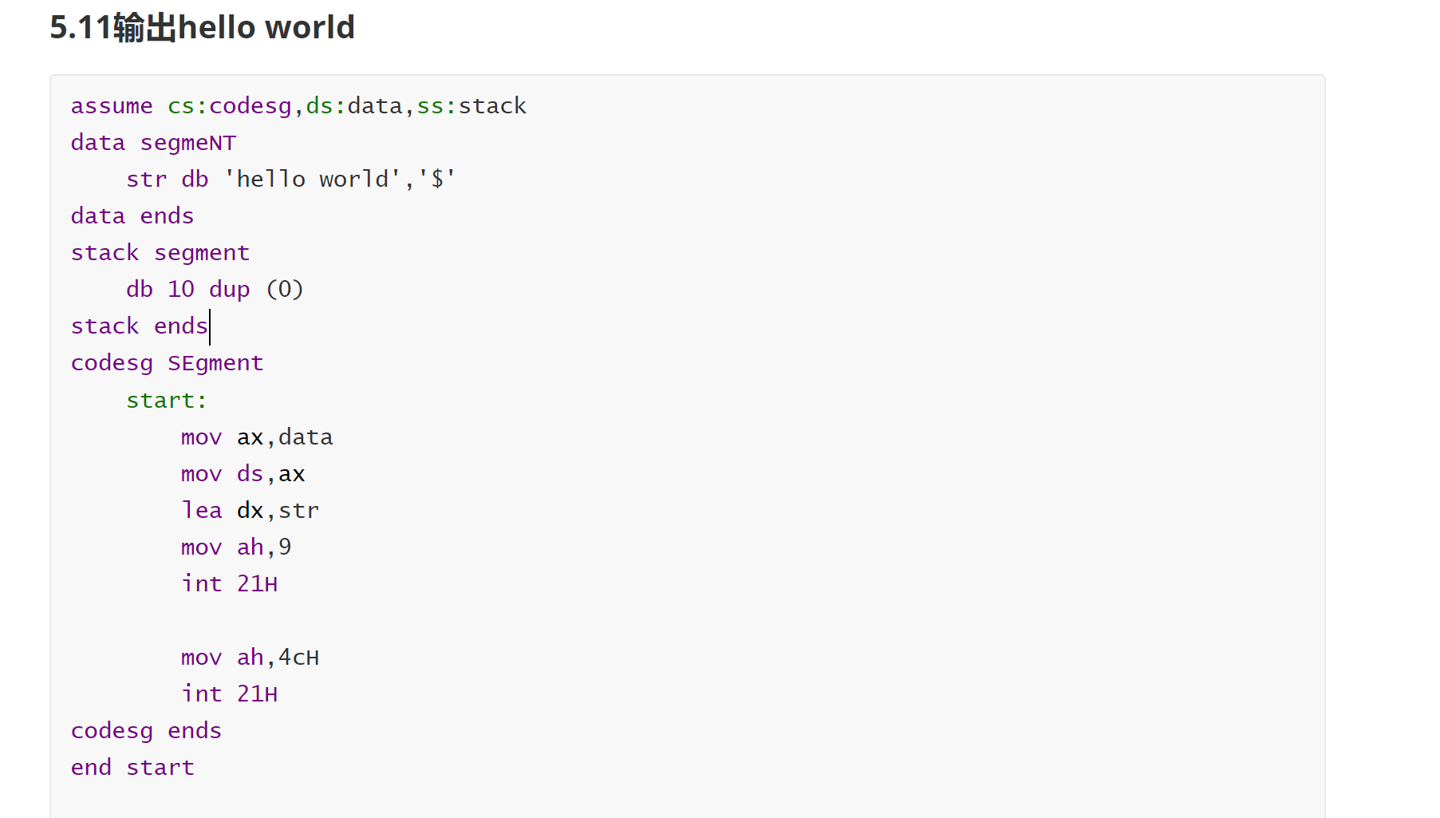
求数组最小值：
assume cs:codesg,ds:data,ss:stack
data segmeNT
str db 'hello world','$'
data ends
stack segment
db 10 dup (0)
stack ends
codesg SEgment
start:
mov ax,data
mov ds,ax

mov bx,0
mov cx,11
mov ah,0FFH
s:
mov al,[bx]
cmp ah,al
jna s1
mov ah,al
s1:
mov [bx],al
inc bx
loop s

;mov dx,offset str
lea dx,str
mov ah,9
int 21H

mov ah,4cH
int 21H
codesg ends
end start
求数组最大值：
assume cs:codesg,ds:data,ss:stack
data segmeNT
str db 'hello world','$'
data ends
stack segment
db 10 dup (0)
stack ends
codesg SEgment
start:
mov ax,data
mov ds,ax

mov bx,0
mov cx,11
mov ah,0
s:
mov al,[bx]
cmp ah,al
jnb s1
mov ah,al
s1:
mov [bx],al
inc bx
loop s

;mov dx,offset str
lea dx,str
mov ah,9
int 21H

mov ah,4cH
int 21H
codesg ends
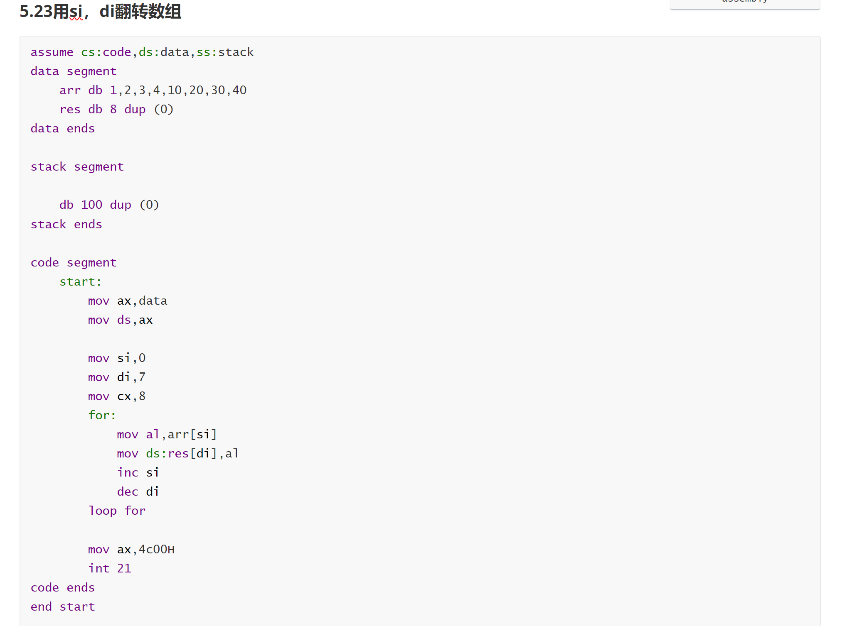
5.31用栈翻转数组
assume cs:code,ds:data,ss:stack
data segment
arr dw 1111H,2222H,3333H,4444H,5555H,6666H,7777H,8888H
res db 800 dup (0)
data ends

stack segment
db 1000 dup (0)
stack ends

code segment
start:
mov ax,data
mov ds,ax
mov ax,stack
mov ss,ax
mov sp,100

mov bx,0
mov cx,8
for:
push ds:arr[bx]
add bx,2
loop for

mov bx,0
mov cx,8
for1:
pop ds:arr[bx]
add bx,2
loop for1

mov ax,4c00H
int 21
code ends
end start
5.32动态规划求斐波那契数列
assume cs:code,ds:data,ss:stack
data segment
arr dw 1H,1H,100 dup (0)
res db 800 dup (0)
data ends

stack segment
db 100 dup (0)
stack ends

code segment
start:
mov ax,data
mov ds,ax
mov ax,stack
mov ss,ax

mov bx,4
mov cx,30
for :
mov dx,0
add dx,ds:arr[bx-2]
add dx,ds:arr[bx-4]
mov ds:arr[bx],dx
add bx,2
loop for

mov ax,4c00H
int 21
code ends
end start
5.42二重循环把指定矩形转大写
assume cs:codesg,ds:data,ss:stack
data segmeNT
str db 'aaaaabbbbbccccc '
db 'aaaaabbbbbccccc '
db 'aaaaabbbbbccccc '
db 'aaaaabbbbbccccc ','$'

data ends
stack segment
db 10 dup (0)
stack ends
codesg SEgment
start:
mov ax,data
mov ds,ax

mov bx,0
mov cx,4
for:
mov dx,cx
mov si,0
mov cx,5
for1:
mov al,ds:str[bx+si]
and al,11011111B
mov ds:str[bx+si],al
inc si
loop for1
mov cx,dx
add bx,16
loop for

lea dx,str
mov ah,9
int 21H

mov ah,4cH
int 21H
codesg ends
end start
5.61十进制转16进制并输出
assume cs:codesg,ds:data,ss:stack
data segmeNT
str db '00002333','$'
res db '0000','$'
data ends
stack segment
db 100 dup (0)
stack ends
codesg SEgment
start:
mov ax,data
mov ds,ax
mov ax,stack
mov ss,ax
mov sp,10
mov si,4

mov bx,0
mov cx,8
mov ax,0
s:
mov dx,ax
shl ax,1
shl ax,1
shl ax,1
shl dx,1
add ax,dx
;乘10

add al,str[bx]
adc ah,0
sub ax,30H

inc bx
loop s

;ax=3039

mov cx,4
l:
mov dx,ax
and dx,0FH
add dx,30H
cmp dx,3AH
jb s1
add dx,7H
;求出3039的ASCII码，push
s1:
dec si
mov ds:res[si],dl
shr ax,1
shr ax,1
shr ax,1
shr ax,1
loop l

;mov dx,offset res
lea dx,res
mov ah,9
int 21H

mov ah,4cH
int 21H
codesg ends
end start
从屏幕上输入多行字符串，用回车分隔开，把所有字符串小写转大写，大写转小写，再输出在屏幕上。
.MODEL SMALL
.STACK 100H
.DATA
inputBuffer DB 128 DUP('$') ; 用于存储输入的字符串
prompt1 DB 'Enter text (Press Enter to end each line, type "END" to finish): $'
prompt2 DB 'Converted Text: $'
endMessage DB 'END$', 0
newline DB 13, 10, '$'

.CODE
MAIN PROC
MOV AX, @DATA ; 初始化数据段
MOV DS, AX

; 显示输入提示
LEA DX, prompt1
MOV AH, 09H
INT 21H

INPUT_LOOP:
; 接收一行输入
LEA DX, inputBuffer
MOV AH, 0AH
INT 21H

; 检查是否输入"END"
LEA DI, inputBuffer + 1 ; DI 指向输入字符串的开头
LEA SI, endMessage
MOV CX, 3 ; 检查前3个字符
CLD ; 清除方向标志位，设置为向前移动
REPE CMPSB ; 比较输入和"END"
JNE PROCESS_INPUT ; 如果不是"END"，处理输入
JMP END_PROGRAM ; 否则结束程序

PROCESS_INPUT:
; 转换字符串大小写
LEA SI, inputBuffer + 1 ; SI指向输入字符串
MOV CX, inputBuffer ; 字符串长度
CONVERT_LOOP:
LODSB ; 加载下一个字符
CMP AL, 'a' ; 检查是否为小写字母
JB CHECK_UPPER
CMP AL, 'z'
JA CHECK_UPPER
SUB AL, 32 ; 小写转大写
JMP OUTPUT_CHAR
CHECK_UPPER:
CMP AL, 'A' ; 检查是否为大写字母
JB OUTPUT_CHAR
CMP AL, 'Z'
JA OUTPUT_CHAR
ADD AL, 32 ; 大写转小写
OUTPUT_CHAR:
MOV AH, 02H ; 显示字符
MOV DL, AL
INT 21H
LOOP CONVERT_LOOP

; 输出换行符
LEA DX, newline
MOV AH, 09H
INT 21H

; 返回到输入循环
JMP INPUT_LOOP

END_PROGRAM:
; 程序结束
MOV AH, 4CH
INT 21H
MAIN ENDP
END MAIN

