Xilinx Design Constraints
Introduction
In this lab you will use the uart_led design that was introduced in the previous labs. You will start the project with I/O Planning type, enter pin locations, and export it to the rtl. You will then create the timing constraints and perform the timing analysis.
Objectives
After completing this lab, you will be able to:
- Create a I/O Planning project
- Enter the pin locations and IO standards via Device view, Package Pins tab, and Tcl commands
- Create Period, Input Setup, and Output Setup delays
- Perform timing analysis

Procedure
This lab is broken into steps that consist of general overview statements providing information on the detailed instructions that follow. Follow these detailed instructions to progress through the lab.
Design Description
The design consists of a uart receiver receiving the input typed on a keyboard and displaying the binary equivalent of the typed character on the 8 LEDs. When a push button is pressed, the lower and upper nibbles are swapped. The block diagram is as shown in Figure 1.

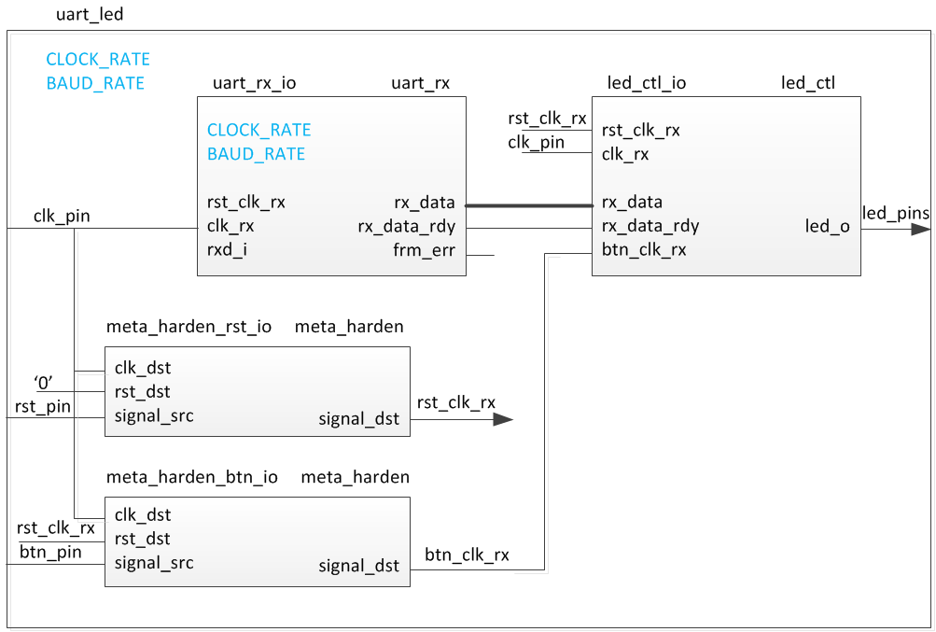
Figure 1. The design
General Flow
Step 5:
Generate the Bitstream and Verify (optional)
Step 2: Assign Various Pins and Source Files

Step 4:
Implement and Perform Timing Analysis
Step 3:
Synthesize and Enter Timing Constraints
Step 1:
Create a Vivado I/O Planning Project

- Create a Vivado I/O Planning Project Step 1
  - Launch Vivado and create an I/O Planning project targetingthe XC7A35TCSG324-1 (EGo1) .
References to <2017_1_artix7_labs> is a placeholder for the c:\xup\fpga_flow\2017_1_artix7_labs directory and <2017_1_artix7_sources> is a place holder for the c:\xup\fpga_flow\2017_1_artix7_sources directory.

    - Open Vivado by selecting Start > All Programs > Xilinx Design Tools > Vivado 2017.1 > Vivado 2017.1
    - Click Create New Project to start the wizard. You will see Create A New Vivado Project dialog box. Click Next.
    - Click the Browse button of the Project location field of the New Project form, browse to <2017_1_artix7_labs>, and click Select.
    - Enter lab5 in the Project name field. Make sure that the Create Project Subdirectory box is checked. Click Next.
    - Select I/O Planning Project option in the Project Type form, and click Next.
    - Select Do not import I/O ports at this time, and click Next.
    - In the Default Part form, using the Parts option and various drop-down fields of the Filter section, select the XC7A35TCSG324-1 (for the EGo1),
    - Click Next.
    - Click Finish to create the Vivado project.
The device view window and package pins tab will be displayed.
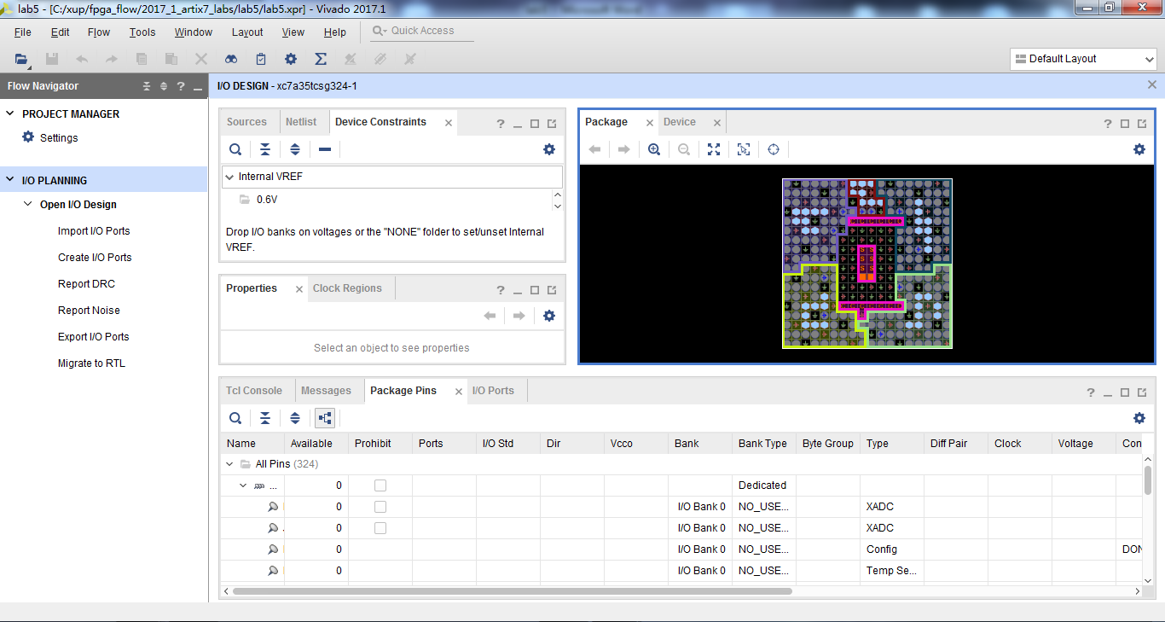
Figure 2. I/O Planning project’s default windows and views for the EGo1
- Create I/O Ports, Assign Various Pins and Add Source Files Step 2
  - Create input ports clk_pin, btn_pin, rxd_pin, and rst_pin.
    - Expand the I/O Design entry under the I/O Planning task of the Flow Manager and click on Create I/O Ports.
The Create I/O Ports form will be displayed.
    - Type clk_pin in the Name field, select Input for the Direction and select LVCMOS33 as the I/O Standard, and click OK.
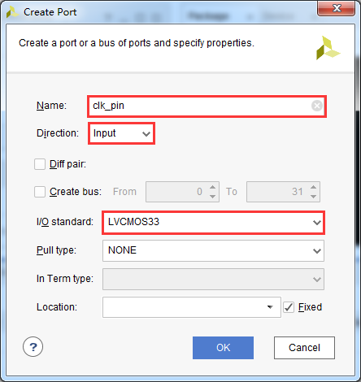
Figure 3. Creating I/O Port for clk_pin input
    - Similarly, create the btn_pin, rxd_pin and rst_pin input ports.
  - For the EGo1,assign input pins clk_in,btn_in,rxd_pin and rst_pin to P17,R11,N5 and P15 locations using the device view and package pins.
    - For the EGo1, move the mouse over the Device view window and hover over it on the P17 location.
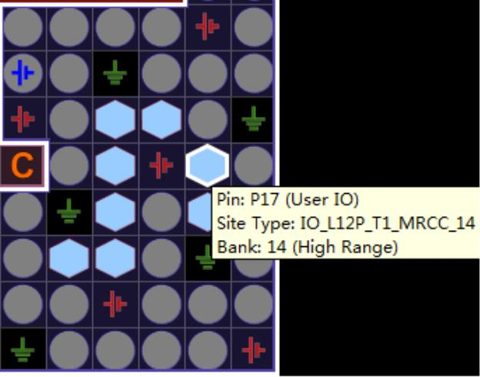



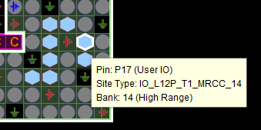
Figure 4. Locating E3 pin in the Device view for the EGo1
    - When located, click on it.
The pin entry will be highlighted and displayed in the Package Pins tab.
    - In the Package Pins pane, click in the Ports column of P17 (EGo1) pin’s row, and select clk_pin.
    - Similarly, add the btn_pin input port at R11 (EGo1).
    - Select Edit > Find or Ctrl-F to open the Find form. Select Package Pins in the Find drop-down field, type *N5(for the EGo1) in the match criteria field, and click on OK.
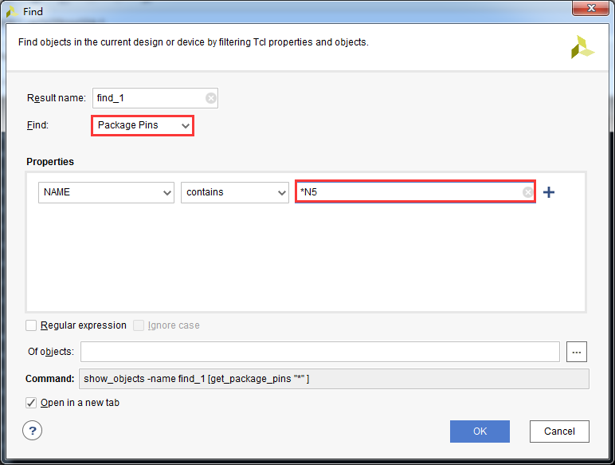
Figure 5. Finding a package pin for the EGo1
Notice that the Find Results tab is opened, and the corresponding entry is shown in the tab.
    - Assign the rxd_pin input to the pin.
    - Similarly add the rst_pin input by assigning it to the P15 location for the EGo1
  - For the EGo1,assign output pins led_pins[7] to led_pins[0] locations K2,J2,J3,H4,J4,G3,G4 and F6,Create them as a vector and assign them using the Tcl command set_properity.They all will be LVCMOS33.
    - In the I/O Ports tab, click on the create I/O port button on the left vertical ribbon.
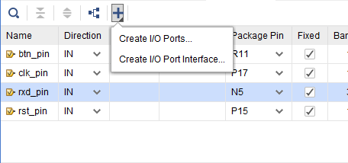
Figure 6. Create I/O Ports button
The Create I/O Ports form will be displayed.
    - Type led_pins in the Name field, select Output direction, click on the check-box of Create bus, set the msb to 7, and select LVCMOS33 I/O standard and click OK.
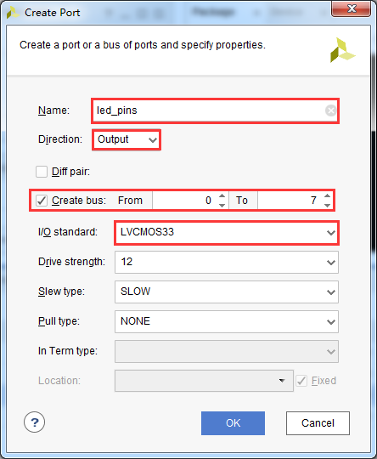
Figure 8. Creating I/O ports for the led_pins output
The led_pins entries will be created and displayed in the I/O Ports tab. Notice that the I/O standard and directions are already set, leaving only the pin locations to be assigned.
    - Type the following commands in the console to assign the pin locations.
set_property PACKAGE_PIN K2 [get_ports led_pins[7]]
set_property PACKAGE_PIN J2 [get_ports led_pins[6]]
set_property PACKAGE_PIN J3 [get_ports led_pins[5]]
set_property PACKAGE_PIN H4 [get_ports led_pins[4]]
set_property PACKAGE_PIN J4 [get_ports led_pins[3]]
set_property PACKAGE_PIN G3 [get_ports led_pins[2]]
set_property PACKAGE_PIN G4 [get_ports led_pins[1]]
set_property PACKAGE_PIN F6 [get_ports led_pins[0]]
    - Select File > Save Constraints.
The Save Constraints form will be displayed.
    - Enter uart_led in the File name field, and click OK.
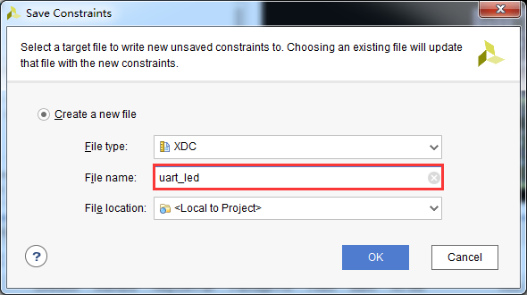
Figure 8. Saving constraints
The uart_led.xdc file will be created and added to the Sources tab.
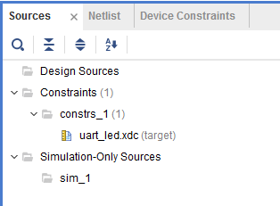
Figure 9. The uart_led.xdc file added to the source tree
    - Expand the I/O Planning > I/O Design in the Flow Navigator pane.
    - Click on Report DRC and click OK. Notice the design rules checker is run and one warning is reported. Ignore the warning.
    - Click on Report Noise and click OK. Notice the noise analysis is done on the output pins only (led_pins) and the results are displayed.
    - Click on Migrate to RTL.
The Migrate to RTL form will be displayed with Top RTL file field showing c:/xup/fpga_flow/2017_1_artix7_labs/lab5/io_1.v entry.
    - Change io_1.v to uart_led.v, and click OK
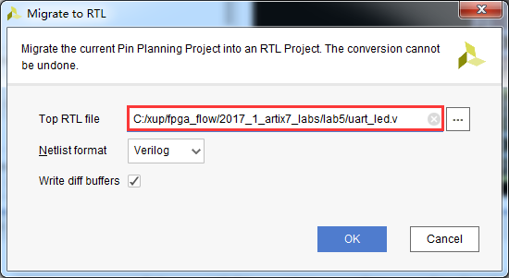
Figure 10. Assigning top-level file name
    - Select the Hierarchy tab and notice that the uart_led.v file has been added to the project with top-level module name as ios. If you double-click the entry, you will see the module name with the ports listing.
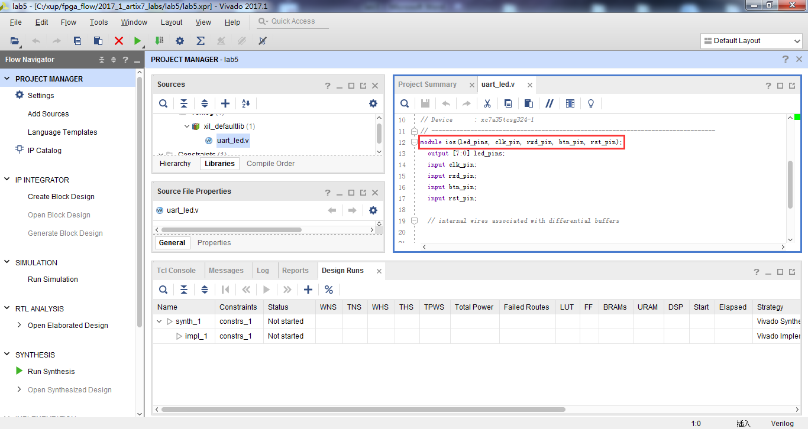Figure 11. The top-level module content and the design hierarchy after migrating to RTL
  - Add the provided source files (from <2017_1_artix7_sources>\lab5) to the project. Copy the uart_led.txt (located in the <2017_1_artix7_sources>\lab5) content into the top-level source file.
    - Click on Add Sources in the Flow Navigator.
    - In the Add Sources form, select Add or Create Design Sources, and click Next.
    - Click on the Green Plus button, then the Add Files…
    - Browse to <2017_1_artix7_sources>\lab5 and select all .v files (led_ctrl, uart_rx, meta_harden, uart_baud_gen, uart_rx_ctl), and click OK.
    - Click Finish.
    - Using Windows Explorer, browse to <2017_1_artix7_sources>\lab5 and open uart_led.txt using any text editor. Copy the content of it and paste it in uart_led.v (around line 22) in the Vivado project.
- Synthesize and Enter Timing Constraints Step 3
  - Synthesize the design. Use the Constraints Wizard to specify a clock frequency, and input and output delay constraints.
    - Click on the Run Synthesis in the Flow Navigator pane.
When synthesis is completed a form with three options will be displayed.
    - Select Open Synthesized Design and click OK.
    - In the Flow Navigator pane (under Synthesized Design), click on the Constraints Wizard button. This will open up the Constraints Wizard.
    - Read the Identify and Recommend Missing Timing Constraints screen of the wizard to understand what the wizard does and click Next.
    - Specify the frequency of the object “clk_pin” to be 100 MHz, notice the Period, Rise At and Fall At are automatically populated. Also notice the Tcl command that can be previewed at the bottom of the wizard. Click Next to proceed.
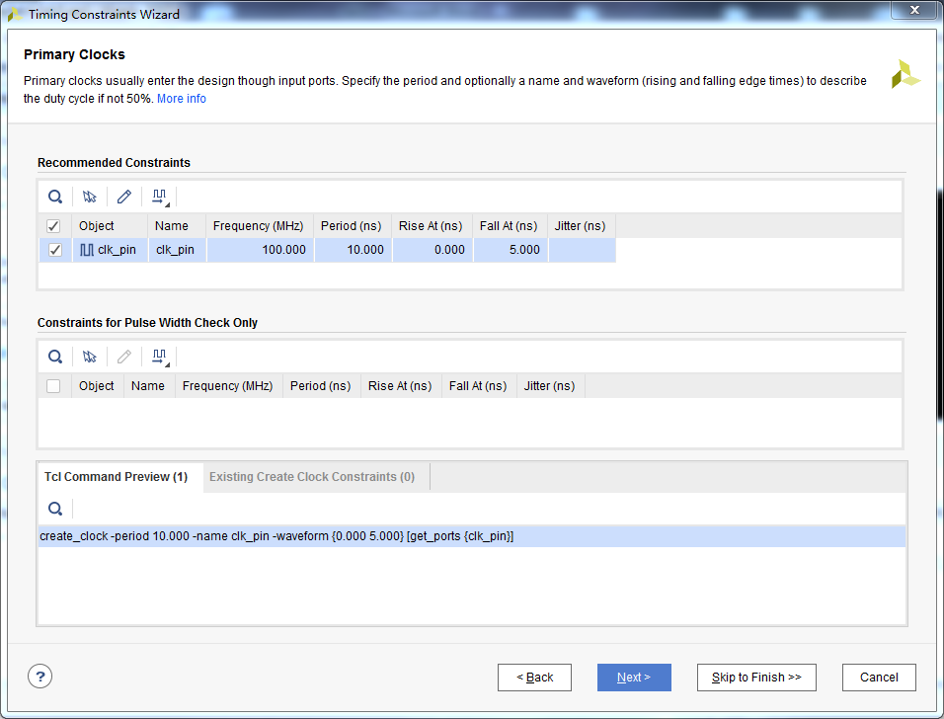
Figure 12. Constraints Wizard clk_pin parameters and Tcl command
    - There are no missing Generated Clocks, click Next to proceed.
    - There are no missing Forwarded Clocks, click Next to proceed.
    - There are no missing External Feedback Delays, click Next to proceed.
    - The wizard identifies Input Delays needed for the pins: btn_pin, rst_pin and rxd_pin. Do the following:
- Press Ctrl and select all three rows.
- Enter the tco_min value to be -0.5 ns and everything else as 0 ns. Click Apply.
- Notice that under the Tcl Command Preview tab, 6 Tcl commands have been generated.
- Click Next.
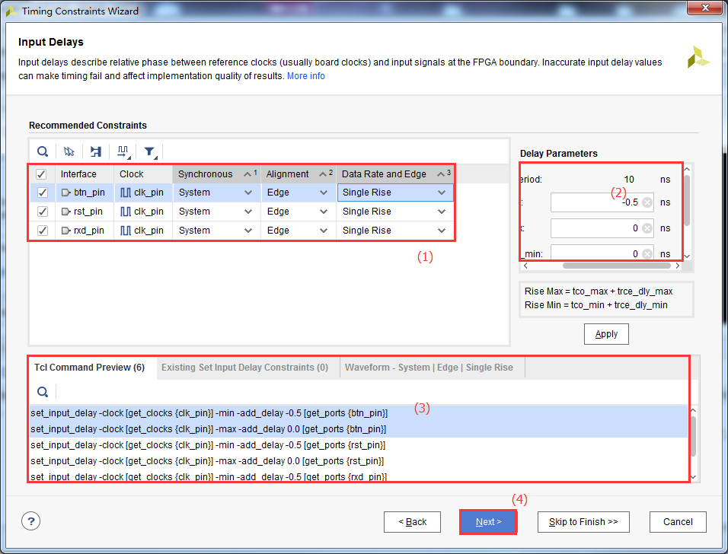
Figure 13. Specifying Input Delays for btn_pin, rst_pin and rxt_pin
    - For Output Delays, specify all values (tsu, trce_dly_max, thd, trce_dly_min) to be 0 ns. Click Apply and then click Next.
    - There are no Combinatorial Delays identified, click Next to proceed.
    - Click Skip to Finish to skip to the final Constraints Summary page. Read the description of each page.
    - Check On Finish – View Timing Constraints and click Finish to close the wizard. The option will open the Timing Constraints Editor to show you the generated timing constraint.
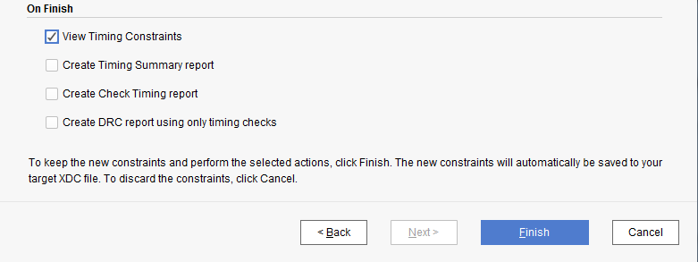
Figure 14. Selecting View Timing constraints
    - Note the wizard generated the clk_pin constraint for a 10 ns period (or 100 MHz). Notice in the All Constraints window, 9 constraints will be created.
There is no need to click Apply since the constraints have already been applied in the Constraints Wizard.
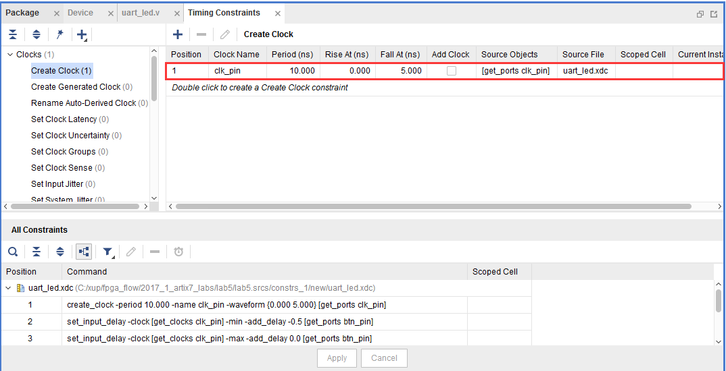
Figure 15. The constraints added after using the Constraints Wizard
    - Open uart_led.xdc (if it was already opened, click Reload in the yellow status bar) and notice additional constraints were added to the last line of the file.
  - Generate an estimated Timing Report showing both the setup and hold paths in the design.
    - In the Flow Navigator, select Synthesized Design > Report Timing Summary.
    - In the Options tab, select min_max from the Path delay type drop-down list.
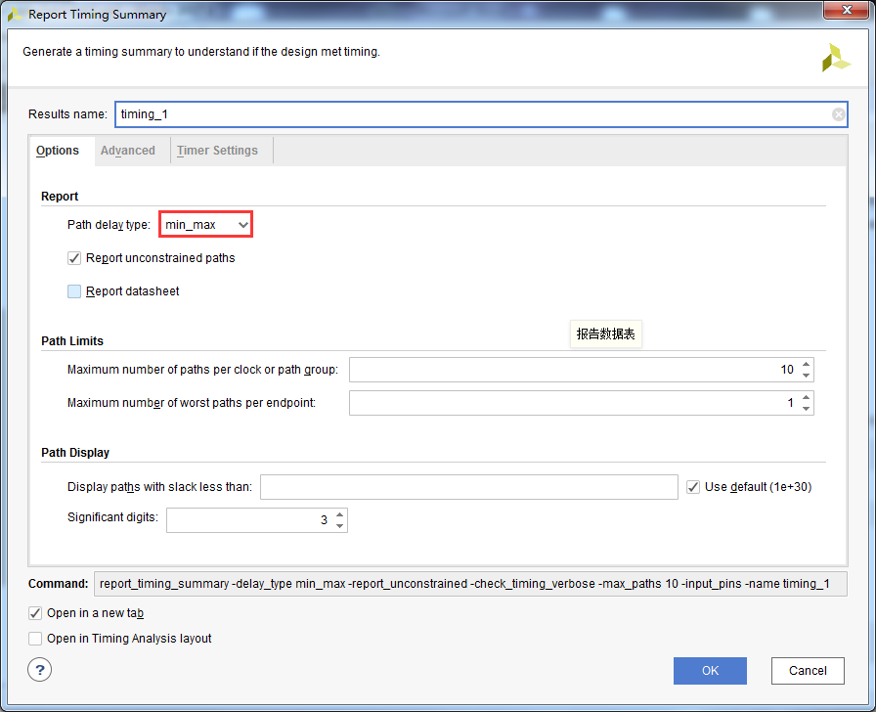
Figure 16. Performing timing analysis
    - Click OK to run the analysis.
The Timing Results view opens at the bottom of the Vivado IDE.
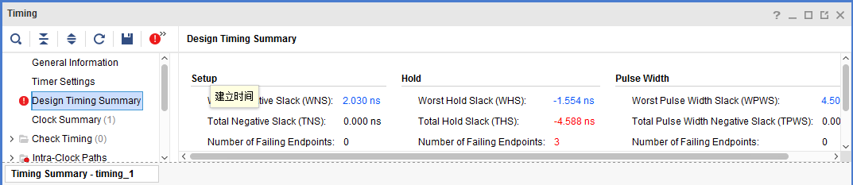
Figure 17. Timing summary for the EGo1
The Design Timing Summary report provides a brief worst Setup and Hold slack information and Number of failing endpoints to indicate whether the design has met timing or not.
Note that there are three timing failures under the hold check.
    - Click on the link next to Worst Hold Slack (WHS) to see the list of failing paths.
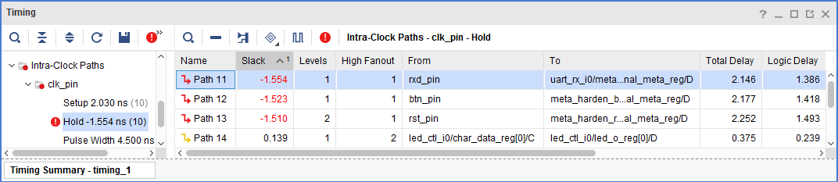
Figure 18. The list of paths showing hold violations for the EGo1
    - Double-click on the Path 11 to see the actual path detail.
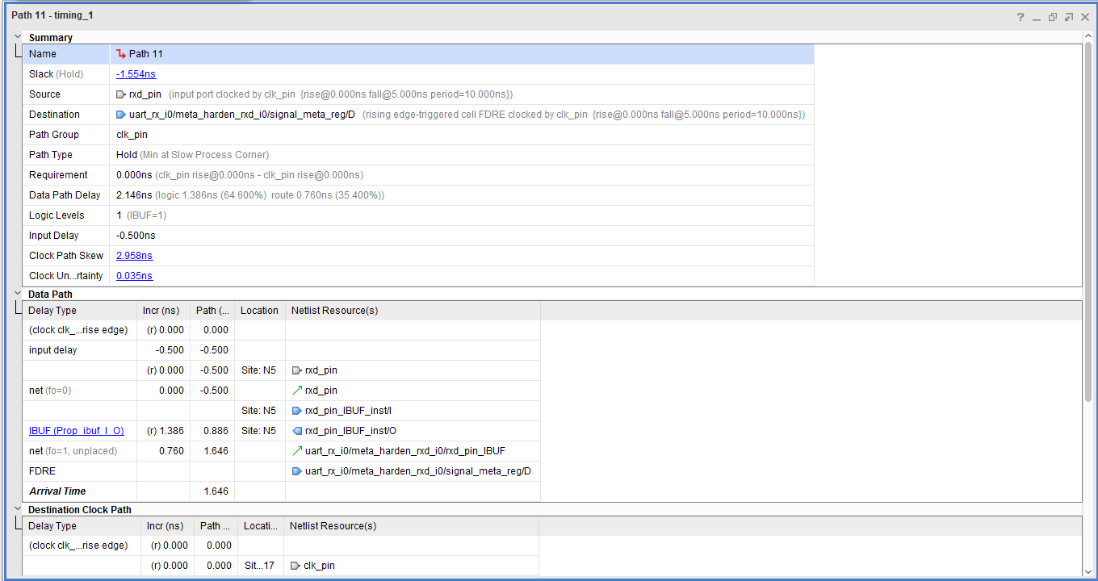
Figure 19. Failing hold path for the EGo1
    - Select Path11, right-click and select Schematic.
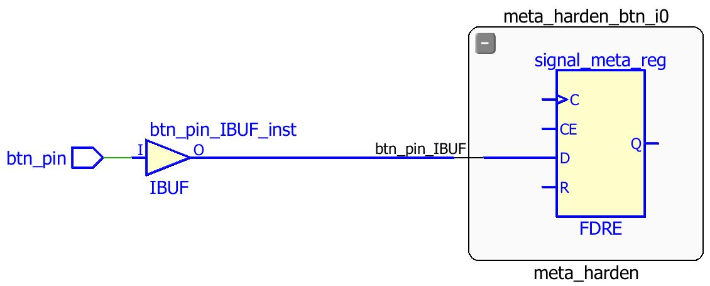
Figure 20. The schematic of the failing path
The three failing paths are of the btn_pin, rxd_pin and rst_pin.
- Implement and Analyze Timing Summary Step 4
  - Implement the design.
    - Click on the Run Implementation in the Flow Navigator pane.
    - Click Yes to run the synthesis first before running the implementation process.
When the implementation is completed, a dialog box will appear with three options.
    - Select the Open Implemented Design option and click OK.
    - Click Yes if you are prompted to close the synthesized design.
  - Generate a timing summary report.
    - In the Flow Navigator, under Implementation > Implemented Design, click Report Timing Summary.
    - Click OK to generate the report using the default settings.
The Design Timing Summary window opens at the bottom in the Timing tab.
Note that failing timing paths are indicated in red.
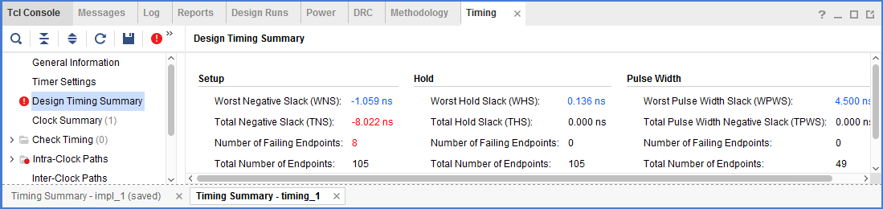
Figure 21. Failing setup paths for the EGo1
    - Click on the WNS to see the failing paths.
    - Double-click on the first failing path from the top and see the detailed analysis.
The output path delay can be reduced by placing the register in IOB.
    - Apply the constraint by typing the following command in the Tcl console.
set_property IOB TRUE [get_ports led_pins[*]]
    - Select File > Save Constraints. Click OK at the warning message. Click Yes to save the project.
    - Click on Run Implementation.
    - Click Yes to reset the synthesis run, perform the synthesis, and run implementation.
    - Open the implemented design and observe that the number of failing paths in the Design Runs tab reported is 0.
    - Click Report Timing Summary, and observe that there are no failing paths.
- Generate the Bitstream and Verify the Functionality (Optional) Step 5
  - Generate the bitstream.
    - In the Flow Navigator, under Program and Debug, click Generate Bitstream.
    - The write_bitstream command will be executed (you can verify it by looking in the Tcl console).
    - Click Cancel when the bitstream generation is completed.
  - Connect the board and power it ON. Open a hardware session, and program the FPGA.
    - Make sure that the Micro-USB cable is connected to the JTAG PROG connector (next to the power supply connector).
    - Turn ON the power.
    - Select the Open Hardware Manager option.
The Hardware Manager window will open indicating “unconnected” status.
    - Click on the Open target link, then Auto Connect from the dropdown menu.
You can also click on the Open recent target link if the board was already targeted before.
    - The Hardware Manager status changes from Unconnected to the server name and the device is highlighted. Also notice that the Status indicates that it is not programmed.
    - Select the device and verify that the uart_led.bit is selected as the programming file in the General tab.
  - Start a terminal emulator program such as TeraTerm or HyperTerminal. Select an appropriate COM port (you can find the correct COM number using the Control Panel). Set the COM port for 115200 baud rate communication. Program the FPGA and verify the functionality.
    - Start a terminal emulator program such as TeraTerm or HyperTerminal.
    - Select an appropriate COM port (you can find the correct COM number using the Control Panel).
    - Set the COM port for 115200 baud rate communication.
    - Right-click on the FPGA entry in the Hardware window and select Programming Device…
    - Click on the Program button.
The programming bit file be downloaded and the DONE light will be turned ON indicating the FPGA has been programmed.
    - Verify the functionality as you did in the previous lab, by typing some characters into the terminal, and watching the corresponding values appear on the LEDs.
    - When satisfied, close the terminal emulator program and power OFF the board.
    - Select File > Close Hardware Manager. Click OK to close it.
    - When done, close the Vivado program by selecting File > Exit and click OK.
Conclusion
In this lab, you learned how to create an I/O Planning project and assign the pins via the Device view, Package Pins tab, and the Tcl commands. You then exported to the rtl project where you added the provided source files. Next you created timing constraints and performed post-synthesis and post-implementation timing analysis.

