Hardware Debugging
Introduction
In this lab you will use the uart_led design that was introduced in the previous labs. You will use Mark Debug feature and also the available Integrated Logic Analyzer (ILA) core (in IP Catalog) to debug the hardware.
Objectives
After completing this lab, you will be able to:
- Use the Integrated Logic Analyzer (ILA) core from the IP Catalog as a debugging tool
- Use Mark Debug feature of Vivado to debug a design
- Use hardware debugger to debug a design
Procedure
This lab is broken into steps that consist of general overview statements providing information on the detailed instructions that follow. Follow these detailed instructions to progress through the lab.
Design Description
The design consists of a uart receiver receiving the input typed on a keyboard and displaying the binary equivalent of the typed character on the 8 LEDs. When a push button is pressed, the lower and upper nibbles are swapped. The block diagram is as shown in Figure 1.
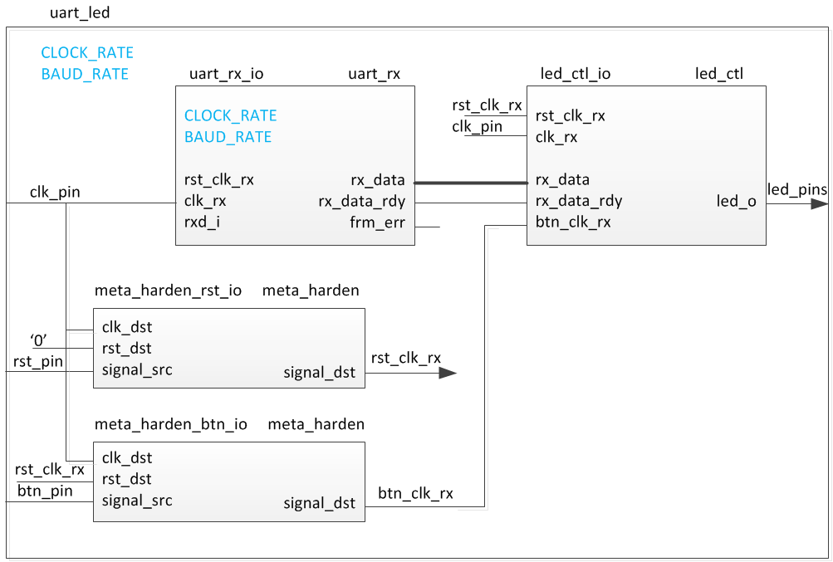
Figure 1. The Completed Design

General Flow
Step 5:
Debug in Hardware
Step 4:
Implement and Generate Bitstream
Step 3:
Synthesize the Design and Mark Debug
Step 2: Add the ILA Core

Step 1: Create a Vivado Project using IDE

- Create a Vivado Project using IDE Step 1
  - Launch Vivado and create a project targeting the XC7A35TCSG324-1 (EGo1), and using the Verilog HDL. Use the provided Verilog and Xilinx Design Constraints source files from the <2017_1_artix7_sources>\lab6 directory.

References to <2017_1_artix7_labs> is a placeholder for the c:\xup\fpga_flow\2017_1_artix7_labs directory and <2017_1_artix7_sources> is a place holder for the c:\xup\fpga_flow\2017_1_artix7_sources directory.

    - Open Vivado by selecting Start > All Programs > Xilinx Design Tools > Vivado 2017.1 > Vivado 2017.1
    - Click Create New Project to start the wizard. You will see Create A New Vivado Project dialog box. Click Next.
    - Click the Browse button of the Project location field of the New Project form, browse to <2017_1_artix7_labs>, and click Select.
    - Enter lab6 in the Project name field. Make sure that the Create Project Subdirectory box is checked. Click Next.
    - Select RTL Project option in the Project Type form, and click Next.
    - Using the drop-down buttons, select Verilog as the Target Language and Simulator Language in the Add Sources form.
    - Click on the Green Plus button, then the Add Files… button and browse to the <2017_1_artix7_sources>\lab6 directory, select all the Verilog files (led_ctl.v, meta_harden.v, uart_baud_gen.v, uart_led.v, uart_rx.v, and uart_rx_ctl.v), click OK, and then click Next.
    - Click Next to get to the Add Constraints form.
    - Click on the Green Plus button, then Add Files… and browse to the c:\xup\fpga_flow\2017_1_artix7_sources\lab6 directory (if necessary), select uart_led_timing.xdc and the appropriate uart_led_pins_<board>.xdc and click Open.
    - Click Next.
    - In the Default Part form, using the Parts option and various drop-down fields of the Filter section, select the XC7A100TCSG324-1 (for the Nexys4 DDR), the XC7A35TCPG236-1 (for the Basys3), or XC7A200tsbg484-1 for the Nexys Video.
Using the Boards option, you may also select the Nexys4 DDR, the Basys3, or the Nexys Video depending on your board.
    - Click Next.
    - Click Finish to create the Vivado project.
- Add the ILA Core Step 2
    - Click IP Catalog under the Project Manager tasks of the Flow Navigator pane.
    - The catalog will be displayed in the Auxiliary pane.
    - Expand the Debug & Verification > Debug folders and double-click the ILA entry.
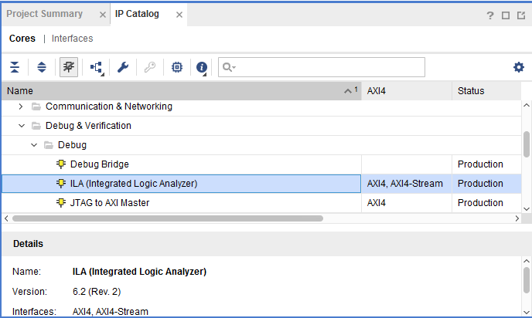
Figure 2. ILA in IP Catalog
This exercise will be connecting the ILA core/component to the LED port which is 8-bit wide.

    - Change the component name to ila_led.
    - Change the Number of Probes to 2.
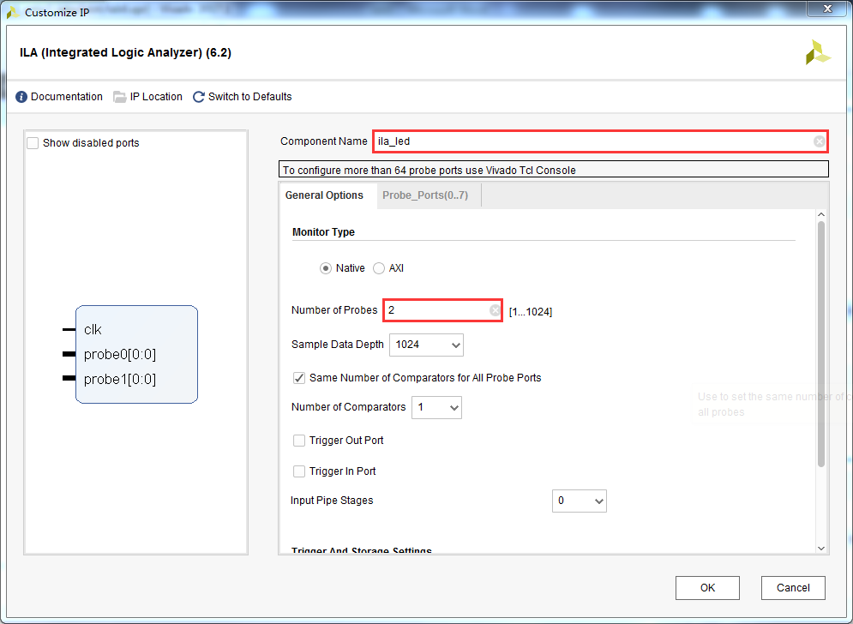
Figure 3. Setting the component name and the number of probes field
    - Select the Probe Ports tab and change the PROBE1 port width to 8, leaving the PROBE0 width to 1.
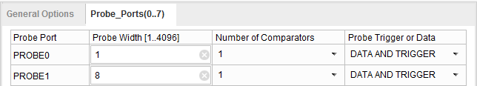
Figure 4. Setting the probes widths
    - Click OK.
The Generate Output Products dialog box will appear.
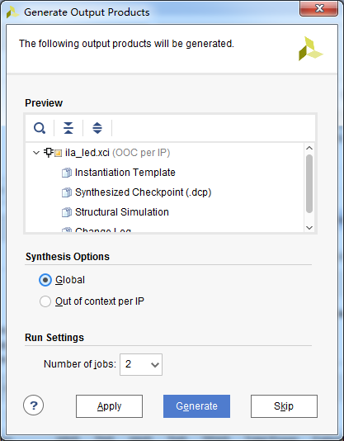
Figure 5. The Generate Output Products
    - Click the Generate button to generate the core including the instantiation template. Click OK at the warning box. Notice the core is added to the Design Sources view.
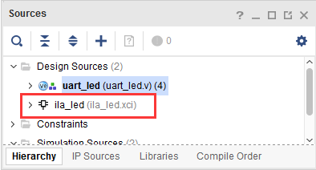
Figure 6. Newly generate ila core added in the design source
    - Select the IP Sources tab, expand the IP(1) > ila_led > Instantiation Template, and double-click the ila_led.veo entry to see the instantiation template.
    - Instantiate the ila_led in design by copying lines 56 – 62 and pasting to ~line 104 (before “endmodule” on the last line) in the uart_led.v file.
    - Change your_instance_name to ila_led_i0.
    - Change the following port names in the Verilog code to connect the ila to existing signals in the design:
.clk(CLK) . clk(clk_pin)
.probe0(PROBE0) . probe0(rx_data_rdy)
.probe1(PROBE1) . probe1(led_pins)
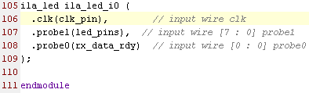
Figure 7. Instantiating the ILA Core in the uart_led.v
    - Select File > Save File.
Notice that the ILA Core instance is in the design hierarchy.
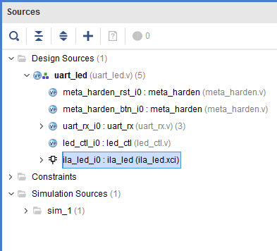
Figure 8. ILA Core added to the design
- Synthesize the Design and Mark Debug Step 3
  - Synthesize the design. Open the synthesized design. View the schematic. Add Mark Debug on the rx_data bus between the uart_rx_i0 and led_ctl_i0 instances.
    - Click on Run Synthesis under the Synthesis tasks of the Flow Navigator pane.
The synthesis process will be run on the uart_led.v and all its hierarchical files. When the process is completed a Synthesis Completed dialog box with three options will be displayed.
    - Select the Open Synthesized Design option and click OK.
    - Click on Schematic under the Synthesized Design tasks of Synthesis tasks of the Flow Navigator pane to view the synthesized design in a schematic view.
    - Select the rx_data bus between the uart_rx_i0 and the led_ctl_i0 instances, right-click, and select Mark Debug.
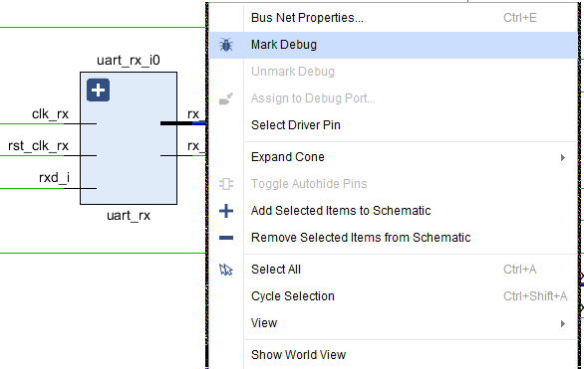
Figure 9. Marking a bus to debug
    - Select File > Save Constraints.
    - Click OK, and then again OK to use uart_led_timing.xdc as the target.
    - Select the Netlist tab and notice that the nets which are marked/assigned for debugging have a debug icon next to them.
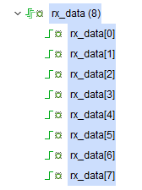
Figure 10. Nets with debug icons
    - Select the Debug layout or Layout > Debug.
Notice that the Debug tab is visible in the Console pane showing Assigned and Unassigned Debug Nets groups.
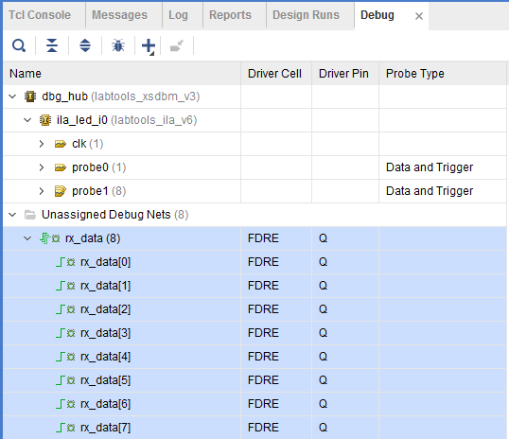
Figure 11. Debug tab showing assigned and unassigned nets
    - Either click on the button in the left vertical tool buttons of the Debug pane, or right-click on the Unassigned Debug Nets and select the Set up Debug… option.
    - In the Set Up Debug wizard click Next.
Note that rx_data is listed, with the Clock Domain as clk_pin_IBUF_BUFG.
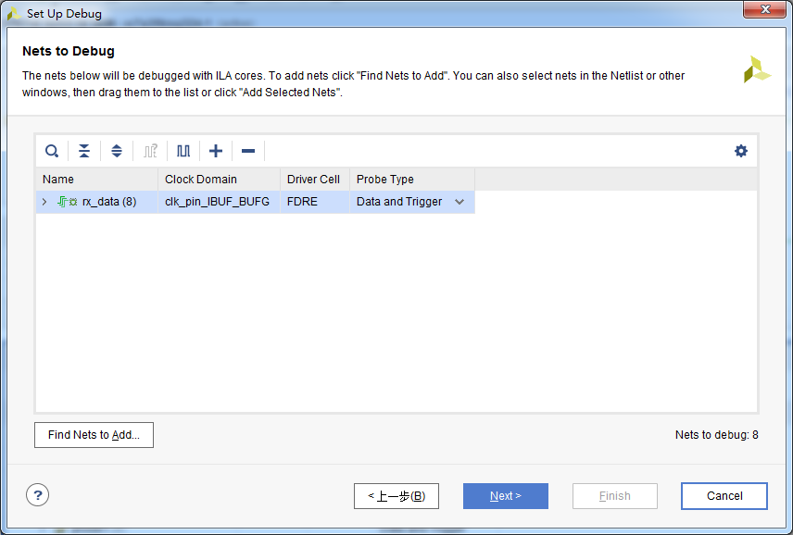
Figure 12. The remaining nets after removing already assigned nets in the Set Up Debug wizard
    - Click Next and again Next (leaving everything as defaults) then Finish.
    - In the Synthesized Design Schematic, click on the net on the output side of the BUFG for the input pin named clk_pin. Hover over the now highlighted net and notice the name is clk_pin_IBUF_BUFG. This is the clock net selected for the debug nets earlier.
Figure 13. Locating clk_pin_IBUF_BUFG in the design
    - Right click on uart_led_pins_EGo1.xdc in the sources pane and select Set as Target Constraint File. This will save the changes to the file
    - Select File > Save Constraints and click OK and Click Yes.
    - Open uart_led_pins_EGo1.xdc and notice the debug nets have been appended to the bottom of the file.
    - Perform this step if synthesis is not already up-to-date: In the Design Runs tab, right-click on the synth_1 and select Force Up-to-Date to ensure that the synthesis process is not re-run, since the design was not changed.
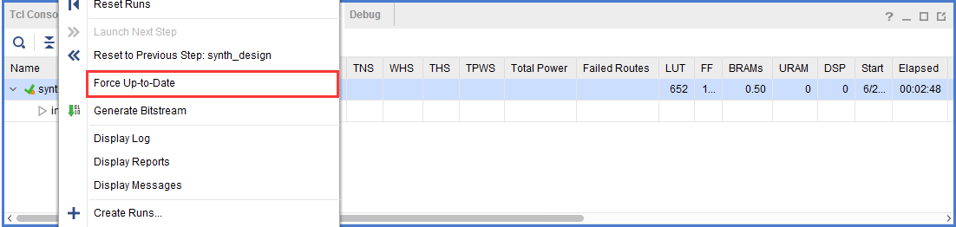
Figure 14. Forcing the design to be up-to-date
- Implement and Generate Bitstream Step 4
  - Generate the bitstream.
    - Click on the Generate Bitstream to run the implementation and bit generation processes.
    - Click Yes to run the implementation processes.
    - When the bitstream generation process has completed successfully, a box with three options will appear. Select the Open Hardware Manager option and click OK.
- Debug in Hardware Step 5
  - Connect the board and power it ON. Open a hardware session, and program the FPGA.
    - Make sure that the Micro-USB cable is connected to the JTAG PROG connector (next to the power supply connector). Make sure that the jumper is set to select USB power.
    - Turn ON the power.
    - Select the Open Hardware Manager option and click OK.
The Hardware Manager window will open indicating “unconnected” status.
    - Click on the Open target link, then Auto Connect from the dropdown menu.
You can also click on the Open recent target link if the board was already targeted before.
    - The Hardware Session status changes from Unconnected to the server name and the device is highlighted. Also notice that the Status indicates that it is not programmed.
    - Select the device and verify that the uart_led.bit is selected as the programming file in the General tab. Also notice that there is an entry in the Debug probes file field.
  - Start a terminal emulator program such as TeraTerm or HyperTerminal. Select an appropriate COM port (you can find the correct COM number using the Control Panel). Set the COM port for 115200 baud rate communication. Program the FPGA and verify the functionality.
    - Start a terminal emulator program such as TeraTerm or HyperTerminal.
    - Select an appropriate COM port (you can find the correct COM number using the Control Panel).
    - Set the COM port for 115200 baud rate communication.
    - Right-click on the FPGA, and select Program Device… and click Program.
The programming bit file be downloaded and the DONE light will be turned ON indicating the FPGA has been programmed
The Debug Probes window will also open, if not, then select Window > Debug Probes. Notice that there are two debug cores, hw_ila_1 and hw_ila_2.
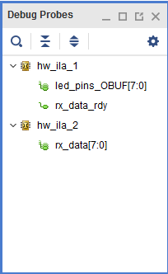
Figure 16. Debug probes
The hardware session status window also opens showing that the FPGA is programmed having two ila cores with the idle state.
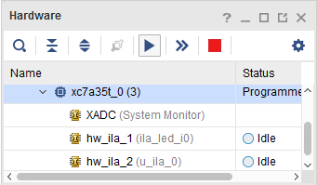
Figure 17. Hardware session status for the EGo1
    - Select the target FPGA (XC7A35T), and click on the Run Trigger Immediate button to see the signals in the waveform window.
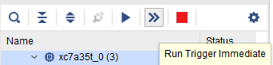
Figure 18. Opening the waveform window
Two waveform windows will be created, one for each ila; one ila is of the instantiated ILA core and another for the MARK DEBUG method.
  - Setup trigger conditions to trigger on a write to led port (rx_data_rdy=1) and the trigger position to 512. Arm the trigger.
    - In the Debug Probes window, right-click on the rx_data_rdy and select Add Probes to Basic Trigger Setup.

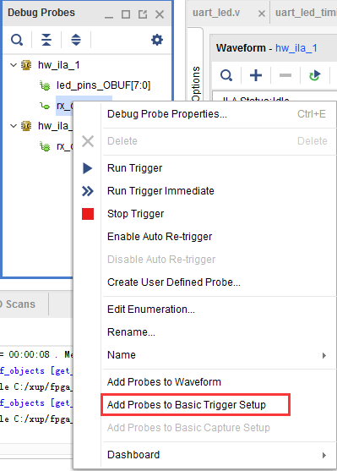
Figure 19. Adding a signal to trigger setup
    - In the Basic Trigger Setup window, click on the drop-down button, set the compare value (== [B] X) and change the value from x to 1. Click OK.
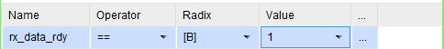
Figure 20. Setting the trigger condition
    - Set the trigger position of the hw_ila_1 to 512.
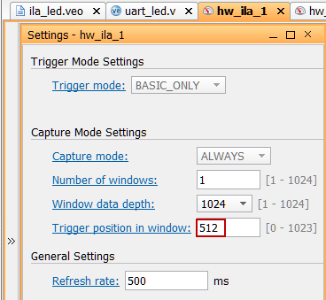
Figure 21. Setting up the trigger position
    - Similarly, set the trigger position of the hw_ila_2 to 512.
    - Select the hw_ila_1 in the Hardware window and then click on the Run Trigger () button. Observe that the hw_ila_1 core is armed and showing the status as Waiting for Trigger.
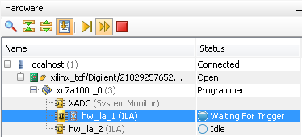
Figure 22. Hardware analyzer running in capture mode
    - In the terminal emulator window, type a character, and observe that the hw_ila_1 status changes from capturing to idle as the rx_data_rdy became 1.
    - Select the hw_ila_data_1.wcfg window and see the waveform. Notice that the rx_data_rdy goes from 0 to 1 at 512th sample and the led_ctl_i0 [7:0] bits also changes from 0 to the bit pattern corresponding to the character you typed.
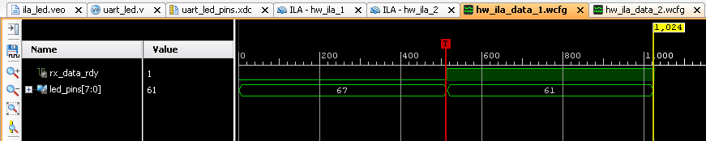
Figure 23. Zoomed waveform view
    - Add the hw_ila_2 probes to the trigger window of the hw_ila_2 and change the trigger condtion for rx_data[7:0]’s Radix from Hexadecimal to binary. Change XXXX_XXXX to 0101_0101 (for the ASCII equivalent of U).
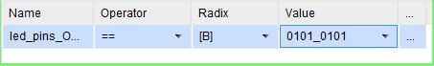
Figure 24. Setting up trigger condition for a particular input pattern
    - In the Hardware window, right-click on the hw_ila_2 and select Run Trigger, and notice that the status of the hw_ila_2 changes from idle to Waiting for Trigger. Also notice that the hw_ila_1 status does not change from idle as it is not armed.
    - Switch to the terminal emulator window and type U (shift+u) to trigger the core.
    - Select the corresponding waveform window and verify that it shows 55 after the trigger.
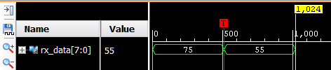
Figure 25. Second ila core triggered
    - When satisfied, close the terminal emulator program and power OFF the board
    - Select File > Close Hardware Manager. Click OK to close it.
    - Close the Vivado program by selecting File > Exit and click OK.
Conclusion
You used ILA core from the IP Catalog and Mark Debug feature of Vivado to debug the hardware design.

