Module 5: Critical Thinking Assignment

Nolan Hill
Colorado State University Global
CSC400: Data Structures and Algorithms
Winter Term A
Professor Santosh Gottipamula
December 13, 2025

Part 1
Implement the radix sort algorithm in Java.
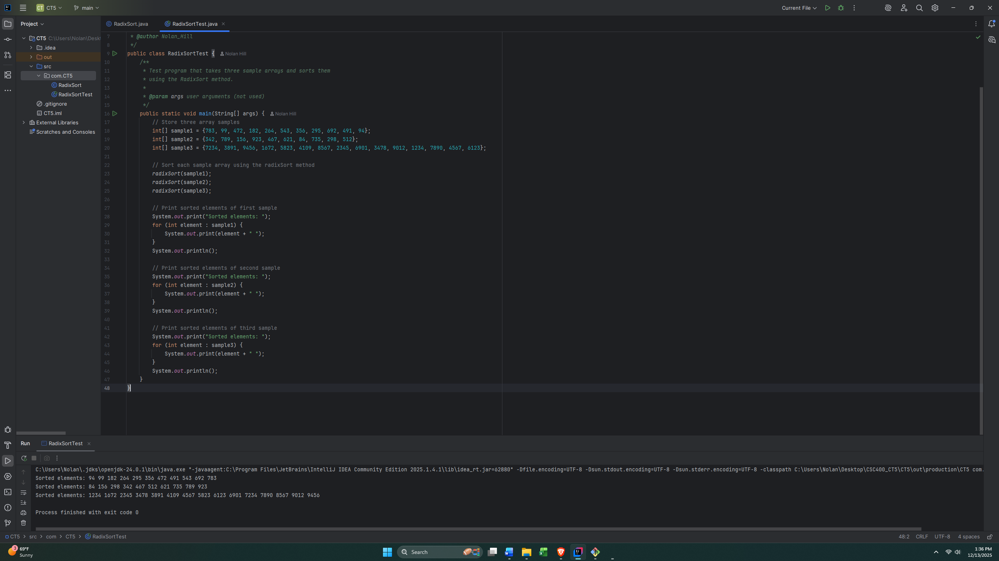
Part 2

Analyze the algorithm by documenting the steps taken when radix sort sorts the following array of Integer objects: 783 99 472 182 264 543 356 295 692 491 94:
- Create 10 buckets to each represent a number from 0 to 9
- Find largest number in array
- Find the total number of digits of the largest number
- Iterate through all elements in the array, evaluating each element at a particular digit, starting from least significant to most significant (1’s place, then 10’s place, then 100’s place, etc..)
- First iteration of elements in array:
- Bucket 0:
- Bucket 1: 491
- Bucket 2: 472, 182, 692
- Bucket 3: 783, 543
- Bucket 4: 264, 94
- Bucket 5: 295
- Bucket 6: 356
- Bucket 7:
- Bucket 8:
- Bucket 9: 99
- Iterate through each bucket (starting at bucket 0) and fill original array:
- New values of array: 491, 472, 182, 692, 783, 543, 264, 94, 295, 356, 99
- Iterate through each bucket and clear all values to prepare for next digit comparison.

- Set multiplier to check for next least significant digit.
- Second iteration of elements in array:
- Bucket 0:
- Bucket 1:
- Bucket 2:
- Bucket 3:
- Bucket 4: 543
- Bucket 5: 356
- Bucket 6: 264
- Bucket 7: 472
- Bucket 8: 182, 783,
- Bucket 9: 491, 692 94, 295, 99
- Iterate through each bucket (starting at bucket 0) and fill original array:
- New values of array: 543, 356, 264, 472, 182, 783, 491, 692, 94, 295, 99
- Iterate through each bucket and clear all values to prepare for next digit comparison.

- Set multiplier to check for next least significant digit.
- Third iteration of elements in array:
- Bucket 0: 94, 99
- Bucket 1: 182
- Bucket 2: 264, 295
- Bucket 3: 356
- Bucket 4: 472, 491
- Bucket 5: 543
- Bucket 6: 692
- Bucket 7: 783
- Bucket 8:
- Bucket 9:
- Iterate through each bucket (starting at bucket 0 and index 0 of each bucket) and fill original array:
- New values of array: 94, 99, 182, 264, 295, 356, 472, 491, 543, 692, 783
- Iterate through each bucket and clear all values to prepare for next digit comparison.

- Set multiplier to check for next least significant digit.
- Iteration stops due to next significant digit out of range.
- Program terminates.
Part 3
Analyze the Big-O of your algorithm.
