Module 1: Critical Thinking Assignment

Nolan Hill
Colorado State University Global
CSC372: Programming III
Winter Term A
Dr. Bindu George
November 16, 2025

Part 1
Pseudocode:
// Main function
START
// Print fictional character's information to console
OUTPUT "First Name: John" + NEWLINE
OUTPUT "Last Name: Smith " + NEWLINE
OUTPUT "Address: 123 Main Street " + NEWLINE
OUTPUT "City: Phoenix" + NEWLINE
OUTPUT "Zip Code: 85001 " + NEWLINE

// Return integer, indicating no error
RETURN 0
END

C++ Source Code
#include <iostream>
using namespace std;

int main() {
// Print fictional character's information to console
cout << "First Name: John" << endl; // Print first name and end with newline
cout << "Last Name: Smith" << endl; // Print last name and end with newline
cout << "Address: 123 Main Street" << endl; // Print address and end with newline
cout << "City: Phoenix" << endl; // Print city and end with newline
cout << "Zip Code: 85001" << endl; // Print zip code and end with newline

// Return integer, indicating no error
return 0;
}

Screenshot – Execution
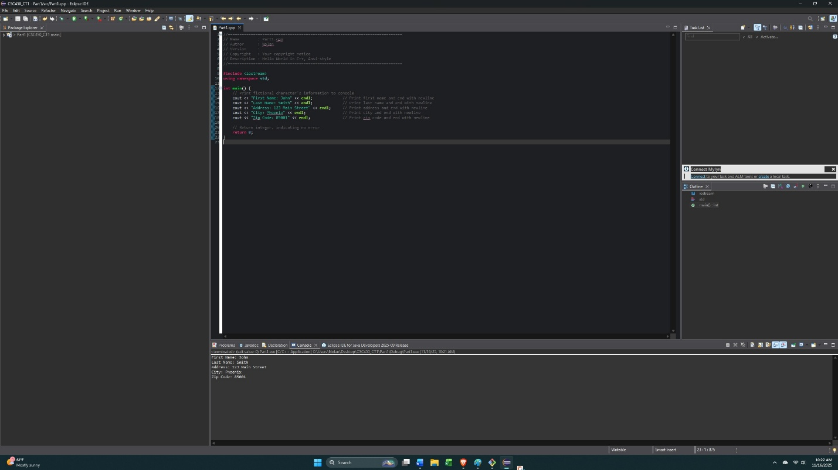

Part 2
Pseudocode
// Main function
START
// Standard Output Statement
OUTPUT "Welcome to this C++ Program" + NEWLINE
OUTPUT "I have corrected all errors for this program." + NEWLINE

// Wait For Output Screen
CALL cin.get()

// Main Function return Statement
RETURN 0
END

C++ Source Code

/*
* Simple Program with a few Errors for Correction
* Please be sure to correct all outlined errors.
*/

#include <iostream>
// #include <conio.h> // Commented this out because getch() is not compatible with this compiler

// Standard namespace declaration
using namespace std;

// Main Function
int main()
{
//Standard Output Statement
cout << "Welcome to this C++ Program" << endl;
cout << "I have corrected all errors for this program." << endl;

// Wait For Output Screen
cin.get();

//Main Function return Statement
return 0;
}

Screenshot – Execution
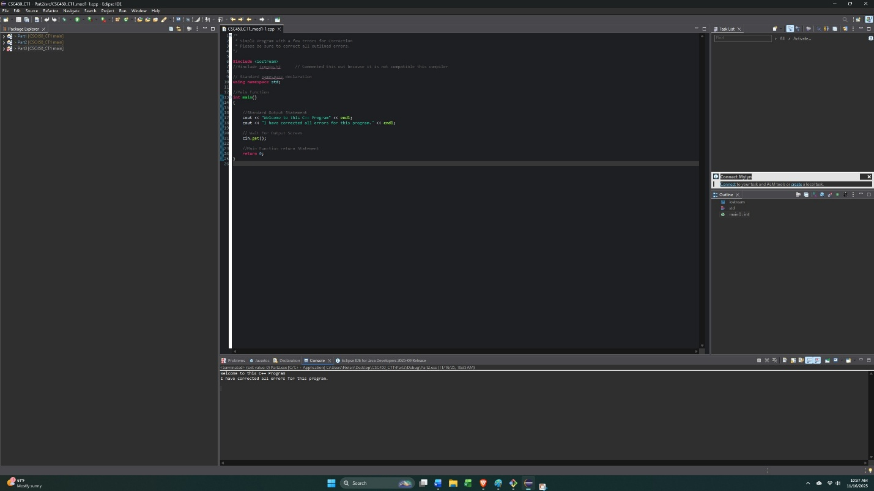

Description of Errors
The first program had several lines of code that were missing the notation for comments (“*/” and “//”), which made the compiler treat them as actual code and causing errors. In addition, the second “cout” statement was missing quotation marks; therefore, it was not treated as a string. After the comment “// Wait For Output Screen”, there was no feature to call getch() or cin.get() which could lead to output window closing. Lastly, there was no return statement to return an integer.

Part 3
Pseudocode
// Main function
START
// Declare variable to hold double value
DECLARE double myMoney = 1000.50

// Standard Output Statement
OUTPUT "Please be sure to correct all syntax errors in this program" + NEWLINE
OUTPUT "I have corrected all errors for this program." + NEWLINE
OUTPUT "The total amount of money available is = " + myMoney + NEWLINE

// Wait For Output Screen
CALL cin.get()

// Main Function return Statement
RETURN 0
END

C++ Source Code
/*
* Simple Program with a few Errors for Correction
* Please be sure to correct all outlined errors.
*/

#include<iostream>
// #include<conio.h> // Commented this out because getch() is not compatible this compiler

// Standard namespace declaration
using namespace std;

// Main Function
int main()
{
double myMoney = 1000.50; //this should be printed out

//Standard Output Statement
cout << "Please be sure to correct all syntax errors in this program" << endl;
cout << "I have corrected all errors for this program." << endl;
cout << "The total amount of money available is = " << myMoney << endl;

// Wait For Output Screen
cin.get();

// Main Function return Statement
return 0;
}

Screenshot – Execution
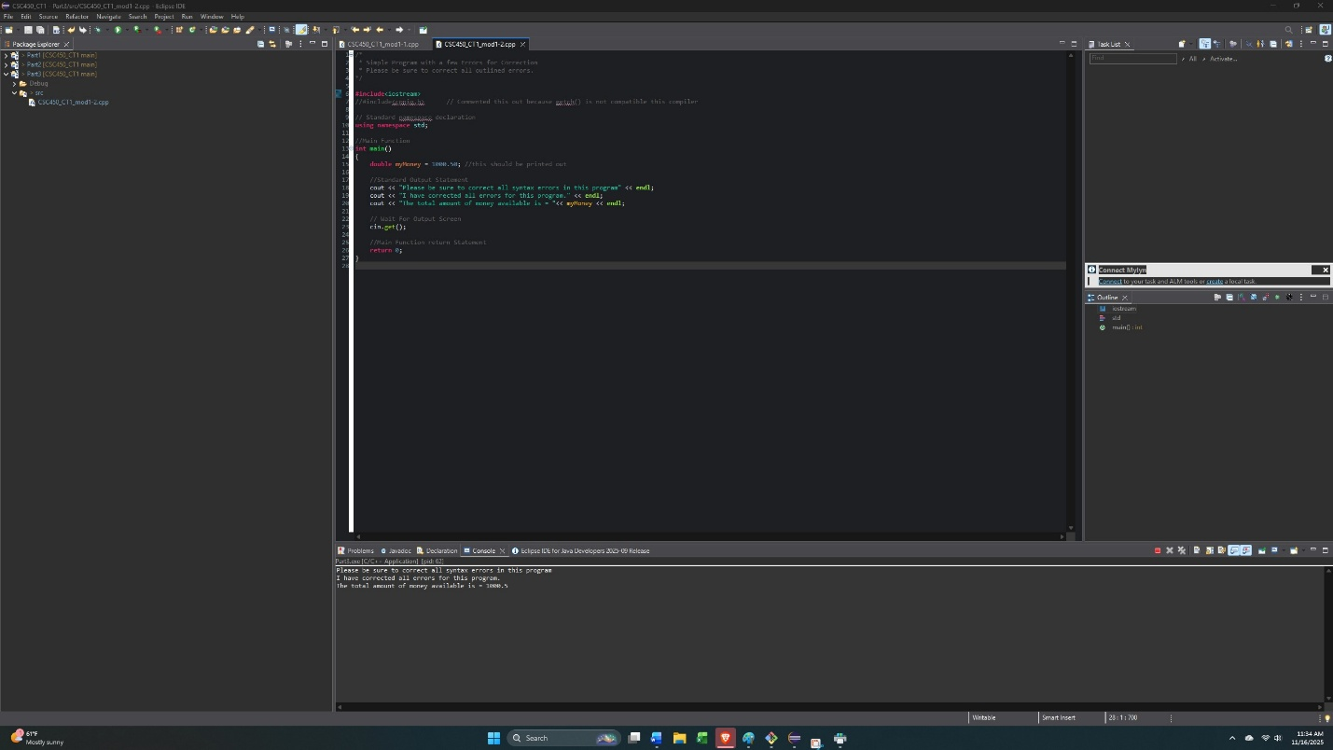

Description of Errors
The second program also had several lines of code that were missing the notation for comments, which made the compiler treat them as actual code and causing errors. Also, the first “cout” statement was missing the first insertion operator (“<<”). For the second “cout” statement, the closing quotation mark was missing on the string. Then the third “cout” statement was missing the variable “myMoney” between the second and third insertion operators. This program was also missing the feature to call getch() or cin.get() to wait for output screen. Lastly, there was a misspelling of the word “Output” in the comment “// Standard Ouput Statement”.
GIT Repository Screenshot
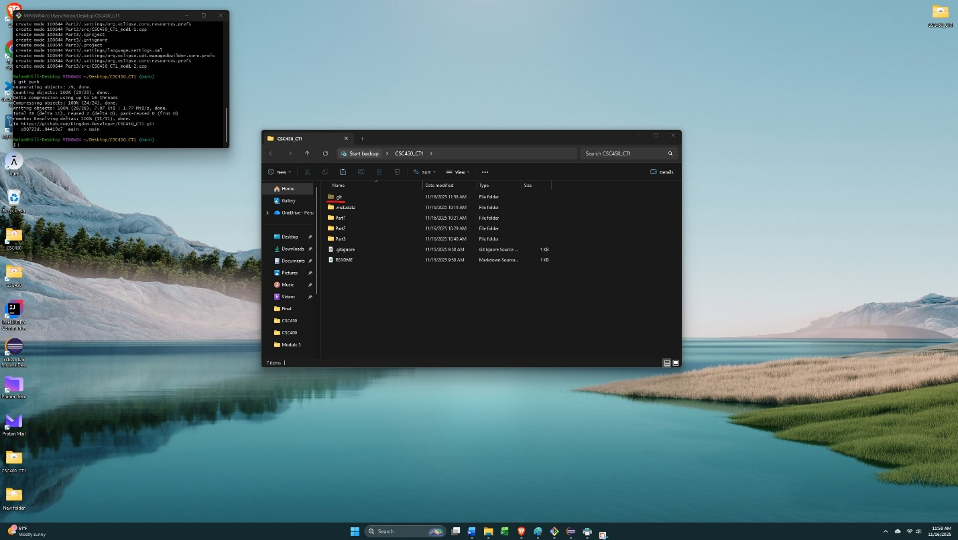

GitHub Repository Screenshot
