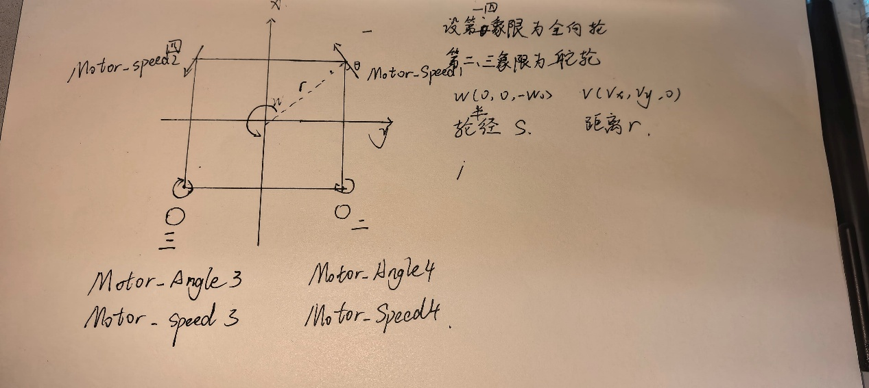
基于以上假设：角度a代替全向轮方向与x轴的夹角
角度b代替位置与x轴的夹角
r为投影点到原点的距离
rx=r*cos(b) ry=r*sin(b)
Motor_speed1=[(vx-w*ry1*cos(-a))+(vy+w*rx1)*sin(-a)]/s
Motor_speed2=[(vx-w*ry2)*-cos(a))+(vy+w*rx2)*-sin(a)]/s
Motor_speed3 =sqrt[(vx-w*ry3)^2+(vy+w*rx3)^2]/s
Motor_speed4 =sqrt[(vx-w*ry4)^2+(vy+w*rx4)^2]/s
Motor_angle3=arctan(vx-w*ry3,vy+w*rx3)
Motor_angle4=arctan(vx-w*ry4,vy+w*rx4)

