Table of Contents

2 Setup 2

3 Project Layout 2

3.1 Blue.Data 2

3.2 Blue.General 3

3.3 Blue.Library 3

3.4 Blue.TestSuite 4

3.5 Blue.WebAPI 4

3.6 HELIX Development Guidelines 4

Blueprint

# Setup

Blueprint requires the following installed on a developer’s workstation:

* Visual Studio 2015 / .NET 4.5 or 4.6
* IIS Express v9 or newer
* GIT (github.com)
* Github @username with access to the repository
* SQL Server 2012 or newer
* Recommended: npm, bower, nuget, and curl (or Fiddler)

# Project Layout

The Blueprint project follows the standard HELIX project layout:

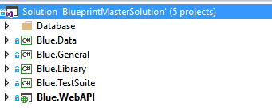

## Blue.Data

The DATA project contains all database access layer code, including enumerations, generics and controllers for every “model.” For the purposes of HELIX, a model has a 1:1 relationship to a SQL TABLE.

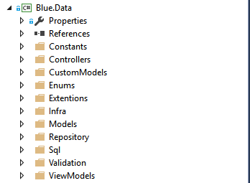

Every table must have the following elements to be accessible by the HELIX framework: A repository class (\repository), a model class (\models), and a generic controller (\controller). For example:

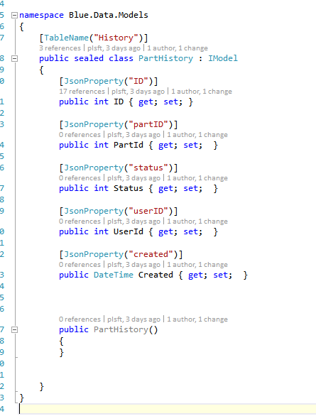

A sample “PartHistory” model

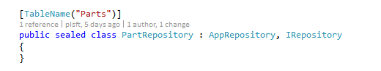

A sample “Parts” repository

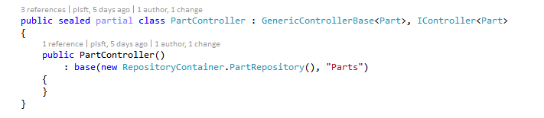

A sample “Parts” controller generic class

## Blue.General

The GENERAL project contains all general utility classes and methods like configuration, error handling, mailing and application general settings. General project should only be used as a reference for the rest of the project and should not need any internal solution references.

## Blue.Library

The LIBRARY project contains all code application business logic for API and business/domain services. All business-layer exceptions, services, responses and results should be placed here.

A **service** encapsulates one or more controller from DAL adding in any business layer or data layer rules.

A **response** is a response from a service call containing success or failure, message(s) and the underlying result.

A **result** is any generic result from an internal operation from the LIBRARY or can be referenced by a response.

An **exception** encapsulates any business layer exception and should perform logging.

## Blue.TestSuite

The TEST SUITE project contains all code test suite code using Nunit, Moq etc. Tests are broken down into several types:

* Performance Tests
* Functional Tests
* Moq Tests
* Nnit Debug Tests

Included in the Blueprint solution are performance and debug tests to illustrate basic library and project functionality.

## Blue.WebAPI

The WebAPI project exposes all the services available via a RESTful API structure and wraps the “SERVICES” section of the Blue.Library project. The WebAPI project also contains token/authentication/authorization framework samples implemented.

## HELIX Development Guidelines

|  |  |  |  |
| --- | --- | --- | --- |
| **Project Name** | **Description** | **References** | **Detail** |
| **Blueprint.Data** | Data access infrastructure code, Models, Compound Models, Sql, Generic Repository and View Models | helixfx; Blueprint.General | |  |  |  | | --- | --- | --- | | **Directory Name** | **What's inside?** | **Code?** | | **Custom Models** | Class for custom data-binding via SQL or SPROC | Yes; POCO Model only | | **Infra** | IBlueprintRepository ( : IHelixPetaRepository) | No | |  | abstract partial BlueprintPetaRepository ( : HelixPetaRepo, IBPRepo) | No | |  | abstract partial BlueprintPetaRepository.Events | Yes; custom database event handlers; e.g. OnAfterDelete, OnBeforeInsert, etc. | | **Models** | Domain model. | Yes; POCO Model only; Add "TableName" attributes and "Ignore" or "Result" attributes where required. | | **Repository** | IRepository ( : IBlueprintRepository) | No | |  | RepositoryContainer class | Yes; | | **Sql** | sealed class for SqlCommands | Yes. Static properties for raw SQL with @ params used in ViewModels | | **ViewModels** | ViewModels are views of the data model for specific workflows, e.g. billing, or loading FK-based data in one view for complex ops. | Yes. If Custom, abstract "CustomView" base class for direct data access for collections, otherwise use repo classes to load relevant data in view. | | **Controllers  and/or**  **Services** | ControllersContainer wraps Repository classes; Exposed methods are Save() [insert or update], Update() [custom update e.g. field(s)], Destroy() [deletes by object ID] | Yes; | |
| **Blueprint.Database** | SqlConnect Project used to maintain SQL DDL | None. | This project isn't used by any other project. Should not be referenced anywhere. |
| **Blueprint.General** | General access code like settings, database connection name, strings, and app-wide enums. This project is referenced by several other projects. Should have NO inbound references other than Helixfx. | helixfx; | |  |  |  | | --- | --- | --- | | **Directory/File** | **What's inside?** | **Code**? | | Config.cs | Exposes name of connection string and connection string from app.config or web.config only. | Y; getter only. | | BlueprintSettings.cs | Exposes Settings.Get() method in helixfx in static properties | Y; getter only. | |
| **Blueprint.Library** | The majority of application functionality lives here including: Contexts, Controllers, Exceptions, Services, UnitsOfWork, Helpers, Providers and Utility methods | helixfx; BP.Data, BP.General, BP.ThirdParty | |  |  |  | | --- | --- | --- | | **Directory** | **What's inside?** | **Code?** | | Context | Contextual object containers for specific application transactions modeled after HttpContext, e.g. ChargingContext used to bill customers. | Yes. Inject ViewModels, expose any custom or relevant objects here. | |  |  |  | | Exceptions | Used to store collection of business exceptions; publishes errors to log | Yes; should publish exceptions | | Extensions | Used to store class extensions methods e(name); | Yes; Pluralize() method is first method in this class. Ref: System.Data.Entity.Design.Pluralization | | Helpers | Simpleton classes to wrap complex or compound objects. | Yes; "new" up objects from Providers | | Providers | Wraps 3rd party clients via DI; naming convention XXXClientProvider.cs, e.g. EmailClientProvider.cs | Yes; ref 3rd party public clients via DI. | | Responses | Processes and returns strongly typed responses from Providers or helpers. | Yes; Pass in response (usually string) to parse in constructor. | | Services | Compound classes/objects to perform app work-flow, complex functions | Yes; all based on requirements | | Units | Units of Work wrappers for complex controller-based transactions. Expose compound Save(), etc., methods should obfuscate complex logic. | Yes; DI the relevant controllers; | | Utility | Utility classes; Used for business auditors, other utility classes used throughout the library. | Yes; | |
| **Blueprint.ThirdParty** | Directly references third-party components, e.g. payment providers, Pdf libraries, faxing, emailing, etc. | helixfx; any third party libs; no other project references should be used. | This exposes "client" classes to wrap functionality of third party controls. only "simple" native objects or tuples, dynamics should be returned, not library-based response or status objects. |
| **Blueprint.Tests** | Test Suite library; Each class in every project should have it's own test fixture (class). | JustMock; helixfx; all other BP project under test. | Each method should have expected input/output, exception case, and any edge cases that appear as development progresses. |
| **Blueprint.WebAPI** | WebApi referencing WebAPI, AttributeRouting.  etc. Directly connects to either controllers or services classes to expose functions. Often used to expose reporting for AJAX-based jQuery calls for charting. | WebAPI; helixfx; | Core API for BP application. Exposes underlying domain model's controllers and services. Optionally add meters to track response times for API calls via DI. |

## Blue Release notes

Initial release pending.