ABSTRACT
This project outlines the design and development of a Library Management API built with the FastAPI framework in Python. Its primary goal is to deliver a scalable and efficient solution for managing core library functions, including adding new books, retrieving book details, borrowing and returning items, and tracking availability. The API is structured around RESTful principles and leverages asynchronous programming to ensure responsiveness and high performance when handling multiple requests simultaneously.
The system uses an in-memory data structure (Python list) to store book records during runtime. Each book entry contains essential attributes such as a unique identifier, title, author, genre, and availability status. Through its endpoints, the API allows interaction via standard HTTP methods (GET, POST), supporting advanced features like filtering and searching by title, author, or genre to enhance usability.
A key strength of the system is its flexible input handling: users can borrow or return books using either a unique identifier or the book title. Additional endpoints provide access to available books and overdue items, reflecting practical scenarios in real-world library management.
By incorporating asynchronous functions, the API simulates concurrent processing, enabling efficient handling of multiple operations without delays. This demonstrates the role of modern web technologies in building scalable, high-performance applications.
While effective in showcasing core API design principles—such as structured JSON data exchange, clear endpoint organization, and modular development—the current implementation has limitations. These include reliance on non-persistent in-memory storage (leading to data loss upon restart) and the absence of authentication and authorization mechanisms.
Overall, the project serves as a foundational model for digital library systems, illustrating how APIs can streamline and optimize service delivery.

INTRODUCTION
The aim of this project is to design and implement a Library Management API using FastAPI. The system simulates a digital library environment where users can perform essential operations such as adding books, searching for titles, borrowing and returning items, and viewing available or overdue records.
The API is built on RESTful principles and communicates using JSON, ensuring efficient data exchange between client and server. Book records are stored temporarily in in-memory structures (Python lists), simplifying implementation while demonstrating core API functionality.
To enhance performance, the system employs asynchronous programming, allowing it to process multiple requests concurrently. This design highlights how APIs can automate and improve library services, particularly in educational contexts.

System Overview

The Library API offers a structured interface for interacting with library data. It enables users to perform operations such as adding new book records, retrieving existing ones, applying filters to search results, and managing borrowing activities. The system is developed using FastAPI and is based on a client–server model, where client requests are processed by the API server.

System Architecture

The application adopts a client–server architecture, with communication handled through HTTP requests and JSON responses. This ensures efficient data exchange between clients and the API server.

Client–API–Server Interaction Diagram

+---------------------+ HTTP Request + ---------------------+

| client | <----------------------- | API server |

| (web\mobile UI) | <--------------------- | (RESTful Service) |

+-------------------+ JSON Response +----------------------+

|

v

+------------------+

| BUSINESS LOGIC |

| (service layer) |

+--------------------+
+-------------------------+
| DATABASE |
| SQL/ NoSQL DB) |
+--------------------------+

Part A – API Design
- GET /books/search
Purpose: Retrieve books based on title, author, or category.
Inputs: title, author, category
Example: GET /books/search?title=python
Output:
{
"status": "success",
"data": [
{
"book_id": 1,
"title": "Python Basics",
"author": "John Doe",
"category": "Technology",
"available": true
}
- POST /borrow
Purpose: Borrow a book.
Input:
{ "user_id": 101, "book_id": 1 }
Output:
{ "status": "success",
"message": "Book borrowed successfully",
"due_date": "2026-05-18"
}
3. POST /return
Purpose: Return a book.
Input:
{
"user_id": 101, "book_id": 1
}
Output:
{ "status": "success",
"message": "Book returned",
"fine": 500 }

- GET /users/{id}/overdue
Purpose: Check overdue books, and fines for a user
Input : user_id in URL
Output:
{ "status": "success",
"overdue_books": [
{
"book_id": 1,
"days_overdue": 5,
"fine": 500 }
}
System Interaction Diagram
[ Client (Web/App) ]
|
| HTTP Request (GET/POST)
v
[ API Layer (FastAPI/Flask) ]
|
| Process Logic
v
[ Database (Books, Users, Loans) ]
|
v
[ API Response (JSON) ]
|
v
[ Client Display
Part B – Implementation
Python Async Code:
import asyncio
from typing import Dict, List
books = {
1: {"title": "Python Basics", "available": True},
2: {"title": "Data Science Intro", "available": True},
}
borrowed_books = {}
async def borrow_book(user_id: int, book_id: int) -> str:
await asyncio.sleep(1)
if not books.get(book_id):
return "Book not found"
if not books[book_id]["available"]:
return "Already borrowed"
books[book_id]["available"] = False
borrowed_books[book_id] = user_id
return f"User {user_id} borrowed book {book_id}"
async def return_book(user_id: int, book_id: int) -> str:
await asyncio.sleep(1)
if borrowed_books.get(book_id) != user_id:
return "Invalid return"
books[book_id]["available"] = True
del borrowed_books[book_id]
return f"User {user_id} returned book {book_id}"
async def main():
tasks = [
borrow_book(101, 1),
borrow_book(102, 1),
return_book(101, 1),
]
results = await asyncio.gather(*tasks)
for r in results:
print(r)
asyncio.run(main())

API SETUP AND EXECUTION
The API was developed using uvicorn. Which runs locally on web browswer
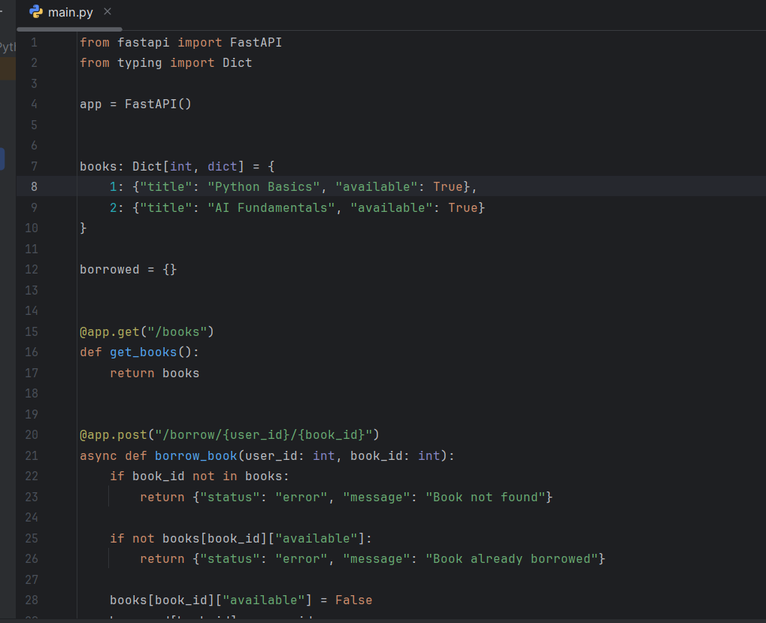

Screenshot 2 activating the uvicorn to run the api
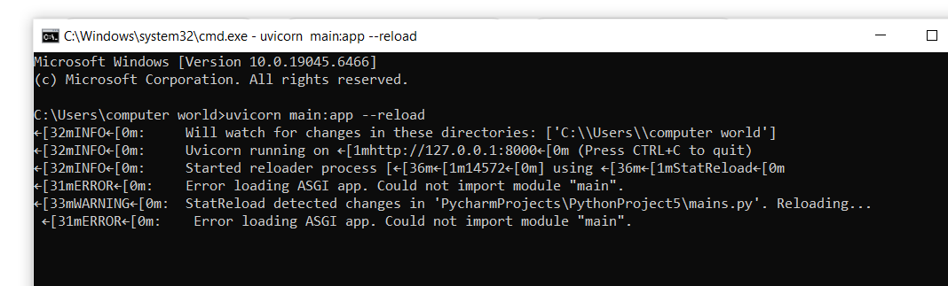
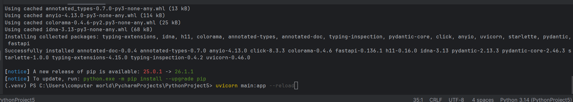

First screenshot
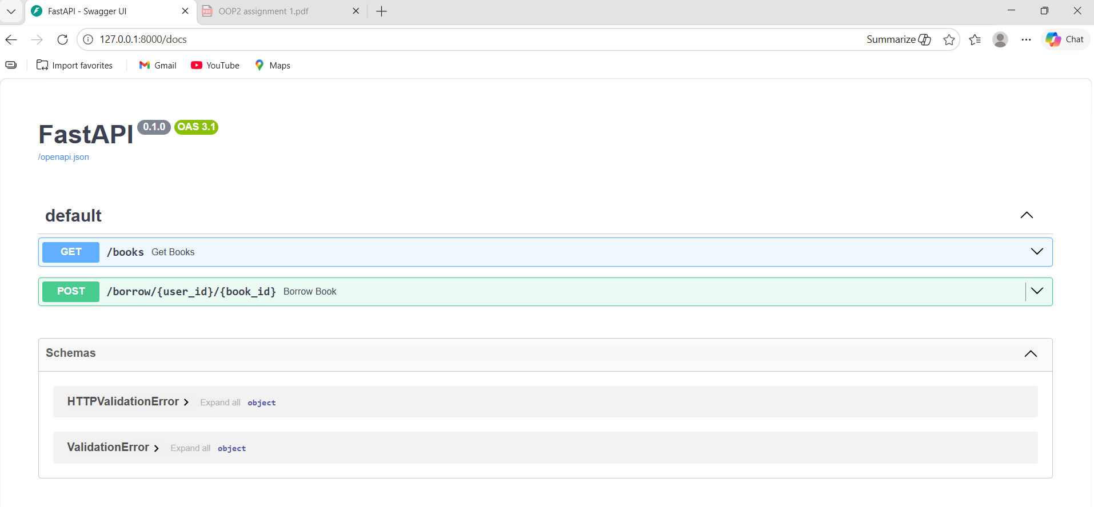

Screenshot 2

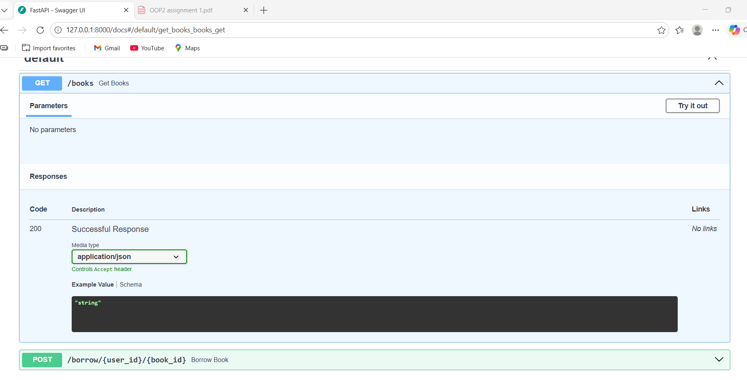

Screenshot 3
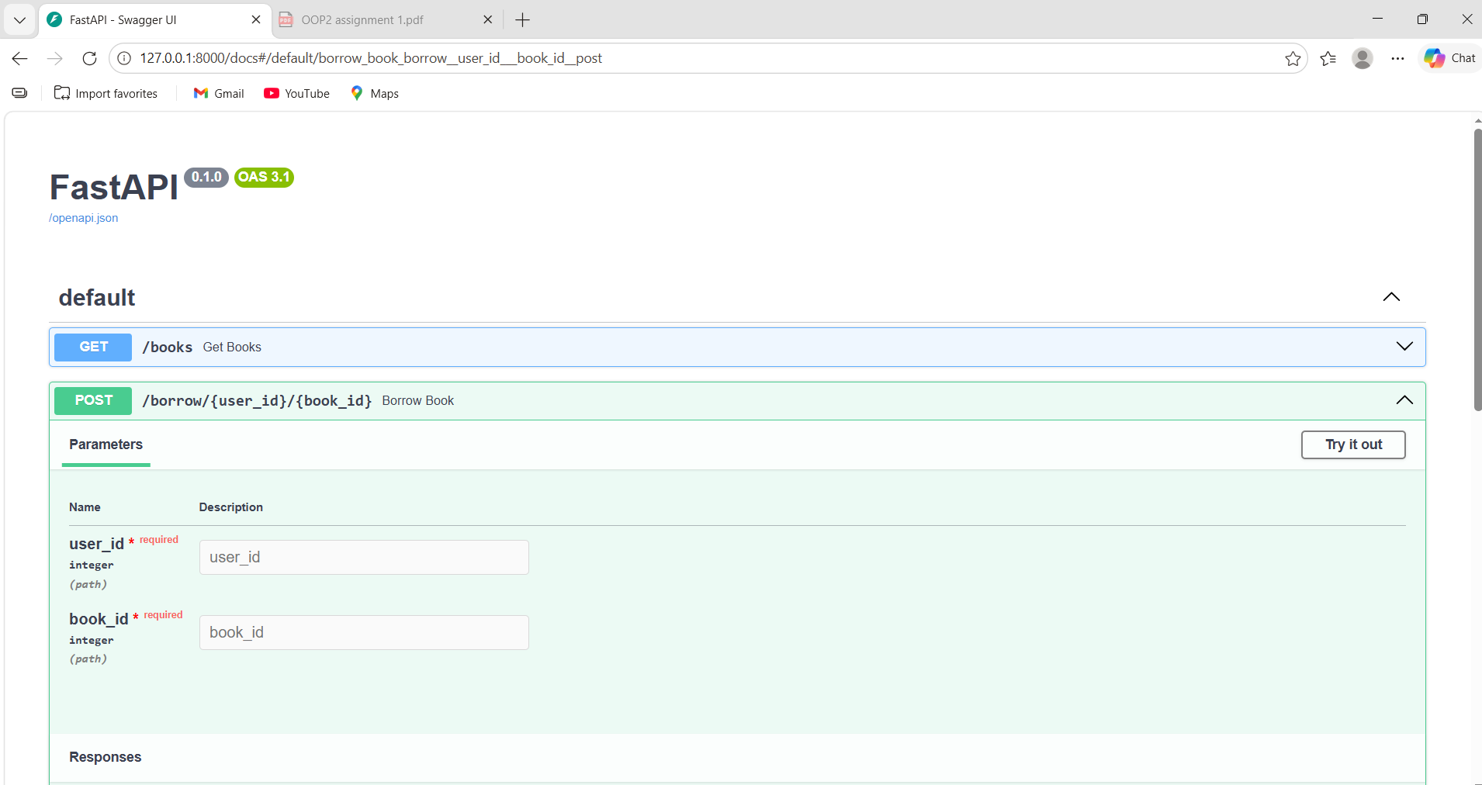

Screenshot 4
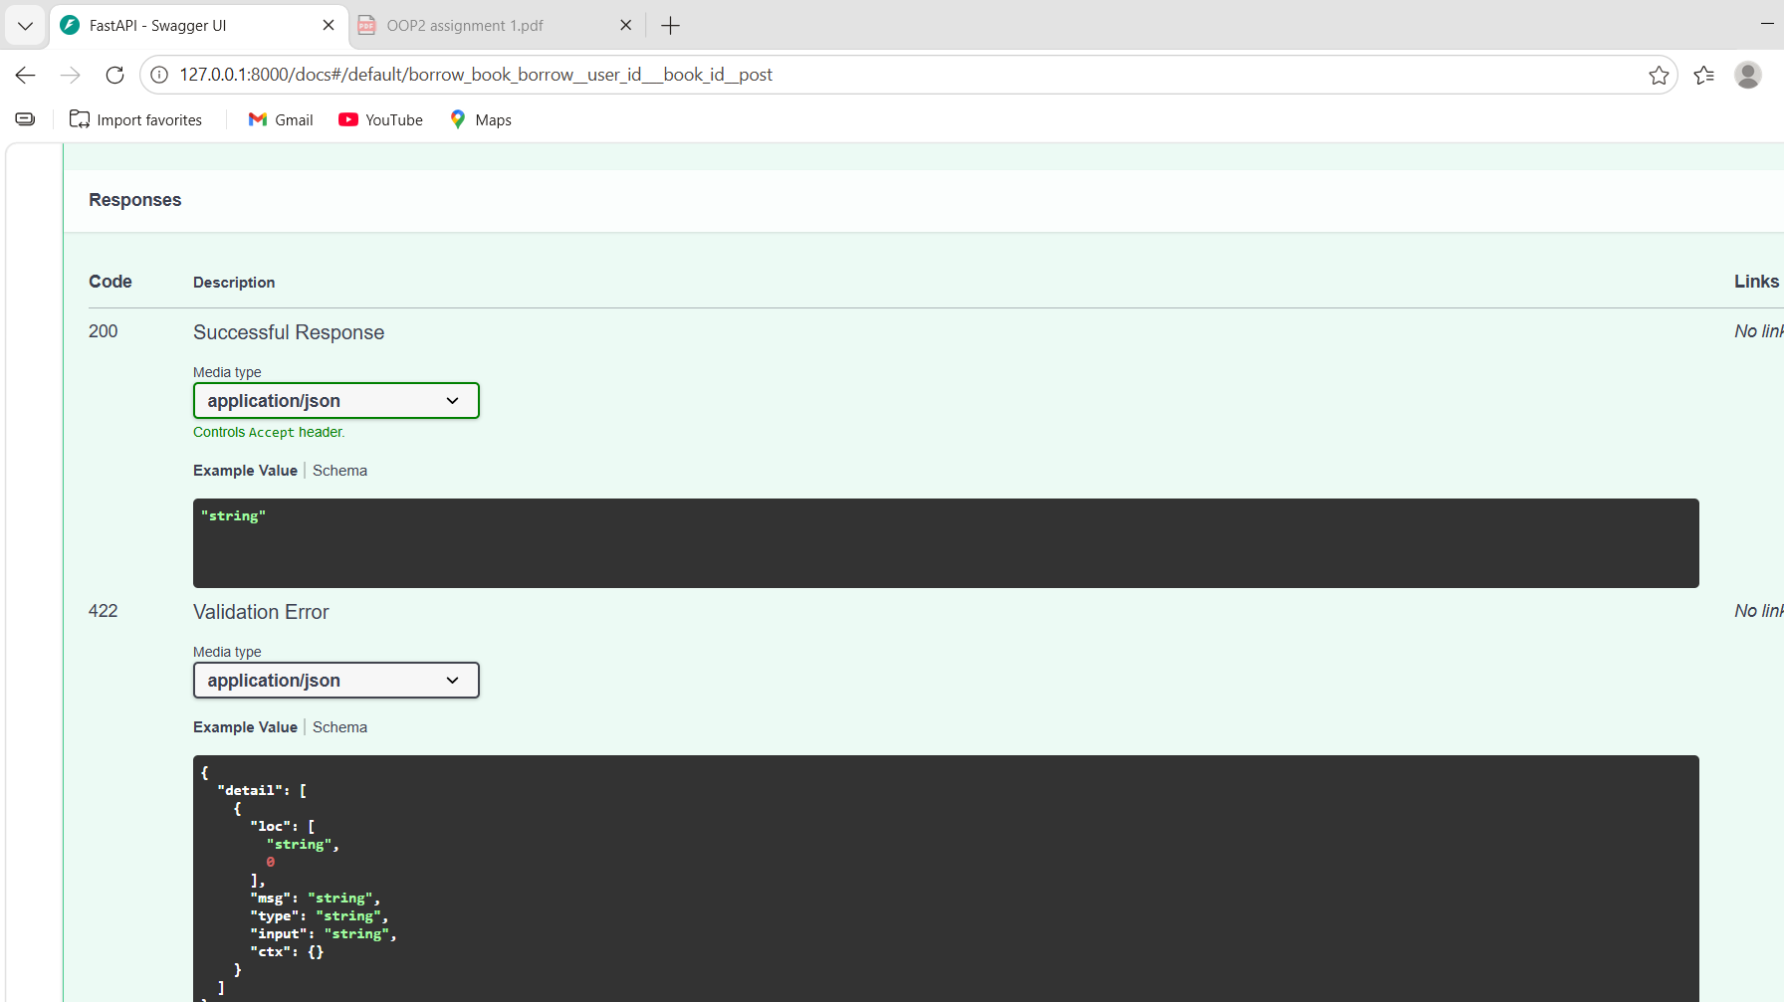

Part C – Reflection

APIs significantly improve efficiency in Limkokwing library services by automating core operations such as searching, borrowing, and returning books. Instead of relying on manual record-keeping, staff can instantly retrieve accurate information through API requests. This reduces human error, speeds up service delivery, and allows multiple users to access the system simultaneously without conflicts. APIs also standardize communication using structured formats like JSON, ensuring consistency across different devices such as web browsers and mobile applications. As a result, the library becomes more scalable and responsive to user needs.

This project aligns with Sustainable Development Goal 4: Quality Education, as it enhances access to learning resources. A digital library system ensures students can efficiently find and borrow books, reducing barriers to education and promoting equal access to knowledge.

One key challenge faced during development was handling multiple requests at the same time. Implementing asynchronous functions required careful structuring to avoid data conflicts, especially when two users attempted to borrow the same book. Additionally, organizing JSON responses clearly while keeping them simple for non-technical users was challenging.

If the library expands, one major improvement would be implementing authentication and role-based access control. This would ensure system security by restricting access based on user roles such as students, staff, and administrators.

