SentinelAI
AI-Powered Behavioral Anomaly Detection for Cybersecurity
Honeywell Campus Connect 2026
Name: SUJOY SEN
GitHub Repository: https://github.com/Kingjoy7/SentinelAI
Live Demo:

1. Executive Summary
Organizations generate massive volumes of authentication logs, device information, and user activity every day. Detecting malicious behaviour manually is difficult and traditional rule-based systems often fail to identify previously unseen attacks. SentinelAI is an AI-powered behavioural threat detection platform that generates realistic enterprise behavioural data, detects anomalies using Isolation Forest, classifies attack types using Random Forest, explains every prediction with confidence scores and recommended actions, and visualizes all results through an interactive Streamlit Security Operations Center dashboard.

2. Problem Statement and Objectives

Problem Statement
Enterprise environments continuously produce user behaviour logs that are challenging to monitor manually. Existing signature-based security systems are effective for known attacks but struggle with behavioural anomalies and emerging threats.

Objectives
- Generate realistic enterprise behavioural data.
- Detect anomalous user behaviour using machine learning.
- Classify different cyber attack types.
- Provide explainable AI recommendations.
- Visualize results through an interactive SOC dashboard.
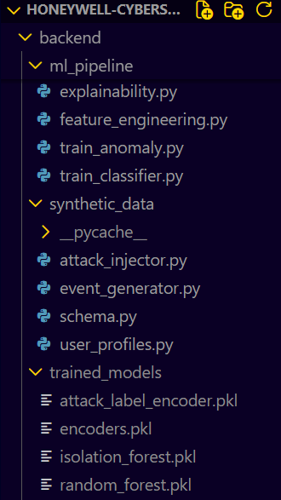
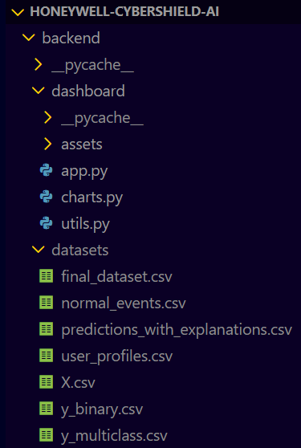
Fig 1: Project Folder Structure

3. System Architecture
SentinelAI follows a layered architecture consisting of synthetic data generation, feature engineering, AI-based anomaly detection, attack classification, explainability, and dashboard visualization. This modular design allows every component to operate independently while forming a complete end-to-end cybersecurity workflow.

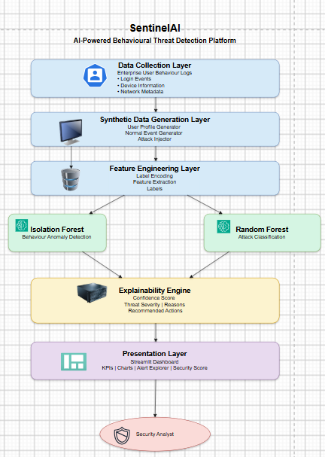
Fig 2: Overall System Architecture

4. Synthetic Enterprise Dataset Generation
Since real enterprise security datasets are rarely publicly available due to privacy and confidentiality constraints, SentinelAI generates a realistic synthetic dataset that closely simulates employee behaviour inside an organization.
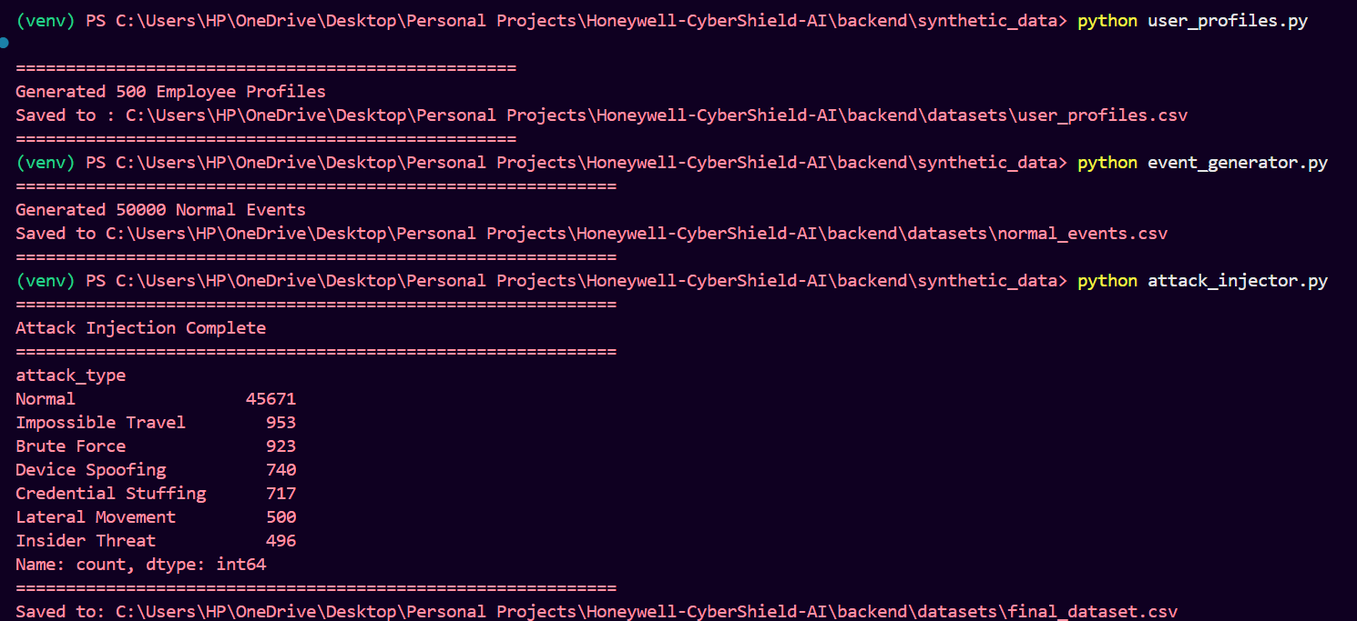 Fig 3: 3 Synthetic dataset files generated

User Profile Generation
About 500 Employee profiles are generated with attributes such as user ID, department, role, device, browser, country, city, authentication method, working behavior and fingerprint.

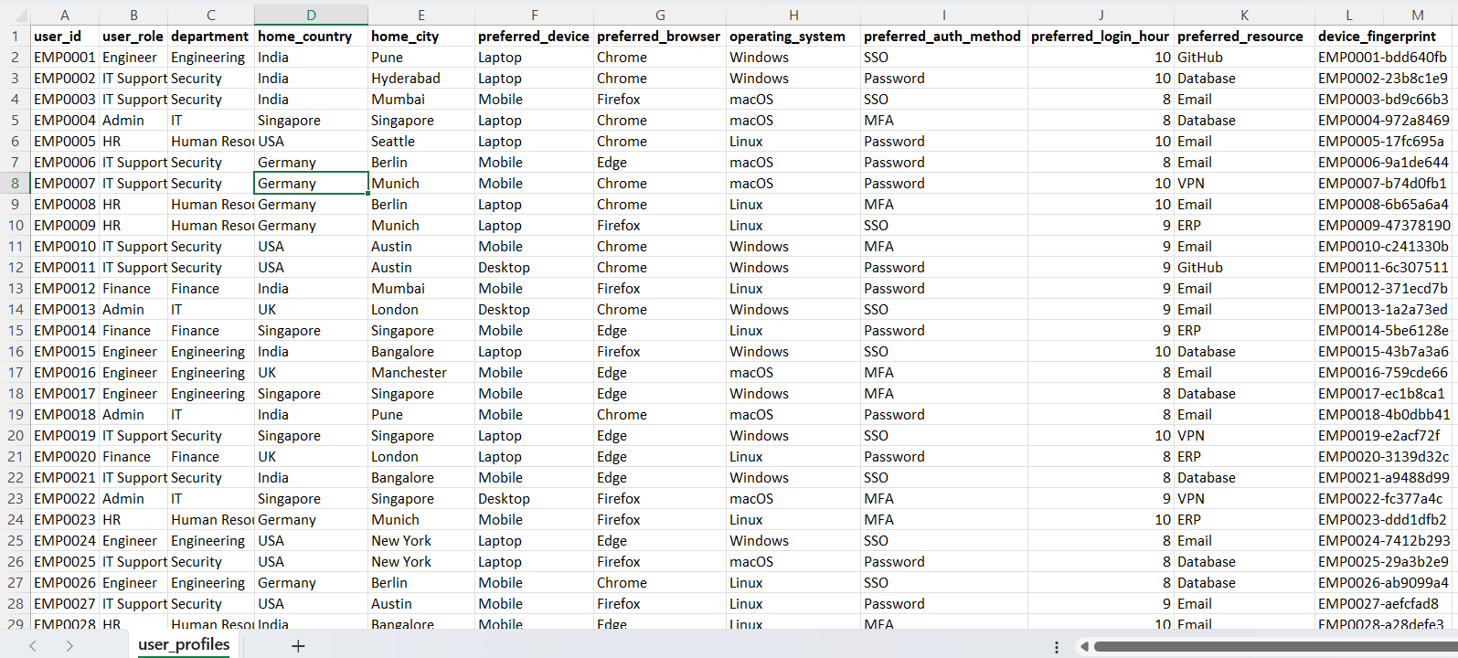
Fig 4: 500 synthetic user profiles created

Normal Behavior Generation
Normal login sessions, resource access, session duration, device usage, and command activity are simulated to create realistic enterprise behaviour.

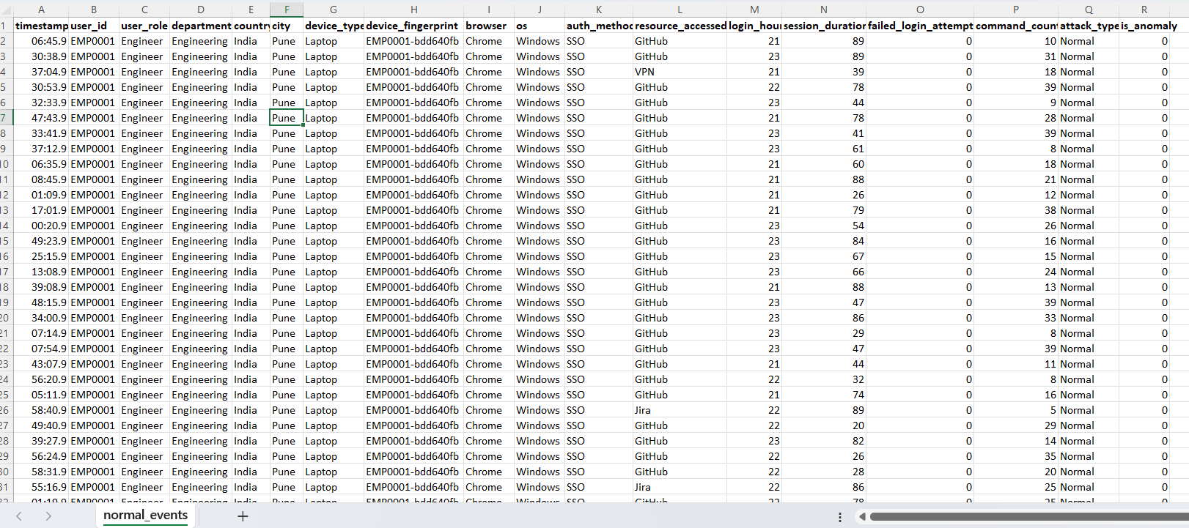
Fig 5: 50,000 simulated normal enterprise activity records

Cyber Attack Injection
Six attack scenarios are injected into the dataset: Brute Force, Credential Stuffing, Impossible Travel, Device Spoofing, Insider Threat, and Lateral Movement.
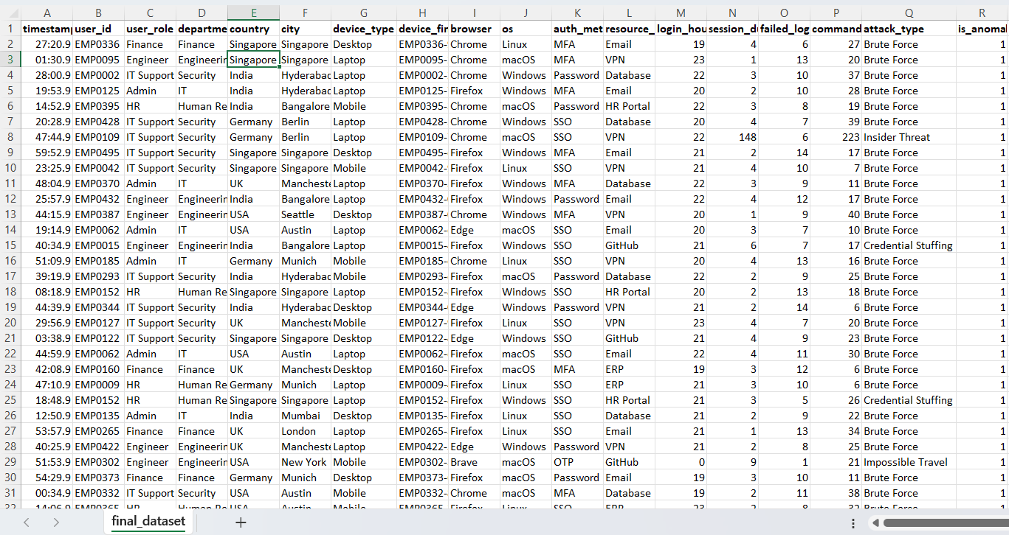Fig 6: 50,000 enterprise activity records enriched with simulated cyber-attack scenarios

5. AI Detection Pipeline

Feature Engineering
Categorical attributes are encoded into numerical values, binary anomaly labels and multi-class attack labels are prepared, and the final feature matrix is generated for machine learning.

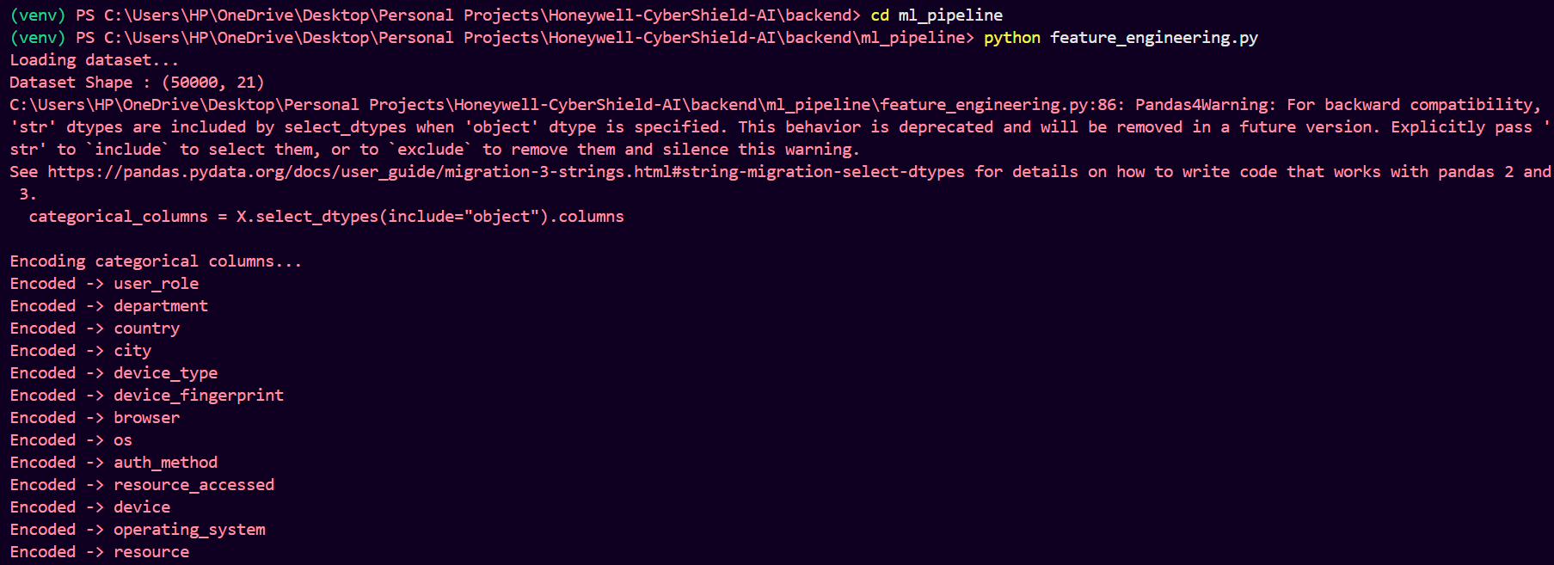
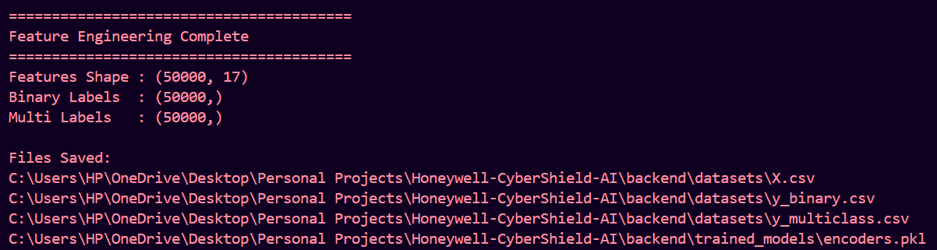

Isolation Forest
Isolation Forest learns normal behavioural patterns and identifies sessions that significantly deviate from expected user activity.

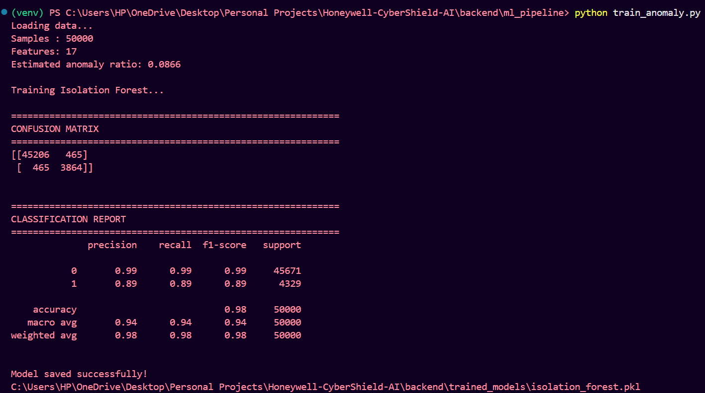

Random Forest Attack Classification
Detected anomalies are classified into predefined cyber attack categories using a Random Forest classifier trained on the generated dataset.

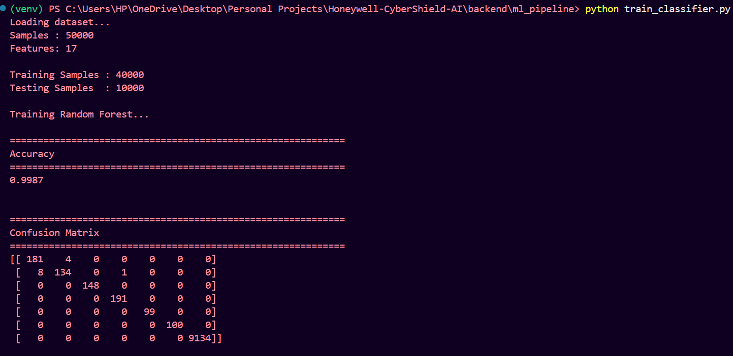
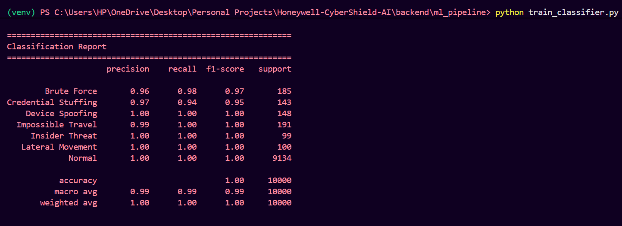
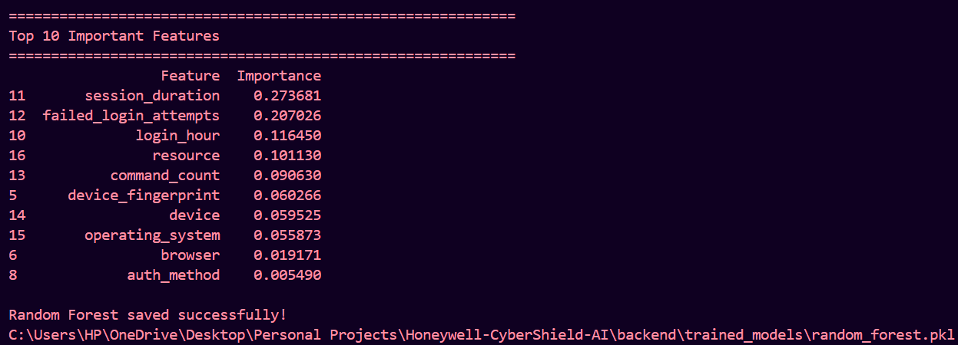

6. Explainable AI
Rather than only predicting attacks, SentinelAI generates analyst-friendly explanations. Each detected threat includes a confidence score, severity level, reasons behind the prediction, and recommended mitigation actions to support faster incident response.

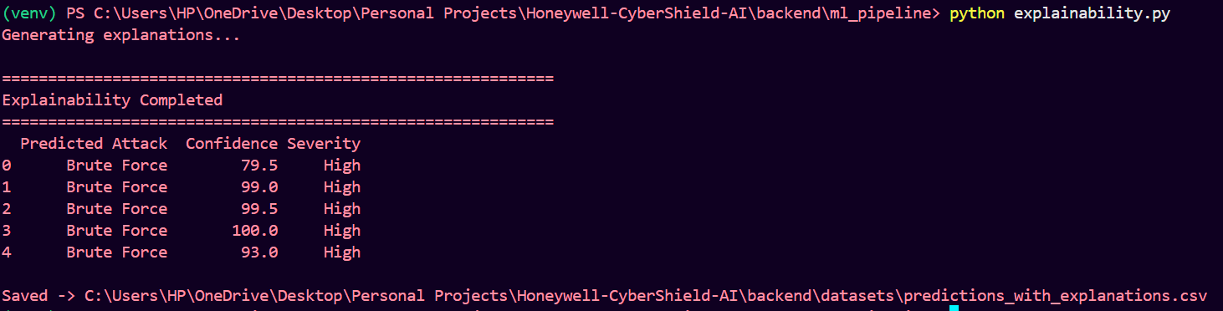

7. Interactive SOC Dashboard
The final predictions are displayed through a Streamlit-based Security Operations Center dashboard. The dashboard enables security analysts to monitor threats through Interactive KPI cards, interactive charts, security score visualization, and an alert explorer containing AI-generated explanations.

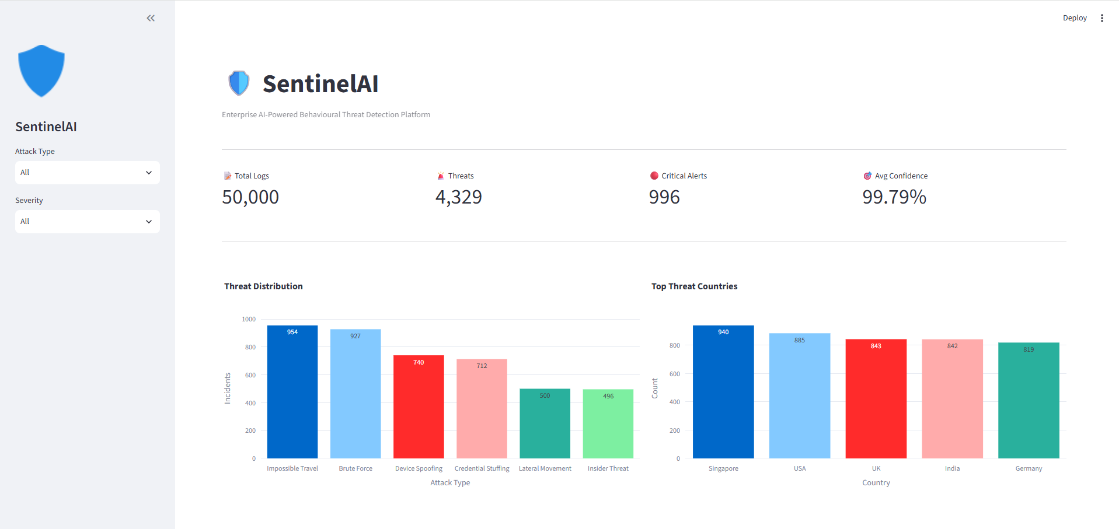

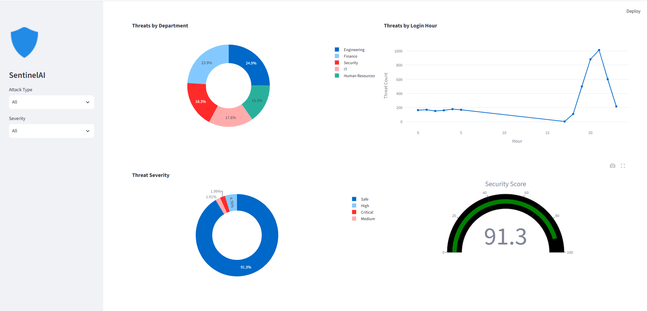
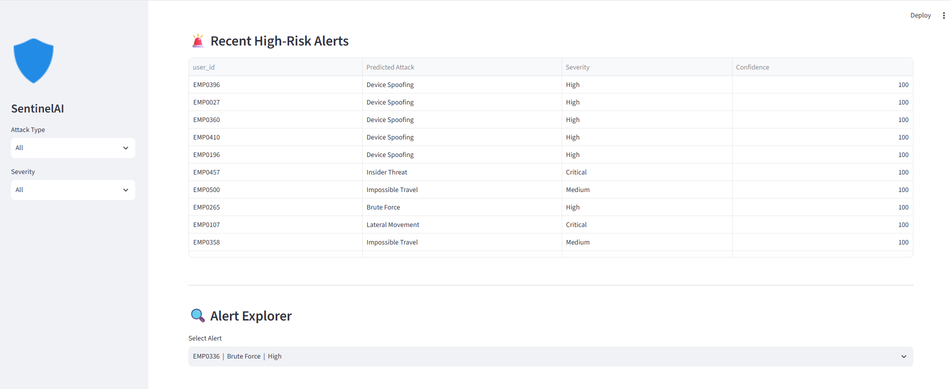
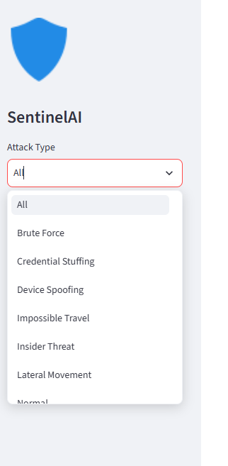
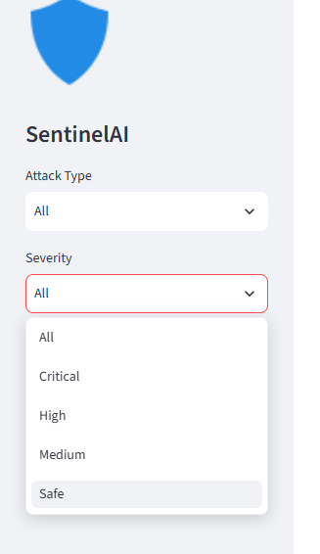
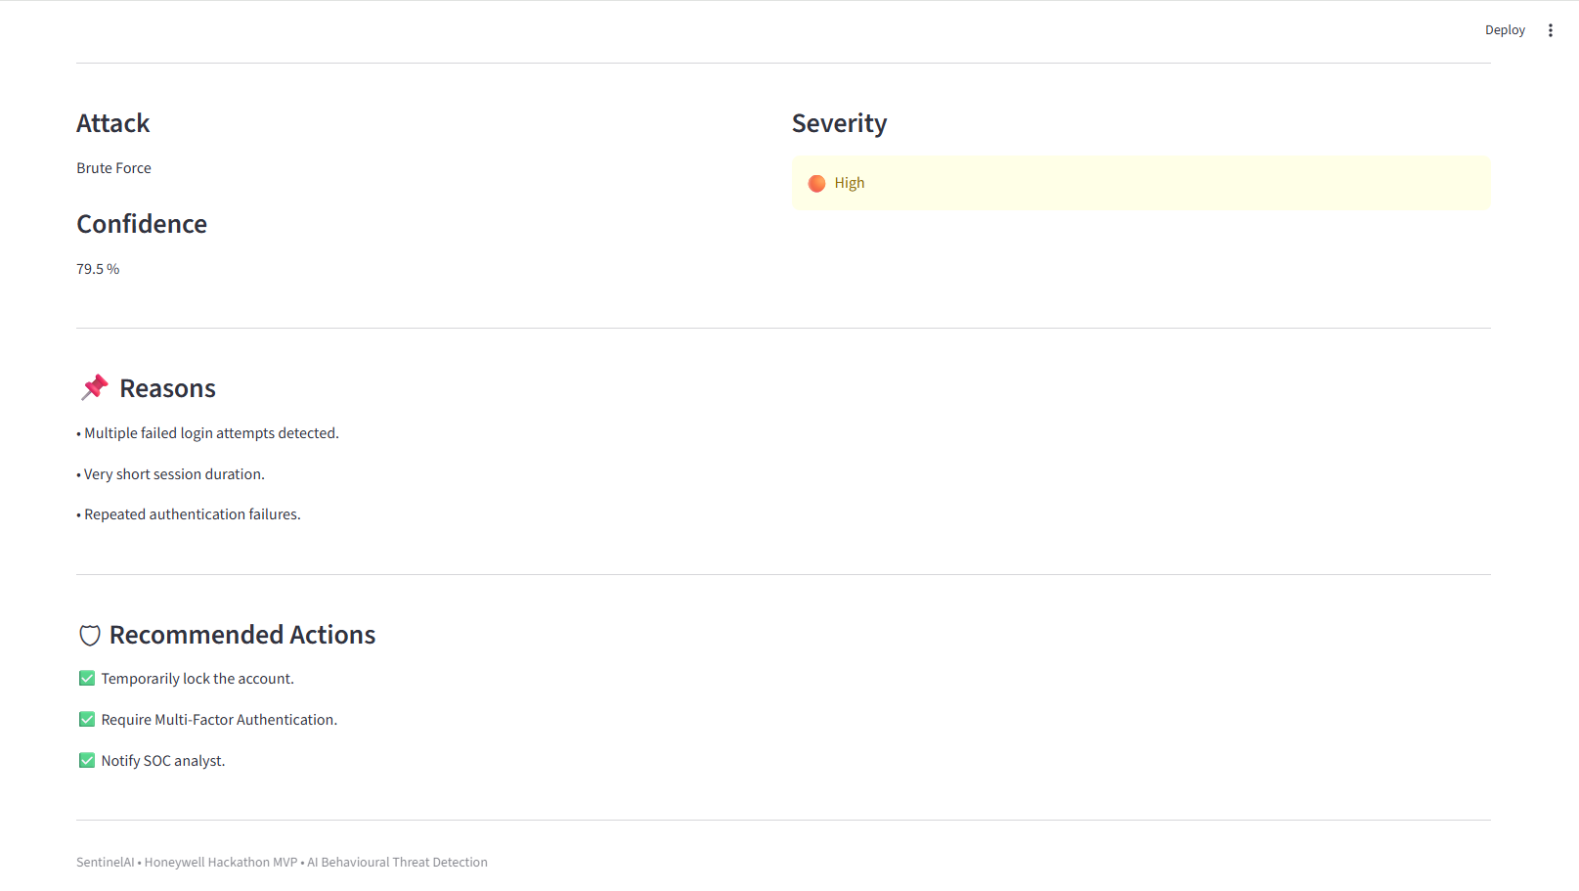

8. Technologies Used
Category | Technology
Programming | Python
Machine Learning | Scikit-learn (Isolation Forest, Random Forest)
Data Processing | Pandas, NumPy
Visualization | Plotly
Dashboard | Streamlit
Model Serialization | Joblib

9. Results
- Successfully generated 500 synthetic enterprise user profiles and approximately 50,000 realistic behavioural activity records for cybersecurity analysis.
- Achieved approximately 98% anomaly detection accuracy using the Isolation Forest model for identifying abnormal user behaviour.
- Achieved approximately 99.9% attack classification accuracy using the Random Forest classifier across six simulated cyber-attack categories.
- Generated explainable AI outputs for every detected alert, including confidence score, threat severity, reasoning, and recommended mitigation actions.
- Developed an interactive Streamlit-based Security Operations Center (SOC) dashboard for real-time behavioural threat visualization and security monitoring.

10. Future Scope
- Real-time enterprise log ingestion.
- Integration with SIEM platforms.
- Deep learning-based behavioural analytics.
- Cloud-native deployment.
- Role-based authentication and access control.

11. Conclusion
SentinelAI demonstrates a complete AI-driven behavioural cybersecurity workflow by combining synthetic enterprise data generation, anomaly detection, attack classification, explainable AI, and interactive visualization. The project highlights how machine learning can assist security analysts in detecting, understanding, and responding to cyber threats efficiently while providing a scalable foundation for future enterprise deployments.

