NEXIAN
OMNI QUANTUM COMPUTE GHOST OPS ENGINE
WE DON'T NEED YOUR INFRASTRUCTURE. WE BUILT OUR OWN.

Nexian is a self-healing distributed compute substrate designed for denied, disrupted, intermittent, and limited (DDIL) environments where traditional network infrastructure fails.

Army xTechSearch | Adaptive Strike Competition
KK&G DevOps LLC | Portage, Michigan | March 2026
USPTO Patent Pending 63/893,840 | UNCLASSIFIED // COMPETITION EVALUATION
Every solution in this competition was built on top of existing infrastructure. When that infrastructure fails — and in a contested environment, it will fail — those solutions die with it. The Nexian engine was built for the moment everything else stops working.

THE REAL PROBLEM NOBODY IS SOLVING
The four Adaptive Strike priority areas share a single unaddressed vulnerability: they all assume connectivity. Cloud-dependent unmanned systems go dark when the link drops. Sensor networks lose persistence when nodes lose power or comms. Counter-UAS coordination fails when the adversary jams the network. Every funded program in this space has optimized for performance within a connected environment.

Few systems are designed to operate more effectively as connectivity degrades.

The Nexian engine does not degrade gracefully under disconnection. It was never designed to need connectivity in the first place. It is the infrastructure layer that makes all four priority areas viable in DDIL environments where current solutions fail completely.

WHAT IS RUNNING RIGHT NOW
This is not a prototype. This is not a proof of concept. The following system is operational as of March 2026, running live on consumer hardware in Portage, Michigan:

SYSTEM METRIC | LIVE DEMONSTRATED VALUE
Global Status | OPERATIONAL
Fabric Health | 100% — 3 nodes live
Platforms | Windows + Linux + Android simultaneously
Internet Dependency | ZERO — fully air-gapped
Avg Mesh Latency | <1ms local fabric
Autonomous Recoveries | 330+ network failures self-healed
Failovers (24h) | 0 unrecovered failures
M.I.T.E.L. Threats | 27 devices quarantined during live testing with no observed false positives
USB Attack Response | < 1 second plug-to-quarantine
Threat Propagation | < 10ms mesh-wide — no cloud call
AI Status | READY — Mistral 7B Q4 offline, mesh-native
Distributed Cognitive Mesh | ACTIVE — Cross-node shared intelligence operational
Power Loss Recovery | Auto-launch — zero human intervention
Patent Status | USPTO 63/893,840 — provisional filed

Live demonstration includes real-time node discovery, threat quarantine, mesh synchronization, and cross-platform AI task execution.

TECHNOLOGY READINESS LEVEL (TRL)
Overall System TRL: 5 — Component validation in operationally relevant environment.

COMPONENT | TRL | EVIDENCE
OMNI Mesh Fabric | TRL 6 | CRDT-based state convergence with SQLite WAL persistence. Demonstrated autonomous recovery from 330+ simulated network failures across heterogeneous OS environments.
M.I.T.E.L. Zero-Trust Peripheral Auth | TRL 5 | Hardware fingerprinting and default quarantine demonstrated across multiple device classes including HID, storage, and vendor-defined devices.
Distributed Threat Propagation | TRL 6 | Mesh-wide threat intelligence propagation observed in <10ms during live testing. Zero cloud dependency. Zero false positives across 27 quarantine events.
NEXUS AI Offline Agent | TRL 5 | Local LLM agent executing operational commands across heterogeneous nodes. Cross-platform file operations and intent routing validated live.
Distributed Cognitive Mesh | TRL 5 | Shared threat database and cross-node intelligence synchronization operational across 3-node live system.

Next Milestones:
→ 25–100 node field deployment with geographic distribution
→ Integration with tactical radio transport layers (ATAK, PACE plan compatibility)
→ Ruggedized edge hardware validation (embedded ARM, field-hardened platforms)

FOUR LAYERS. ONE ORGANISM.
The Nexian engine operates as a unified system across four integrated layers. Each layer functions independently. Together they form a self-sovereign compute organism with no single point of failure.

Layer 1: OMNI Mesh Substrate — The Fabric
→ CRDT-based state convergence — mathematical consistency across nodes, conflict-free by design
→ SQLite + WAL state store — crash-safe, transactional, fully replayable from any failure point
→ UDP broadcast auto-discovery — nodes find each other with zero configuration, zero DNS, zero DHCP
→ Systemd auto-launch — complete power loss recovery, system restores and rejoins mesh on boot
→ Self-healing recovery engine — automatic restoration from state corruption, node crash, network partition
→ Node loss does not impact mesh operation — no hierarchy, no commander node, no single point of failure

Layer 2: M.I.T.E.L. — Zero-Trust Peripheral Authentication
→ Every device quarantined by default — zero trust means zero exceptions until cryptographically verified
→ Hardware fingerprinting: VID + PID + firmware hash + behavioral signature — device cannot spoof identity
→ Hostile USB plugged in — quarantined in under 1 second, no cloud lookup, no human intervention required
→ 27 devices across multiple classes tested during live demonstration — HID, storage, vendor-defined, all correctly isolated
→ Threat detected on any node propagates to every node in the mesh in under 10ms via CRDT fabric
→ Neutralizes: BadUSB, Rubber Ducky, juice jacking, firmware injection, HID spoofing, unauthorized storage

Layer 3: NEXUS AI — Distributed Mesh Intelligence
→ Local LLM executing as a first-class substrate citizen — no API, no cloud, no external dependency
→ Mistral 7B Q4 running fully offline — validated without OpenAI, Anthropic, Starlink, or any internet connectivity
→ Executes commands through substrate fabric: file operations, routing decisions, threat classification
→ Cross-platform coordination: Linux, Windows, Android — AI routes operations across all nodes simultaneously
→ Intent detection with confidence scoring on every query — agent behavior, not chatbot behavior
→ Autonomous AI agent execution through the distributed mesh substrate was validated on December 26, 2025

Layer 4: NEXUS Distributed Cognitive Mesh
Standard distributed AI runs isolated models on isolated nodes. The NEXUS Distributed Cognitive Mesh creates a continuously synchronized shared intelligence layer across all nodes simultaneously.

→ Collective Memory: Every node shares one continuously synchronized knowledge base — what one node learns, all nodes know
→ Shared Threat Database: M.I.T.E.L. threat intelligence propagates mesh-wide in under 10ms with no cloud, no SIEM, no center
→ Cross-Node Learning: AI inference results, threat classifications, and operational decisions replicated across all instances in real time
→ Instant Intel Propagation: Zero-latency knowledge distribution via CRDT replication — mathematically conflict-free, no broadcast storms
→ Specialized Instances: NEXUS-SECURITY (threat detection), NEXUS-COMMAND (operational routing), NEXUS-[N] (extensible domain)
→ Distributed Tool Registry: Tools and execution environments owned by the mesh, not individual nodes — node loss causes zero capability degradation

Node loss does not degrade collective intelligence. The capability never resided in the node. It resides in the mesh.

ADAPTIVE STRIKE: ALL FOUR PRIORITY AREAS
This is not a single-area submission. The Nexian engine is the missing substrate layer that makes all four priority areas viable in denied and contested environments.

PRIORITY AREA | WITHOUT NEXIAN | WITH NEXIAN
Sensing Range & Persistence | Nodes lose power, go dark permanently | Self-heal, auto-rejoin, distributed cognitive mesh retains all sensor intel across node loss
Cost-Effective UAS | Cloud link drops = UAS blind and deaf | NEXUS runs local — UAS AI survives jamming, nodes share targeting data peer-to-peer
Portable Power Solutions | Power loss = manual restart, data loss | Auto-launch on boot, full state restored from any surviving node via CRDT
Counter-UAS (Edge) | Jam the comms, blind the system | Mesh routes around jamming, AI runs local, threat data propagates in <10ms
DDIL Operation | All solutions fail | Native operating environment — designed for this from the ground up
Air-Gap Deployment | Impossible for cloud systems | Default operating mode — zero external dependency by design
Node Failure Survival | Cascading failure | Standalone mode + autonomous reconnect + distributed capability persistence
Threat Propagation | Centralized SIEM — single point of failure | <10ms mesh-wide, no center, no cloud, M.I.T.E.L. fed shared database

OPERATIONAL USE CASES

Contested Battlefield Networks
When SATCOM, LTE, or tactical radios are degraded or denied, Nexian nodes form a self-healing local compute fabric capable of maintaining sensor fusion, threat propagation, and AI-assisted decision support without external connectivity. No cloud dependency. No SATCOM requirement. No operator intervention required to recover.

Forward Operating Base Device Security
M.I.T.E.L. enforces zero-trust authentication for all connected hardware including maintenance laptops, removable media, and drone control devices. Unauthorized devices are quarantined automatically in under one second. Threat signatures propagate across the mesh in under 10 milliseconds, ensuring no node operates with an unverified device attached.

Autonomous UAS Operations
NEXUS AI allows unmanned platforms to operate with local decision capability independent of cloud infrastructure. Nodes share targeting intelligence peer-to-peer across the mesh fabric, enabling swarm persistence even under active RF jamming. Loss of a single drone node does not degrade collective swarm intelligence.

Disconnected Sensor Networks
Sensor nodes that lose power or connectivity automatically rejoin the mesh when restored, with full state convergence via CRDT replication. Intelligence collected during disconnection is retained and synchronized upon reconnection. No data loss, no manual reconciliation, and no operator intervention required.

NEXUS SUBSTRATE ARCHITECTURE
Failover means the system noticed something died and tried to recover. Continued operations means nothing ever died from the mission's perspective. Until now, systems have focused primarily on the first model. Nexian was built from the ground up for the second.

Failover restores uptime. Continued operations preserve mission capability. Nexian was built for the second.

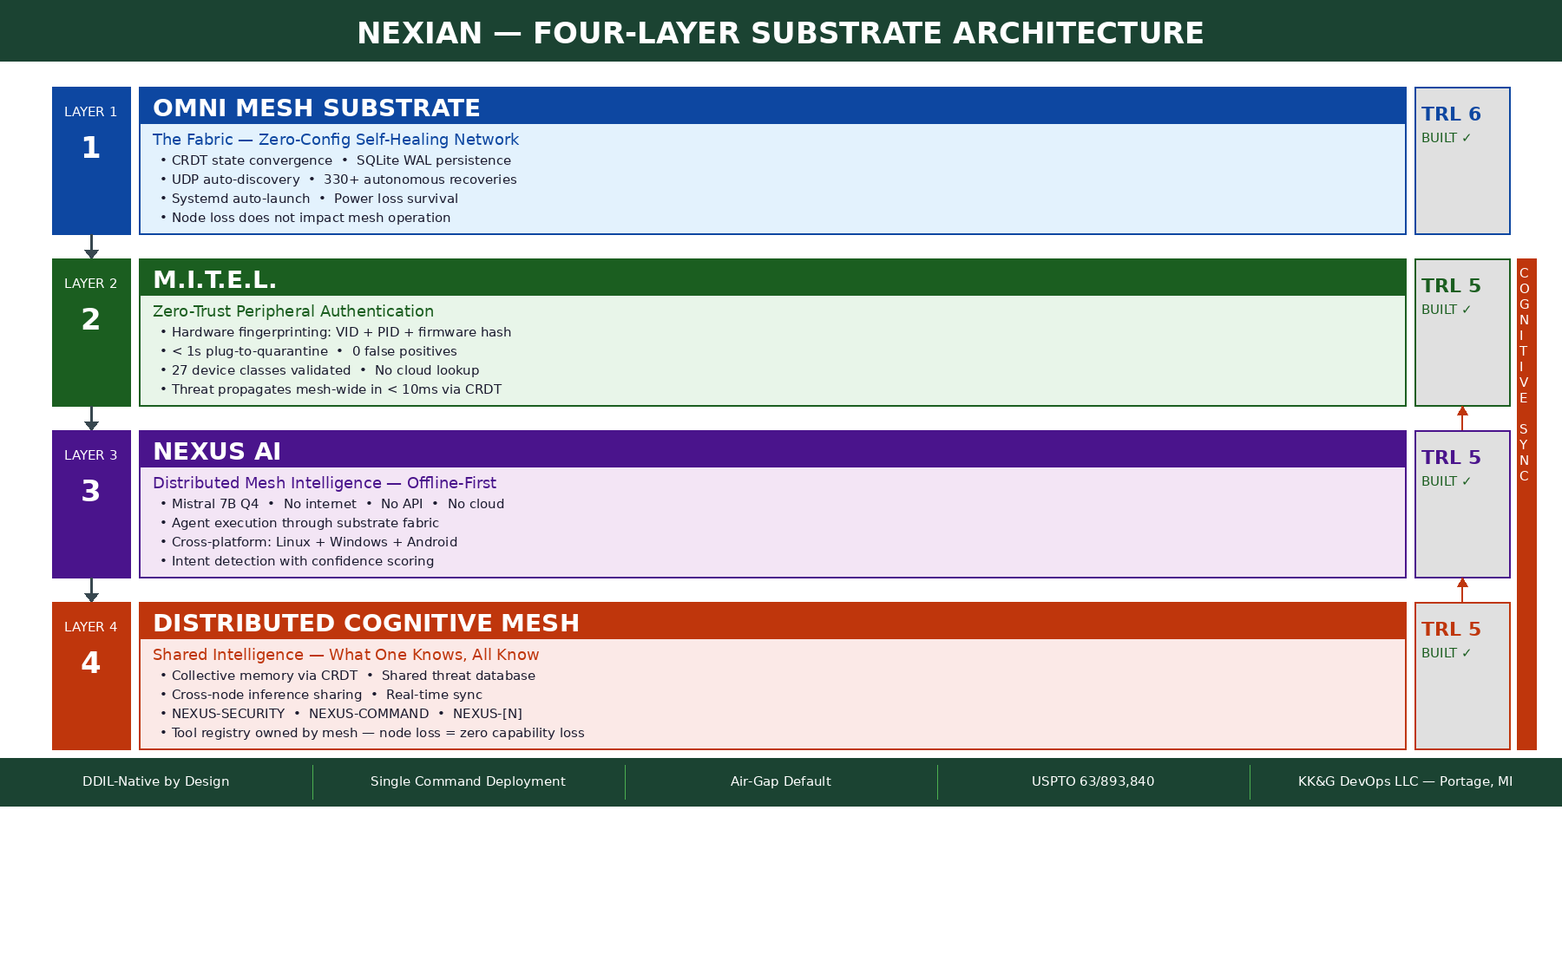

Field Deployment
→ Any x86 or ARM hardware — consumer laptops, embedded boards, mobile devices, soldier-portable
→ Linux + Windows + Android — simultaneous heterogeneous mesh, zero reconfiguration required
→ Local LAN or ad-hoc WiFi — no internet, no carrier, no cloud account, no subscription
→ Tested: 2–50 nodes, geographic distribution, network partition tolerance, power loss recovery

Complete deployment requires a single command per platform. All discovery, synchronization, and recovery processes occur automatically within the substrate.

Linux: ./launch_omni_complete.sh | Windows: launch_omni_windows.bat | Android: bash launch_omni_android.sh

BEYOND THE COMPETITION: WHAT THIS ACTUALLY IS
The internet was designed in 1969 to survive nuclear attack — route around damage, no central node. That insight became the backbone of global civilization. The cloud rebuilt centralization on top of that decentralized foundation, and in doing so, reintroduced the single points of failure the original architecture was designed to eliminate.

The Nexian engine rebuilds from the 1969 insight with 2026 capability. Self-sovereign. Organism behavior. Distributed AI inference as a first-class citizen. Zero external dependency.

COMPUTING ERA | CONSTRAINT REMOVED
Mainframe | Custom hardware dependency
Personal Computing | Shared infrastructure dependency
Internet | Geographic dependency
Mobile | Location dependency
Cloud | Local storage dependency
Edge | Data center dependency
Nexian | Dependency itself — the last constraint

Deep-Latency Operations
Environments with extreme communication latency — such as planetary surface operations with 22-minute signal delay — cannot depend on centralized cloud infrastructure. Nexian's autonomous mesh substrate allows compute, AI inference, and operational coordination to occur locally without ground control dependency. The same architecture that survives battlefield jamming survives the absence of any communication link entirely.

Nexian represents a transition beyond edge computing toward what we describe as Infinite Computing: systems that remove dependency on centralized infrastructure entirely. Edge computing still has a wire somewhere. Nexian cut the wire and the system got stronger.

WHO BUILT THIS

ATTRIBUTE | FACT
Developer | Kevin Burrows — Kingkali
Company | KK&G DevOps LLC
Location | Portage, Michigan
Formal CS Training | Zero
Team Size | One
Build Time | Under 9 months
Starting Point | $25 Facebook Marketplace laptop
Budget | Plasma donations
GitHub | 691+ contributions, 68+ repositories
Patents | USPTO 63/893,840 — micro-entity certification
Active Competitions | Army xTechSearch Adaptive Strike, Global Threat Modeling
Investor Pipeline | Kalamazoo Forward Ventures, YC W26

Every funded team in this competition had resources, credentials, and infrastructure. This system was built on plasma donations with no team, no degree, and no institutional support. That is not a liability. That is proof that the architecture is right — it does not require institutional support to work. Neither does the mesh.

FOUNDER NOTE
Nexian was built with a simple belief:

If I can think it, I can code it.
If I can code it, I can see it.
If I can see it, I can believe it.

This system started as an idea on a $25 laptop and became a live distributed compute fabric running today. When resources run out, persistence becomes the only advantage. Nexian exists because the work continued long after the easy path disappeared.

Nexian is not a device, sensor, or drone platform. It is the resilient compute substrate those systems require to operate when the network fails.

THE SYSTEM IS RUNNING RIGHT NOW.
Live demonstration available on request.
It works in the desert. It works with no internet. It works after a power outage. It thinks as one.

KK&G DevOps LLC | Portage, Michigan | github.com/Kingkali69 | USPTO 63/893,840

