**Npc name being read correctly**

The way that I tested my work was seeing if the Npc name was being correctly read after my fixes and when I press the right arrow key reading the name that is shown when it comes up and comparing that to the actual list

| Test | Expected Output | Actual Output | Passed? |
| --- | --- | --- | --- |
| On open | Tom | Tom | Yes |
| Pressed right on arrow keys(x1) | Grutt | Grutt | Yes |
| Pressed right on arrow keys(x2) | Metal Mouth | Metal Mouth | Yes |
| Pressed right on arrow keys(x3) | Commander Keen | Commander Keen | Yes |
| Pressed right on arrow keys(x4) | Judy | Judy | Yes |

**Crash after 5th record**

The way that I tested my work was seeing if the next Npc that came up had looped around to the beginning once I had pressed the right arrow key five times and checked that it had correctly looped around to the beginning of the set of Npcs so that it would show Tom again with the correct image as wellok

| Test | Expected Output | Actual Output | Passed? |
| --- | --- | --- | --- |
| Press right arrow key x5 | Tom | Tom | Yes |

**Testing the Wrapping effect**

The way that I tested my work here was by pressing the left arrow key once to loop to the end of the list and then pressing the right arrow key to loop back to the beginning of the list to make sure that the implemented fixes to the crash at the end of the list have worked in both directions

| Test | Expected Output | Actual Output | Passed? |
| --- | --- | --- | --- |
| Pressed the left arrow key then the right arrow key | Tom | Tom | Yes |

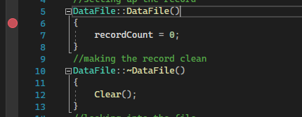

A break point

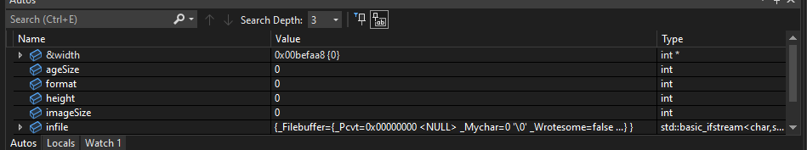

Auto Watch Points

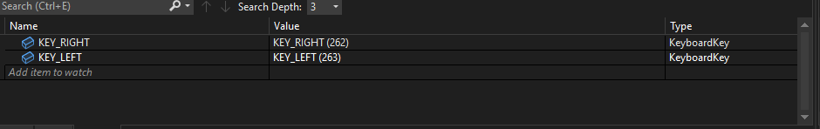

Custom Watch Points

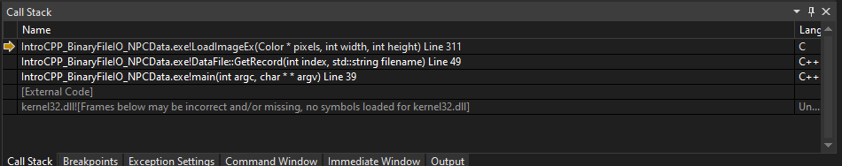

Call Stack Whilst Debugging

The keyboard shortcuts for running through the code in debugging mode are, step into is F11, step over is F10, Step out is Shift + F11 and stop debugging is Shift + F5

**Version Control Documentation**

1. <https://github.com/Kinglesssss/IntroToCpp>
2. [Merge pull request #1 from Kinglesssss/whitespace-branch · Kinglesssss/IntroToCpp@d3a5e23 (github.com)](https://github.com/Kinglesssss/IntroToCpp/commit/d3a5e23a99457f436aa731925c95e4181398b77d)

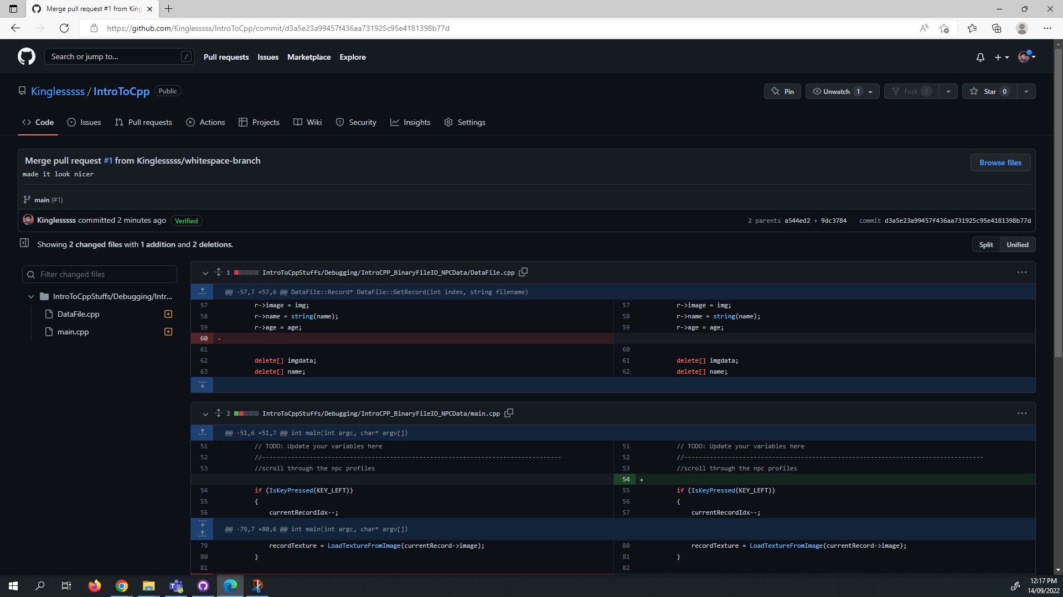

1. [made it look nicer by Kinglesssss · Pull Request #1 · Kinglesssss/IntroToCpp (github.com)](https://github.com/Kinglesssss/IntroToCpp/pull/1)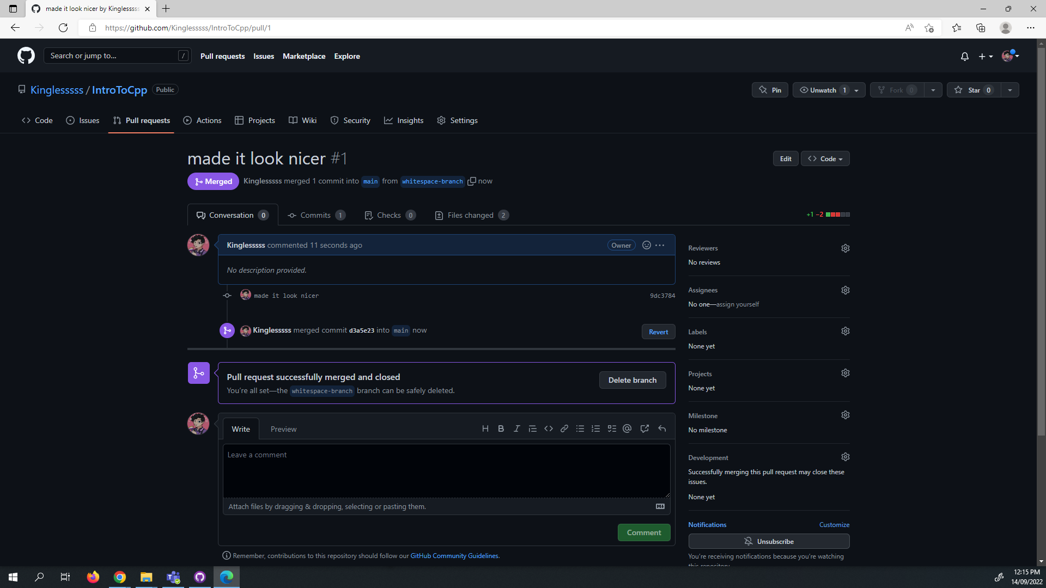
2. a) i)small game businesses

ii)something cheaper easier to use

b) i)it's cheaper, less strain on the company, helps with more people knowing the game.In the situation where There is a fire in the building that the company are in GitHub has off site saving so all the work won't get lost by whatever the company are saving on being brunt and making stuff unusable. There is also the fact that if someone makes a mistake it is possible to go back saves in the archive to a point where the mistake wasn't made

ii)specific problems that can't be helped by something like github can require someone to spend a lot of time and/or resources on something that really shouldn't.

1. Previous experience from perforce