Melvin Vazquez Andujar

3/7/24

**Stats Library/Set Operations**

**Program Description:**

This program is created by using the formulas that I have learned throughout the first half of the semester. These are all stats formulas, and we integrate formulas to create these methods and if a previous formula is used inside a new formula, you can just call the previous method inside that new method to construct and complete the formula. This program will keep updating with new formulas until the end of the school year.

The second program is called Set Operations and this program uses multiple ArrayList to find the intersection and union of the two lists. Then we use a subset of one of the ArrayList to find the complement of values.

**How Program Works:**

The program works using data types int, double, or Big Integer and using conditional statements. We also use the built-in method math to get the power of a variable and anything else we need to complete the formula.

The second program works by using nested for loops to compare values from the first list with second list and depending on which operation is being done, it will print a new list. Complement on the other hands compares a list with a subset and finds the values not in subset and returns that.

**OUTPUT**

**SetOperations:**

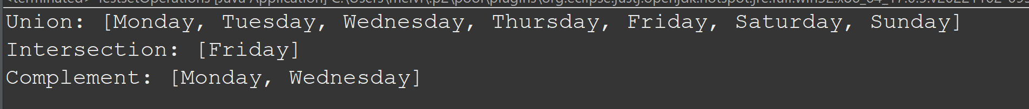

**StatsLibrary:**

