# Future of Supply Chain Security

David A. Wagle North Central University

TIM-8301: Principles of Cybersecurity Dr. Bill Souza

May 30, 2021

# Future of Supply Chain Security Company and Blog Location

**Company Name and URL**

A.P. Moller - Maersk [https://maersk.com](https://maersk.com/)

# Blog Post Location

<https://dawworld.wordpress.com/2021/05/30/future-of-supply-chain-security/>

# Introduction

The supply chain is no longer simply about ordering supplies and maintaining inventories. Today, the supply chain represents the heart of a corporation’s operational capability. A well-engineered supply chain is a significant, and often lasting, strategic advantage. Further, the supply chain is an extensive source of data, that can be leveraged using big-data analytics to support ever-more lean operations and economic efficiencies Arunachalam et al., 2018.

The supply chain is also a major source of cybersecurity concerns. First, there is the very real issue that most supply chains contain some level of corruption which is ignored by the corporation Webb, 2017. Second, the simply reality is that the supply chain represents an enormous attack-surface for would-be attackers as the modern supply chain creates large deeply interconnected systems between multiple corporations Govindan et al., 2017.

Supply chain management (SCM) is focused on the integration of critical operational business processes to provide products, services, and information between companies connected in a supply chain relationship. In an end-to-end supply chain, there can be dozens of companies that are sharing data. The optimal supply chain, from an operational perspective, is highly flexible and dynamic. This flexibility, however, comes with a loss of control Linawati, 2017. Thus, the global supply chain becomes an ideal target for cyber-attackers wishing to create maximum havoc either for a particular company, industry, or nation.

# The Future of Risk Mitigation Might Be Now Enter Blockchain

Consider a global shipping and logistics company: what are the cutting edge technologies currently being explored? The most famous new technology in such scenarios is blockchain Litke et al., 2019. Integration of blockchain into SCM systems for global logistics firms is already happening at a fairly rapid pace Groenfeldt, 2017, although for

smaller logistic and shipping firms, adoption can still be very low Papathanasiou et al., 2020. One of the reasons for the low adoption rate is actually concerns about security. This is ironic, as blockchain technology offers an intriguing potential to increase both physical and cybersecurity in the shipping and logistics industry Xu et al., 2018.

# What is Blockchain

Simply put, blockchain is a technology for creating a shared database of transactions that can be trusted by all parties.

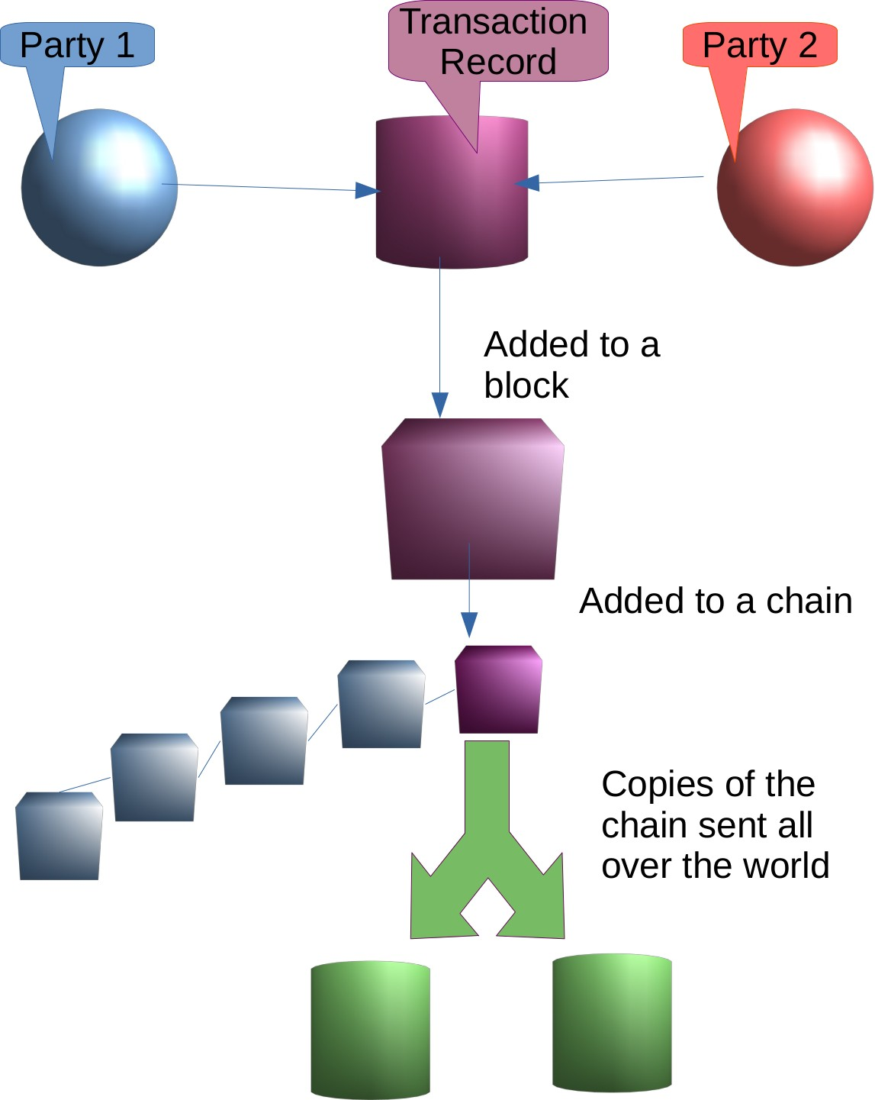

As the diagram suggests, a transaction is encoded into package called a block, that block is connected to other blocks on a chain, and the whole chain is then shared with

many, many users around the world. The “secret sauce” that makes these transactions secure is two-fold. First, the transaction is encrypted using very strong encryption technologies that are virtually impossible to break. Second, and more important, the block is given a unique identifying number as it is added to the chain that is cryptographically guaranteed to be unalterable. Now, when the chain is shared to many users, the validity of the transaction and its place on the chain can be proven by having all holders of a copy of the chain “vote” to validate if a block belongs on the chain, and its place on the chain Mearian, 2019.

This public verification scheme makes a blockchain ledger virtually unalterable in practice.

If the problem of adoption can be solved, and larger shipping and logistic companies are pushing that issue, supply chain security can be protected against malicious record alteration between suppliers, shippers, and end consumers.

Without blockchain, the supply chain is open to record manipulation that allows cyber attackers to delete records, corrupt data, or even re-route shipments, allowing the cyber attackers to commit physical theft and fraud. With Blockchain, the security of the supply chain can be protected at scale across the globe. Proof of this concept has already been shown in a wide varity of industries from aggriculture to pharmaceuticals Tse et al., 2017.

# References

Arunachalam, D., Kumar, N., & Kawalek, J. P. (2018). Understanding big data analytics capabilities in supply chain management: Unravelling the issues, challenges and implications for practice. *Transportation Research Part E: Logistics and* *Transportation Review*, *114*, 416–436. <https://doi.org/10.1016/j.tre.2017.04.001>

Govindan, K., Fattahi, M., & Keyvanshokooh, E. (2017). Supply chain network design under uncertainty: A comprehensive review and future research directions. *European Journal of Operational Research*, *263* (1), 108–141. <https://doi.org/10.1016/j.ejor.2017.04.009>

Groenfeldt, T. (2017). Ibm and maersk apply blockchain to container shipping [magazine].

*Forbes*. Retrieved February 6, 2021, from [https://www.forbes.com/sites/tomgroenfeldt/2017/03/05/ibm-and-maersk-apply-](https://www.forbes.com/sites/tomgroenfeldt/2017/03/05/ibm-and-maersk-apply-blockchain-to-container-shipping/) [blockchain-to-container-shipping/](https://www.forbes.com/sites/tomgroenfeldt/2017/03/05/ibm-and-maersk-apply-blockchain-to-container-shipping/)

Linawati, N. (2017). Supply chain flexibility: Drivers and enablers - a literature review.

*International Journal of Organizational Innovation*, *9* (4), 116–132. Retrieved

February 4, 2021, from http://proxy1.ncu.edu/login?url=https://search.ebscohost. com/login.aspx?direct=true&db=bth&AN=122231668&site=eds-live

Litke, A., Anagnostopoulos, D., & Varvarigou, T. (2019). Blockchains for supply chain management: Architectural elements and challenges towards a global scale deployment. *Logistics*, *3* (1), 5. <https://doi.org/10.3390/logistics3010005>

Mearian, L. (2019). What is blockchain? the complete guide [magazine]. *Computerworld*.

Retrieved December 19, 2020, from [https://www.computerworld.com/article/3191077/what-is-blockchain-the-complete-](https://www.computerworld.com/article/3191077/what-is-blockchain-the-complete-guide.html) [guide.html](https://www.computerworld.com/article/3191077/what-is-blockchain-the-complete-guide.html)

Papathanasiou, A., Cole, R., & Murray, P. (2020). The (non-)application of blockchain technology in the greek shipping industry. *European Management Journal*, *38* (6), 927–938. <https://doi.org/10.1016/j.emj.2020.04.007>

Tse, D., Zhang, B., Yang, Y., Cheng, C., & Mu, H. (2017, December). Blockchain application in food supply information security, In *2017 ieee international conference on industrial engineering and engineering management (ieem)*. 2017 IEEE International Conference on Industrial Engineering and Engineering Management (IEEM). <https://doi.org/10.1109/IEEM.2017.8290114>

Webb, J. (2017). Two-thirds of corporations ignore corruption in their supply chains [magazine]. *Forbes*. Retrieved December 19, 2020, from [https://www.forbes.com/sites/jwebb/2017/07/19/two-thirds-of-corporations-](https://www.forbes.com/sites/jwebb/2017/07/19/two-thirds-of-corporations-ignore-corruption-in-their-supply-chains/) [ignore-corruption-in-their-supply-chains/](https://www.forbes.com/sites/jwebb/2017/07/19/two-thirds-of-corporations-ignore-corruption-in-their-supply-chains/)

Xu, L., Chen, L., Gao, Z., Chang, Y., Iakovou, E., & Shi, W. (2018, October). Binding the physical and cyber worlds: A blockchain approach for cargo supply chain security enhancement, In *2018 ieee international symposium on technologies for homeland security (hst)*. 2018 IEEE International Symposium on Technologies for Homeland Security (HST). <https://doi.org/10.1109/THS.2018.8574184>