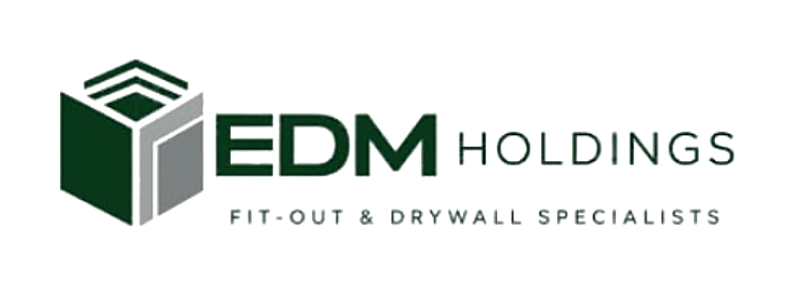 | C O N T A C T  +971 (0) 58 601 2021  enquiries@edmholdings.ae  edmholdings.ae
──────────────
NO OBJECTION CERTIFICATE (NOC)
Ref: [NOC-2026-001] | Date: [DD Month YYYY]

To Whom It May Concern,
This is to certify that [Mr./Ms. Full Name], holder of Emirates ID No. [784-XXXX-XXXXXXX-X], is employed by E D M TECHNICAL SERVICES L.L.C (Trade Licence No. 1627658, Department of Economy and Tourism, Dubai) as [Position], since [DD Month YYYY].
We hereby confirm that the company has no objection to the above-named [state purpose], subject to the applicable laws and regulations of the United Arab Emirates.
This certificate is issued at the request of the above-named for official purposes and without any liability on the company. Should you require any further information, please contact us on the details above.
Sincerely,
For and on behalf of E D M TECHNICAL SERVICES L.L.C
_____________________________________  Authorised Signatory  Name & title: [Name, Title] | Company stamp  ⸻⸻⸻⸻⸻⸻

E D M TECHNICAL SERVICES L.L.C · Trade Licence 1627658 · Specialist fit-out & drywall contractor
Dubai, UAE · +971 (0) 58 601 2021 · enquiries@edmholdings.ae · edmholdings.ae

