Game Design Document

Fill up the following document

1. Write the title of your project.

Zombie Crush

1. What is the goal of the game?

Survive the zombies till the last wave.

1. Write a brief story of your game.

A person is stuck in a city with zombie apocalypse going on and must

Survive until help arrives.(after 5-6 waves the game will be over)

The person has a gun to defend himself/herself.

1. Which are the playing characters of this game?

* Playing characters are the ones who respond to the user based on the input from the user.
* Cars, monkeys, dinos, wizards, etc., are the playing characters in the game.

|  |  |  |
| --- | --- | --- |
| Number | Character Name | What can this character do? |
| 1 | Player(there will be choice to name yourself) no multiplayer | Playing character can shoot and kill zombies. |
| 2 |  |  |
| 3 |  |  |
| 4 |  |  |
| 5 |  |  |
| 6 |  |  |
| 7 |  |  |
| 8 |  |  |

1. Which are the Non-Playing Characters of this game?

* Non-Playing characters are the ones that don't have an action or behavior when the user interacts with the game.
* Hurdles, stones, bananas, coins, etc., are non-playing characters in the game.

|  |  |  |
| --- | --- | --- |
| Number | Character Name | What can this character do? |
| 1 | Zombie 1(different types of zombies) | Attack the player |
| 2 | Zombie 2 | Attack the player |
| 3 | Zombie 3 | Attack the player |
| 4 | Zombie 4 | Attack the player |
| 5 | Medkit | Heal the player |
| 6 | Helicopter | Arrives and saves the player after the waves are over |
| 7 | Guns | Be a gun |
| 8 |  |  |

Draw your imagination of this game. What does this game look like?

* Draw the game either on your computer or on paper.
* Add images of the game scenes to show each of the playing and non-playing

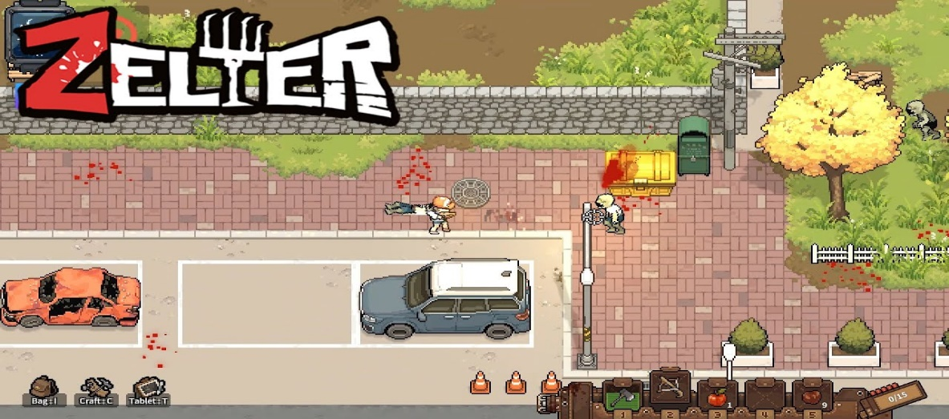

How do you plan to make your game engaging?

There will be waves of zombies and the player must survive after collecting a certain amount of coins the player can upgrade the weapon for a better weapon and can get medkits to heal themselves. There will 5-6 waves and a boss wave each wave will get harder.