Name: Aarya Thapa
Q1. Write a C program to find the maximum and minimum elements in an array.
#include<stdio.h>
int main(){
int n,min,max;

printf("Enter the size of array:");
scanf("%d",&n);

int arr[n];
printf("Enter the elements of array:");

for(int i=0;i<n;i++) scanf("%d",&arr[i]);
min=max=arr[0];

for(int i=1;i<n;i++)
{
if(arr[i]<min)min=arr[i];
if(arr[i]>max)max=arr[i];
}

printf("Minimum:%d\n",min);
printf("Maximum:%d\n",max);
return 0;
}
Output:
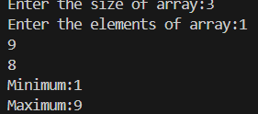
Q2. Implement a C program to reverse the elements of an array.
#include<stdio.h>
int main(){
int n,temp;
printf("Enter the size of array:");
scanf("%d",&n);

int arr[n];
printf("Enter the elements of array:");
for(int i=0;i<n;i++) scanf("%d",&arr[i]);

printf("The elements of the array are:");

for(int i=0;i<n;i++) printf("%d",arr[i]);
printf("\n");
for(int i=0;i<n/2;i++)
{
temp=arr[i];
arr[i]=arr[n-1-i];
arr[n-1-i]=temp;
}
printf("The elements of array after reversing are:");

for(int i=0;i<n;i++) printf("%d",arr[i]);
printf("\n");
return 0;
}
Output:
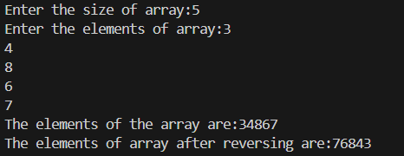
Q3. Write a C program to sort an array of integers in ascending order using a sorting algorithm of your choice (e.g., bubble sort, selection sort, insertion sort).
#include<stdio.h>
int main(){
int n,temp;
printf("Enter the size of array:");
scanf("%d",&n);

int arr[n];
printf("Enter the elements of array:");
for(int i=0;i<n;i++) scanf("%d",&arr[i]);

printf("The elements of the array are:");
for(int i=0;i<n;i++) printf("%d",arr[i]);
printf("\n");

for(int i=0;i<n-1;i++)
{
for(int j=0;j<n-1-i;j++)
{
if(arr[j]>arr[j+1])
{
temp=arr[j];
arr[j]=arr[j+1];
arr[j+1]=temp;
}
}
}
printf("The elements of array after sorting are:");
for(int i=0;i<n;i++) printf("%d",arr[i]);
printf("\n");

return 0;
}

Output:
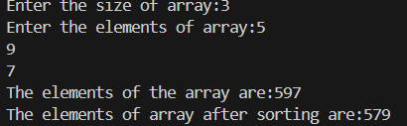
Q4. Implement a C program to find the second largest element in an array.
#include <stdio.h>

int main() {
int arr[] = {12, 35, 1, 10, 34, 1};
int n = sizeof(arr) / sizeof(arr[0]);

int largest, second;

if (arr[0] > arr[1]) {
largest = arr[0];
second = arr[1];
} else {
largest = arr[1];
second = arr[0];
}

for (int i = 2; i < n; i++) {
if (arr[i] > largest) {
second = largest;
largest = arr[i];
} else if (arr[i] > second && arr[i] != largest) {
second = arr[i];
}
}

printf("Second Largest Element: %d\n", second);

return 0;
}
Output:
Q5. Write a C program to merge two sorted arrays into a single sorted array.
#include<stdio.h>
int main(){
int n1,n2;

printf("Enter the size of the first array:");
scanf(" %d",&n1);

printf("Enter the size of the second array:");
scanf(" %d",&n2);

int arr1[n1], arr2[n2];

printf("Enter the value of first array:");
for (int i=0; i<n1; i++)
scanf(" %d", &arr1[i]);

printf("Enter the value of second array:");
for (int j=0; j<n2; j++)
scanf(" %d", &arr2[j]);

int x=0, y=0, z=0;

int merged_arr[n1+n2];

while(x<n1 || y<n2)
{
if (arr1[x]<arr2[y]) merged_arr[z++]=arr1[x++];
else
merged_arr[z++]=arr2[y++];

}
printf("Merged array:");
for (int k=0; k<n1+n2; k++)
printf(" %d",merged_arr[k]);
printf("\n");

return 0;
}
Output:
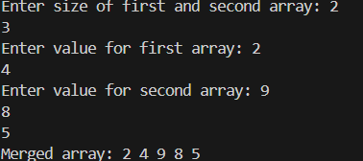
Q6. Write a C program to find the length of a string without using the built-in string functions.
#include<stdio.h>
int main(){
int count=0;
char abc[100];

printf("Enter a string:");
scanf(" %s", abc);

for (int i=0; i<=100; i++)
{
if (abc[i]=='\0')
{
break;
}
count++;
}
printf("The length of the string is: %d", count);
return 0;
}
Output:
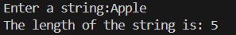
Q7. Implement a C program to reverse a string.
#include <stdio.h>

int main() {
char str[100];
int i, length = 0;
char temp;

printf("Enter a string: ");
scanf("%s", str);

while (str[length] != '\0') {
length++;
}

for (i = 0; i < length / 2; i++) {
temp = str[i];
str[i] = str[length - 1 - i];
str[length - 1 - i] = temp;
}

printf("Reversed string: %s\n", str);

return 0;
}
Output:
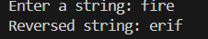
Q8. Write a C program to check if a given string is a palindrome.
#include<stdio.h>
#include<string.h>
#include<ctype.h>
int main(){
char str[100];
int i , length;
int isPalindrome=1;

printf("Enter a string:");
scanf("%s", str);

for(i=0; str[i]; i++){
str[i]= tolower(str[i]);
}

length=strlen(str);

for(i=0; i<length/2; i++)
{

if(str[i] != str[length-i-1])
{
isPalindrome=0;
break;
}
}
if(isPalindrome)
{
printf("%s is a palindrome",str);
}
else{
printf("%s is not a palindrome",str);
}
return 0;
}
Output:
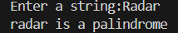
Q9. Implement a C program to count the occurrence of a specific character in a string.
#include <stdio.h>
#include<ctype.h>
int main(){

char str[100];
int i, count=0;
char ch;

printf("Enter a string:");
scanf(" %s", str);

printf("Enter the character to count:");
scanf(" %c", &ch);

for (i=0; str[i]!='\0'; i++)
{
if (tolower(str[i])==tolower(ch))
{
count++;
}
}
printf(" %c comes %d times in the string %s\n", ch, count, str);
return 0;
}
Output:
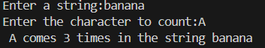
Q10. Write a C program to concatenate two strings without using the built-in string functions.
#include<stdio.h>
int main(){

char str1[100];
char str2[100];

printf("Enter the first string:");
scanf(" %s", str1);

printf("Enter the second string:");
scanf(" %s", str2);

int i=0;
while (str1[i]!= '\0')
{
i++;
}

str1[i]= ' '; //adding a space
i++;

int j=0;
while (str2[j]!= '\0')
{
str1[i]=str2[j];
i++;
j++;
}

str1[i]= '\0';
printf("The concatenated string is %s", str1);

return 0;

}
Output:
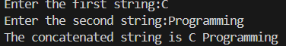
Q11. Write a function named calculateAverage that takes an array of integers as input and returns the average of the numbers.
#include <stdio.h>
float calculateAverage (float arr[], int size)
{
int sum=0;
float average;

for (int i=0; i<size; i++)
{
sum=sum+arr[i];
}
average=(float)sum/size;
return average;
}
int main(){
float arr[100];
int n;
float avg;

printf("Enter the no. of integers:");
scanf(" %d", &n);

printf("Enter %d no. of integers\n",n);
for (int i=0; i<n; i++)
{
printf("Number %d:",i+1);
scanf(" %f" , &arr[i]);
}

avg=calculateAverage (arr,n);
printf("\nAverage: %.2f\n",avg);

return 0;
}
Output:
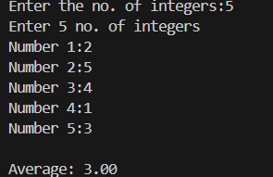
Q12. Write a function named isPalindrome that takes a string as input and returns 1 if it is a palindrome (reads the same forwards and backwards), and 0 otherwise.
#include<stdio.h>
#include<string.h>
#include<ctype.h>
int isPalindrome (char str[])
{
int length;

for(int i = 0; str[i] != '\0'; i++)
{
str[i] = tolower(str[i]);
}

length=strlen(str);

for (int i=0; i<length/2; i++)
{
if (str[i] != str[length-i-1])
{
return 0; //not palindrome
}
}
return 1;
}
int main(){
char str[100];
int result;

printf("Enter a string:");
scanf(" %s", str);

result=isPalindrome(str);

if(result==1){
printf("Palindrome\n");
}
else{
printf("Not palindrome\n");
}
return 0;
}
Output:
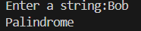
Q13. Write a function named findFactorial that takes an integer as input and returns its factorial.
#include<stdio.h>
int findFactorial (int n)
{
int i=1;
int factorial=1;

while(i<=n)
{
factorial=factorial*i;
i++;
}
return factorial;
}

int main(){
int n;

printf("Enter a number:");
scanf(" %d", &n);

int factorial=findFactorial(n);

printf(" %d! = %d",n, factorial);
return 0;
}
Output:
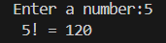
Q14. Write a function named convertTemperature that takes a temperature value in Celsius and converts it to Fahrenheit. The function should return the converted temperature.
#include <stdio.h>
int convertTemperature (float celsius)
{
float fahrenheit;

fahrenheit=(celsius*9/5)+32;
return fahrenheit;
}
int main(){
float celsius, fahrenheit;

printf("Enter the temperature in celsius:");
scanf(" %f", &celsius);

fahrenheit=convertTemperature(celsius);
printf(" %.2f%cC is %.2f%cF",celsius, 248, fahrenheit, 248);
return 0;
}
Output:
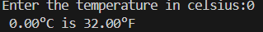
Q15. Write a function named countOccurrences that takes a string and a character as input and returns the number of times the character appears in the string.
#include<stdio.h>
#include<ctype.h>
int countOccurrences (char str[], char ch)
{
int count=0;

for (int i=0; str[i]; i++)
{
str[i]=tolower(str[i]);
}

for (int i=0; str[i] != '\0'; i++)
{
if(str[i]==ch)
{
count++;
}
}
return count;
}
int main(){
char str[100];
char ch;
int result;

printf("Enter a string:");
scanf(" %s", str);

printf("Enter character to count:");
scanf(" %c", &ch);

result=countOccurrences (str, ch);
printf("%c comes %d times in the string %s",ch, result, str);

return 0;
}
Output:
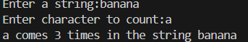

Q16. Write a function named reverseArray that takes an array of integers as input and reverses the order of the elements in the array.
#include<stdio.h>
int reverseArray (int arr[],int size)
{
for ( int i=0; i<size/2; i++)
{
int temp=arr[i];
arr[i]=arr[size-i-1];
arr[size-i-1]=temp;
}
return 1;
}
int main(){
int arr[100];
int n, result;

printf("Enter the no. of integers:");
scanf(" %d", &n);

printf("Enter the integers:");
for (int i=0; i<n; i++)
{
scanf(" %d", &arr[i]);
}
result=reverseArray (arr,n);

printf("After reversing:");
for (int i=0; i<n; i++)
{
printf(" %d", arr[i]);
}

return 0;
}
Output:
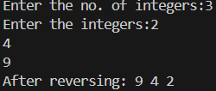
Q17. Write a function named calculatePower that takes two integers, base and exponent, as input and returns the result of raising the base to the exponent.
#include<stdio.h>
int calculatePower(int base, int exponent)
{
int result=1;

for( int i=0; i<exponent; i++)
{
result=result*base;
}
return result;
}

int main(){
int base, exponent;

printf("Enter the base:");
scanf(" %d",&base);

printf("Enter the exponent:");
scanf(" %d",&exponent);

int result=calculatePower(base,exponent);

printf("The power is %d\n",result);

return 0;
}
Output:
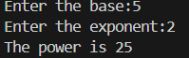
Q18. Write a function named findPrimeNumbers that takes an integer n as input and prints all prime numbers from 1 to n.
#include <stdio.h>
int findPrimeNumbers (int n)
{
int isPrime;
int count=0;

printf("Prime Numbers from 1 to %d\n",n);

for (int i=2; i<=n; i++)
{
isPrime=1;
for (int j=2; j<i; j++)
{
if(i%j==0)
{
isPrime=0;
break;
}
}
if (isPrime==1)
{
printf(" %d", i);
count++;
}
}
return count;
}
int main()
{
int n;
int Prime;

printf("Enter a number:");
scanf(" %d", &n);

Prime=findPrimeNumbers(n);

printf("\nTotal Prime Numbers: %d\n", Prime);
return 0;
}
Output:
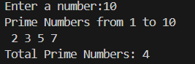
Q19. Write a function named calculateFactorialSeries that takes an integer n as input and prints the factorial series up to n.
#include <stdio.h>
int calculateFactorialSeries (int n)
{
int factorial;

for (int i=1; i<=n; i++)
{
factorial=1;
for (int j=1; j<=i; j++)
{
factorial=factorial*j;
}
printf("%d! = %d\n",i,factorial);
}
return 1;
}
int main()
{
int n;
printf("Enter a number for calculating Factorial Series:");
scanf(" %d", &n);

calculateFactorialSeries(n);
return 0;
}
Output:
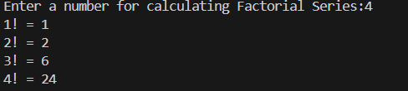
Q20. Write a function named calculateGCD that takes two integers as input and returns their greatest common divisor (GCD).
#include<stdio.h>
int calculateGCD (int num1, int num2)
{
int temp;

while(num2!=0)
{
temp=num2;
num2=num1%num2;
num1=temp;
}
return num1;
}
int main()
{
int num1,num2;
int result;

printf("Enter first number:");
scanf(" %d", &num1);
printf("Enter second number:");
scanf(" %d", &num2);

result=calculateGCD (num1, num2);
printf("\nGCD of %d and %d is %d",num1, num2, result);

return 0;
}
Output:
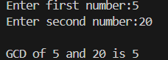
Q21. Write a recursive function named calculateFactorial that takes an integer n as input and returns its factorial.
#include<stdio.h>
int calculateFactorial (int num)
{
if (num==0 || num==1)
{
return 1;
}
else{
return num * calculateFactorial(num-1);
}
}
int main()
{
int num, result;

printf("Enter a number:");
scanf(" %d", &num);

result=calculateFactorial(num);

printf("The factorial is %d\n",result);

printf("%d! = %d",num, result);

return 0;
}
Output:
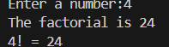
Q22. Write a recursive function named calculateFibonacci that takes an integer n as input and returns the nth Fibonacci number. The Fibonacci sequence starts with 0 and 1, and each subsequent number is the sum of the two preceding numbers.
#include<stdio.h>
int calculateFibonacci (int num)
{
if(num==0)
{
return 0;
}
else if(num==1){
return 1;
}
else{
return calculateFibonacci(num-1) + calculateFibonacci(num-2);
}
}
int main()
{
int num, result;

printf("Enter a number:");
scanf(" %d", &num);

result=calculateFibonacci(num);

printf("Fibonacci (%d) = %d",num, result);

return 0;
}
Output:
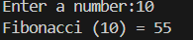
Q23. Write a recursive function named calculateGCD that takes two integers a and b as input and returns their greatest common divisor (GCD).
#include<stdio.h>
int calculateGCD (int a, int b)
{
if(b==0)
{
return a;
}
else{
return calculateGCD(b, a%b);
}
}
int main()
{
int a,b,result;

printf("Enter the first number:");
scanf(" %d", &a);

printf("Enter the second number:");
scanf(" %d", &b);

result=calculateGCD(a,b);

printf("The GCD of %d and %d is %d",a,b,result);

return 0;
}
Output:
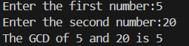
Q24. Write a recursive function named calculatePower that takes two integers base and exponent as input and returns the result of raising the base to the exponent.
#include<stdio.h>
int calculatePower(int base, int exponent)
{
if(exponent==0)
{
return 1;
}
else{
return base * calculatePower(base, exponent-1);
}
}
int main()
{
int base, exponent;
int result;

printf("Enter the base:");
scanf(" %d", &base);

printf("Enter the exponent:");
scanf(" %d", &exponent);

result= calculatePower(base, exponent);

printf("The result is %d\n",result);

printf("%d^%d = %d", base, exponent, result);

return 0;
}
Output:
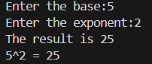
Q25. Write a recursive function named calculateSumOfDigits that takes an integer n as input and returns the sum of its digits.
#include<stdio.h>
int calculateSumOfDigits(int n)
{
if(n==0)
{
return 0;
}
else{
return (n%10) + calculateSumOfDigits(n/10);
}
}
int main(){
int n;

printf("Enter a number:");
scanf(" %d", &n);

int result=calculateSumOfDigits(n);

printf("The sum of digits is %d", result);

return 0;
}
Output:
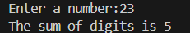
Q26. Write a recursive function named reverseString that takes a string as input and returns the reversed string.
#include<stdio.h>
#include<string.h>
int reverseString (char str[], int i, int j)
{
if(i>=j){
return 1;
}
char temp= str[i];
str[i]=str[j];
str[j]=temp;

return reverseString(str, i+1, j-1);
}
int main(){
char str[100];
int result;

printf("Enter a string:");
scanf(" %s", str);

int length=strlen(str);

result=reverseString(str, 0, length-1);

if(result==1)
{
printf("Reversed string is %s", str);
}
return 0;
}
Output:

Q27. Write a recursive function named printTriangle that takes an integer n as input and prints a triangle of asterisks (*) with n rows.
#include<stdio.h>
int printTriangle(int n)
{
if(n==0)
{
return 1;
}
printTriangle(n-1);

for (int i=0; i<n; i++)
{
printf(" *");
}
printf("\n");
return 1;
}
int main()
{
int n,result;

printf("Enter the number of rows:");
scanf(" %d", &n);

result=printTriangle(n);
printf("Triangle:%d\n", result);

return 0;

}

Output:
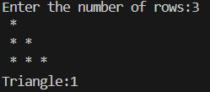
Q28. Write a recursive function named calculateBinary that takes an integer n as input and returns its binary representation as a string.
#include<stdio.h>
int calculateBinary(int n)
{
if(n==0)
{
return 1;
}
calculateBinary(n/2);
printf("%d", n%2);

return 1;
}
int main()
{
int n;

printf("Enter a number:");
scanf(" %d", &n);

printf("The binary of %d is ", n);

if(n==0)
{
printf("0");
}
else{
calculateBinary(n);
}
return 0;
}
Output:
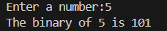
Q29. Write a recursive function named isPalindrome that takes a string as input and returns 1 if it is a palindrome (reads the same forwards and backwards), and 0 otherwise.
#include<stdio.h>
#include<string.h>
#include<ctype.h>
int isPalindrome(char str[], int start, int end)
{
if(start>=end)
{
return 1;
}
if (tolower(str[start]) != tolower(str[end]))
{
return 0;
}
return isPalindrome(str, start+1, end-1);
}
int main()
{
char str[100];

printf("Enter a string:");
scanf(" %s", str);

int length=strlen(str);

if(isPalindrome(str, 0, length-1))
{
printf("%s is a palindrome",str);
}
else{
printf("%s is not a palindrome",str);
}
return 0;
}
Output:
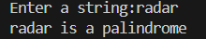
Q30. Write a recursive function named countOccurrences that takes a string and a character as input and returns the number of times the character appears in the string.
#include<stdio.h>
#include<ctype.h>
int countOccurrences(char str[], char ch)
{
if (str[0]=='\0')
{
return 0;
}
if (tolower(str[0])==tolower(ch))
{
return 1+ countOccurrences(str+1, ch);
}
return countOccurrences(str+1, ch);
}
int main()
{
char str[100];
char ch;

printf("Enter a string:");
scanf(" %s", str);

printf("Enter a character to count:");
scanf(" %c", &ch);

int count=countOccurrences(str,ch);

printf("%c appears %d times in %s",ch, count, str);

return 0;

}

Output:
