**PROVIDER PORTAL FIXES**

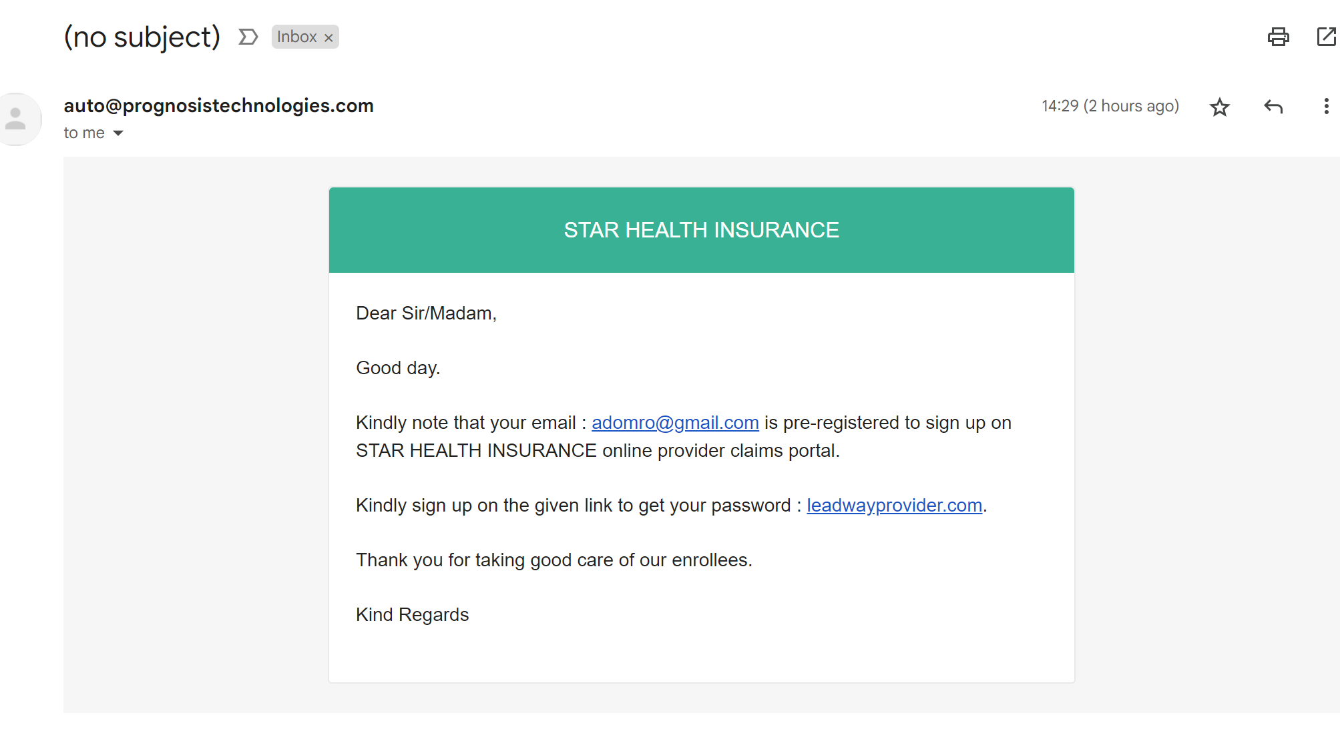

**PROVIDER PORTAL SUPPORT EMAIL ADDRESS**

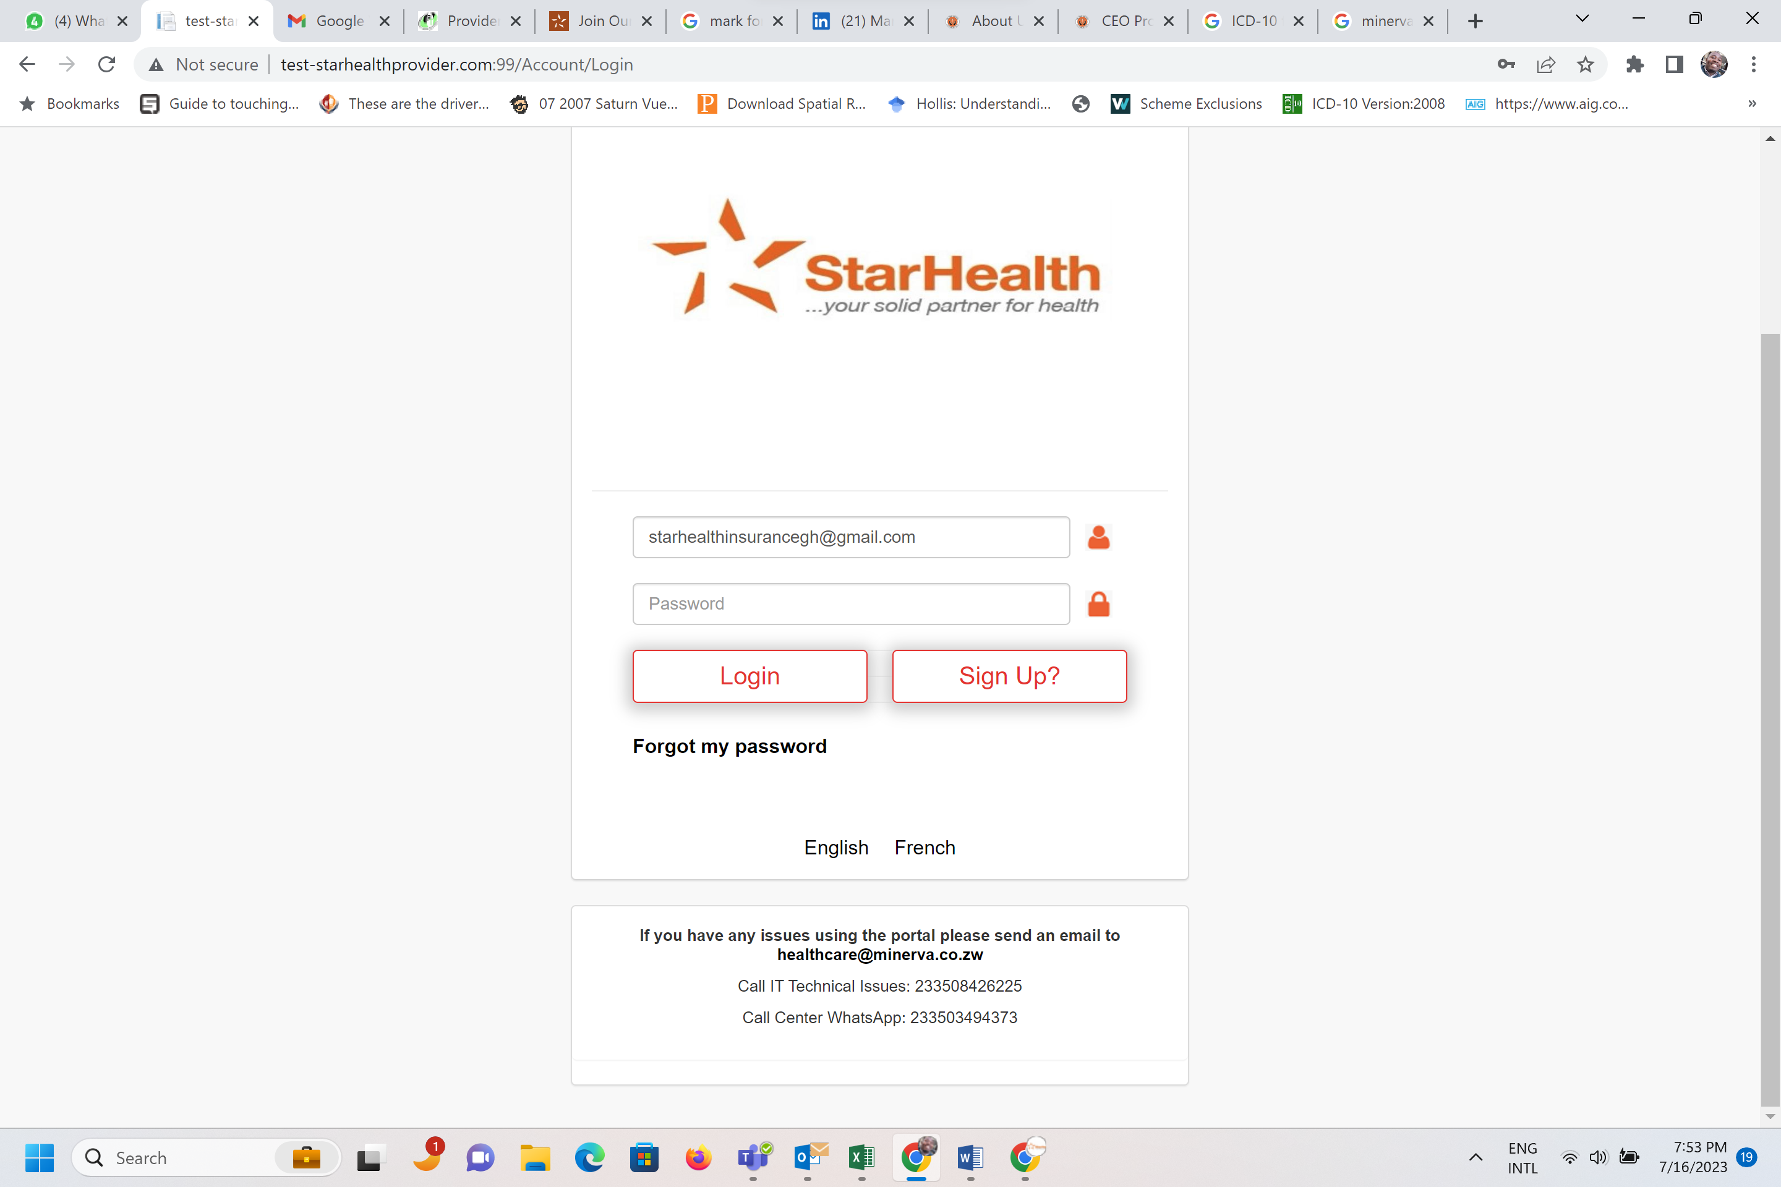

Support email should be updated to

[hspclaims@starhealthinsurancegh.com](mailto:hspclaims@starhealthinsurancegh.com)

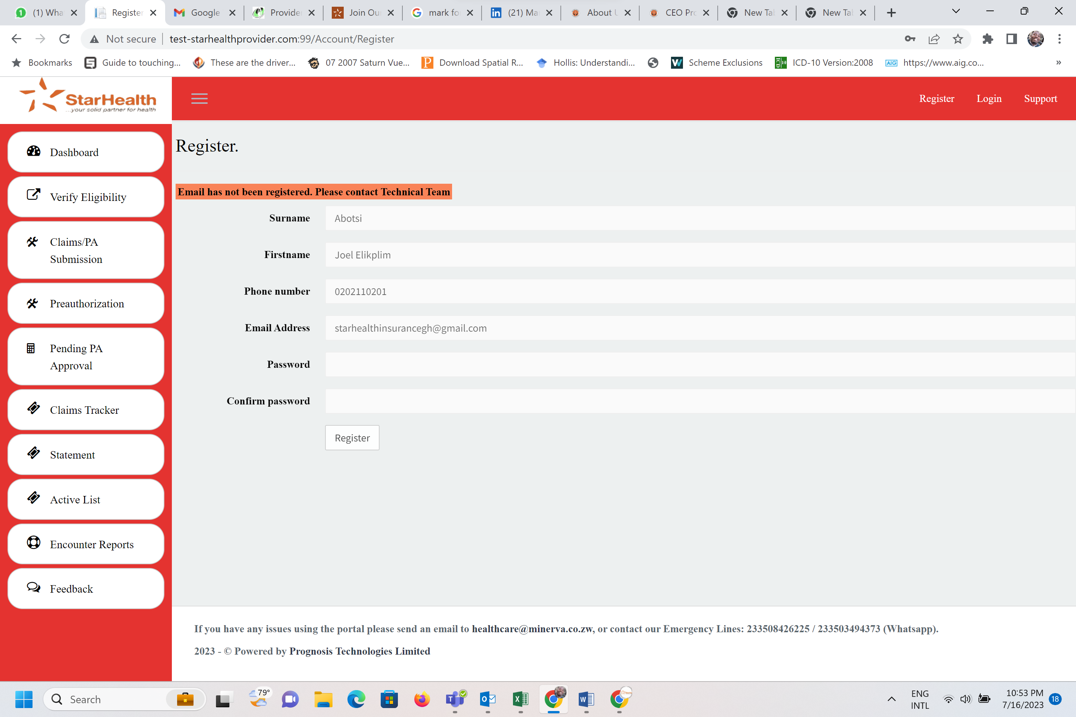

The Contact Support points to Oceanic HMO and must be changed to **STAR HEALTH INSURANCE GH. LTD.** The email address should be [hspclaims@starhealthinsurancegh.com](mailto:hspclaims@starhealthinsurancegh.com)

This functionality of approving emails for the portal must sit with us here in Ghana

**SUPPORT TAB ON PORTAL**

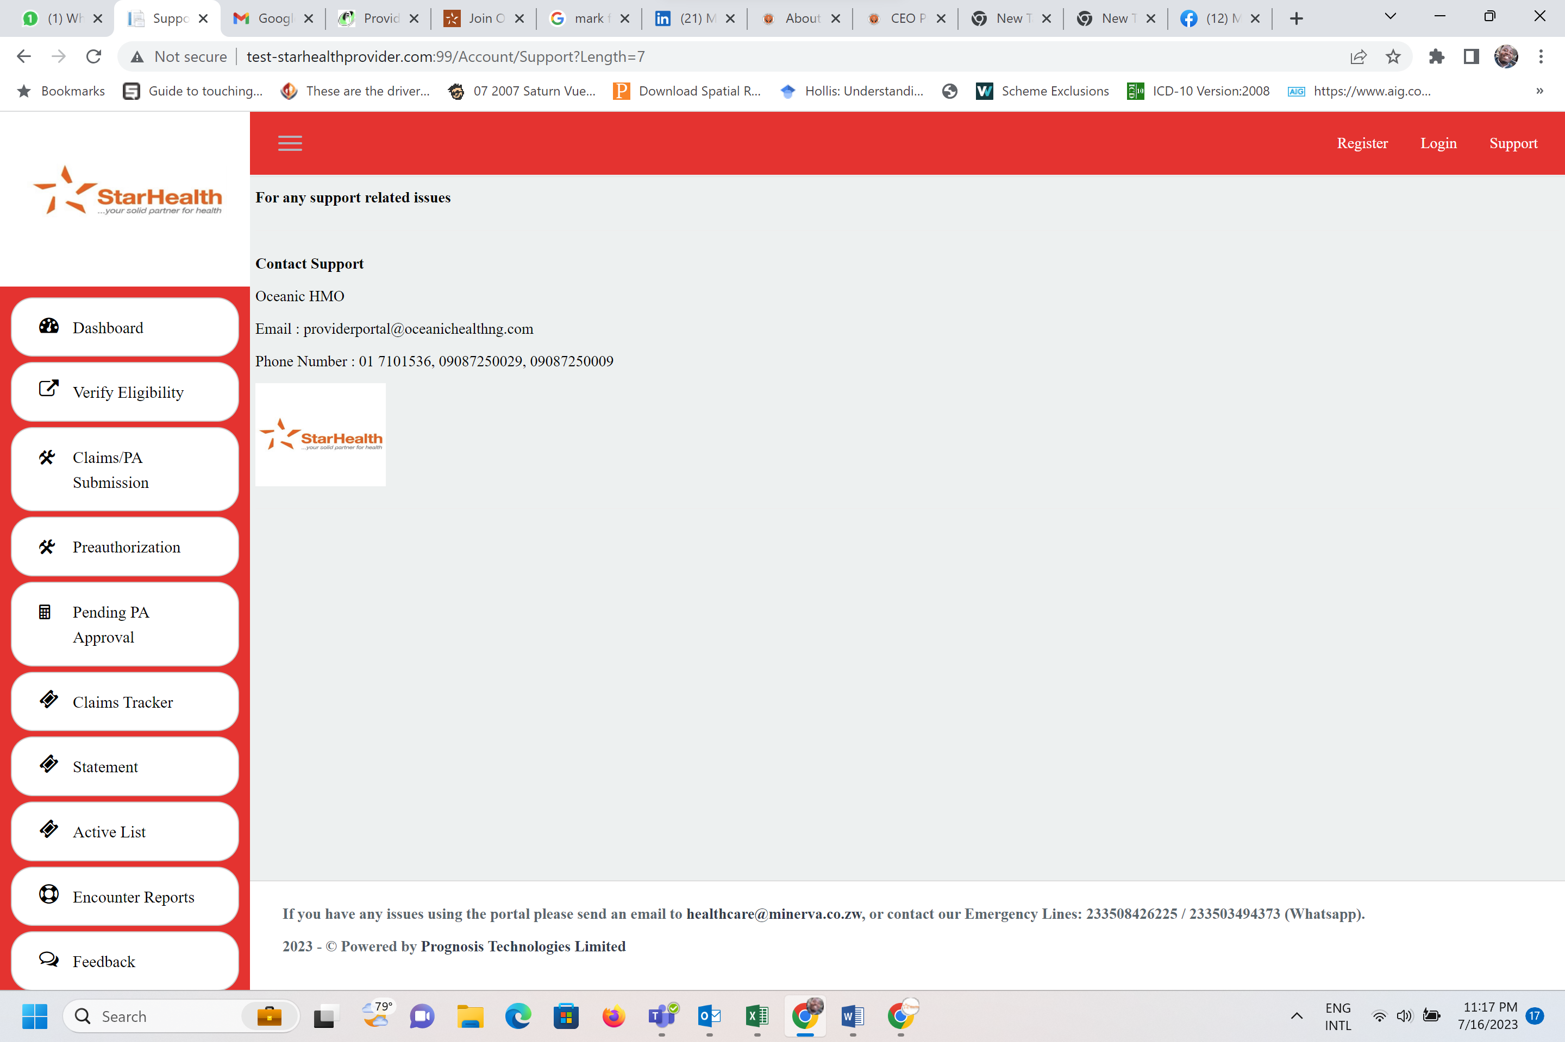

**VERIFYING ENROLEE PAGE**

The PROCESS should be changed as follows:  
1. Member presents at Hospital and gives their Enrolee # to provider to VERIFY

Provider enters Enrolee ID and Click on VERIFY with SMS or email.

3, Verification Code should appear on the member’s Phone and not the Provider Portal.

4. Member must now share Verifying Code (OTP) with Provider before the Provider can click on UTILIZATION

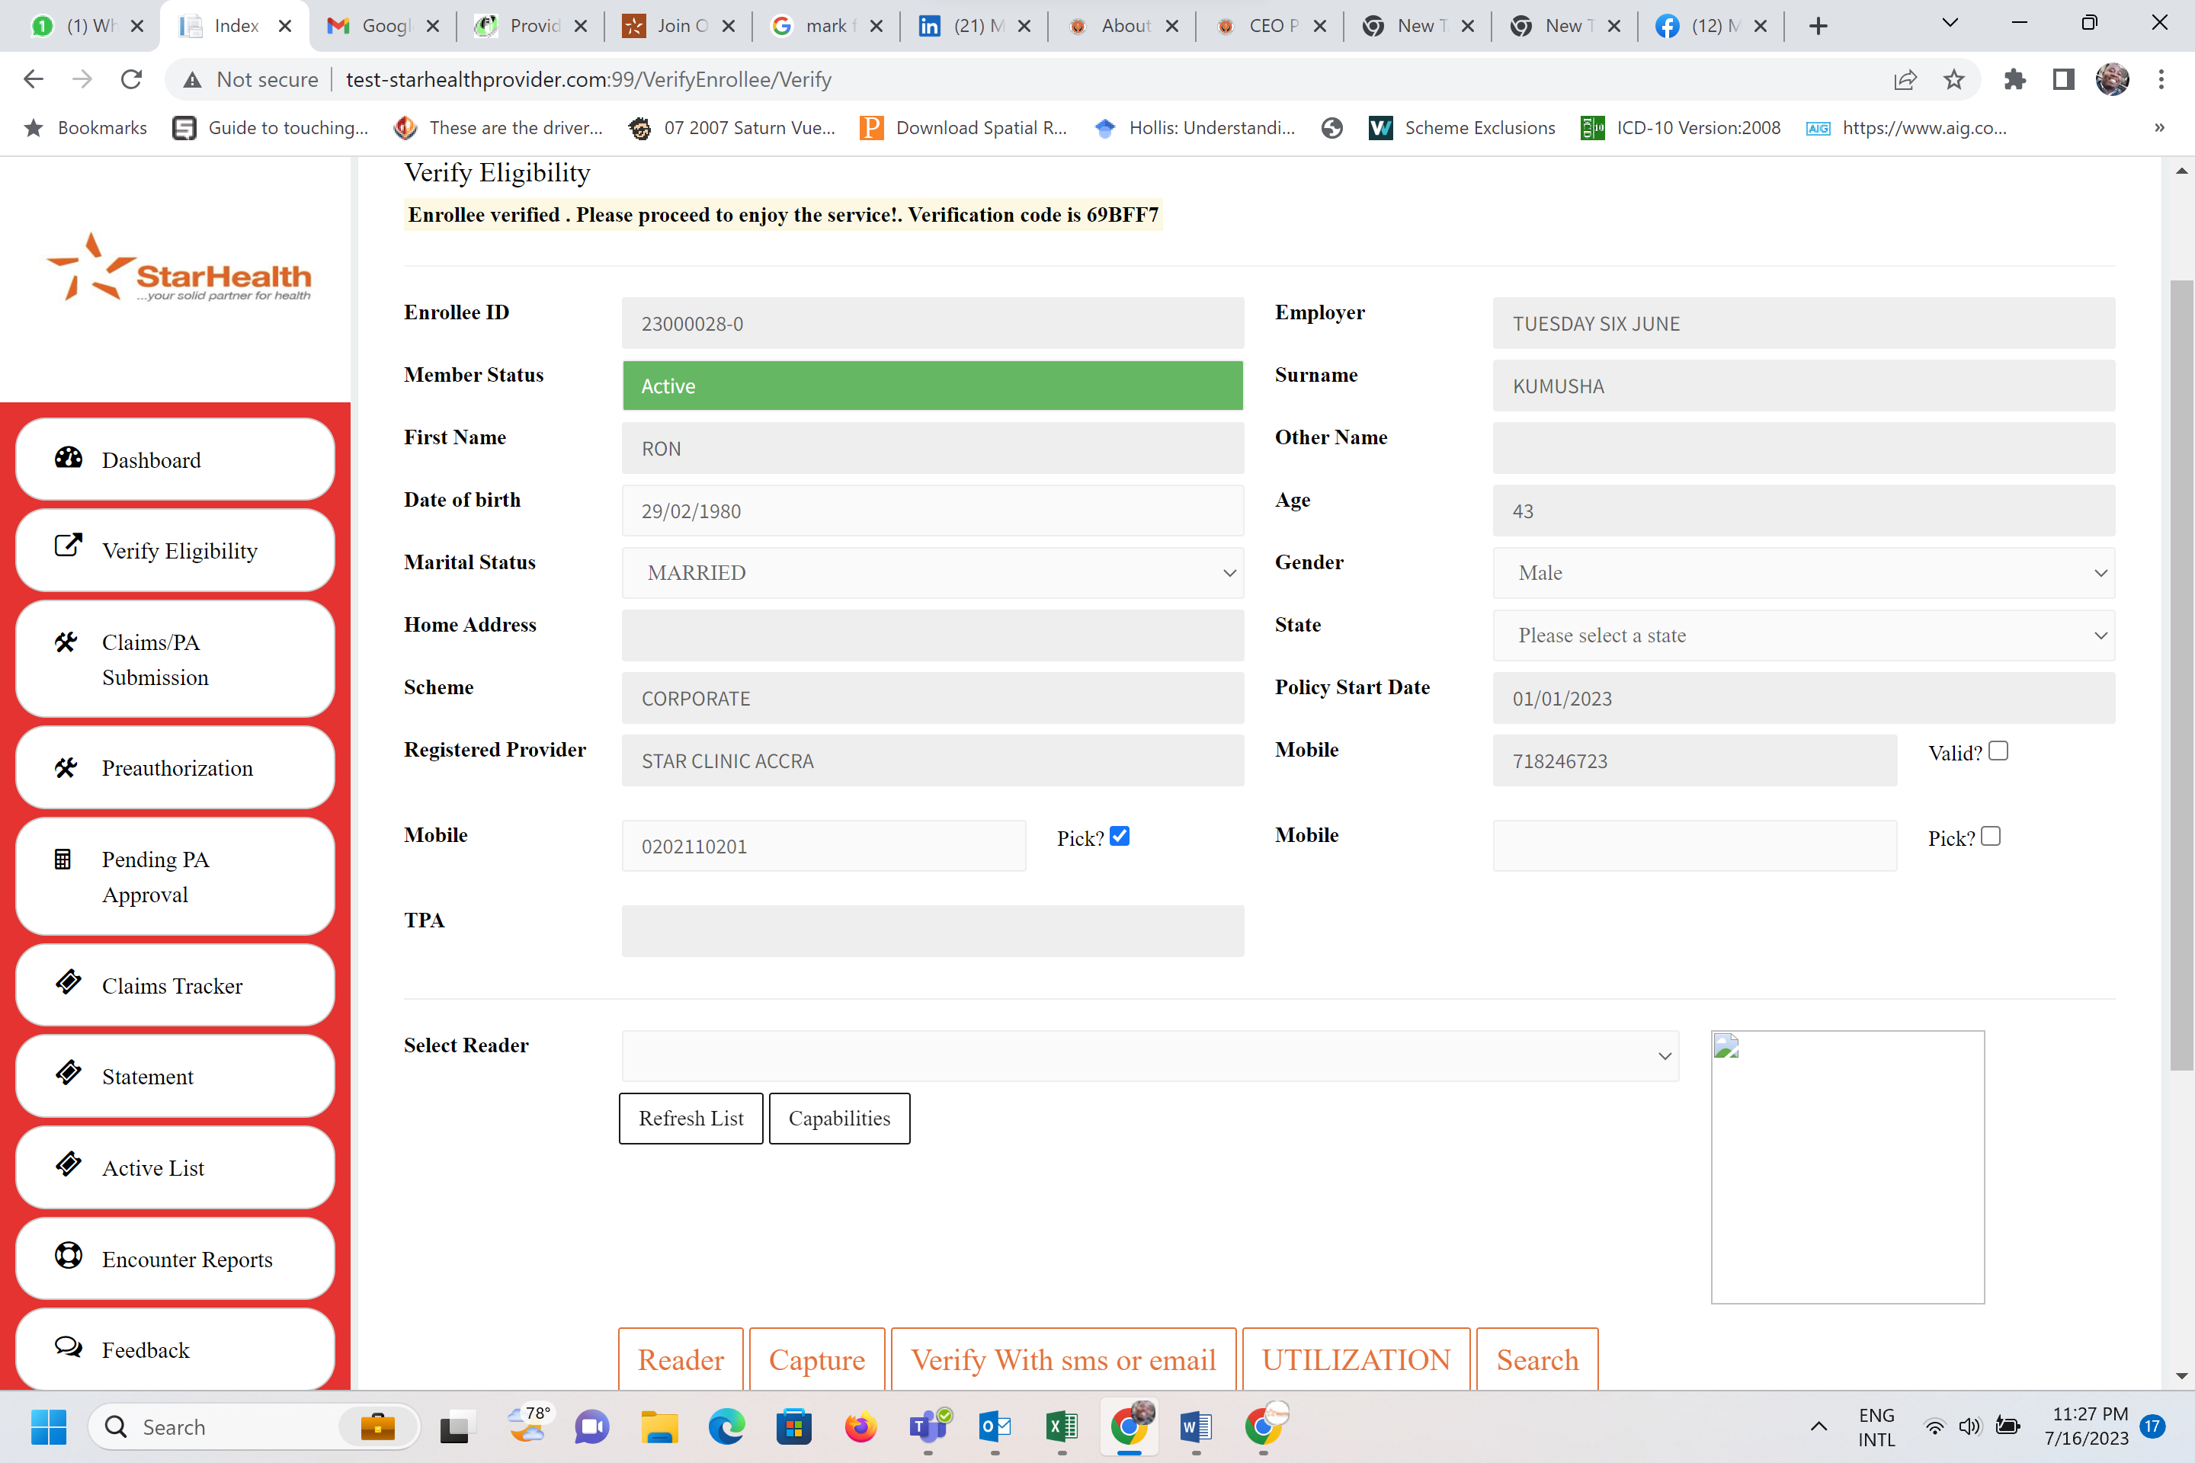

READER Tab – Delete it

**CAPTURE** Tab – Rename as **SCAN**

**UTILIZATION** Tab – Rename as **CAPTURE CLAIMS & VITALS**

**TARIFF**

Share Uploaded Ghana Tariff in Excel. Can we customize this per provider?