 Surigao State College of Technology

Narciso Street, Surigao City

FINAL PROJECT FOR ITE 211 – DATA STRUCTURES AND ALGORITHMS

By: Pakilit, Marc Lojane Yngwie, P.

BSIS 2A

ARRAY:

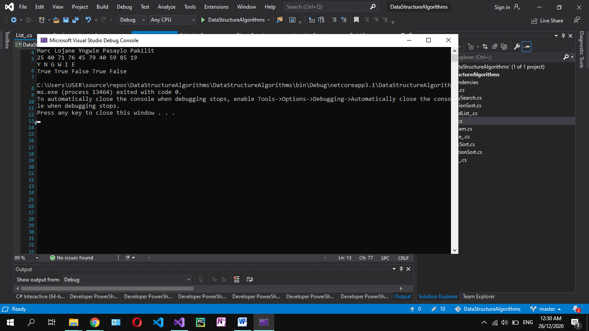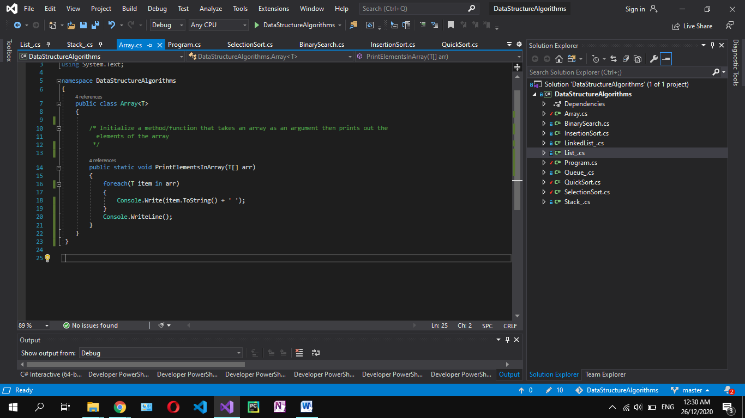Problem: Flowchart: Algorithm: Code: An output:

Initialize a method/function that takes an array as an argument then prints out the elements of the array

Create a generic class named Array. Then create a function called PrintElementsInArray that will take an array as an argument. Then use a foreach loop to the array and in each loop print each element in array and concatenate it with empty space. Lastly, print a new line to the console.

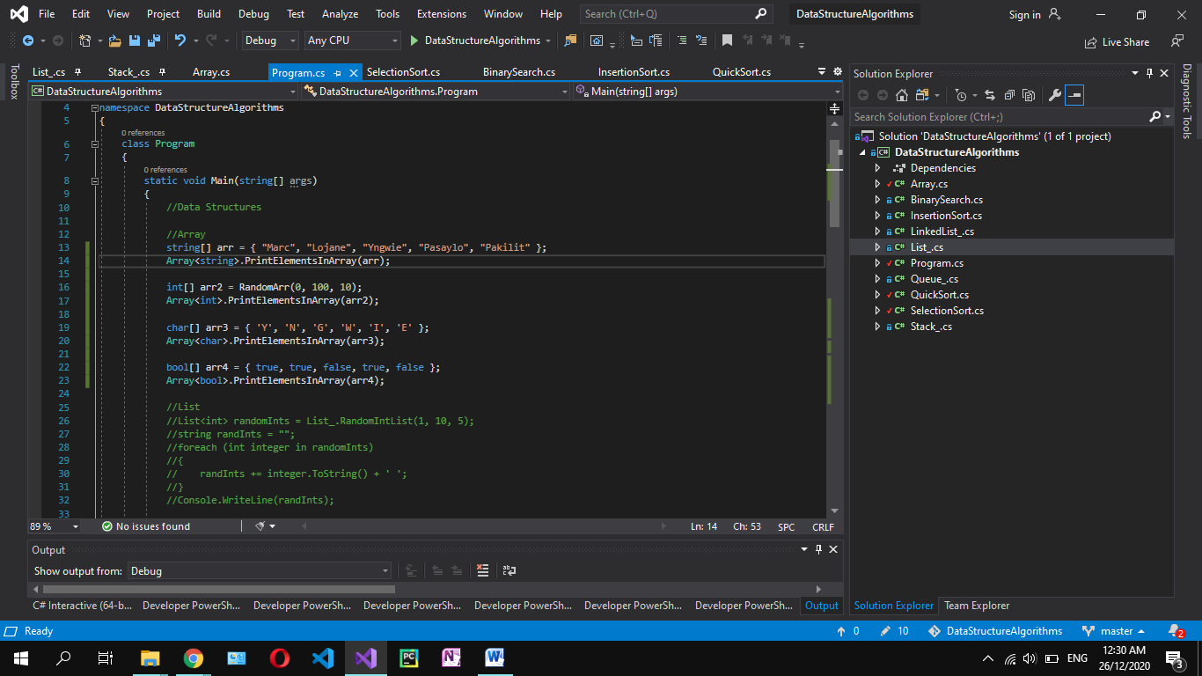

For Testing: