Space-Time Complexity Graph
Space-Time Complexity measures how the resource usage of an algorithm changes with the size of the input. It focuses on two primary resources:
- Time Complexity: How the runtime grows as the input size increases.
- Space Complexity: How the memory usage grows as the input size increases.

Components of the Graph
- X-Axis (Input Size): Represents the size of the input data (e.g., number of elements in an array).
- Y-Axis (Resource Usage): Represents the resource consumed:
  - For Time Complexity: Execution time (seconds, milliseconds).
  - For Space Complexity: Memory used (kilobytes, megabytes).

Common Time and Space Complexities
The growth rates commonly visualized in such graphs are:
- Constant Time/Space: O(1)
- Logarithmic Time/Space: O(logn)
- Linear Time/Space: O(n)
- Linear Logarithmic Time/Space: O(nlogn)
- Quadratic Time/Space: O(n2)
- Exponential Time/Space: O(2n)
- Factorial Time/Space: O(n!)

Space-Time Complexity Graph Description
- Constant: Flat line indicating no change with input size.
- Logarithmic: Slopes upwards initially, but growth slows significantly as input increases.
- Linear: Straight line indicating a direct proportionality to input size.
- Quadratic or Higher: Steep curves showing rapid growth.
Let me generate the graph for you!
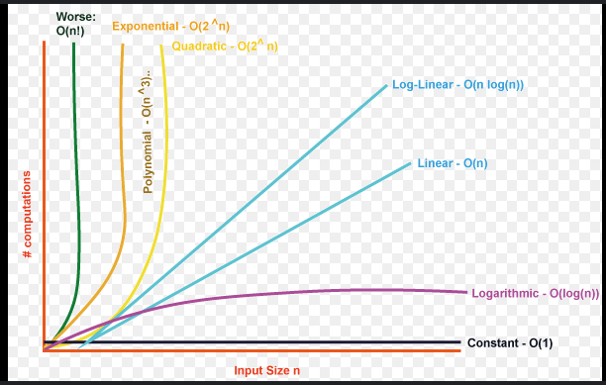
The graph above illustrates various space-time complexities and how they grow as the input size increases. Here's a breakdown:
- O(1) - Constant: Flat line; resource usage does not change with input size.
- O(log n) - Logarithmic: Slow growth; ideal for algorithms like binary search.
- O(n) - Linear: Directly proportional to input size; common for loops over input.
- O(n log n) - Linear Logarithmic: Moderate growth; typical for efficient sorting algorithms.
- O(n²) - Quadratic: Rapid growth; common in nested loops.
- O(2ⁿ) - Exponential: Explosive growth; typical for algorithms solving combinatorial problems (e.g., brute force).

