1、

## R code

> data<-read.csv(("ACTG175(speff2trial).txt"))

> Y<-Surv(data$days, data$cens==1)

> kmfit <- survfit(Y ~data$arms)

> plot(kmfit, xlab="survival time in days", ylab="survival probabilities", col=c("red","blue","green","orange"))

> legend("bottomleft", c("treatment 0","treatment 1","treatment 2","treatment 3"), lty="solid", col=c("red","blue","green","orange"))

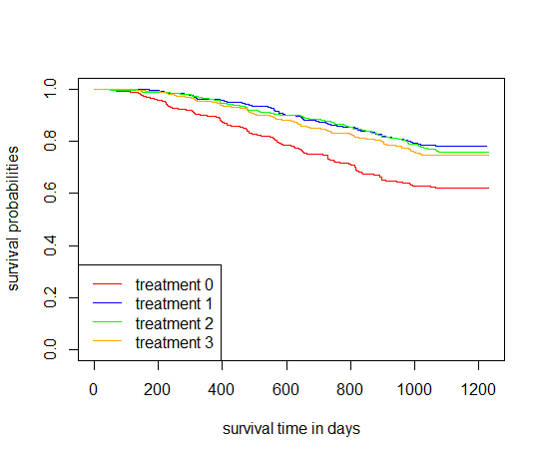

可以看出，treatment1，也即zidovudine and didanosine对于延长病人的生命最有帮助。

2、

四个组的生存曲线均在0.5以上，故Median survival time均不存在。

3、

## R code

> summary(kmfit, times=365)

得到如下结果

|  |  |  |  |
| --- | --- | --- | --- |
|  | survival function | lower 95% CI | upper 95% CI |
| treatment 0 | 0.895 | 0.869 | 0.921 |
| treatment 1 | 0.959 | 0.942 | 0.976 |
| treatment 2 | 0.961 | 0.944 | 0.978 |
| treatment 3 | 0.951 | 0.933 | 0.969 |

## R code

> summary(kmfit, times=730)

得到如下结果

|  |  |  |  |
| --- | --- | --- | --- |
|  | survival function | lower 95% CI | upper 95% CI |
| treatment 0 | 0.7322 | 0.6942 | 0.7722 |
| treatment 1 | 0.8650 | 0.8355 | 0.8957 |
| treatment 2 | 0.8752 | 0.8466 | 0.9048 |
| treatment 3 | 0.838 | 0.807 | 0.870 |

4、

