|  |  |  |  |
| --- | --- | --- | --- |
|  | Knn | 逻辑回归 | svm |
| accuracy | 0.8693 | 0.8806 | 0.8409 |
| auc_score | 0.7617 | 0.7863 | 0.6566 |

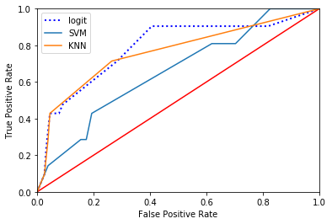

ROC 曲线