MATLAB作业二

- 试求出如下极限。
（1）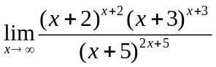，（2）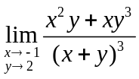， （3）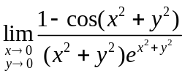
(1)
Code:
clc,clearvars;
syms x;
f = (x+2).^(x+2).*(x+3).^(x+3)./(x+5).^(2.*x+5);
limit(f,x,inf)

Result:
ans =

exp(-5)

(2)
Code:
clc,clearvars;
syms x y;
f = (x.^2.*y+x.*y.^3)/(x+y).^3;
limit((limit(f,x,-1)),y,2)

Result:
ans =

-6

(3)
Code:
clc,clearvars;
syms x y;
f = (1-cos(x.^2+y.^2))./((x.^2+y.^2).*exp(x.^2+y.^2));
limit(limit(f,x,0),y,0)

Result:
ans =

0

- 试求出下面函数的导数。
（1）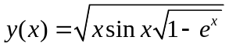, (2)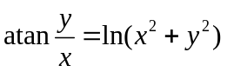
(1)
Code:
clc,clearvars;
syms x;
f = sqrt(x*sin(x)*sqrt(1-exp(x)));
simplify(diff(f),IgnoreAnalyticConstraints=true,Criterion="preferReal")

Result:
ans =

-(2*exp(x)*sin(x) - 2*sin(x) - 2*x*cos(x) + 2*x*exp(x)*cos(x) + x*exp(x)*sin(x))/(4*x^(1/2)*sin(x)^(1/2)*(1 - exp(x))^(3/4))
(2)
Code:
clc,clearvars;
syms x y;
f=log(x.^2+y.^2)-atan(y./x);
F = -diff(f,x)/diff(f,y);
simplify(F,"Criterion","preferReal")

Result:
ans =

(2*x + y)/(x - 2*y)

- 假设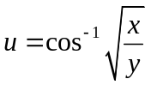，试验证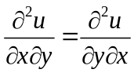。

Code:
clc,clearvars;

syms x y;
f(x,y) = cos(sqrt(x./y))^(-1);
f1 = diff(diff(f,x),y);
pretty(f1)
f2 = diff(diff(f,y),x);
pretty(f2)

Result:
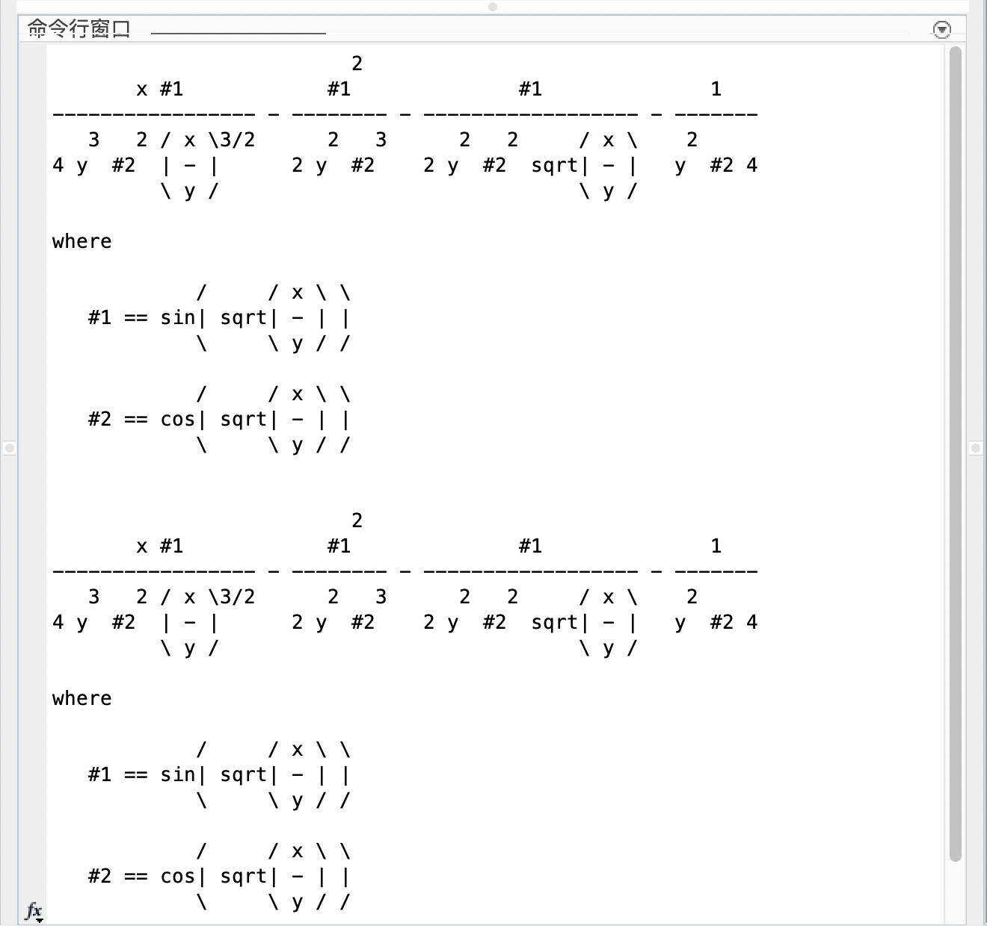
- 假设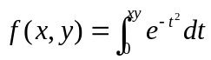，试求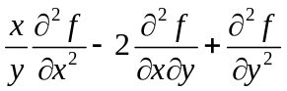。

Code:
clc,clearvars;
syms x y t;
f(x,y) = int(exp(-t.^2),t,0,x.*y);
f1 = (x./y).*diff(diff(f,x),x)-2*diff(diff(f,x),y)+diff(diff(f,y),y);
simplify(f1)

Result:

ans(x, y) =

-2*exp(-x^2*y^2)*(x^3*y - x^2*y^2 + 1)

- 假设已知函数矩阵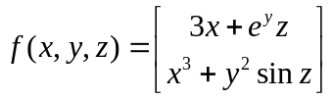，试求出其Jacobi矩阵。
Code:

clc,clearvars;
syms x y z;
F = [3*x+exp(y).*z;x.^3+y.^2.*sin(z)];
f = jacobian(F,[x,y,z]);
simplify(f)

Result:

ans =

[ 3, z*exp(y), exp(y)]
[3*x^2, 2*y*sin(z), y^2*cos(z)]

- 试求解下面的不定积分问题。
（1）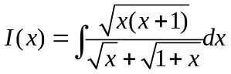， （2）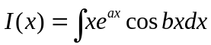

(1)
Code:
clc,clearvars;
syms x;
% 做一步变换，把分母变为 1
f = int((sqrt(x*(x+1)))*(sqrt(x+1)-sqrt(x)),x);
simplify(f)

Result:
ans =

(2*(x*(x + 1))^(1/2)*(x + 5*x^(3/2)*(x + 1)^(1/2) + 3*x^(5/2)*(x + 1)^(1/2) - 4*x^2 - 3*x^3 + 2))/(15*x^(1/2)*(x + 1))

(2)
Code:
clc,clearvars;
syms x a b;
f = int(x*exp(a*x)*cos(b*x),x);
simplify(f)

Result:
ans =

(exp(a*x)*(b^2*cos(b*x) - a^2*cos(b*x) + a^3*x*cos(b*x) + b^3*x*sin(b*x) - 2*a*b*sin(b*x) + a*b^2*x*cos(b*x) + a^2*b*x*sin(b*x)))/(a^2 + b^2)^2

7、试求解下面的定积分或无穷积分。
（1）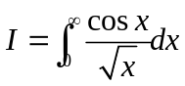， （2）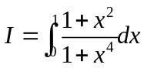

(1)
Code:
clc,clearvars;
syms x;
f = (cos(x))./sqrt(x);
I = simplify(int(f,x,0,inf));
I

Result:
I =

(2^(1/2)*pi^(1/2))/2

(2)
Code:
clc,clearvars;
syms x;
f = (1+x.^2)./(1+x.^4);
I = simplify(int(f,x,0,1));
I

Result:
I =

(pi*2^(1/2))/4

8、试对下面函数进行Fourier幂级数展开。
（1）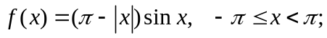 （2）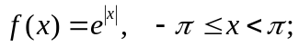

(1)
Code:
clc,clearvars;
syms x n;
f = (pi - abs(x))*sin(x);
[A,B,F] = fseries(f,x,6,-pi,pi);
A,
B,
F,

Result:
A =

[0, 0, 0, 0, 0, 0, 0]

B =

[pi/2, 16/(9*pi), 0, 32/(225*pi), 0, 48/(1225*pi)]

F =

(16*sin(2*x))/(9*pi) + (32*sin(4*x))/(225*pi) + (48*sin(6*x))/(1225*pi) + (pi*sin(x))/2

(2)
Code:
clc,clearvars;
syms x;
f = exp(abs(x));
[A,B,F]=fseries(f,x,6,-pi,pi);
A,B,F

Result:
A =

[(2*exp(pi) - 2)/pi, -(exp(pi) + 1)/pi, ((2*exp(pi))/5 - 2/5)/pi, -(exp(pi)/5 + 1/5)/pi, ((2*exp(pi))/17 - 2/17)/pi, -(exp(pi)/13 + 1/13)/pi, ((2*exp(pi))/37 - 2/37)/pi]

B =

[0, 0, 0, 0, 0, 0]

F =

(2*exp(pi) - 2)/(2*pi) - (cos(3*x)*(exp(pi)/5 + 1/5))/pi + (cos(2*x)*((2*exp(pi))/5 - 2/5))/pi - (cos(5*x)*(exp(pi)/13 + 1/13))/pi + (cos(4*x)*((2*exp(pi))/17 - 2/17))/pi + (cos(6*x)*((2*exp(pi))/37 - 2/37))/pi - (cos(x)*(exp(pi) + 1))/pi

9、试求出下面函数的Taylor幂级数展开。
（1）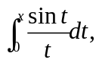 （2）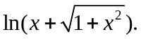（3）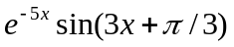分别关于、的幂级数展开。（4）对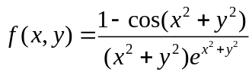关于、进行二维
Taylor幂级数展开。

(1)
Code:
clc,clearvars;
syms x t a;
f = int(sin(t)./t,t,0,x);
% 在 0 处展开 4 阶
taylor(f,x,0,'Order',4)
% 在 a 处展开 4 阶
taylor(f,x,a,'Order',4)

Result:
ans =

- x^3/18 + x

ans =

sinint(a) + (a - x)^3*(cos(a)/(3*a^2) + sin(a)/(6*a) - sin(a)/(3*a^3)) + (cos(a)/(2*a) - sin(a)/(2*a^2))*(a - x)^2 - (sin(a)*(a - x))/a

(2)
Code:
clc,clearvars;
syms x a;
f = log(x+sqrt(1+x^2));
% 在 0 处展开 4 阶
taylor(f,x,0,'Order',4)
% 在 a 处展开 4 阶
simplify(taylor(f,x,a,'Order',4))

Result:
ans =

- x^3/6 + x

ans =

-(6*a - 6*x - 6*log(a + (a^2 + 1)^(1/2))*(a^2 + 1)^(5/2) - 15*a^2*x - 18*a^4*x + 14*a^3 + 11*a^5 + x^3 - 2*a^2*x^3 + 9*a^3*x^2)/(6*(a^2 + 1)^(5/2))

(3)
Code:
clc,clearvars;
syms x a;
f = exp(-5*x)*sin(3*x+pi/3)
% 在 0 处展开 4 阶
taylor(f,x,0,'Order',4)
% 在 a 处展开 4 阶
simplify(taylor(f,x,a,'Order',4))

Result:
ans =

((5*3^(1/2))/6 + 33/2)*x^3 + (4*3^(1/2) - 15/2)*x^2 + (3/2 - (5*3^(1/2))/2)*x + 3^(1/2)/2

ans =

sin(3*a + pi/3)*exp(-5*a) - (a - x)^3*(33*cos(3*a + pi/3)*exp(-5*a) + (5*sin(3*a + pi/3)*exp(-5*a))/3) - (a - x)^2*(15*cos(3*a + pi/3)*exp(-5*a) - 8*sin(3*a + pi/3)*exp(-5*a)) - (a - x)*(3*cos(3*a + pi/3)*exp(-5*a) - 5*sin(3*a + pi/3)*exp(-5*a))

(4)
Code:
clc,clearvars;
syms x y;
f(x,y)=(1-cos(x^2+y^2))/((x^2+y^2)*exp(x^2+y^2));
simplify(taylor(f,[x,y],[1,0],'Order',3))

Result:
ans(x, y) =

(2*exp(-1)*sin(1) + 4*exp(-1)*(cos(1) - 1))*(x - 1) - (x - 1)^2*(8*exp(-1)*sin(1) - exp(-1)*(2*cos(1) + sin(1)) + 8*exp(-1)*(cos(1) - 1)) + y^2*(exp(-1)*sin(1) + 2*exp(-1)*(cos(1) - 1)) - exp(-1)*(cos(1) - 1)

10、求级数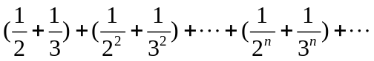的前项及无穷项的和。

Code:
clc,clearvars;
syms k n;
% 前 n 项的和
symsum((1/2).^k+(1/3).^k,k,1,n)
% 无穷项的和
symsum((1/2)^k+(1/3)^k,k,1,inf)

Result:
ans =

3/2 - (1/3)^n/2 - (1/2)^n

ans =

3/2

11、试求出下面的极限。
（1）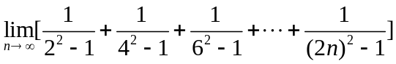，
（2）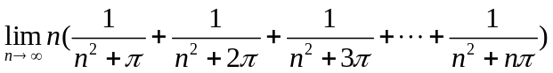。
(1)
Code:
clc,clearvars;
syms k;
symsum(1/((2*k)^2-1),k,1,inf)

Result:
ans =

1/2

(2)
Code:
clc,clearvars;
syms n k;
f = symsum(1/(n+(k*pi)/n),k,1,n)
limit(f,n,inf)

Result:
f =

(n*psi(n^2/pi + n + 1))/pi - (n*psi(n^2/pi + 1))/pi

ans =

1

