MATLAB作业5

- 试求出下面线性微分方程的通解。
假设上述微分方程满足已知条件，试求出满足该条件的微分方程的解析解。
Code:
clc,clearvars;
syms t y;
y=dsolve(['D5y+13*D4y+64*D3y+152*D2y+176*Dy+80*y=','exp(-2*t)*(sin(2*t+pi/3)+cos(3*t))'],'y(0)=1', ...
'y(1)=3','y(pi)=2','Dy(0)=1','Dy(1)=2');
vpa(y,10)

Result:
59.4050449*t^3*exp(-2.0*t) + exp(-5.0*t)*(31.7321521 + 8.997059016e-18i) + t*exp(-2.0*t)*(98.15920606 - 2.435153428e-19i) - t^2*exp(-2.0*t)*(106.2442261 - 5.551115123e-17i) - 30.74189278*exp(-2.0*t) + 0.0001582779361*exp(-2.0*t)*(18.0*sin(2.0*t + 1.047197551) - 12.0*cos(2.0*t + 1.047197551) + 13.0*cos(3.0*t) + 13.0*sin(3.0*t)) - 1.0*exp(-2.0*t)*(exp(-t*2.0i)*(- t^3*(0.006944444444 - 0.01202813061i) + t^2*(0.01109775147 + 0.02244479727i) + t*(0.01781516765 - 0.003078997729i) - (0.003082708741 + 0.00623466591i)) + exp(t*2.0i)*(- t^3*(0.006944444444 + 0.01202813061i) + t^2*(0.01109775147 - 0.02244479727i) + t*(0.01781516765 + 0.003078997729i) - (0.003082708741 - 0.00623466591i)) + exp(-t*3.0i)*(t^3*0.009259259259i + t^2*(0.009259259259 + 0.009259259259i) + 0.006172839506*t) + exp(t*3.0i)*(- t^3*0.009259259259i + t^2*(0.009259259259 - 0.009259259259i) + 0.006172839506*t)) - 1.0*t^3*exp(-2.0*t)*(0.02777777778*cos(2.0*t + 1.047197551) - 0.01851851852*sin(3.0*t)) - 1.0*t^2*exp(-2.0*t)*(0.04166666667*sin(2.0*t + 1.047197551) - 0.02777777778*cos(2.0*t + 1.047197551) + 0.01851851852*cos(3.0*t) + 0.01851851852*sin(3.0*t) + 0.05555555556*t*sin(3.0*t) - 0.08333333333*t*cos(2.0*t + 1.047197551)) + t*exp(-2.0*t)*(0.02314814815*cos(2.0*t + 1.047197551) + 0.02777777778*sin(2.0*t + 1.047197551) + 0.01234567901*cos(3.0*t) - 0.08333333333*t^2*cos(2.0*t + 1.047197551) + 0.03703703704*t*cos(3.0*t) + 0.03703703704*t*sin(3.0*t) + 0.05555555556*t^2*sin(3.0*t) - 0.05555555556*t*cos(2.0*t + 1.047197551) + 0.08333333333*t*sin(2.0*t + 1.047197551))

- 试求解下面微分方程的通解以及满足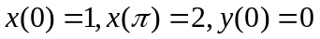条件下的解析解。
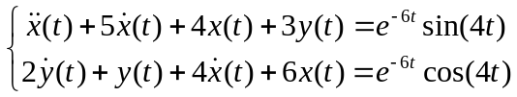
Code:
clc,clearvars;
syms x y t;
[x,y]=dsolve('D2x(t)+5*Dx(t)+4*x(t)+3*y(t)=exp(-6*t)*sin(4*t)', ...
'2*Dy(t)+y(t)+4*Dx(t)+6*x(t)=exp(-6*t)*cos(4*t)','x(0)=1','x(pi)=2','y(0)=0');
x = vpa(x,10),y = vpa(y,10)

Result:
x =

exp(t)*(0.001591511936*exp(-7.0*t)*(3.0*cos(4.0*t) - 11.0*sin(4.0*t)) + 0.08586166859) - 0.1946487702*exp(-5.137458609*t)*(0.02648644598*exp(-0.8625413912*t)*sin(4.0*t) - 0.2627938358*exp(-0.8625413912*t)*cos(4.0*t) + 0.2962181024) + 0.7339226584*exp(-1.362541391*t)*(0.008146889645*exp(-4.637458609*t)*sin(4.0*t) - 0.0423897067*exp(-4.637458609*t)*cos(4.0*t) + 1.290300202)

y =

0.3053512298*exp(-5.137458609*t)*(0.02648644598*exp(-0.8625413912*t)*sin(4.0*t) - 0.2627938358*exp(-0.8625413912*t)*cos(4.0*t) + 0.2962181024) - 3.333333333*exp(t)*(0.001591511936*exp(-7.0*t)*(3.0*cos(4.0*t) - 11.0*sin(4.0*t)) + 0.08586166859) + 0.2339226584*exp(-1.362541391*t)*(0.008146889645*exp(-4.637458609*t)*sin(4.0*t) - 0.0423897067*exp(-4.637458609*t)*cos(4.0*t) + 1.290300202)

- 试求出微分方程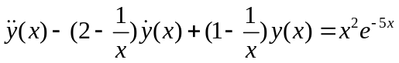的解析解通解，并求出满足边界条件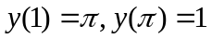的解析解。
Code:
clc,clearvars;
syms y x;
% 通解
y = dsolve('D2y-(2-1/x)*Dy+(1-1/x)*y=x^2*exp(-5*x)','x')
% 满足边界条件的解
y1 = dsolve('D2y-(2-1/x)*Dy+(1-1/x)*y=x^2*exp(-5*x)','y(1)=pi','y(pi)=1','x')

Result:
通解：
y =

C1*exp(x) + (exp(-5*x)*(30*x + 6*log(x) + 108*x^2*log(x) + 216*x^3*log(x) - 6*ei(-6*x)*exp(6*x) + 36*x*log(x) + 36*x^2 + 11))/1296 - (exp(-5*x)*log(x)*(216*x^3 + 108*x^2 + 36*x + 6))/1296 + C2*exp(x)*log(x)

满足边界条件的解：
y1 =

(exp(-5*x)*(30*x + 6*log(x) + 108*x^2*log(x) + 216*x^3*log(x) - 6*ei(-6*x)*exp(6*x) + 36*x*log(x) + 36*x^2 + 11))/1296 + (exp(-6)*exp(x)*(6*ei(-6)*exp(6) + 1296*pi*exp(5) - 77))/1296 - (exp(-5*x)*log(x)*(216*x^3 + 108*x^2 + 36*x + 6))/1296 - (exp(-6*pi)*exp(-6)*exp(x)*log(x)*(11*exp(6) - 77*exp(6*pi) + 30*pi*exp(6) + 36*pi^2*exp(6) - 1296*exp(5*pi)*exp(6) + 6*ei(-6)*exp(6*pi)*exp(6) + 1296*pi*exp(6*pi)*exp(5) - 6*exp(6*pi)*exp(6)*ei(-6*pi)))/(1296*log(pi))

- Lotka-Volterra扑食模型方程为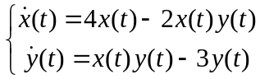，且初值为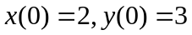，试求解该微分方程，并绘制相应的曲线。
Code:
clc;clearvars;
x0=[2;3];
t_final = 100;
[t,x]=ode45('Lotka_Volterra',[0,t_final],x0);
plot(x(:,1),x(:,2))

function func1=Lotka_Volterra(t,x)
func1 = [4*x(1)-2*x(1)*x(2);x(1)*x(2)-3*x(2)];
end

Result:
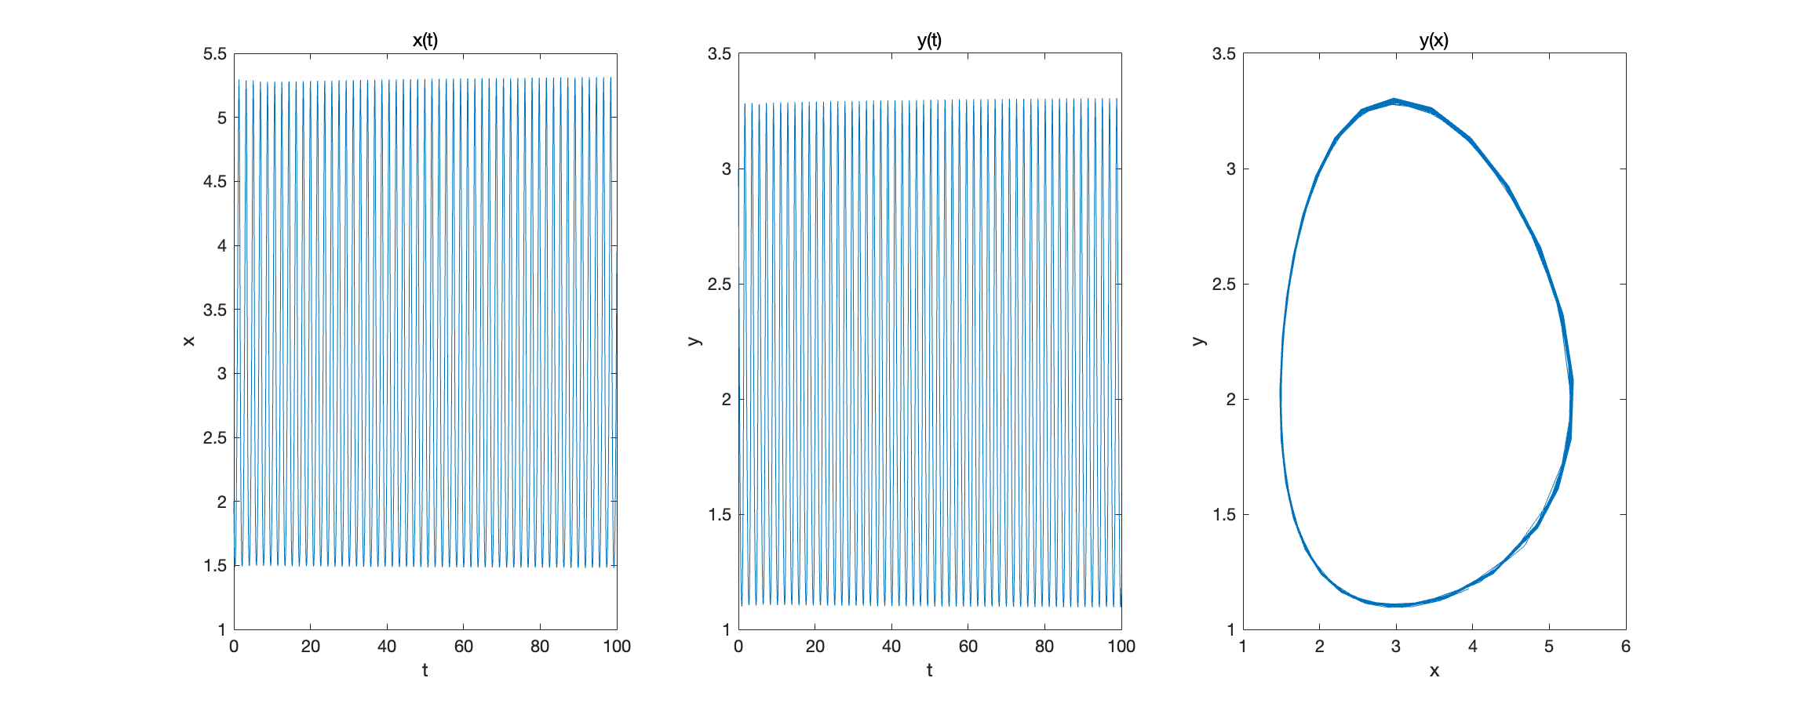
- 是给出求解下面微分方程的MATLAB命令，
并绘制出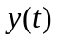曲线。试问该方程存在解析解吗？选择四阶定步长Runge-Kutta算法求解该方程时，步长选择多少可以得出较好的精度，MATLAB语言给出的现成函数在速度、精度上进行比较。
Code:
clc,clearvars;
syms y t;
y = dsolve('D3y+t*y*D2y+t^2*Dy*y^2=exp(-t*y)','y(0)=2','Dy(0)=0','D2y(0)=0');
t_final=100;
x0 = [2;0;0];
tic;
[t,x] = ode45('eq1',[0,t_final],x0);
time1 = toc
subplot(1,2,1)
plot(t,x(:,1))
title("Ode45算法")
tspan=0:0.01:10;
tic;
[t2,x2]=rk_4('eq1',tspan,x0);
time2 = toc
subplot(1,2,2)
plot(t2,x2(:,1))
title("四阶定步长Runge-Kutta算法,0:0.1:100")

Result:

Unable to find symbolic solution.

Ode45:
time1 =

0.0560

四阶定步长Runge-Kutta算法,0:0.1:100:
time2 =

0.7590

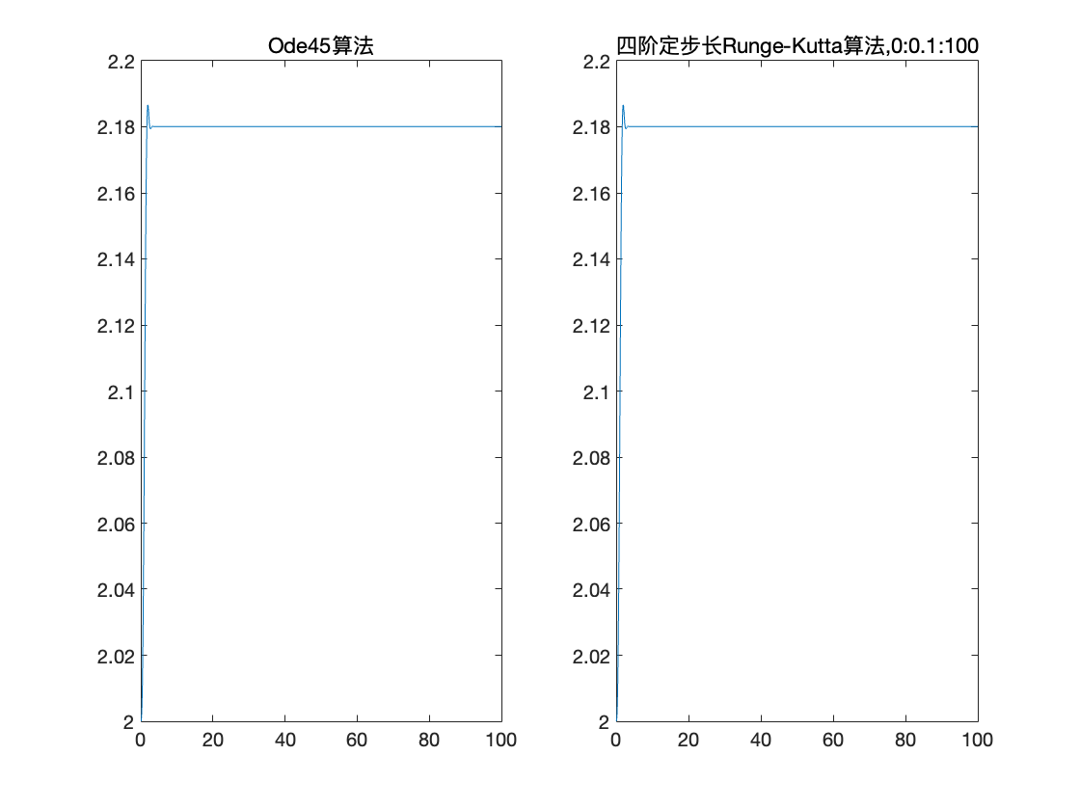
- 试用解析解和数值解的方法求解下面的微分方程组
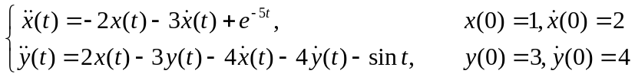

Code:
clc,clearvars;
%解析解
syms x y t;
[x,y] = dsolve('D2x(t)=-2*x(t)-3*Dx(t)+exp(-5*t)','D2y(t)=2*x(t)-3*y(t)-4*Dx(t)-4*Dy(t)-sin(t)' ...
,'x(0)=1','Dx(0)=2','y(0)=3','Dy(0)=4')
% 数值解：
x0 = [1;2;3;4];
t_final=100;
[t,x] = ode45('eq2',[0,t_final],x0);
subplot(1,2,1)
plot(x(:,1),x(:,3))
xlabel("x")
ylabel("y")
title("数值解")
f1 = @(t) exp(-2*t).*(exp(-3*t)/3 - 10/3) - 2*exp(-t).*(exp(-4*t)/8 - 17/8);
f2 = @(t) (8*exp(-t) - 6.*t.*exp(-t)).*(exp(-4*t)/8 - 17/8) - 10*exp(-2*t).*(exp(-3*t)/3 - 10/3) - 2*exp(-3*t).*((exp(3*t).*(cos(t) - 3*sin(t)))/40 - (7*exp(-2*t))/8 + 71/10) + 6*exp(-t).*((exp(t).*((13*exp(-5*t))/8 + cos(t)/2 - sin(t)/2 + (3.*t.*exp(-5*t))/2))/12 + 7/96);
x1 = f1(t);
y1 = f2(t);
subplot(1,2,2)
plot(x1,y1)
xlabel("x")
ylabel("y")
title("解析解")

function y1 = eq2(t,x)
y1 = [x(2);-2*x(1)-3*x(2)+exp(-5*t);x(4);2*x(1)-3*x(3)-4*x(2)-4*x(4)-sin(t)];
end

Result:
x =
exp(-2*t)*(exp(-3*t)/3 - 10/3) - 2*exp(-t)*(exp(-4*t)/8 - 17/8)

y =
(8*exp(-t) - 6*t*exp(-t))*(exp(-4*t)/8 - 17/8) - 10*exp(-2*t)*(exp(-3*t)/3 - 10/3) - 2*exp(-3*t)*((exp(3*t)*(cos(t) - 3*sin(t)))/40 - (7*exp(-2*t))/8 + 71/10) + 6*exp(-t)*((exp(t)*((13*exp(-5*t))/8 + cos(t)/2 - sin(t)/2 + (3*t*exp(-5*t))/2))/12 + 7/96)
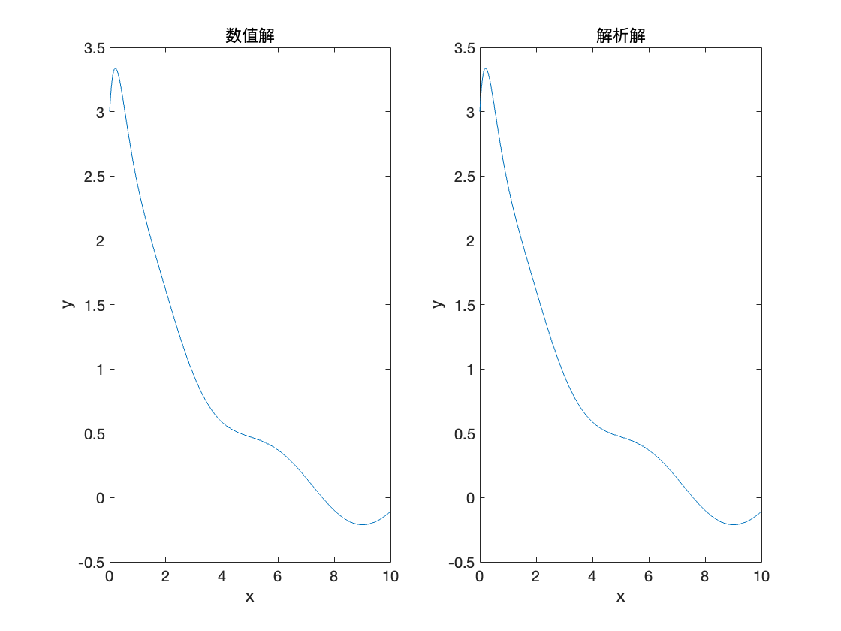
- 下面的方程在传统微分方程教程中经常被认为是刚性微分方程。使用常规微分方程解法和刚性微分方程解法分别求解这两个微分方程的数值解，并求出解析解，用状态变量曲线比较数值求解的精度。
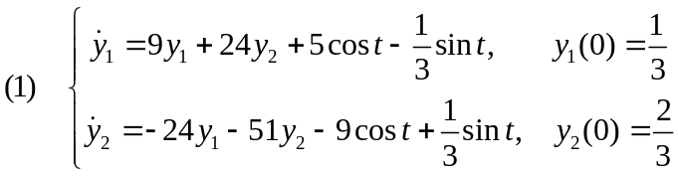
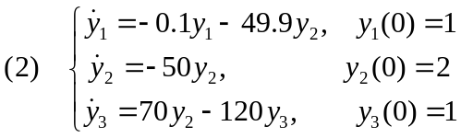
Code:
(1)
clc,clearvars;
% 解析解
syms y1 y2 t;
[y1,y2] = dsolve('Dy1(t)=9*y1+24*y2+5*cos(t)-1/3*sin(t)','Dy2(t)=-24*y1(t)-51*y2(t)-9*cos(t)+1/3*sint(t)', ...
'y1(0)=1/3','y2(0)=2/3')

% 常规微分方程解法
t_final =10;
x0 = [1/3;2/3];
[t,x] = ode45('eq3',[0,t_final],x0);
% 刚性微分方程解法
[t2,x2] = ode15s('eq3',[0,t_final],x0);
subplot(2,2,1)
plot(t,x)
xlabel("t")
ylabel("y1,y2")
legend('y1','y2')
title("ode45")
subplot(2,2,2)
plot(x(:,1),x(:,2))
title('ode45')
xlabel('y1')
ylabel('y2')
subplot(2,2,3)
plot(t2,x2)
xlabel("t")
ylabel("y1,y2")
legend('y1','y2')
title("ode15s")
subplot(2,2,4)
plot(x2(:,1),x2(:,2))
title('ode15s')
xlabel('y1')
ylabel('y2')

function y3=eq3(t,x)
y3 = [9*x(1)+24*x(2)+5*cos(t)-sin(t)/3;-24*x(1)-51*x(2)-9*cos(t)+sin(t)/3];
end
(2)
function y = eq4(t,x)
y = [-0.1*x(1)-49.9*x(2);-50*x(2);70*x(2)-120*x(3)];
end

clc,clearvars;
syms y1 y2 y3 t s;
% 解析解
[y1,y2,y3] = dsolve('Dy1=-0.1*y1-49.9*y2','Dy2=-50*y2','Dy3=70*y2-120*y3','y1(0)=1', ...
'y2(0)=2','y3(0)=1')

f1= @(s) 2*exp(-50*s) - exp(-s/10);
f2= @(s) 2*exp(-50*s);
f3= @(s) 2*exp(-50*s) - exp(-120*s);
%普通数值解
x0 = [1;2;1];
t_final =10;
[t,x] = ode45('eq4',[0,t_final],x0);

%刚性数值解
[t2,x2] = ode15s('eq4',[0,t_final],x0);
subplot(2,2,2)
plot3(x(:,1),x(:,2),x(:,3))
title("ode45解")
subplot(2,2,1)
plot3(f1(t),f2(t),f3(t))
title("精确解")
subplot(2,2,3)
plot3(f1(t2),f2(t2),f3(t2))
title("精确解")
subplot(2,2,4)
plot3(x2(:,1),x2(:,2),x2(:,3))
title("ode15s解")

Result:
(1)
解析解：
y1 =

9*t*y1 + 24*t*y2 + (2*cos(t/2)^2)/3 + 10*cos(t/2)*sin(t/2) - 1/3

y2 =

exp(-51*t)*(int((exp(51*x)*(216*y1 + 576*y2 - 339*cos(x) - 8*sin(x) + 17*sint(x)))/51, x, 0, t, 'IgnoreSpecialCases', true, 'IgnoreAnalyticConstraints', true) + 14/17) - (72*t*y1)/17 - (192*t*y2)/17 - (16*cos(t/2)^2)/51 - (80*cos(t/2)*sin(t/2))/17 + 8/51

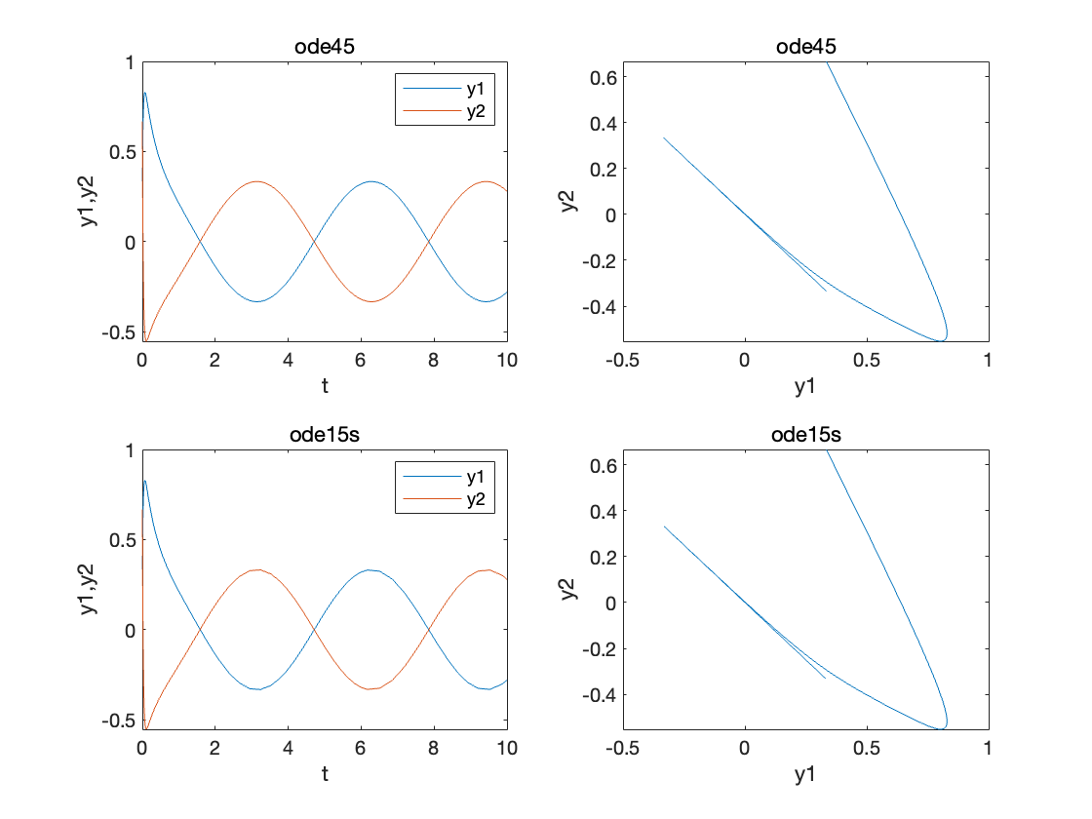
(2)
解析解：
y1 =

2*exp(-50*t) - exp(-t/10)

y2 =

2*exp(-50*t)

y3 =

2*exp(-50*t) - exp(-120*t)
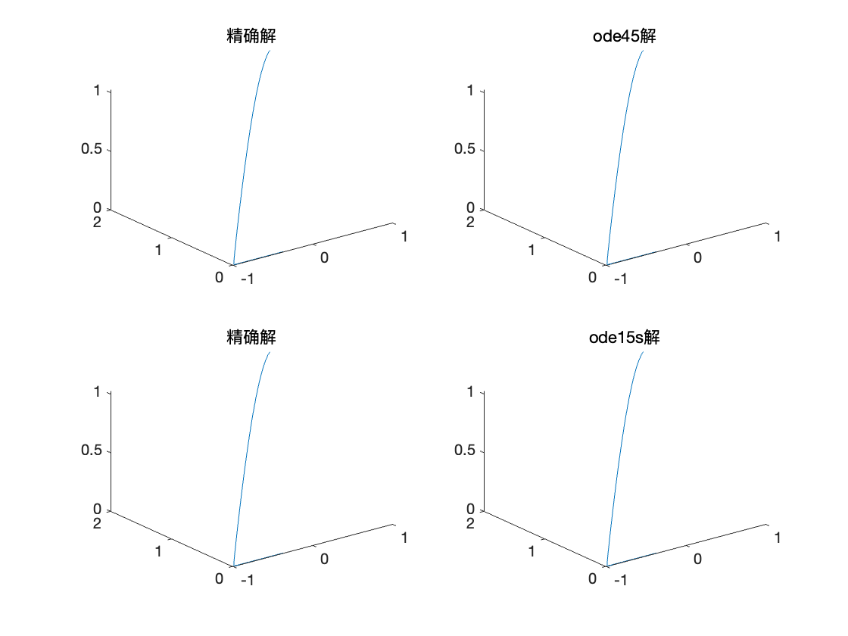

- 试求出习题3中给出的微分方程边值问题数值解， 绘制出曲线，并和该习题得出的解析解比较精度。
Code:
clc,clearvars;
syms y x;
f = dsolve('D2y-(2-1/x)*Dy+(1-1/x)*y=x^2*exp(-5*x)','y(1)=pi','y(pi)=1','x')

% 数值解
[t,y]=shooting('eq51','eq52',[1,pi],[pi,1]);
plot(t,y)

vpa(norm(y(:,1)-vpa(subs(f,x,t))))

function y = eq52(t,x)
y=[x(2);t^2*exp(-5*t)+(2-1/t)*x(2)-(1-1/t)*x(1)];
end

function y=eq51(t,x)
y=[x(2);-(1-1/t)*x(1)+(2-1/t)*x(2)];
end

Result:
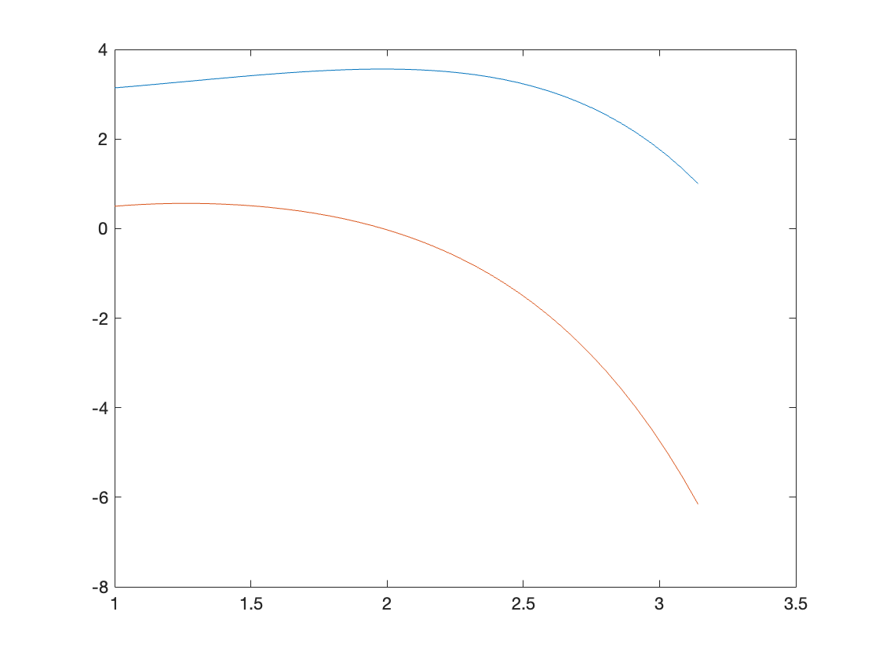
误差：
0.0000065198624

- 试用数值方法求解偏微分方程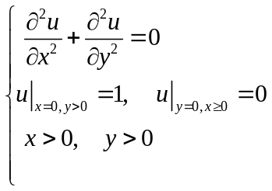，并绘制出函数曲面。

