MATLAB作业4

- 用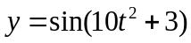在（0，3）区间内生成一组较稀疏的数据，并用一维数据插值的方法对给出的数据进行曲线拟合，并将结果与理论曲线相比较。
Code:
clc,clearvars;
% 生成等距的 50 个点
t = linspace(0,3,50);
y = sin(10*t.^2+3);
ti = linspace(0,3,1000);
% 使用一维数据进行差值
yi = interp1(t,y,ti);
ys = sin(10*ti.^2+3);
%画出精确值
plot(ti,yi,'b--',ti,ys,'r-');
legend("interp1","sin(10t^2+3)")
Result:
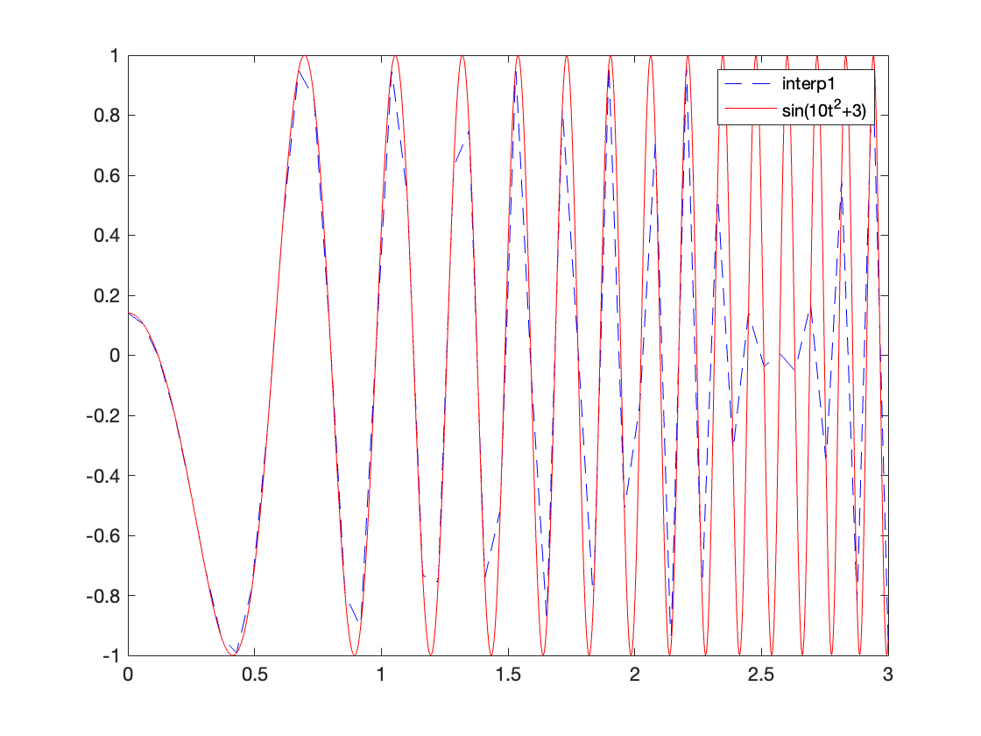

- 用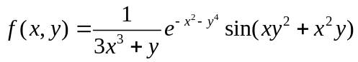原型函数生成一组网络数据或随机数据，分别拟合出曲面，并和原曲面进行比较。

Code:

clc,clearvars;
% 定义函数
f= @(x,y) (1./(3*x.^3+y)).*exp(-x.^2-y.^4).*sin(x.*y.^2+x.^2.*y);
% 生成等距网格点
[x,y]=meshgrid(0.2:0.2:2);
z = f(x,y);
% 插值
[xe,ye] = meshgrid(0.2:0.02:2);
ze = interp2(x,y,z,xe,ye,"spline");
% 真实值
z2 = f(xe,ye);
% 画出等距插值得到的曲面
subplot(2,2,1)
mesh(xe,ye,ze);
title("等距网格插值")
% 画出误差
subplot(2,2,3)
mesh(xe,ye,abs(ze-z2))
title("与真实值的误差")
% 生成随机网格点
x3 = 4*(rand(1,91))-2;
y3 = 4*(rand(1,91))-2;
z3 = f(x3,y3);
% 插值
ze2 = griddata(x3,y3,z3,xe,ye,"v4");
% 画出随机差值得到的曲面
subplot(2,2,2);
mesh(xe,ye,ze2);
title("随机网格差值");
% 画出误差
subplot(2,2,4)
mesh(xe,ye,abs(ze2-z2))
title("与真实值的误差")

Result:
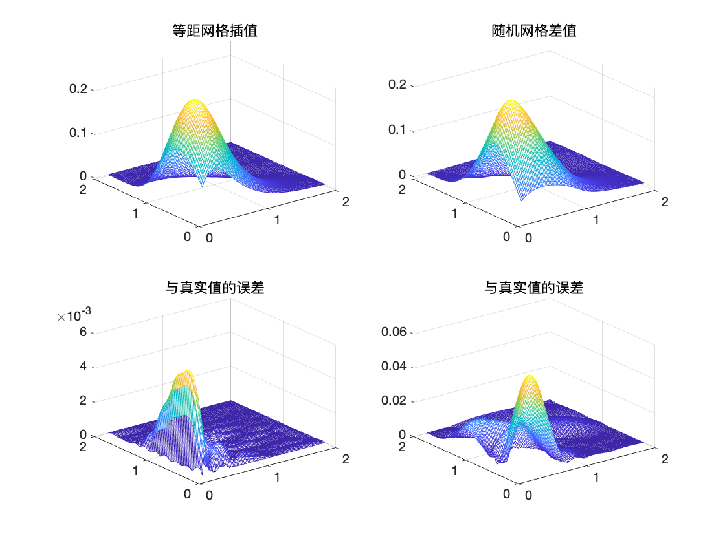

- 假设已知一组数据，试用插值方法绘制出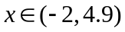区间内的光滑函数曲线，比较各种插值算法的优劣。
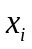 | -2 | -1.7 | -1.4 | -1.1 | -0.8 | -0.5 | -0.2 | 0.1 | 0.4 | 0.7 | 1 | 1.3
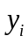 | .10289 | .11741 | .13158 | .14483 | .15656 | .16622 | .17332 | .1775 | .17853 | .17635 | .17109 | .16302
 | 1.6 | 1.9 | 2.2 | 2.5 | 2.8 | 3.1 | 3.4 | 3.7 | 4 | 4.3 | 4.6 | 4.9
 | .15255 | .1402 | .12655 | .11219 | .09768 | .08353 | .07015 | .05786 | .04687 | .03729 | .02914 | .02236

>> x=[-2,-1.7,-1.4,-1.1,-0.8,-0.5,-0.2,0.1,0.4,0.7,1,1.3,...
1.6,1.9,2.2,2.5,2.8,3.1,3.4,3.7,4,4.3,4.6,4.9];
y=[0.10289,0.11741,0.13158,0.14483,0.15656,0.16622,0.17332,...
0.1775,0.17853,0.17635,0.17109,0.16302,0.15255,0.1402,...
0.12655,0.11219,0.09768,0.08353,0.07019,0.05786,0.04687,...
0.03729,0.02914,0.02236];

Code:
clc,clearvars;
x=[-2,-1.7,-1.4,-1.1,-0.8,-0.5,-0.2,0.1,0.4,0.7,1,1.3,...
1.6,1.9,2.2,2.5,2.8,3.1,3.4,3.7,4,4.3,4.6,4.9];

y=[0.10289,0.11741,0.13158,0.14483,0.15656,0.16622,0.17332,...
0.1775,0.17853,0.17635,0.17109,0.16302,0.15255,0.1402,...
0.12655,0.11219,0.09768,0.08353,0.07019,0.05786,0.04687,...
0.03729,0.02914,0.02236];

n=15;
xi = linspace(-2,4.9,n);
% 真实数据点
subplot(1,3,1)
scatter(x,y);
title("真实数据点")
% 一维数据差值
subplot(1,3,2)
yi1 = interp1(x,y,xi);
plot(xi, yi1,'b');
title("一维数据差值");
hold on;
scatter(x,y);
% Lagrange插值
yi2 = lagrange(x,y,xi);
subplot(1,3,3)
plot(xi,yi2,'b');
title("Lagrange 插值");
hold on;
scatter(x,y);
Result:
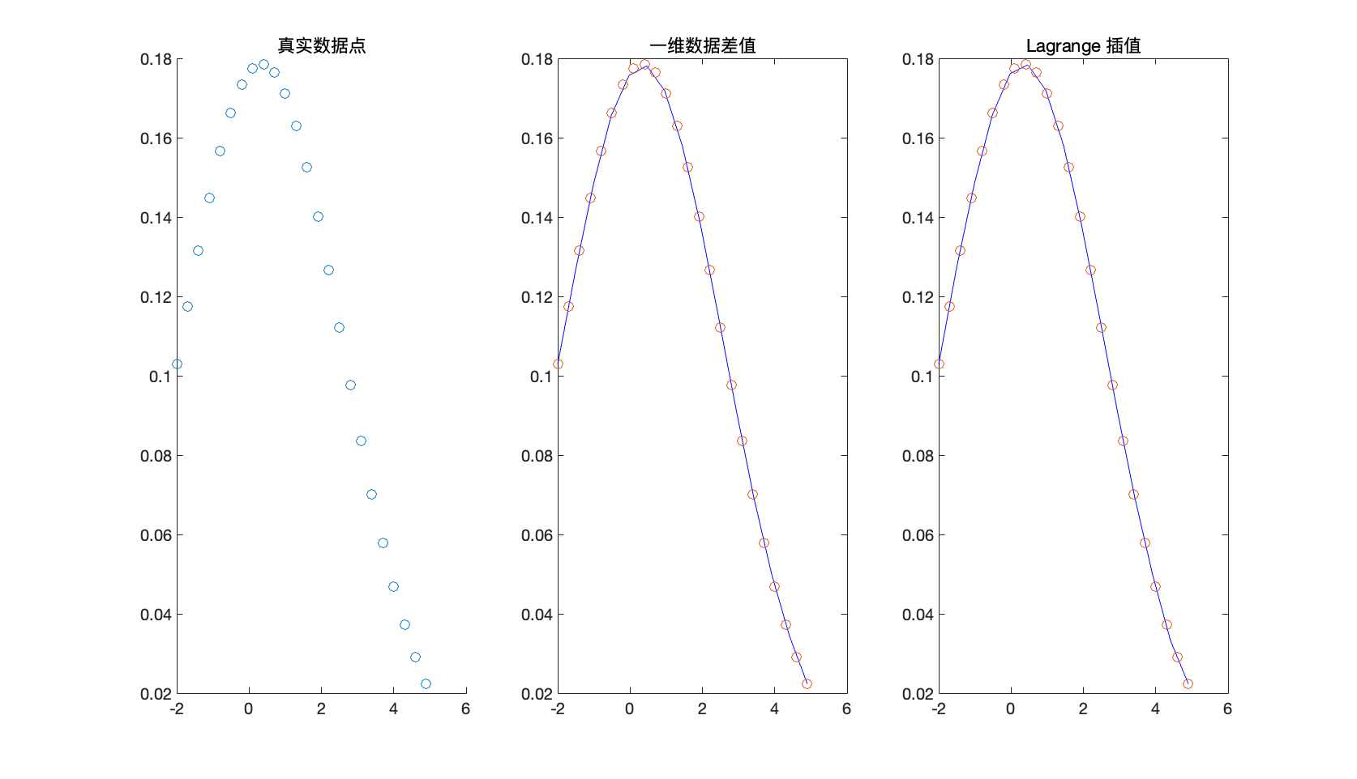
Lagrange 插值可能会存在Runge现象，一维数据差值不连续。
- 假设已知实测数据由下表给出，试对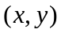在(0.1,0.1)~(1.1,1.1)区域内的点进行插值，并用三维曲面的方式绘制出插值结果。
 | 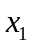 | 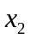 | 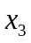 | 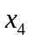 | 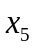 | 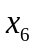 | 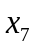 | 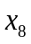 | 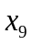 | 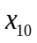 | 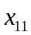
0 | 0.1 | 0.2 | 0.3 | 0.4 | 0.5 | 0.6 | 0.7 | 0.8 | 0.9 | 1 | 1.1
0.1 | .83041 | .82727 | .82406 | .82098 | .81824 | .8161 | .81481 | .81463 | .81579 | .81853 | .82304
0.2 | .83172 | .83249 | .83584 | .84201 | .85125 | .86376 | .87975 | .89935 | .92263 | .94959 | .9801
0.3 | .83587 | .84345 | .85631 | .87466 | .89867 | .9284 | .96377 | 1.0045 | 1.0502 | 1.1 | 1.1529
0.4 | .84286 | .86013 | .88537 | .91865 | .95985 | 1.0086 | 1.0642 | 1.1253 | 1.1904 | 1.257 | 1.3222
0.5 | .85268 | .88251 | .92286 | .97346 | 1.0336 | 1.1019 | 1.1764 | 1.254 | 1.3308 | 1.4017 | 1.4605
0.6 | .86532 | .91049 | .96847 | 1.0383 | 1.118 | 1.2046 | 1.2937 | 1.3793 | 1.4539 | 1.5086 | 1.5335
0.7 | .88078 | .94396 | 1.0217 | 1.1118 | 1.2102 | 1.311 | 1.4063 | 1.4859 | 1.5377 | 1.5484 | 1.5052
0.8 | .89904 | .98276 | 1.082 | 1.1922 | 1.3061 | 1.4138 | 1.5021 | 1.5555 | 1.5573 | 1.4915 | 1.346
0.9 | .92006 | 1.0266 | 1.1482 | 1.2768 | 1.4005 | 1.5034 | 1.5661 | 1.5678 | 1.4889 | 1.3156 | 1.0454
1 | .94381 | 1.0752 | 1.2191 | 1.3624 | 1.4866 | 1.5684 | 1.5821 | 1.5032 | 1.315 | 1.0155 | .62477
1.1 | .97023 | 1.1279 | 1.2929 | 1.4448 | 1.5564 | 1.5964 | 1.5341 | 1.3473 | 1.0321 | .61268 | .14763

>> [x,y]=meshgrid(0.1:0.1:1.1);
z=[0.83041,0.82727,0.82406,0.82098,0.81824,0.8161,0.81481,0.81463,0.81579,0.81853,0.82304;
0.83172,0.83249,0.83584,0.84201,0.85125,0.86376,0.87975,0.89935,0.92263,0.94959,0.9801;
0.83587,0.84345,0.85631,0.87466,0.89867,0.9284,0.96377,1.0045,1.0502,1.1,1.1529;
0.84286,0.86013,0.88537,0.91865,0.95985,1.0086,1.0642,1.1253,1.1904,1.257,1.3222;
0.85268,0.88251,0.92286,0.97346,1.0336,1.1019,1.1764,1.254,1.3308,1.4017,1.4605;
0.86532,0.91049,0.96847,1.0383,1.118,1.2046,1.2937,1.3793,1.4539,1.5086,1.5335;
0.88078,0.94396,1.0217,1.1118,1.2102,1.311,1.4063,1.4859,1.5377,1.5484,1.5052;
0.89904,0.98276,1.082,1.1922,1.3061,1.4138,1.5021,1.5555,1.5573,1.4915,1.346;
0.92006,1.0266,1.1482,1.2768,1.4005,1.5034,1.5661,1.5678,1.4889,1.3156,1.0454;
0.94381,1.0752,1.2191,1.3624,1.4866,1.5684,1.5821,1.5032,1.315,1.0155,0.62477;
0.97023,1.1279,1.2929,1.4448,1.5564,1.5964,1.5341,1.3473,1.0321,0.61268,0.14763];

Code:
clc,clearvars;
[x,y]=meshgrid(0.1:0.1:1.1);
z=[0.83041,0.82727,0.82406,0.82098,0.81824,0.8161,0.81481,0.81463,0.81579,0.81853,0.82304;
0.83172,0.83249,0.83584,0.84201,0.85125,0.86376,0.87975,0.89935,0.92263,0.94959,0.9801;
0.83587,0.84345,0.85631,0.87466,0.89867,0.9284,0.96377,1.0045,1.0502,1.1,1.1529;
0.84286,0.86013,0.88537,0.91865,0.95985,1.0086,1.0642,1.1253,1.1904,1.257,1.3222;
0.85268,0.88251,0.92286,0.97346,1.0336,1.1019,1.1764,1.254,1.3308,1.4017,1.4605;
0.86532,0.91049,0.96847,1.0383,1.118,1.2046,1.2937,1.3793,1.4539,1.5086,1.5335;
0.88078,0.94396,1.0217,1.1118,1.2102,1.311,1.4063,1.4859,1.5377,1.5484,1.5052;
0.89904,0.98276,1.082,1.1922,1.3061,1.4138,1.5021,1.5555,1.5573,1.4915,1.346;
0.92006,1.0266,1.1482,1.2768,1.4005,1.5034,1.5661,1.5678,1.4889,1.3156,1.0454;
0.94381,1.0752,1.2191,1.3624,1.4866,1.5684,1.5821,1.5032,1.315,1.0155,0.62477;
0.97023,1.1279,1.2929,1.4448,1.5564,1.5964,1.5341,1.3473,1.0321,0.61268,0.14763];

[xi,yi] = meshgrid(0.1:0.01:1.1);
zi = griddata(x,y,z,xi,yi);
subplot(1,2,1)
mesh(x,y,z)
title("插值前")
subplot(1,2,2)
mesh(xi,yi,zi)
title("差值后")

Result:
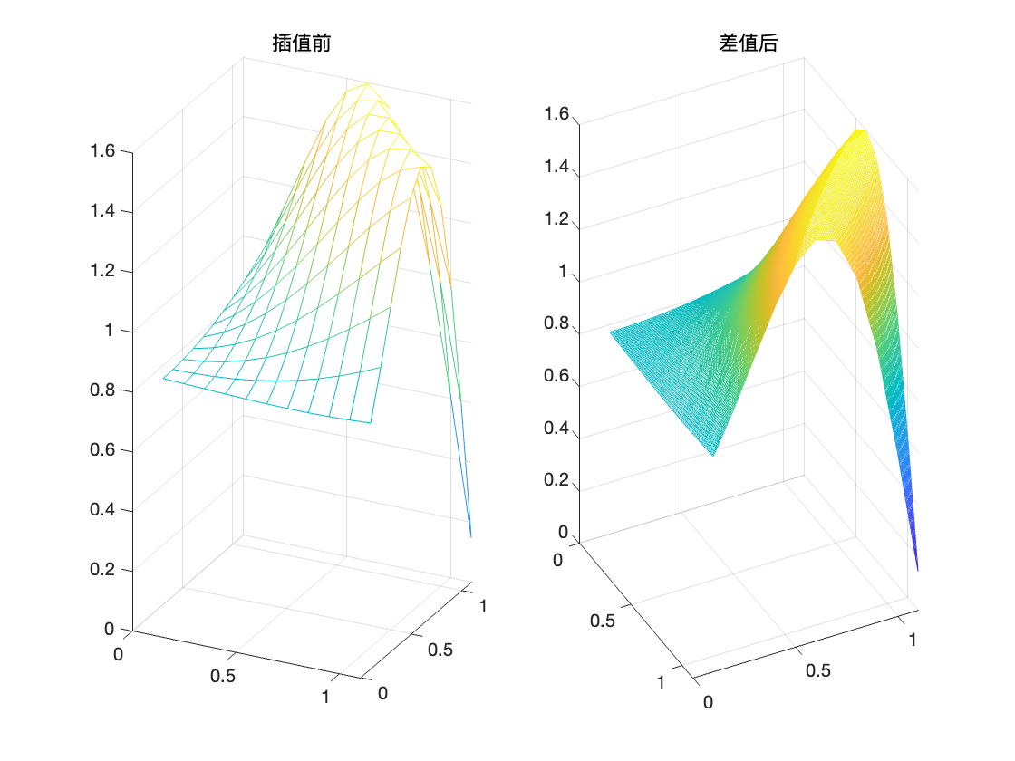
- 习题3和4给出的数据分别为一元数据和二元数据，试用分段三次样条函数和B样条函数对其进行拟合。
Code:
clc,clearvars;
x=[-2,-1.7,-1.4,-1.1,-0.8,-0.5,-0.2,0.1,0.4,0.7,1,1.3,...
1.6,1.9,2.2,2.5,2.8,3.1,3.4,3.7,4,4.3,4.6,4.9];

y=[0.10289,0.11741,0.13158,0.14483,0.15656,0.16622,0.17332,...
0.1775,0.17853,0.17635,0.17109,0.16302,0.15255,0.1402,...
0.12655,0.11219,0.09768,0.08353,0.07019,0.05786,0.04687,...
0.03729,0.02914,0.02236];

% 分段三次样条
subplot(2,2,1)
sp1=csapi(x,y);
fnplt(sp1);
hold on;
scatter(x,y);
title("分段三次样条")
% 5次 B样条插值
subplot(2,2,2)
sp2=spapi(5,x,y);
fnplt(sp2);
hold on;
scatter(x,y);
title("5次B样条插值")

% 分段三次样条
x0=0.1:0.1:1.1;
y0=0.1:0.1:1.1;
z0=[0.83041,0.82727,0.82406,0.82098,0.81824,0.8161,0.81481,0.81463,0.81579,0.81853,0.82304;
0.83172,0.83249,0.83584,0.84201,0.85125,0.86376,0.87975,0.89935,0.92263,0.94959,0.9801;
0.83587,0.84345,0.85631,0.87466,0.89867,0.9284,0.96377,1.0045,1.0502,1.1,1.1529;
0.84286,0.86013,0.88537,0.91865,0.95985,1.0086,1.0642,1.1253,1.1904,1.257,1.3222;
0.85268,0.88251,0.92286,0.97346,1.0336,1.1019,1.1764,1.254,1.3308,1.4017,1.4605;
0.86532,0.91049,0.96847,1.0383,1.118,1.2046,1.2937,1.3793,1.4539,1.5086,1.5335;
0.88078,0.94396,1.0217,1.1118,1.2102,1.311,1.4063,1.4859,1.5377,1.5484,1.5052;
0.89904,0.98276,1.082,1.1922,1.3061,1.4138,1.5021,1.5555,1.5573,1.4915,1.346;
0.92006,1.0266,1.1482,1.2768,1.4005,1.5034,1.5661,1.5678,1.4889,1.3156,1.0454;
0.94381,1.0752,1.2191,1.3624,1.4866,1.5684,1.5821,1.5032,1.315,1.0155,0.62477;
0.97023,1.1279,1.2929,1.4448,1.5564,1.5964,1.5341,1.3473,1.0321,0.61268,0.14763];
subplot(2,2,3)
sp3=csapi({x0,y0},z0);
dspxy=fnder(sp3,[0.1,1.1]);
fnplt(dspxy)
title("分段三次样条")

% B样条插值
subplot(2,2,4)
sp4=spapi({5,5},{x0,y0},z0);
dspxy2=fnder(sp4,[0.1,1.1]);
fnplt(dspxy2)
title("5次B样条插值")
Result:
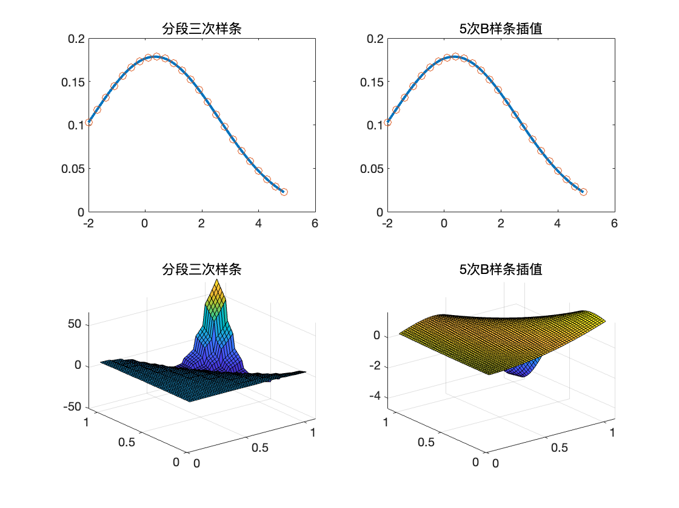
- 重新考虑习题3中给出的数据，试考虑用多项式插值的方法对其数据进行逼近，并选择一个能较好拟合原数据的多项式阶次。
Code:
clc,clearvars;
x=[-2,-1.7,-1.4,-1.1,-0.8,-0.5,-0.2,0.1,0.4,0.7,1,1.3,...
1.6,1.9,2.2,2.5,2.8,3.1,3.4,3.7,4,4.3,4.6,4.9];

y=[0.10289,0.11741,0.13158,0.14483,0.15656,0.16622,0.17332,...
0.1775,0.17853,0.17635,0.17109,0.16302,0.15255,0.1402,...
0.12655,0.11219,0.09768,0.08353,0.07019,0.05786,0.04687,...
0.03729,0.02914,0.02236];

x0 = -2:0.1:4.9;
p3 = polyfit(x,y,3);
y3 = polyval(p3,x0);
p4 = polyfit(x,y,4);
y4 = polyval(p4,x0);
p5 = polyfit(x,y,5);
y5 = polyval(p5,x0);
scatter(x,y);
hold on
plot(x0,y3,'b');
hold on;
plot(x0,y4,'r');
hold on;
plot(x0,y5,'black');
legend("散点","三次","四次","五次")
title("不同次数多项式拟合结果")

Result:
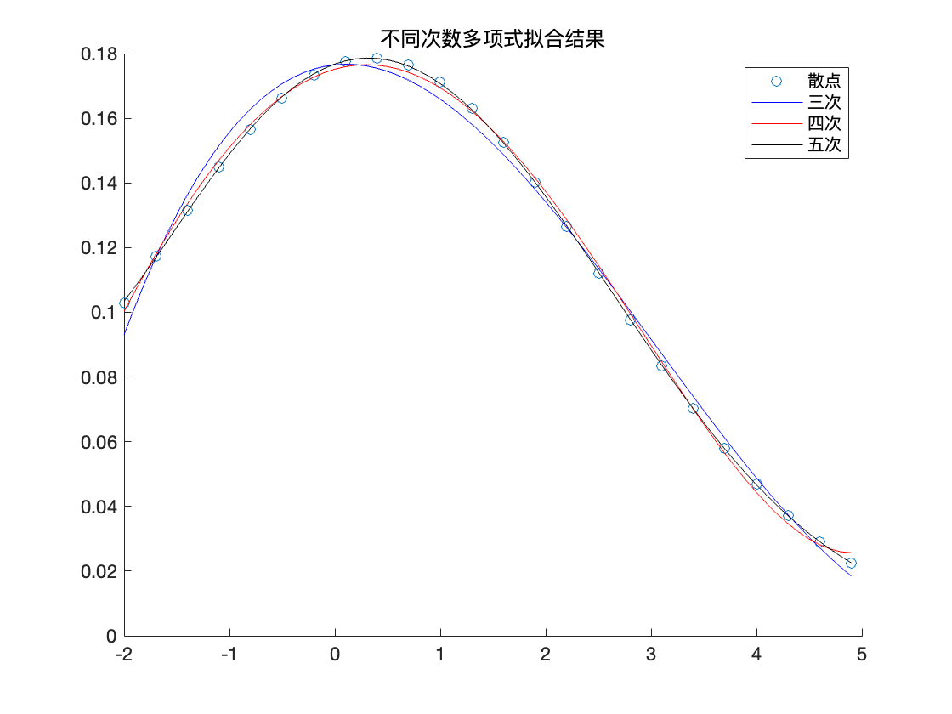
- 假设习题3中给出的数据满足原型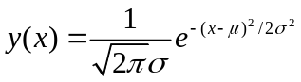，试用最小二乘法求出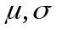的值，并用得出的函数将函数曲线绘制出来，观察拟合效果。
Code:
clc,clearvars;
x=[-2,-1.7,-1.4,-1.1,-0.8,-0.5,-0.2,0.1,0.4,0.7,1,1.3,...
1.6,1.9,2.2,2.5,2.8,3.1,3.4,3.7,4,4.3,4.6,4.9];

y=[0.10289,0.11741,0.13158,0.14483,0.15656,0.16622,0.17332,...
0.1775,0.17853,0.17635,0.17109,0.16302,0.15255,0.1402,...
0.12655,0.11219,0.09768,0.08353,0.07019,0.05786,0.04687,...
0.03729,0.02914,0.02236];

f= @(a,x) 1./(sqrt(2*pi).*a(2)).*exp(-((x-a(1)).^2)./(2.*a(2).^2));
[xx,res]=lsqcurvefit(f,[1,1],x,y);
xx',res

x1 = -2:0.1:4.9;
y1 = f(xx,x1);
plot(x1,y1);
hold on;
scatter(x,y);

Result:
Mu = 0.3461,sigma = 2.2340,误差res=1.8117e-09
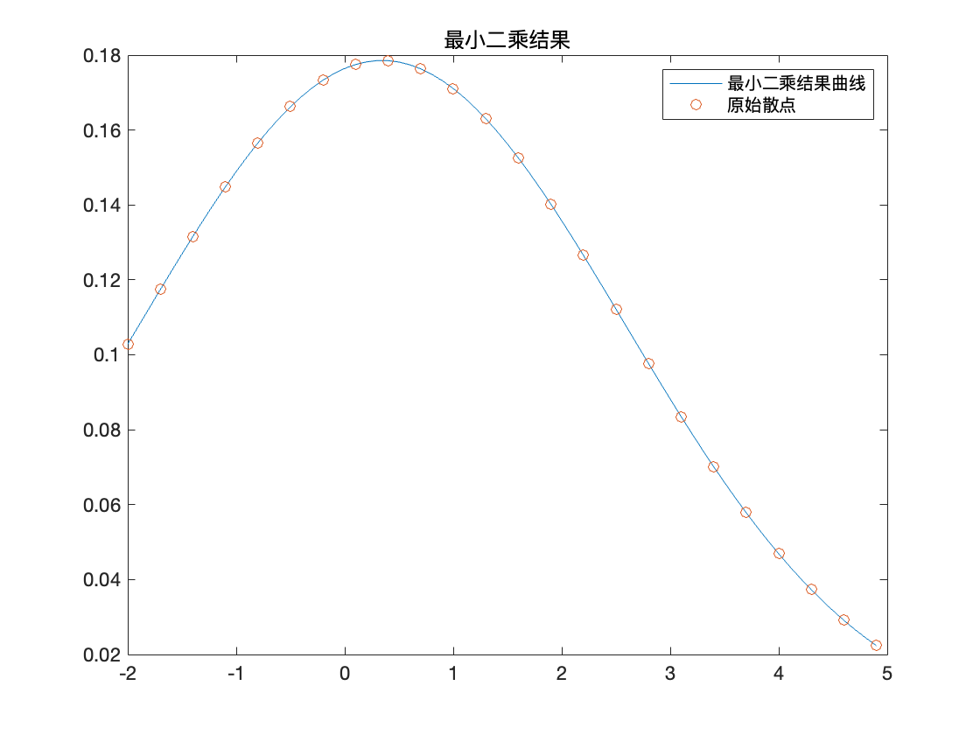

- 假设习题4中数据的原型函数为，试用最小二乘方法识别出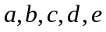的数值。
Code:
clc,clearvars;
[x,y]=meshgrid(0.1:0.1:1.1);
z=[0.83041,0.82727,0.82406,0.82098,0.81824,0.8161,0.81481,0.81463,0.81579,0.81853,0.82304;
0.83172,0.83249,0.83584,0.84201,0.85125,0.86376,0.87975,0.89935,0.92263,0.94959,0.9801;
0.83587,0.84345,0.85631,0.87466,0.89867,0.9284,0.96377,1.0045,1.0502,1.1,1.1529;
0.84286,0.86013,0.88537,0.91865,0.95985,1.0086,1.0642,1.1253,1.1904,1.257,1.3222;
0.85268,0.88251,0.92286,0.97346,1.0336,1.1019,1.1764,1.254,1.3308,1.4017,1.4605;
0.86532,0.91049,0.96847,1.0383,1.118,1.2046,1.2937,1.3793,1.4539,1.5086,1.5335;
0.88078,0.94396,1.0217,1.1118,1.2102,1.311,1.4063,1.4859,1.5377,1.5484,1.5052;
0.89904,0.98276,1.082,1.1922,1.3061,1.4138,1.5021,1.5555,1.5573,1.4915,1.346;
0.92006,1.0266,1.1482,1.2768,1.4005,1.5034,1.5661,1.5678,1.4889,1.3156,1.0454;
0.94381,1.0752,1.2191,1.3624,1.4866,1.5684,1.5821,1.5032,1.315,1.0155,0.62477;
0.97023,1.1279,1.2929,1.4448,1.5564,1.5964,1.5341,1.3473,1.0321,0.61268,0.14763];
x1 = x(:);
y1 = y(:);
z1 = z(:);
A = [sin(x1.^2.*y1),cos(y1.^2.*x1),(x1.^2),(x1.*y1),ones(121,1)];
xx = A\z1
f = @(x,y) xx(1)*sin(x.^2.*y)+xx(2)*cos(y.^2.*x)+xx(3)*x.^2+xx(4)*x.*y+xx(5);
[x0,y0]=meshgrid(0.1:0.1:1.1);
z0=f(x0,y0);
subplot(1,3,1)
mesh(x0,y0,z);
title("原始值")
subplot(1,3,2);
mesh(x0,y0,z0);
title("最小二乘解")
subplot(1,3,3);
mesh(x0,y0,abs(z0-z))
title("误差")
Result:
-0.8920
3.0938
-0.1220
2.7083
-2.4251
