Published September 2015

IT Showcase Productivity Guide

Microsoft Edge

Summary: Microsoft Edge, the new browser in Windows 10, is designed to deliver a better web experience. It’s fast, compatible, and built for the modern web—designed to work the way you do and help you get things done through easy sharing, reading, discovery, and more.

# Topics in this guide include:

Search

The Hub

Web Notes

For more information

Opening with Internet Explorer

PDF reader

Cortana

Reading List

Reading view

# Search

With Microsoft Edge, when you want to search for something, there’s no need to go to a website. Just enter your search in the handy address bar and you’ll get search suggestions and results from the web, your browsing history, and your favorites—all right on the spot.

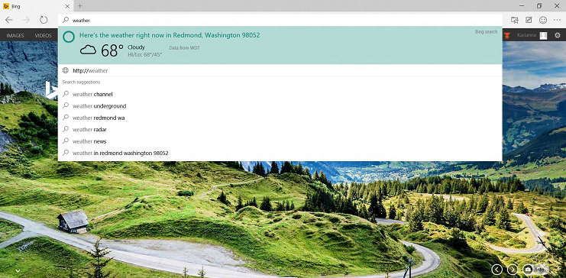

# The Hub

Think of the Hub as the place where Microsoft Edge keeps the things you collect on the web—including your favorites, reading list, browsing history, and current downloads.

* To open the Hub, select **Hub** Image of Hub icon.

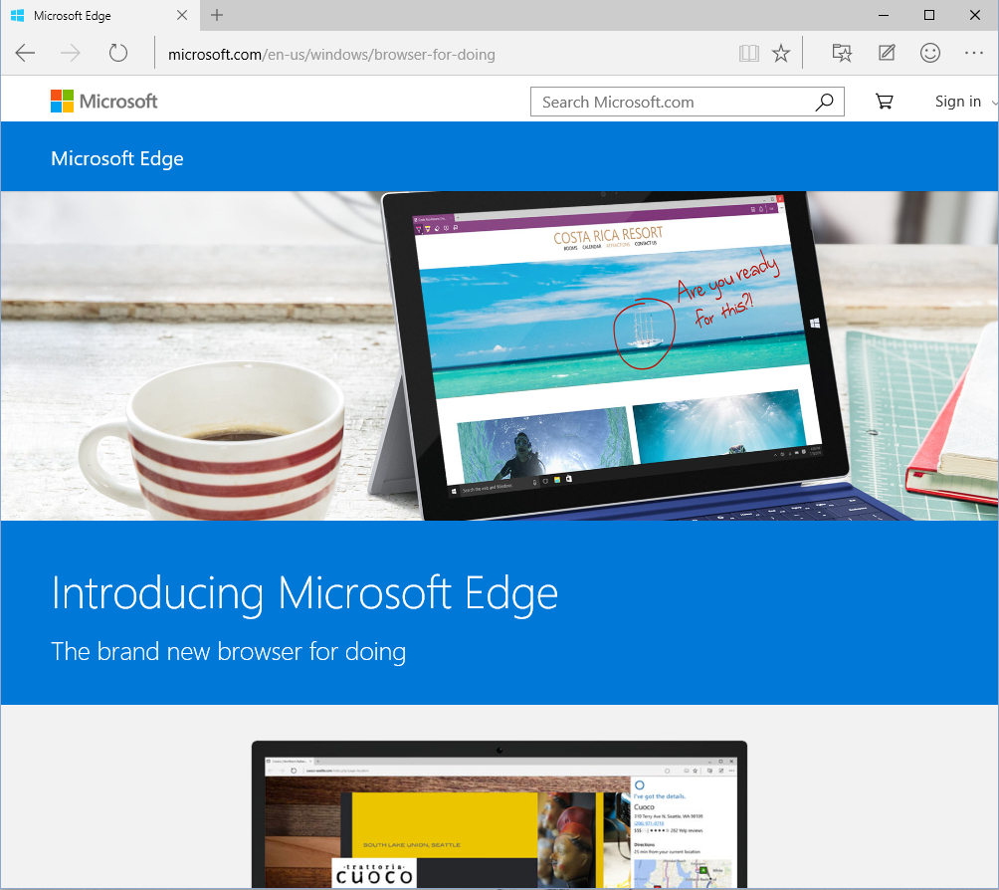

* To change views, select a button at the top of the Hub: **Favorites** , **Reading List** , **Browsing History** , or **Downloads** .

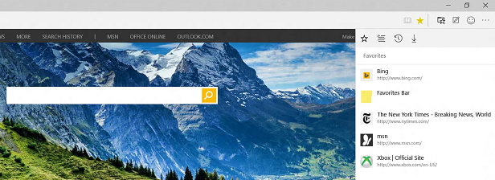

# Web Notes

Microsoft Edge is the only browser that lets you take notes, write, doodle, and highlight directly on webpages. You can add a few secret ingredients to a recipe to share with your fellow amateur chefs, collaborate on a new project with your coworkers, or have fun with your kids—and then save your “Web Note” for later or share it with others.

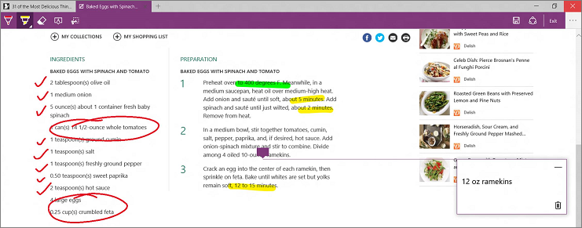

Select **Make a Web Note** Image of Web Note icon to display the **Web Note** toolbar, and then you can:

* Select **Draw**   to draw on the page. When the **Draw** tool is active, select it again to adjust color or tool size.
* Select **Highlight**   to highlight content on the page. When the **Highlight** tool is active, select it again to adjust color or tool shape.
* Select **Erase**  to erase everything you’ve added using the **Draw** and **Highlight** tools. When the **Erase** tool is active, select **Erase** again and select **Erase All**.
* Select **Comment** to add a comment, select the place on the page where you want to anchor the comment, and then enter the comment.
* Select **Clip**  to clip part of a page, and then drag to select the region of the webpage you want to clip. Release your finger or mouse, and then to save, share, or copy what you clipped, select the **Save** button that appears next to the clipped region.

When you’re done creating a Web Note, you can:

* Select **Save**  on the **Web Note** toolbar to save the Web Note to your Favorites or Reading List.
* Select **Share**  on the **Web Note** toolbar to share the Web Note via OneNote or to your Reading List.
* Select **Exit** on the **Web Note** toolbar to close it and return to the normal view.

# Cortana

Only Microsoft Edge has Cortana, your chatty personal assistant, right in the address bar. She's there to help you do things faster and easier—like make reservations and get at-a-glance directions to the perfect dinner spot.

When Cortana has information that may be useful, you’ll see the Cortana icon D:\Users\Scott\Documents\Case Studies\Active Case Studies\Windows 10 Work Smart\A8 - Microsoft Edge\SS Sandeep\Cortana_AddressBar_Icon.png in the Microsoft Edge address bar—just select it and Cortana will show you the details on the right side of the screen.

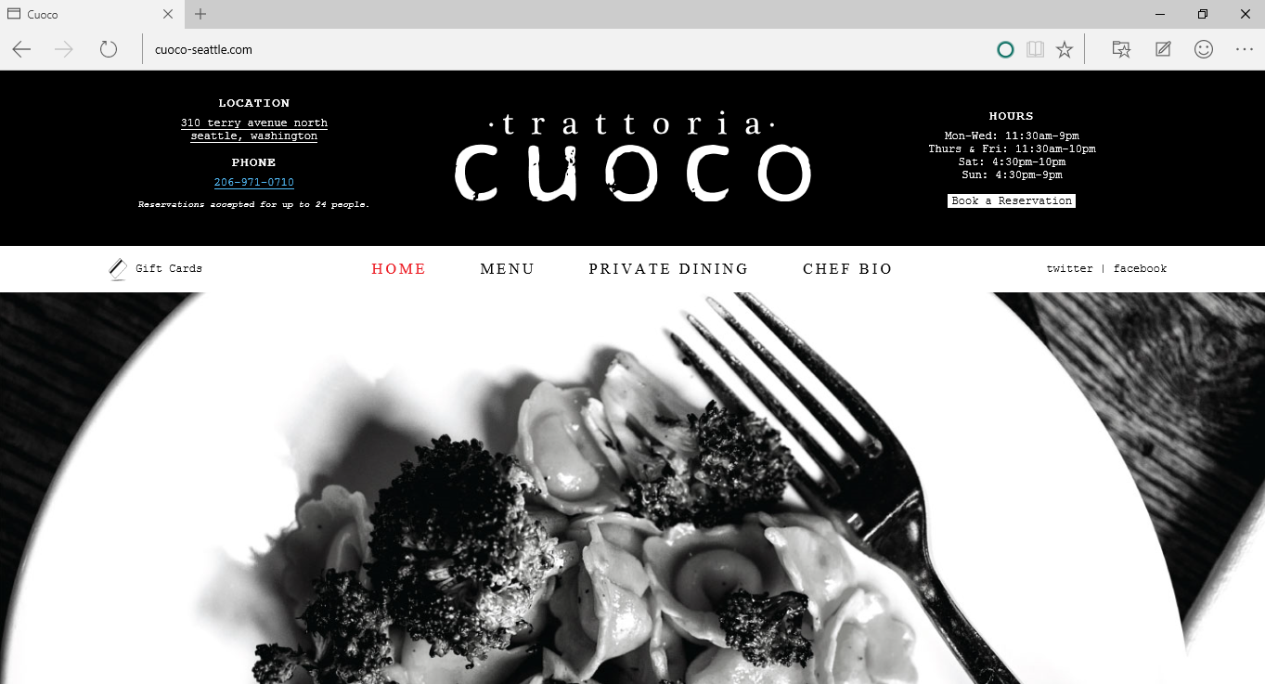

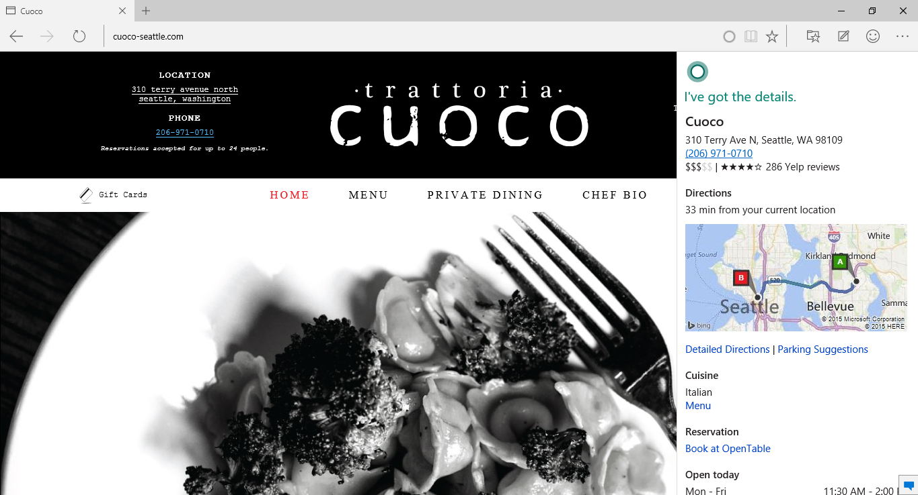

You can also ask Cortana about content on a webpage:

1. Use your finger or mouse to select a word or phrase on the webpage.
2. Press and hold (or right-click) the selected content, and then select **Ask Cortana**.

She’ll appear on the right side of the screen with information that may be useful.

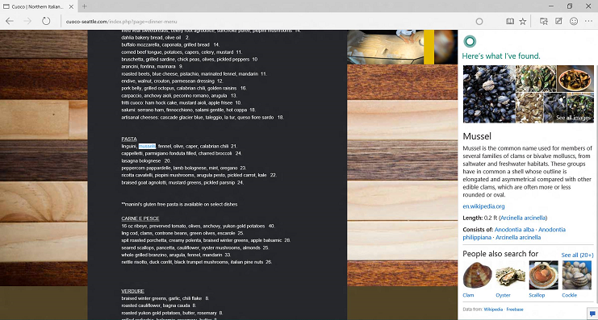

# Reading List

Reading List gives you a place to save content you want to read later.

* To save content to Reading List, select Image of Add to Reading list icon **>** **Reading List** **> Add**.
* When you’re ready to read what you’ve saved, go to the **Hub** Image of Hub icon, and then select   
  **Reading List** Image of Reading list icon.

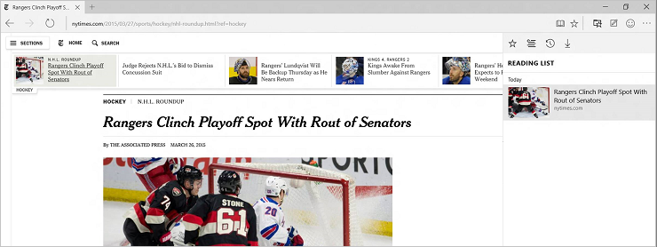

# Reading view

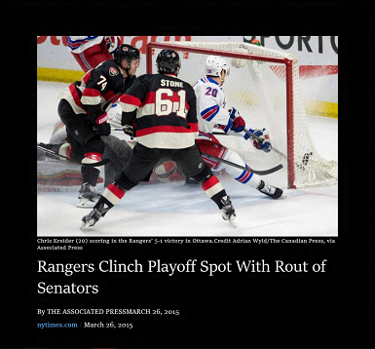Microsoft Edge includes an integrated **reading view**, which provides a clean and simple layout to help you stay focused on the content.

* Select **Reading View** Image of Reading view icon in the address bar to turn on reading view. If reading view isn’t available for a particular webpage, the button will be dimmed.
* To adjust reading view style and font size, select **More actions** Image of More actions icon **> Settings**.

# PDF reader

Microsoft Edge includes a built-in PDF reader, so you won’t need to download a separate PDF reader app.

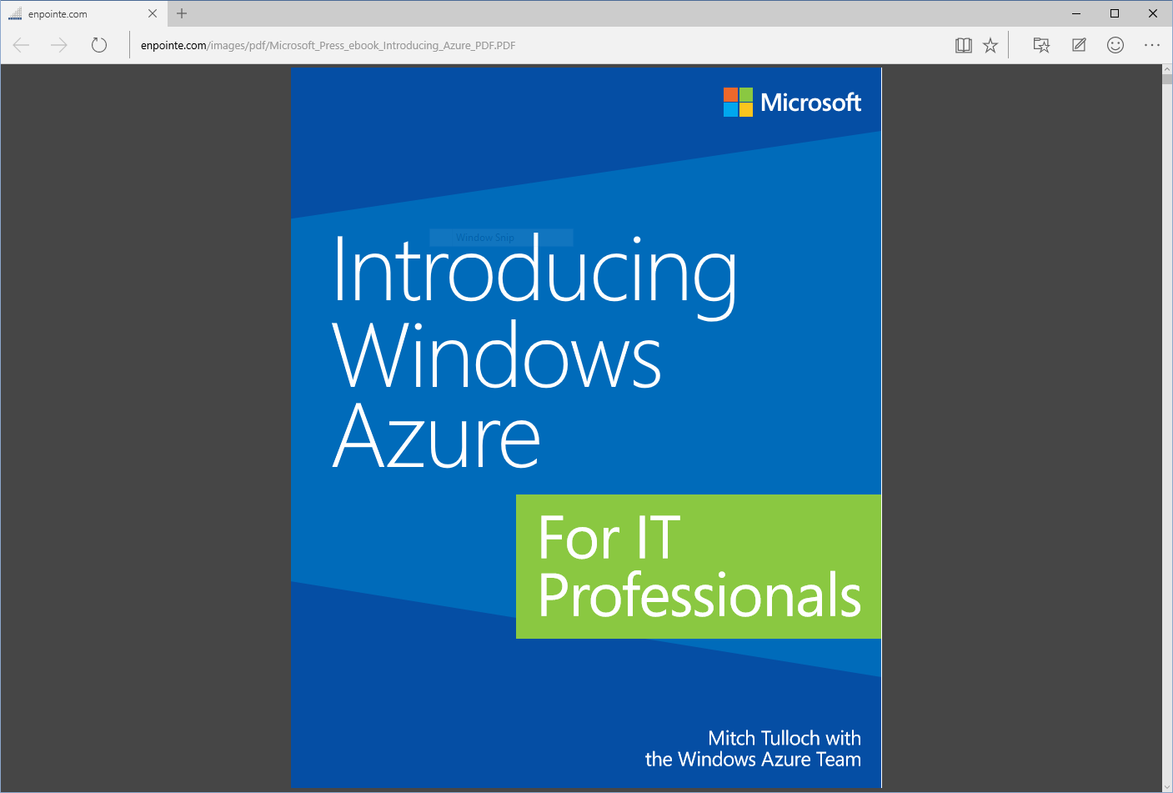

# Opening with Internet Explorer

Microsoft Edge uses a new rendering engine to help you get the most out of modern webpages. If a page doesn’t look quite right in Microsoft Edge, you can open the same page with Internet Explorer—just select **More actions Image of More actions icon >** **Open with Internet Explorer**.

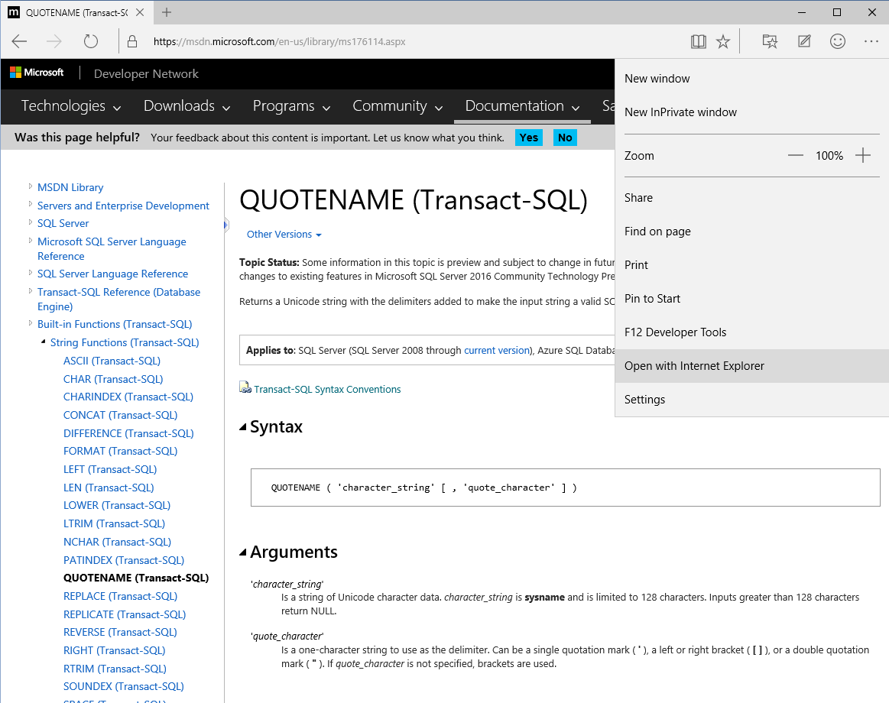

# For more information

## For more great productivity guidance, visit…

<http://microsoft.com/ITShowcase/Productivity>

## Microsoft IT Showcase

<http://www.microsoft.com/ITShowcase>

## Windows

## <http://windows.microsoft.com>

For more information about Microsoft products or services, call the Microsoft Sales Information Center at (800) 426-9400. In Canada, call the Microsoft Canada Order Centre at (800) 933-4750. Outside the 50 United States and Canada, please contact your local Microsoft subsidiary. To access information via the web, go to:

<http://www.microsoft.com>

© 2015 Microsoft Corporation. All rights reserved. Microsoft and Windows are either registered trademarks or trademarks of Microsoft Corporation in the United States and/or other countries. The names of actual companies and products mentioned herein may be the trademarks of their respective owners. This document is for informational purposes only. MICROSOFT MAKES NO WARRANTIES, EXPRESS OR IMPLIED, IN THIS SUMMARY.