Study the sources below and answer the questions that follow.

Source I
The following is an excerpt from a modern history book (Source: David Thomson, Europe Since Napoleon, Harmondsworth: Penguin Books, 1966).

The frightening feature of the rival alliances by 1914 was their rigidity and reliability. Each succeeding international crisis, with its latent threat to the security of the great powers, tightened the ties within each group.

Source II
The following map shows Europe at the beginning of World War I.

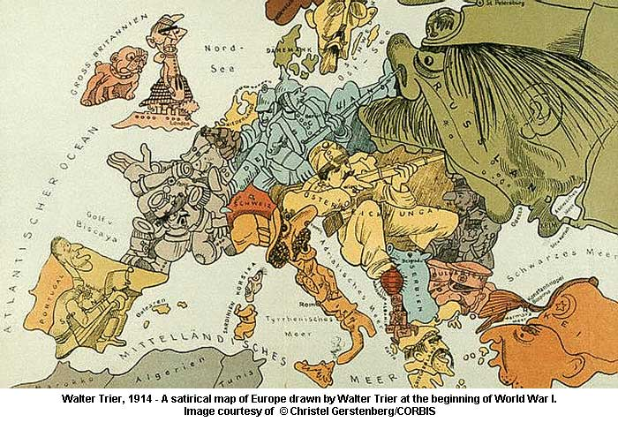
Russia
Britain
Germany
France
Italy
Austria-Hungary

- Name the rival alliances mentioned in Source I.
__________________________________________________________________
- With reference to Source II, which two countries marked on the map were not fighting with the other countries? To which rival alliances you mentioned in the previous question did each belong?
__________________________________________________________________
__________________________________________________________________
- “The alliance system led to the outbreak of the First World War as the powers were bound by the alliances to help their allies.” Do you agree with the statement? Explain your answer with reference to Sources I and II, and using your own knowledge.
__________________________________________________________________
____________________________________________________________________________________________________________________________________
##
- The Triple Alliance and the Triple Entente.
- Britain and Italy. Britain was a member of the Triple Entente and Italy was included in the Triple Alliance.
- Yes. As reflected in Source I, by 1914 two rival alliances had been formed in Europe, dividing the powers into two rival camps. The Triple Alliance included Germany, Austria-Hungary and Italy while the Triple Entente included France, Russia and Britain. The alliances were rigid and reliable, and contributed to the outbreak of the First World War. As a result of the Triple Alliance, Germany supported Austria in dealing with Serbia and Russia after the Sarajevo Incident. Owing to the Triple Entente, France supported Russia and the local conflict between Austria and Serbia became a general war involving the great powers. As reflected in Source II, most of the powers were involved in the First World War in 1914.
OR
No. As reflected in Source I, by 1914 two rival alliances had been formed in Europe, dividing the powers into two rival camps. The Triple Alliance included Germany, Austria-Hungary and Italy while the Triple Entente included France, Russia and Britain. Though the alliances were rigid and reliable, they were defensive in nature and members did not have to join a war if it was started by other members of the alliance. As reflected in Source II, Britain, a member of the Triple Entente, and Italy, a member of the Triple Alliance, did not join the First World War at the beginning.
##

Study the sources below and answer the questions that follow.

Source I
The following maps show Eastern Europe before and after the First World War.

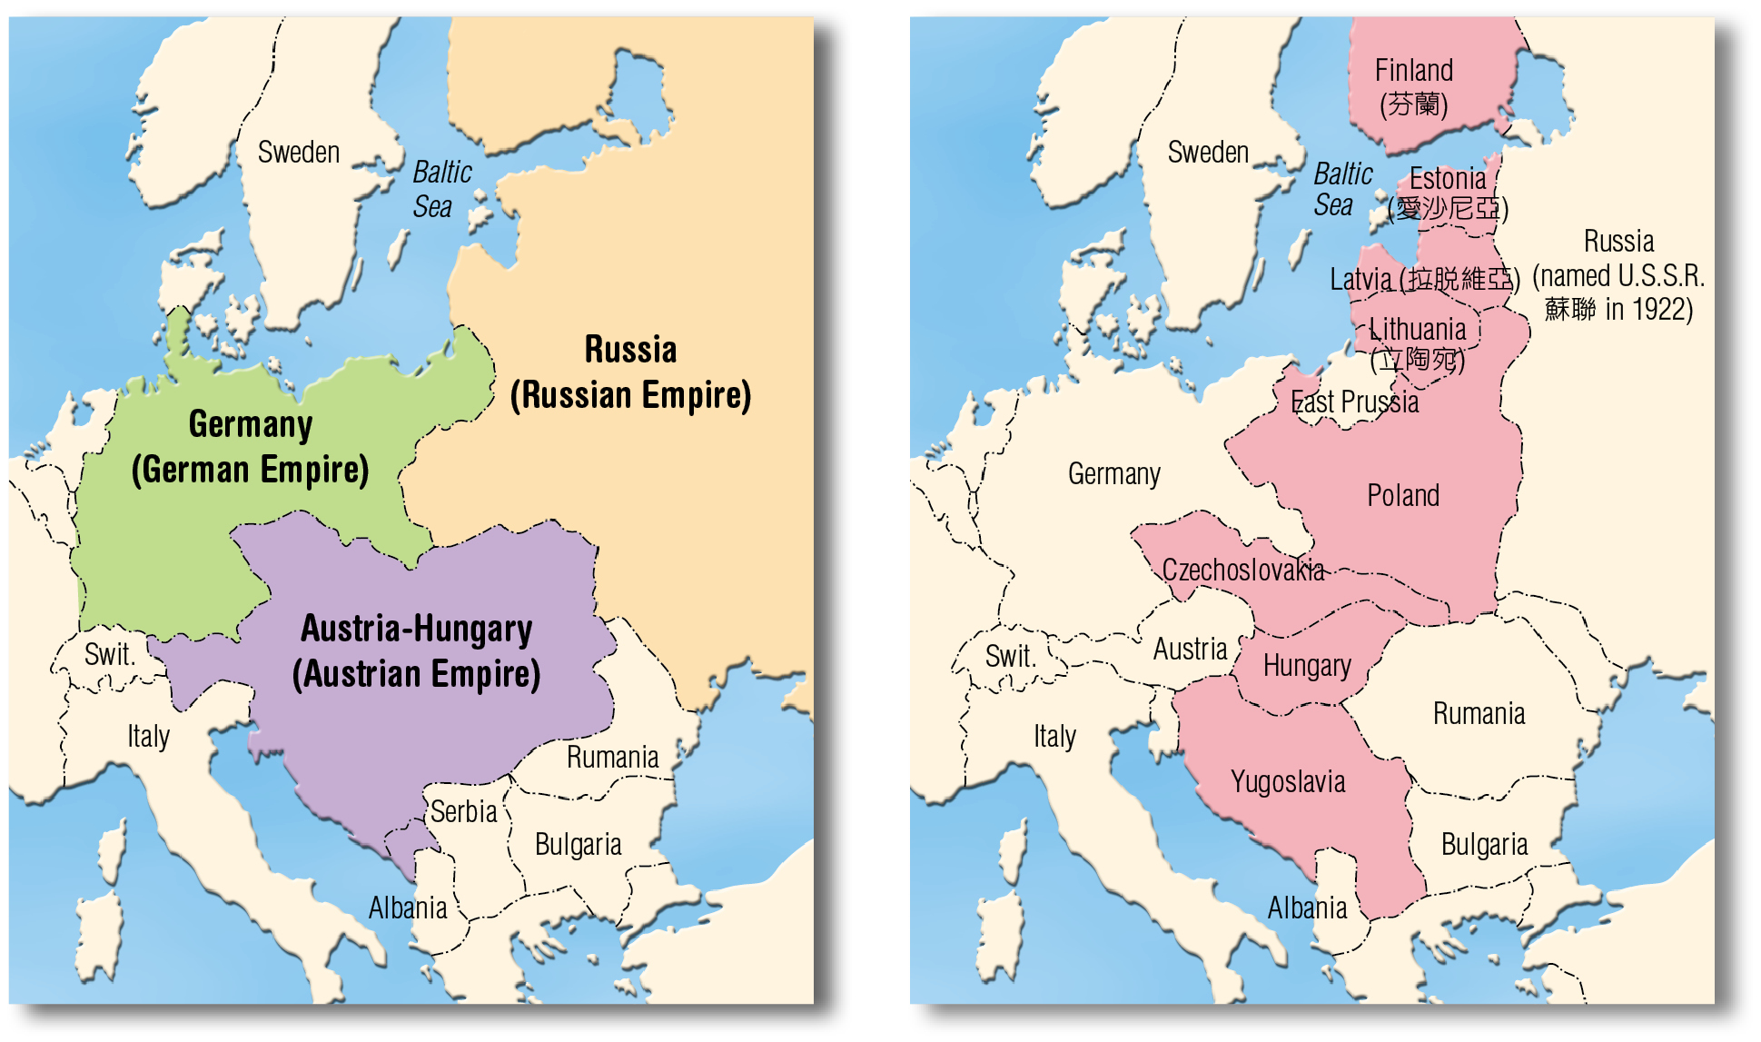

Source II
The following excerpt is adapted from a petition by the inhabitants of Saarbriicken in December 1918 (Source: G.M.D. Howat, European History, 1789-1970, London: Edward Arnold (publishers) ltd., 1973).

We are German as regards race, history, language and sentiment. We desire to remain united with our German brothers even in this time of trouble and misfortune. For more than 900 years Saarbriicken was an independent German principality. In 1807, at the time of the French Revolution, it was annexed to France, but was restored to Germany by the Second Peace of Paris in 1815, as a part of the Prussian Rhine province. The annexation of the region of Saarbriicken to France for the second time would be inconsistent with the principles of peace settlement laid down by President Wilson.

- With reference to Source I, name three new nation-states set up in Eastern Europe after the First World War.
__________________________________________________________________
- According to Source II, what was the settlement of Saarbriicken after the First World War?
__________________________________________________________________
- What was the attitude of the inhabitants of Saarbriicken towards the settlement you mentioned in question B? Explain your answer with reference to Source II.
__________________________________________________________________
__________________________________________________________________
- How did the post-WWI settlement affect the political situation in Eastern Europe? Explain your answer with reference to Sources I and II, and using you own knowledge.
__________________________________________________________________
__________________________________________________________________
__________________________________________________________________
__________________________________________________________________
##
- Finland, Estonia, Latvia, Lithuania, Poland, Czechoslovakia, Hungary and Yugoslavia (Any three).
- The region would be given to France.
- They were discontented with the settlement. In the petition, they said that they desired to remain united with Germany because they were German as regards race, history, language and sentiment.
- As reflected in Source I, the First World War greatly changed the political map of Europe. After the war, the three old empires in Eastern Europe, the Russian Empire, the Austro-Hungarian Empire and the German Empire, broke up and a number of nation-states were formed. The Germans resented the changes because many Germans lived in the new nation-states of Eastern Europe. Like the inhabitants in the Saar region in Source II who wanted to remain united with Germany because they were German, the Germans wanted that the Germans in Eastern Europe could be re-united with Germany after the war. The situation in Eastern Europe remained unstable after the war.
##

Study the source below and answer the questions that follow.

The following British cartoon about the Munich Conference was published in October 1938.

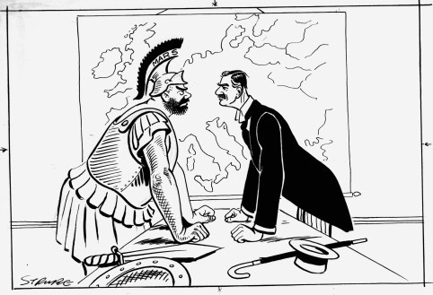
MARS: Ancient Greek God of War.

- Which two countries did Mars and the man in the cartoon represent?
_________________________________________________________________
- What were Mars and the man in the cartoon arguing about? Explain you answer with reference to the source, and using your own knowledge.
_________________________________________________________________
_________________________________________________________________
- Do you think that the cartoonist would regard the man as a brave man? Explain your answer with reference to the cartoon.
_________________________________________________________________
_________________________________________________________________
- Was the view of the cartoonist you mentioned in question C supported by historical facts? Explain your answer with reference to the source, and using your own knowledge.
_________________________________________________________________
_________________________________________________________________
_________________________________________________________________
##
- Mars: Germany
Man: Britain
- They were arguing about the Sudetenland in Czechoslovakia. The caption of the cartoon tells that it was about the Munich Conference which was held to discuss the Sudetenland problem.
- Yes. The cartoonist showed that the man was facing Mars bravely, looking straight into his eyes though Mars was much stronger than he.
- No. In the Munich Conference, Britain adopted an appeasement policy towards the demands of Germany. The Munich Agreement gave the Sudetenland to Germany.
##

Study the sources below and answer the questions that follow.

Source I
The following is a table about Soviet Russia’s foreign relations.

1933  1934  1935  March 1938  Sept. 1938  May 1939  Aug. 1939  Sept. 1939 | the U.S. recognizes Soviet Russia diplomatically  joins the League of Nations and becomes a permanent member of the Council  signs a treaty of mutual assistance with France and Czechoslovakia separately  suggests calling an international conference to discuss collective actions to be taken in peace time in face of German threat  not invited to attend the Munich Conference  fails to form a grand alliance with France, Britain and the Eastern European countries  signs the Nazi-Soviet Non-aggression Pact in Moscow  the Second World War breaks out

Source II
The following British cartoon about the Nazi-Soviet Non-Aggression Pact was published in October 1939.
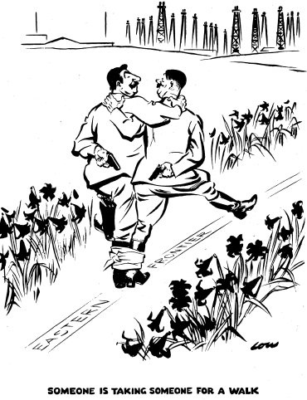

- With reference to Source I, and using your own knowledge, explain the changes in Soviet Russia’s foreign policies in the 1930s.
__________________________________________________________________
__________________________________________________________________
- What was the view of the cartoonist on Nazi-Soviet relations under the Nazi-Soviet Pact? Explain your answer with reference to Source II.
____________________________________________________________________________________________________________________________________
- Was the view of the cartoonist you mentioned in question B supported by historical facts? Explain your answer with reference to Source II, and using your own knowledge.
_________________________________________________________________
_________________________________________________________________
_________________________________________________________________
- Do you agree that the Nazi-Soviet Non-Aggression Pact led to the outbreak of the Second World War? Explain your answer using your own knowledge.
__________________________________________________________________
__________________________________________________________________
__________________________________________________________________
##
- In the early 1930s Soviet Russia improved its relations with the Western democracies. It joined the League of Nations and signed a treaty of mutual assistance with France and Czechoslovakia separately. It was because of the rise of the Nazis to power in Germany. The Nazis had a programme of military expansion in Eastern Europe to build a large German empire. In face of German expansion, Soviet Russia hoped that the international community could take collective action against Germany and aimed to form a grand alliance with Britain, France and the countries in Eastern Europe. However, it failed. It therefore improved its relations with Nazi Germany and signed a non-aggression pact with Germany in 1939 for self-defense.
- Nazi Germany and Soviet Union were pretending to be allies only and did not really trust each other. In the cartoon, though Hitler of Germany and Stalin of Soviet Russia were tied at the ankle as in a three-legged race, both were holding a gun behind their back. It shows that though they had singed the Nazi-Soviet Non-aggression Pact promising not to attack each other, both were merely waiting the chance to attack and destroy the other.
- Yes. The cartoon showed that Hitler of Germany and Stalin of the Soviet Union did not really trust each other despite the Nazi-Soviet Non-aggression Pact. In September 1939, the Second World War broke out. Despite the pact, in June 1941 Germany suddenly invaded the Soviet Union.
- Yes. Under the Nazi-Soviet Non-Aggression Pact, the two countries agreed not to go to war against the other. As a result, Germany did not have to fear a two-front war against Britain and France on the east and Soviet Russia on the west. By the pact, Nazi Germany and Soviet Russia also secretly agreed to divide Poland. Immediately after the signing of the pact, German troops invaded Poland on 1 September 1939. Britain and France demanded immediate German withdrawal. Without any reply, they declared war on Germany on 3rd September and the Second World War broke out.
##
Study the source below and answer the questions that follow.

The following is a statement by President Truman in June 1950 (Source: https://www.mtholyoke.edu/acad/intrel/pentagon/doc8.htm).

In Korea the Government forces, which were armed to prevent border raids and to preserve internal security, were attacked by invading forces from North Korea. The Security Council of the United Nations called upon the invading troops to cease hostilities and to withdraw to the 38th parallel. This they have not done, but on the contrary have pressed the attack. The Security Council called upon all members of the United Nations to render every assistance to the United Nations in the execution of this resolution. In these circumstances I have ordered United States air and sea forces to give the Korean Government troops cover and support.
The attack upon Korea makes it plain beyond all doubt that Communism has beyond the use of subversion to conquer independent nations and will use armed invasion and war….

- According to the source, what was the resolution of the UN Security Council regarding the war in Korea?
_________________________________________________________________
- According to the source, how would the United States respond to the resolution you mentioned in question A?
_________________________________________________________________
_________________________________________________________________
- According to President Truman, what methods had been and would be used by Communism to conquer independent nations?
_________________________________________________________________
_________________________________________________________________
- Was the Cold War after the Second World War just a European conflict? Explain your answer with reference to the source, and using your own knowledge.
_________________________________________________________________
_________________________________________________________________
_________________________________________________________________
##
- The resolution called upon North Korean troops to cease hostilities and to withdraw to the 38th parallel.
- The United States would give assistance to the United Nations in the execution of the resolution. It would send air and sea forces to give the South Korean troops cover and support.
- Communism had used subversion and would use armed invasion and war.
- The Cold War was not just a European conflict. The Cold War refers to the confrontation between the capitalist bloc, led by the United States, and the communist bloc, led by the Soviet Union, after the Second World War. At first, Europe was the center of the confrontation because of the expansion of communist influence in Europe after the war. The war also accelerated the process of decolonization and many new independent states were formed in Africa and Asia after the end of the war. Both the United States and Soviet Union tried to win over these states and their confrontation spread beyond Europe. As reflected in the source, during the Korea War, the United States supported the UN Security Council’s solution calling upon North Korean troops to cease withdraw to the 38th parallel and sent air and sea forces to give the South Korean troops cover and support. It was because North Korea was a communist country and was supported by the Soviet Union whereas South Korea was supported by the United States. The Cold War became a global conflict.
##

Study the source below and answer the questions that follow.

The following cartoon was published in 1962.

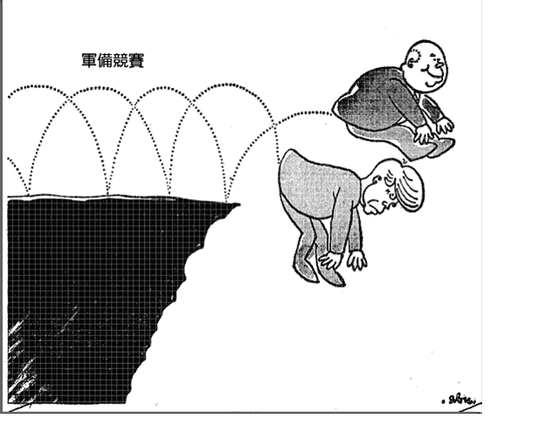

- According to the source, which two countries were involved in the armaments race?
__________________________________________________________________
- According to the source, what would be the consequence of the armaments race for the two countries you mentioned in question A? Explain your answer with reference to the source.
__________________________________________________________________
__________________________________________________________________
- Did the two countries you mentioned in question A make any attempt at disarmament? Explain your answer with reference to relevant historical facts.
__________________________________________________________________
__________________________________________________________________
__________________________________________________________________
__________________________________________________________________
##
- They were the United States and the Soviet Union.
- In the cartoon, the two men were competing to see which one could jump further away from the cliff. It shows that the armaments race would lead to the destruction of the two countries.
- As a result of the Cold War after the Second World War, the United States and the Soviet Union were involved in an arms race. They competed to develop and produce more powerful weapons such as nuclear weapons. This not only increased the risk of war, but it also made the war more destruction once it broke out. To prevent this, the two powers started to improve their relations and made attempts at disarmaments in the late 1960s. From 1969 to 1979, the two powers held two rounds of SALT. They agreed to limit the number of their missiles and nuclear weapons.
##

