Computation of Shallow Water Equation
Student ID: r07525117 Student Name: Chang-Syuan Syu
- Governing Equations
In this study, I will use basic numerical methods to solve the linear shallow water equation (LSWE) in 1DH:
 | $$\left\{\begin{aligned}\frac{∂η}{∂t}+\frac{∂hU}{∂x}=0 \\ \frac{∂U}{∂t}=-g\frac{∂η}{∂x}\end{aligned}\right.$$ | (1)

Whereηis the free surface elevation, U is the horizontal flow velocity, h is the still water depth, and g is the gravitational acceleration.
- Discretization
We can employ the Lax-Friedrichs method to discretize (1) as
 | $$\left\{\begin{aligned}η_{i}^{(n+1)}=\frac{η_{i+1}^{(n)}+η_{i-1}^{(n)}}{2}-\frac{∆t}{2∆x}[U_{i+1}^{(n)}h_{i+1}-U_{i-1}^{\left(n\right)}h_{i-1}] \\ U_{i}^{(n+1)}=\frac{U_{i+1}^{(n)}+U_{i-1}^{(n)}}{2}-\frac{∆t}{2∆x}g[η_{i+1}^{n}-η_{i-1}^{n}]\end{aligned}\right.$$ | (2)

where (n) denotes variables at the current time step, (n + 1) denotes variables at the new time step, i denotes the i-th discretized node in space, Δx is the step size in space, andΔt is the step size in time
The relation betweenΔx andΔt is required by the CFL (Courant, Friedrichs, and Lewy) condition:
 | $$∆t=C_{CFL}\frac{∆x}{\sqrt{gh_{0}}} ,$$ | (3)

where the constant CCFL is often referred to as the Courant number or the CFL number, and h0 is the maximum water depth in the problem.
The Lax-Friedrichs method can be proved to be stable for 0≦CCFL≦1 (see for example the textbook by LeVeque, 1992). In practice, CCFL = 0.9 is found to be an optimal choice, which I will use in this assignment.
- Boundary Conditions
Let us consider a numerical wave flume spanning from x = -12 m to x = 24 m. The water depth is constant, h = h₀ = 0.3 m. The two ends of the wave flume are solid walls. At the left end, x = -12 m for example, the wall boundary condition means
 | $$\left\{\begin{aligned}U_{i=1}=0 \\ \frac{∂U}{∂t}=0=-g\frac{∂η}{∂x} →{\left(\frac{∂η}{∂x}\right)}_{i=1}=0\end{aligned}\right.$$ | (4)

This also means the ghost cells to the left of x = -12 have the values
 | $$\left\{\begin{aligned}η_{i=0}=η_{i=2} \\ U_{i=0}=0\end{aligned}\right.$$ | (5)

- Initial Conditions
I specify the initial conditions -η(x, 0) and U(x, 0). In constant water depth, we know that any wave of translation (平移波) moving at the speed $\sqrt{gh}$ is a solution to the 1DH LSWE (1). This can be verified by checking that a function of the form f(x - $\sqrt{gh}·t$) is a solution to (1) in constant water depth.
In an addition, based on the linear wave theory the horizontal flow velocity for linear shallow water waves can be determined as
 | $$U\left(x, t\right)=\frac{η(x, t)}{h}\sqrt{gh}$$ | (6)

As the initial conditions for this assignment, I will use a wave of translation of the form
 | $$η\left(x,t\right)=Hsech^{2}\left(K\left(x-Ct\right)\right), K= \frac{1}{h}\sqrt{\frac{3H}{4h}},$$ | (7)

where H is the wave height, C denotes the wave speed (C =$\sqrt{gh}$ for LSWE), and sech(x) is the hyperbolic secant function. K can be seen as the effective wave number for this wave, and an effective wavelength L can be defined as
 | $$L= \frac{2π}{K}$$ | (8)

An effective wave period T can also be defined:
 | $$T=\frac{L}{C}$$ | (9)

A wave of the form (7), whose flow velocity can be calculated from (6), is called the solitary wave (孤立波). It is often used as a benchmark wave in many long-wave studies. I will use H = 0.04 m. In a water depth of h = 0.3 m, this means that the effective wavelength is L = 5.961 m, and the effective wave period is T = 3.475 s.

The initial conditions, i.e., η(x; 0) and U(x; 0), to be used in the simulations shown in the Figure 1.
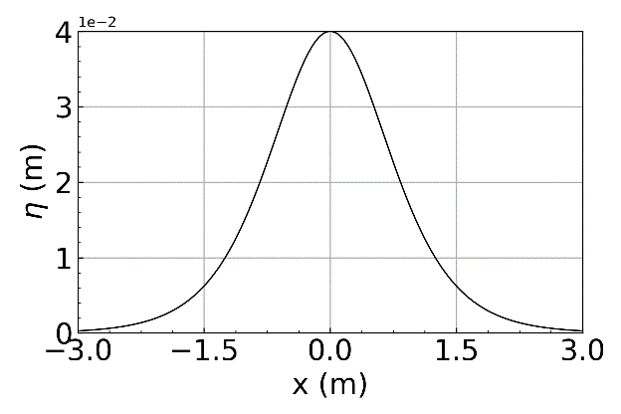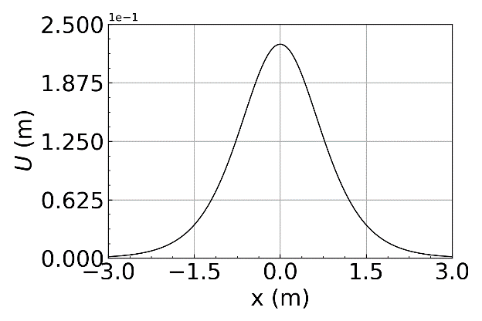
Figure 1: Initial value plot

- Solve the 1DH LSWE
In this study, I written a program to solve the 1DH LSWE using these initial conditions, for -12 < x < 24 (m) and 0 < t < 6.95 (s). I try using the step sizeΔx = 0.06 m as a start. The codes are shown in the appendix.

- Validation
In order to make sure my code runs correctly. I compared my numerical results forηagainst the analytical solution at t = 6.95 s, i.e., (7). The results are shown in Figure 2

- Behavior on Different Step Sizes
I run several simulations with different step sizesΔx at physical time equal 6.95. The results are shown in Figure 2.

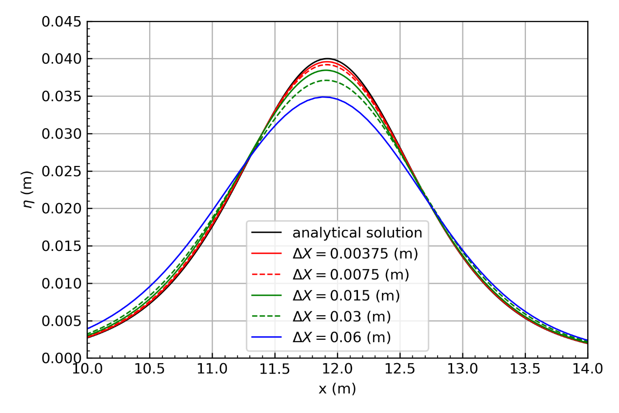
Figure 2: Reference plot for topic 6 and 7.
- Grid Dependency Test
The results are shown in Figure 3 which shown that the convergence rate of the Lax-Friedrichs numerical scheme is first-order.
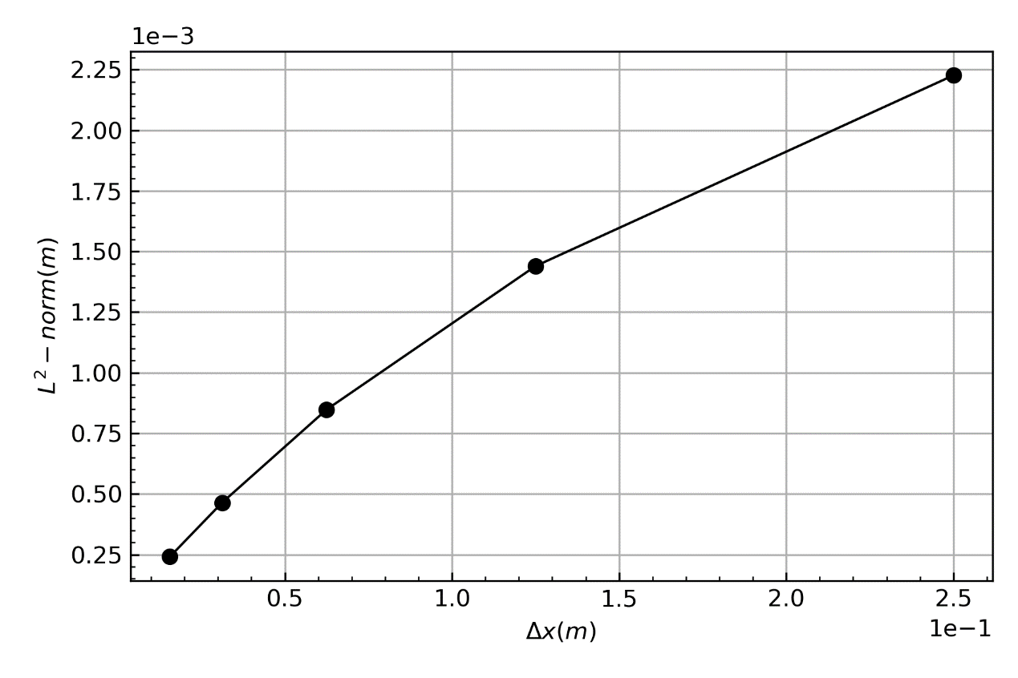
Figure 3: Reference plot for topic 8.
Appendix

Python Code:

# -*- coding: utf-8 -*-
"""
Created on Tue Mar 17 12:33:45 2020

@author: 88693
"""

import numpy as np
import matplotlib.pyplot as plt
from matplotlib.ticker import ScalarFormatter
import os
os.chdir('D:\ShallowWaterComputation\HW2b')
from numba import jit

g = 9.806
h = 0.3

def sech(x):
return 1.0/np.cosh(x)

def eta(x, t=0, H=0.04):
K = (1.0/h)*np.sqrt( (3*H) / (4*h) )
C = np.sqrt(g*h)
return H*np.power( sech( K*( x-C*t ) ) , 2 )

def U(x, t=0):
TEMP = eta(x, t)
return TEMP *np.sqrt(g*h) /float(h)

def plot(x,y,xlim=None,ylim=None,xn=5,yn=5,xlabel='',ylabel='',filename=None):
fig, ax1 = plt.subplots()
ax1.plot( x, y, '-', color = 'black', linewidth= 1)
ax1.tick_params(which='both',direction='in')
ax1.minorticks_on()
ax1.grid()
if ( xlim!=None ):
ax1.set_xlim( xlim )
if ( ylim!=None ):
ax1.set_ylim( ylim )
if ( xlabel!='' ):
ax1.set_xlabel(xlabel, fontsize=20)
if ( xlabel!='' ):
ax1.set_ylabel(ylabel, fontsize=20)
plt.xticks( np.linspace(xlim[0],xlim[1],xn), fontsize=20 )
plt.yticks( np.linspace(ylim[0],ylim[1],yn), fontsize=20 )
yfmt = ScalarFormatter()
yfmt.set_powerlimits((0,0))
ax1.yaxis.set_major_formatter(yfmt)
#plt.ticklabel_format(style='sci', axis='y', scilimits=(0,0))
fig.tight_layout()
fig.savefig( filename , dpi=300)

@jit
def Numeri(deltaX,End_Time=6.95,Ccfl=1):
deltaT = float(deltaX)/np.sqrt(g*h)*Ccfl

x = np.arange(-12, 24, deltaX)
t = np.arange(0, End_Time, deltaT)

tlen = len(t)
xlen = len(x)

ETA = np.empty( ( tlen, xlen+2 ) )
Vel_U = np.empty( ( tlen, xlen+2 ) )

#####Initialize

##Cell
x = np.append(x, x[-1]+deltaX )
x = np.append(x[0]-deltaX, x )

xlen = len(x)

for i in range(1,xlen-1):
ETA[0][i] = eta(x[i])

for i in range(1,xlen-1):
Vel_U[0][i] = U(x[i])

##BC
ETA[0][0] = ETA[0][2]
ETA[0][-1] = ETA[0][-3]
Vel_U[0][0] = 0
Vel_U[0][-1] = 0

n = 0
#######Numerical Solution
while( n < (tlen-1) ):
#cell
for i in range(1,xlen-1):
ETA[n+1][i] = ( ETA[n][i+1] + ETA[n][i-1] )/2.0 - (deltaT*h)/(2*deltaX)*( Vel_U[n][i+1] - Vel_U[n][i-1] )
Vel_U[n+1][i] = ( Vel_U[n][i+1] + Vel_U[n][i-1] ) /2.0 - (deltaT*g)/(2*deltaX)*( ETA[n][i+1] - ETA[n][i-1] )
#BC
ETA[n+1][0] = ETA[n+1][2]
ETA[n+1][-1] = ETA[n+1][-3]
Vel_U[n+1][0] = 0
Vel_U[n+1][-1] = 0
n = n+1
return x, ETA

####Initial Plot
deltaX = 0.00375
x = np.arange(-12, 24, deltaX)
U0 = U(x)
ETA0 = eta(x, t=0, H=0.04)

plot(x,ETA0, xlim = [-3,3], ylim = [0,0.04],xlabel='x (m)' ,ylabel='${\eta}$ (m)',filename='ETA0.png')
plot(x,U0, xlim = [-3,3], ylim = [0,0.25],xlabel='x (m)' ,ylabel='${U}$ (m)',filename='U0.png')

####Q1
Cfl = 0.9
x1,ETA1= Numeri(0.00375, Ccfl=Cfl)
x2,ETA2= Numeri(0.0075, Ccfl=Cfl)
x3,ETA3= Numeri(0.015, Ccfl=Cfl)
x4,ETA4= Numeri(0.03, Ccfl=Cfl)
x5,ETA5= Numeri(0.06, Ccfl=Cfl)

#Analytical Solution
x = np.arange(-12, 24, 0.015)
AnalyticalSol = eta(x,t=6.95)

fig, ax1 = plt.subplots()
l1 = ax1.plot( x, AnalyticalSol, '-', color = 'black', linewidth= 1)
l2 = ax1.plot( x1, ETA1[-1], '-', color = 'r', linewidth= 1)
l3 = ax1.plot( x2, ETA2[-1], '--', color = 'r', linewidth= 1)
l4 = ax1.plot( x3, ETA3[-1], '-', color = 'g', linewidth= 1)
l5 = ax1.plot( x4, ETA4[-1], '--', color = 'g', linewidth= 1)
l6 = ax1.plot( x5, ETA5[-1], '-', color = 'b', linewidth= 1)

ax1.set_xlim( [10,14] )
ax1.set_ylim( [0,0.045] )
ax1.tick_params(which='both',direction='in')
ax1.minorticks_on()
ax1.grid()
ax1.set_xlabel( 'x (m)' )
ax1.set_ylabel( '${\eta}$ (m)' )

lns = l1 + l2 + l3 + l4 + l5 +l6
labels = [ 'analytical solution', '${\Delta}X = 0.00375$ (m)' ,'${\Delta}X = 0.0075$ (m)' ,'${\Delta}X = 0.015$ (m)' ,'${\Delta}X = 0.03$ (m)','${\Delta}X = 0.06$ (m)' ]
ax1.legend(lns ,labels , loc = 'lower center' )

fig.tight_layout()
fig.savefig( 'Q1.png', dpi=300)

###L-norm
@jit
def norm(EtaNum, EtaTheory):
temp = 0
for i , j in zip(EtaNum, EtaTheory):
temp = temp + np.power(i-j, 2)
N = len(EtaNum)
temp = np.sqrt( float(temp) / float(N) )
return temp

Cfl = 0.9
x1,ETA1= Numeri(0.015625, Ccfl=Cfl)
x2,ETA2= Numeri(0.03125, Ccfl=Cfl)
x3,ETA3= Numeri(0.0625, Ccfl=Cfl)
x4,ETA4= Numeri(0.125, Ccfl=Cfl)
x5,ETA5= Numeri(0.25, Ccfl=Cfl)

AnalySol1 = eta(x1,t=6.95)
AnalySol2 = eta(x2,t=6.95)
AnalySol3 = eta(x3,t=6.95)
AnalySol4 = eta(x4,t=6.95)
AnalySol5 = eta(x5,t=6.95)

e1 = norm(ETA1[-1],AnalySol1 )
e2 = norm(ETA2[-1],AnalySol2 )
e3 = norm(ETA3[-1],AnalySol3 )
e4 = norm(ETA4[-1],AnalySol4 )
e5 = norm(ETA5[-1],AnalySol5 )

x = np.array([0.015625, 0.03125, 0.0625, 0.125, 0.25])
Error = np.array([e1,e2,e3,e4,e5])

fig, ax1 = plt.subplots()
l1 = ax1.plot( x, Error, '-o', color = 'black', linewidth= 1)

#ax1.set_xlim( [10,14] )
#ax1.set_ylim( [0,0.045] )
ax1.tick_params(which='both',direction='in')
ax1.minorticks_on()
ax1.grid()
ax1.yaxis.get_major_formatter().set_powerlimits((0,2))
ax1.xaxis.get_major_formatter().set_powerlimits((0,1))
ax1.set_xlabel( '${\Delta}x (m)$ ' )
ax1.set_ylabel( '${L^2}-norm (m)$' )

fig.tight_layout()
fig.savefig( 'Q2.png', dpi=300)

