姓名 : 徐昶亘 學號 : r07525117
Time = 0s
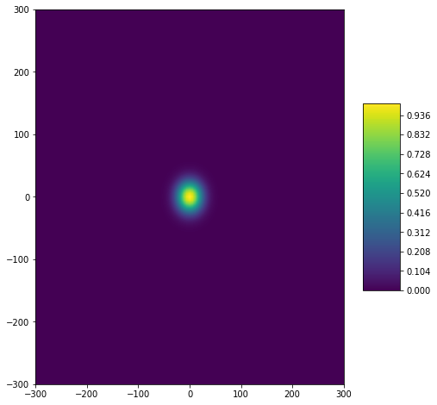
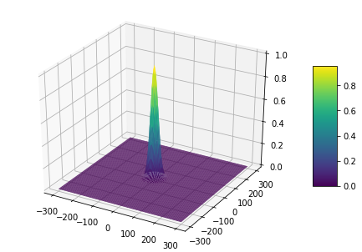

Time = 10s
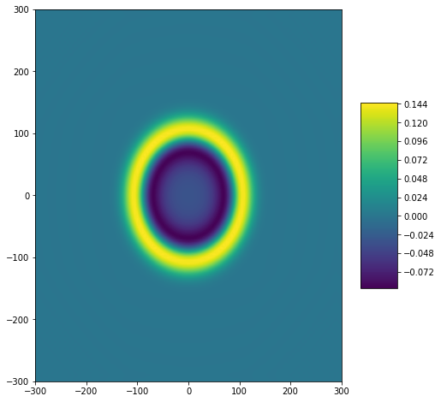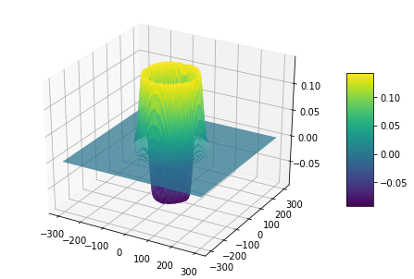

Time = 20s
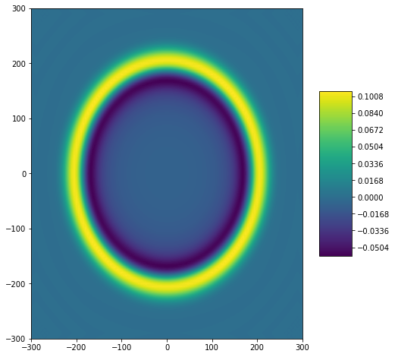
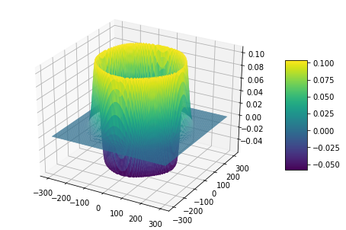
Appendix
# -*- coding: utf-8 -*-
"""
Created on Wed Apr 29 12:52:10 2020

@author: r07525117
"""

import os
os.chdir(r'D:\ShallowWaterComputation\HW4')
import numpy as np

def eta0(x,y,H=1,L=100):
return H*np.exp( -18*( x / L )**2 )*np.exp( -18*( y / L )**2 )

def U0(x,y):
return 0.0

def V0(x,y):
return 0.0

g = 9.806

xMax = 300
xMin = -300
yMax = 300
yMin = -300

tMax = 20
tMin = 0

deltaX = 5
deltaY = 5
deltaT = 0.05
# CFL = 0.85
# deltaT = CFL*( min(deltaX,deltaY) / np.sqrt(g*10) )

x = np.arange(xMin-2*deltaX, xMax+3*deltaX, deltaX)
y = np.arange(yMin-2*deltaY, yMax+3*deltaY, deltaY)
t = np.arange(0, tMax, deltaT)

[X,Y]=np.meshgrid(x,y)
Y = np.flip(Y) ## Make +Y direction be Upper

tlen = len(t)
xlen = len(x)
ylen = len(y)

ETA = np.zeros( ( tlen, ylen, xlen) )
U = np.zeros( ( tlen, ylen, xlen ) )
V = np.zeros( ( tlen, ylen, xlen ) )

ETAs1 = np.zeros( ( ylen, xlen) )
Us1 = np.zeros( ( ylen, xlen ) )
Vs1 = np.zeros( ( ylen, xlen ) )

ETAs2 = np.zeros( ( ylen, xlen) )
Us2 = np.zeros( ( ylen, xlen ) )
Vs2 = np.zeros( ( ylen, xlen ) )

h = np.zeros( ( ylen, xlen) )
h[:] = 10

GN = 2

##Initialization
ETA[0][GN:-GN, GN:-GN] = eta0( X[GN:-GN, GN:-GN], Y[GN:-GN, GN:-GN] )
U[0][GN:-GN, GN:-GN] = U0( X[GN:-GN, GN:-GN], Y[GN:-GN, GN:-GN] )
V[0][GN:-GN, GN:-GN] = V0( X[GN:-GN, GN:-GN], Y[GN:-GN, GN:-GN] )

#Initialization BC
ETA[0][GN:-GN, GN:-GN][ : , [0,1,-1,-2] ] = ETA[0][GN:-GN, GN:-GN][ : , [4,3,-5,-4] ]
ETA[0][GN:-GN, GN:-GN][ [0,1,-1,-2] , : ] = ETA[0][GN:-GN, GN:-GN][ [4,3,-5,-4] , : ]
U[0][GN:-GN, GN:-GN][:,[0,1,-1,-2]] = -U[0][GN:-GN, GN:-GN][:,[4,3,-5,-4]] ##L boundary
U[0][GN:-GN, GN:-GN][[0,1,-1,-2],:] = U[0][GN:-GN, GN:-GN][[4,3,-5,-4],:] ##D boundary
V[0][GN:-GN, GN:-GN][:,[0,1,-1,-2]] = V[0][GN:-GN, GN:-GN][:,[4,3,-5,-4]]
V[0][GN:-GN, GN:-GN][[0,1,-1,-2],:] = -V[0][GN:-GN, GN:-GN][[4,3,-5,-4],:]

# import matplotlib.pyplot as plt
# from mpl_toolkits.mplot3d import Axes3D

# fig = plt.figure(figsize=(8, 8))
# plt.contourf( X[2:-2,2:-2] ,Y[2:-2,2:-2] , ETA[0][2:-2,2:-2] )
# plt.xlim([-40, 40])
# plt.ylim([-40, 40])
# plt.show()

n = 0
while( n < (tlen-1) ):

#Cell-first round
ETAs1[GN:-GN, GN:-GN] = ETA[n][GN:-GN, GN:-GN]\
- ( (deltaT) / (12*deltaX) )*\
( -U[n][GN:-GN, (GN+2):]*h[GN:-GN, (GN+2):]\
+ 8*U[n][GN:-GN, (GN+1):(-GN+1)]*h[GN:-GN, (GN+1):(-GN+1)]\
-8*U[n][GN:-GN, (GN-1):(-GN-1)]*h[GN:-GN, (GN-1):(-GN-1)] \
+ U[n][GN:-GN, (GN-2):(-GN-2)]*h[GN:-GN, (GN-2):(-GN-2)] )\
-( (deltaT) / (12*deltaY) )*\
( -V[n][(GN+2):, GN:-GN]*h[(GN+2):, GN:-GN] \
+8*V[n][(GN+1):(-GN+1), GN:-GN]*h[(GN+1):(-GN+1), GN:-GN]\
-8*V[n][(GN-1):(-GN-1), GN:-GN]*h[(GN-1):(-GN-1), GN:-GN] \
+ V[n][(GN-2):(-GN-2), GN:-GN]*h[(GN-2):(-GN-2), GN:-GN] )

Us1[GN:-GN, GN:-GN] = U[n][GN:-GN, GN:-GN] - ( (deltaT*g) / (12*deltaX) )*\
(-ETA[n][GN:-GN, (GN+2):]
+8*ETA[n][GN:-GN, (GN+1):(-GN+1)]\
-8*ETA[n][GN:-GN, (GN-1):(-GN-1)]\
+ETA[n][GN:-GN, (GN-2):(-GN-2)] )

Vs1[GN:-GN, GN:-GN] = V[n][GN:-GN, GN:-GN] - ( (deltaT*g) / (12*deltaY) )*\
(-ETA[n][(GN+2):, GN:-GN]\
+8*ETA[n][(GN+1):(-GN+1), GN:-GN]\
-8*ETA[n][(GN-1):(-GN-1), GN:-GN]\
+ETA[n][(GN-2):(-GN-2), GN:-GN] )

#BC-first round
ETAs1[GN:-GN, GN:-GN][ : , [0,1,-1,-2] ] = ETAs1[GN:-GN, GN:-GN][ : , [4,3,-5,-4] ]
ETAs1[GN:-GN, GN:-GN][ [0,1,-1,-2] , : ] = ETAs1[GN:-GN, GN:-GN][ [4,3,-5,-4] , : ]

Us1[GN:-GN, GN:-GN][:,[0,1,-1,-2]] = -Us1[GN:-GN, GN:-GN][:,[4,3,-5,-4]] ##L boundary
Us1[GN:-GN, GN:-GN][[0,1,-1,-2],:] = Us1[GN:-GN, GN:-GN][[4,3,-5,-4],:] ## D boundary

Vs1[GN:-GN, GN:-GN][:,[0,1,-1,-2]] = Vs1[GN:-GN, GN:-GN][:,[4,3,-5,-4]] ##L boundary
Vs1[GN:-GN, GN:-GN][[0,1,-1,-2],:] = -Vs1[GN:-GN, GN:-GN][[4,3,-5,-4],:] ##D boundary

#Cell-Second round
ETAs2[GN:-GN, GN:-GN] = (3.0/4.0)*ETA[n][GN:-GN, GN:-GN] + (1.0/4.0)*ETAs1[GN:-GN, GN:-GN]\
-( deltaT/(4.0*12*deltaX) )*\
(-Us1[GN:-GN, (GN+2):]*h[GN:-GN, (GN+2):]\
+8*Us1[GN:-GN, (GN+1):(-GN+1)]*h[GN:-GN, (GN+1):(-GN+1)]\
-8*Us1[GN:-GN, (GN-1):(-GN-1)]*h[GN:-GN, (GN-1):(-GN-1)]\
+Us1[GN:-GN, (GN-2):(-GN-2)]*h[GN:-GN, (GN-2):(-GN-2)] )\
-( deltaT/(4.0*12*deltaY) )*\
(-Vs1[(GN+2):, GN:-GN ]*h[(GN+2):, GN:-GN]\
+8*Vs1[(GN+1):(-GN+1), GN:-GN]*h[(GN+1):(-GN+1), GN:-GN]\
-8*Vs1[(GN-1):(-GN-1), GN:-GN]*h[(GN-1):(-GN-1), GN:-GN]\
+Vs1[(GN-2):(-GN-2), GN:-GN]*h[(GN-2):(-GN-2), GN:-GN])

Us2[GN:-GN, GN:-GN] = (3.0/4.0)*U[n][GN:-GN, GN:-GN] + (1.0/4.0)*Us1[GN:-GN, GN:-GN]\
- ( (deltaT*g) / (4.0*12*deltaX) )*\
( -ETAs1[GN:-GN, (GN+2):]\
+8*ETAs1[GN:-GN, (GN+1):(-GN+1)]\
-8*ETAs1[GN:-GN, (GN-1):(-GN-1)]\
+ETAs1[GN:-GN, (GN-2):(-GN-2)] )

Vs2[GN:-GN, GN:-GN] = (3.0/4.0)*V[n][GN:-GN, GN:-GN] + (1.0/4.0)*Vs1[GN:-GN, GN:-GN]\
- ( (deltaT*g) / (4.0*12*deltaY) )*\
( -ETAs1[(GN+2):, GN:-GN]\
+8*ETAs1[(GN+1):(-GN+1), GN:-GN]\
-8*ETAs1[(GN-1):(-GN-1), GN:-GN]\
+ETAs1[(GN-2):(-GN-2), GN:-GN] )

#BC-Second round
ETAs2[GN:-GN, GN:-GN][ : , [0,1,-1,-2] ] = ETAs2[GN:-GN, GN:-GN][ : , [4,3,-5,-4] ]
ETAs2[GN:-GN, GN:-GN][ [0,1,-1,-2] , : ] = ETAs2[GN:-GN, GN:-GN][ [4,3,-5,-4] , : ]

Us2[GN:-GN, GN:-GN][:,[0,1,-1,-2]] = -Us2[GN:-GN, GN:-GN][:,[4,3,-5,-4]] ##L boundary
Us2[GN:-GN, GN:-GN][[0,1,-1,-2],:] = Us2[GN:-GN, GN:-GN][[4,3,-5,-4],:] ## D boundary

Vs2[GN:-GN, GN:-GN][:,[0,1,-1,-2]] = Vs2[GN:-GN, GN:-GN][:,[4,3,-5,-4]] ##L boundary
Vs2[GN:-GN, GN:-GN][[0,1,-1,-2],:] = -Vs2[GN:-GN, GN:-GN][[4,3,-5,-4],:] ##D boundary

#Cell-Third round
ETA[n+1][GN:-GN, GN:-GN] = (1.0/3.0)*ETA[n][GN:-GN, GN:-GN] + (2.0/3.0)*ETAs2[GN:-GN, GN:-GN]\
-( (2*deltaT) / (3.0*12*deltaX) )*\
(-Us2[GN:-GN, (GN+2):]*h[GN:-GN, (GN+2):]\
+8*Us2[GN:-GN, (GN+1):(-GN+1)]*h[GN:-GN, (GN+1):(-GN+1)]\
-8*Us2[GN:-GN, (GN-1):(-GN-1)]*h[GN:-GN, (GN-1):(-GN-1)]\
+Us2[GN:-GN, (GN-2):(-GN-2)]*h[GN:-GN, (GN-2):(-GN-2)] )\
-( (2*deltaT) / (3.0*12*deltaY) )*\
( -Vs2[(GN+2):, GN:-GN]*h[(GN+2):, GN:-GN]\
+8*Vs2[(GN+1):(-GN+1), GN:-GN]*h[(GN+1):(-GN+1), GN:-GN]\
-8*Vs2[(GN-1):(-GN-1), GN:-GN]*h[(GN-1):(-GN-1), GN:-GN]\
+Vs2[(GN-2):(-GN-2), GN:-GN]*h[(GN-2):(-GN-2), GN:-GN] )

U[n+1][GN:-GN, GN:-GN] = (1.0/3.0)*U[n][GN:-GN, GN:-GN] + (2.0/3.0)*Us2[GN:-GN, GN:-GN]\
- ( (2*deltaT*g)/(3.0*12*deltaX) )*\
( -ETAs2[GN:-GN, (GN+2):]\
+8*ETAs2[GN:-GN, (GN+1):(-GN+1)]\
-8*ETAs2[GN:-GN, (GN-1):(-GN-1)]\
+ETAs2[GN:-GN, (GN-2):(-GN-2)] )

V[n+1][GN:-GN, GN:-GN] = (1.0/3.0)*V[n][GN:-GN, GN:-GN] + (2.0/3.0)*Vs2[GN:-GN, GN:-GN]\
-( (2*deltaT*g)/(3.0*12*deltaY) )*\
( -ETAs2[(GN+2):, GN:-GN]\
+8*ETAs2[(GN+1):(-GN+1), GN:-GN]\
-8*ETAs2[(GN-1):(-GN-1), GN:-GN]\
+ETAs2[(GN-2):(-GN-2), GN:-GN] )

#BC-Third round
ETA[n+1][GN:-GN, GN:-GN][ : , [0,1,-1,-2] ] = ETA[n+1][GN:-GN, GN:-GN][ : , [4,3,-5,-4] ]
ETA[n+1][GN:-GN, GN:-GN][ [0,1,-1,-2] , : ] = ETA[n+1][GN:-GN, GN:-GN][ [4,3,-5,-4] , : ]

U[n+1][GN:-GN, GN:-GN][:,[0,1,-1,-2]] = -U[n+1][GN:-GN, GN:-GN][:,[4,3,-5,-4]] ##L boundary
U[n+1][GN:-GN, GN:-GN][[0,1,-1,-2],:] = U[n+1][GN:-GN, GN:-GN][[4,3,-5,-4],:] ##D boundary

V[n+1][GN:-GN, GN:-GN][:,[0,1,-1,-2]] = V[n+1][GN:-GN, GN:-GN][:,[4,3,-5,-4]]
V[n+1][GN:-GN, GN:-GN][[0,1,-1,-2],:] = -V[n+1][GN:-GN, GN:-GN][[4,3,-5,-4],:]
n = n+1
#return x,t,ETA,U,V

import matplotlib.pyplot as plt
from mpl_toolkits.mplot3d import Axes3D
from matplotlib import cm

fig = plt.figure(figsize=(8, 8))
surf = plt.contourf( X[2:-2,2:-2], Y[2:-2,2:-2], ETA[0][2:-2,2:-2], levels=250)
# plt.xlim([-300, 300])
# plt.ylim([-300, 300])

fig.colorbar(surf, shrink=0.5, aspect=5.0)
plt.show()

fig = plt.figure()
ax = Axes3D(fig)
surf = ax.plot_surface(X[2:-2, 2:-2], Y[2:-2, 2:-2], ETA[0][2:-2, 2:-2], rstride=1, cstride=1, cmap=cm.viridis)
fig.colorbar(surf, shrink=0.5, aspect=5.0)
plt.show()

