徐昶亘 r07525117 工海碩二
一、
Input :
$$\vec{u}=[8,4,1,0,0,0,4,3,0,-5,-5,2]$$

Output:

$$\vec{u^{+}}=\left[10,5.71429,1.75,0,0,0,4,3.75,1.875,-5,-5,-1.5\right] \\ \vec{u^{-}}=[6,2.28571,0.25,0,0,0,4,2.25,-1.875,-5,-5,5.5]$$

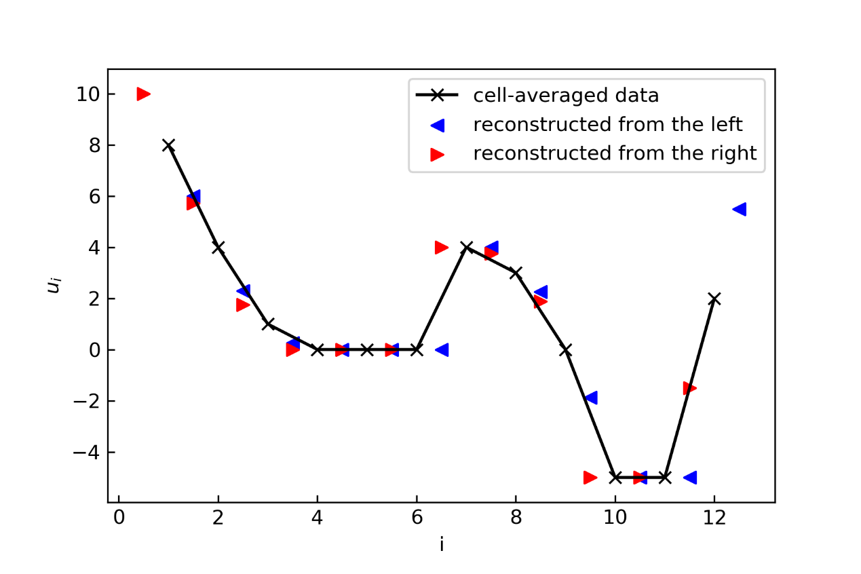

Code:
import numpy as np
import matplotlib.pyplot as plt
import os
os.chdir(r'D:\ShallowWaterComputation\HW5')

def MUSCL(u):
u = np.concatenate( ( [ 2*u[0] -u[1] ] , u , [ 2*u[-1] - u[-2] ] ) )
GN = 1
DelP = u[GN+1:] - u[GN:-GN]
DelN = u[GN:-GN]- u[GN-1:-GN-1]

DelBar = ( DelP*abs(DelN) + abs(DelP)*DelN )/( abs(DelP) + abs(DelN) )
DelBar[np.isnan(DelBar)] = 0

uP = u[GN:-GN] - 0.5*DelBar
uN = u[GN:-GN] + 0.5*DelBar
return uP,uN

u = np.array( [0,0,1,4,-4,0,0,5,4,2,-1,2] )
uP,uN = MUSCL(u)

u2 = np.array( [8,4,1,0,0,0,4,3,0,-5,-5,2] )
u2P,u2N = MUSCL(u2)

i = np.arange(1,13)
#plt.figure(figsize=(5,5))
plt.plot(i , u2 , '-x' ,c = 'black' , label = "cell-averaged data" )
#plt.scatter(i , u2 , marker = 'x' , c = 'black')
plt.scatter(i+0.5 , u2N , marker = '<' , c = 'blue', label = "reconstructed from the left" )
plt.scatter(i-0.5 , u2P , marker = '>' , c = 'red', label = "reconstructed from the right")
plt.legend()

plt.xlabel(xlabel='i')
plt.ylabel(ylabel='$u_i$')

plt.tick_params(which='both',direction='in')
plt.savefig("HW5Q1.png" , dpi = 300)

二、
Input :

$$\left\{\begin{aligned}\vec{η^{-}}=\left[-0.01,-0.01,-0.33,-0.40,0.28,0.29,0.13\right] \\ \vec{η^{+}}=\left[-0.01,-0.13,-0.4,0.17,0.29,0.13,0.13\right] \\ \vec{U^{-}}=\left[-0.02,-0.09,-0.38,-0.45,0.36,0.36,-0.02\right] \\ \vec{U^{+}}=[0.02,-0.18,-0.45,0.28,0.36,0.20,0.017] \\ h=10\end{aligned}\right.$$

F | 0 | -0.7518 | -3.671 | -3.523 | 3.652 | 3.689 | -0.01517
G | -2.958 | -2.287 | -30.43 | -47.79 | 29.64 | 30.34 | 10.96

Code :

import numpy as np
g = 9.806

def HLLC(EtaN, EtaP, UN, UP, h):
HP = EtaP + h
HN = EtaN + h
HU_N = HN*UN
HU_P = HP*UP

NegPara = HN*(UN**2) + 0.5*g*(EtaN**2 + 2*EtaN*h)
PosPara = HP*(UP**2) + 0.5*g*(EtaP**2 + 2*EtaP*h)

us = 0.5*(UN+UP) + (g*HN)**0.5 - (g*HP)**0.5
cs = 0.5*( (g*HN)**0.5 + (g*HP)**0.5 ) + 0.25*( UN - UP )
SN = np.array( [ min(i,j) for i , j in zip( UN - (g*HN)**0.5 , us - cs ) ] )
SP = np.array( [ max(i,j) for i , j in zip( UP + (g*HP)**0.5 , us + cs ) ] )
PhiSN = HN*(SN - UN)/(SN - us)*np.array( [[1]*len(us), list(us)] )
PhiSP = HP*(SP - UP)/(SP - us)*np.array( [[1]*len(us), list(us)] )
PhiN = np.array( [ HN , HU_N] )
PhiP = np.array( [ HP , HU_P] )

fN = np.array( [ HU_N , NegPara ] )
fP = np.array( [ HU_P , PosPara ] )

f = np.zeros((2,len(SN)))
for i in range( len(SN) ):
if ( 0 <= SN[i] ):
f[:,[i]] = fN[:,[i]]
elif ( SN[i] < 0 <= us[i] ):
f[:,[i]] = fN[:,[i]] + SN[i]*( PhiSN[:,[i]] - PhiN[:,[i]] )
elif ( us[i] < 0 <= SP[i] ):
f[:,[i]] = fP[:,[i]] + SP[i]*( PhiSP[:,[i]] - PhiP[:,[i]] )
elif ( SP[i] < 0 ):
f[:,[i]] = fP[:,[i]]
return f[0] , f[1]

EtaN2 = np.array([-0.01,-0.01,-0.33,-0.40,0.28,0.29,0.13])
EtaP2 = np.array([-0.01,-0.13,-0.4,0.17,0.29,0.13,0.13])
UN2 = np.array([-0.02,-0.09,-0.38,-0.45,0.36,0.36,-0.02])
UP2 = np.array([0.02,-0.18,-0.45,0.28,0.36,0.20,0.017])
h2 = 10

F2,G2 = HLLC(EtaN2, EtaP2, UN2, UP2, h2)

