Game Design Document

Fill up the following document

1. Write the title of your project.

THE SPACE BLASTERS

1. What is the goal of the game?

To destroy as many comets as possible in the shortest amount of time.

1. Write a brief story of your game.

It’s the year 2500 the Earth is under severe danger. A number of comets are headed towrads Earth and each planetoid can inflict mass sclae destruction on the planet. A space organisation named WJSO aims on destroying these comets before they enter the Earth’s atmosphere. They need your help in doing so. Quick take control of your pod and help destroy all these extraterristrial objects before they can unleah havoc on our planet

1. Which are the playing characters of this game?

* Playing characters are the ones who respond to the user based on the input from the user.
* Cars, monkeys, dinos, wizards, etc., are the playing characters in the game.

|  |  |  |
| --- | --- | --- |
| Number | Character Name | What can this character do? |
| 1 | Pod 1 | Eliminate comets |
| 2 |  |  |
| 3 |  |  |
| 4 |  |  |
| 5 |  |  |
| 6 |  |  |
| 7 |  |  |
| 8 |  |  |

1. Which are the Non-Playing Characters of this game?

* Non-Playing characters are the ones that don't have an action or behavior when the user interacts with the game.
* Hurdles, stones, bananas, coins, etc., are non-playing characters in the game.

|  |  |  |
| --- | --- | --- |
| Number | Character Name | What can this character do? |
| 1 | Comet | Destroy pod |
| 2 |  |  |
| 3 |  |  |
| 4 |  |  |
| 5 |  |  |
| 6 |  |  |
| 7 |  |  |
| 8 |  |  |

Draw your imagination of this game. What does this game look like?

* Draw the game either on your computer or on paper.
* Add images of the game scenes to show each of the playing and non-playing characters at least once.

POD

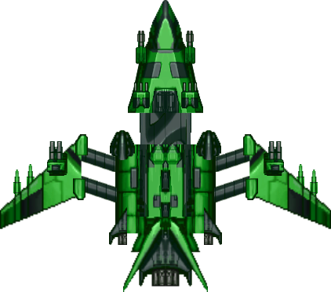

COMET



How do you plan to make your game engaging?

The game will start a little slow for players to get a hang of it. Hoowever as the player makes progress the speed and intensity of the game will pick up pace to a point where it will become almost impossible for the players to keep up with it. It will be a challenge for the all the game lovers to test their abilities and the amount of time they can last.