Page_all.html

index.html

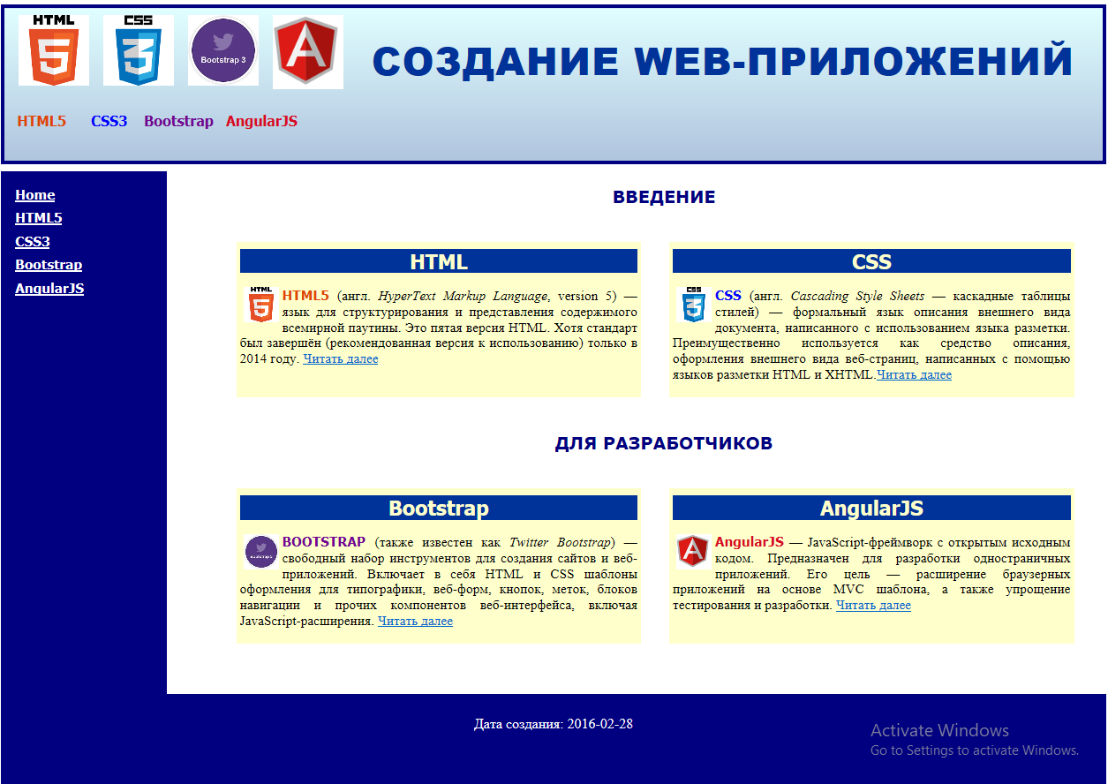

HTML5

CSS3

Bootstrap

AngularJS