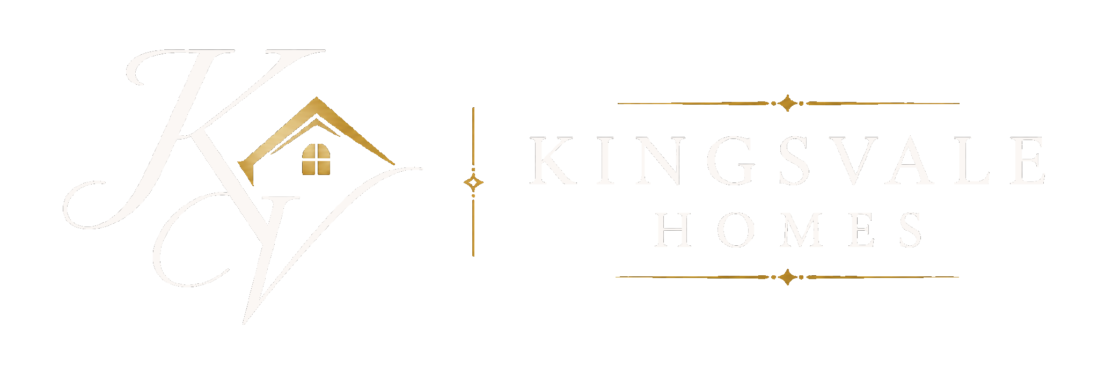

PRIVATE & CONFIDENTIAL  {{legal_name}}  {{street}}  {{address_line_2}}  {{town}}  {{county}}  {{postal_code}} | {{date}}

Dear Sir/Madam,
I am writing to you regarding your property, as it may have the potential to unlock additional value through the planning process.
At Kingsvale Homes, we work with landowners where there may be a genuine opportunity to enhance the value of land or property in a careful and considered manner.
In many cases, landowners are realising six-figure increases in value by taking the right approach and exploring planning potential at the right time. With extensive experience navigating the planning process and identifying opportunities that are often overlooked, we are well placed to assess what may realistically be achievable. “
What makes this different is how we work:
• We cover all planning and professional costs
• We take on the full risk
• You remain in control throughout
• You benefit financially once planning is secured and the land is sold
There is no cost to you at any stage.
I appreciate this may not be something you have actively considered, and approaches of this nature are often treated with caution. However, where there is genuine potential, it can be worth understanding what may be possible before the opportunity is missed.
If you are open to it, I would suggest a brief, confidential conversation. I can give you a clear view of what could realistically be achieved with your property, without obligation. Please contact me via email at thomas@kingsvalehomes.co.uk or if you prefer, please call 07879 587587. Alternatively, scan the QR code to visit our website. I look forward to hearing from you.
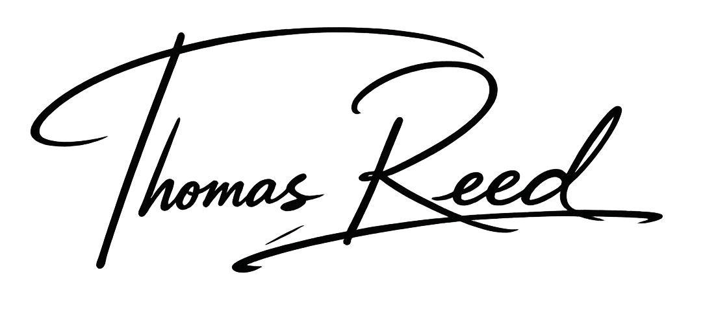  Kind Regards  Thomas Reed  Land & Planning Manager
  Scan to view | 

