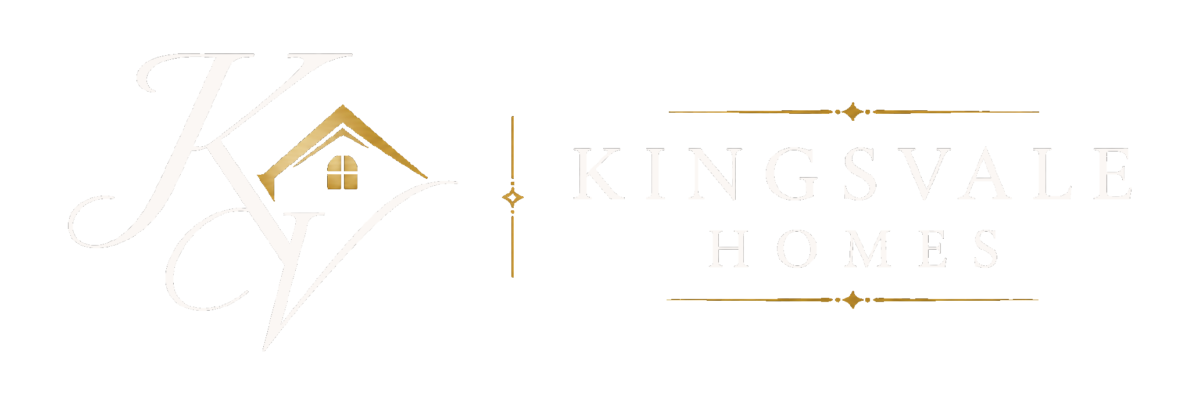

PRIVATE & CONFIDENTIAL  {{legal_name}}  {{street}}  {{address_line_2}}  {{town}}  {{county}}  {{postal_code}} | {{date}}

Dear Sir/Madam
I wrote to you recently regarding your property and wanted to follow up.
Since then, I have taken a closer look, and opportunities like yours are becoming increasingly rare, particularly where there is potential to unlock significant value through planning.
In many cases, we are seeing landowners realize six-figure increases in value by approaching this correctly.
What makes this different is how we work:
• We cover all planning and professional costs
• We take on the full risk
• You remain in control throughout
• You benefit financially once planning is secured and the land is sold
There is no cost to you at any stage.
I appreciate this isn’t something most people actively consider, however where there is genuine potential, it is often worth exploring sooner rather than later.
If you’re open to it, I’d suggest a quick, confidential conversation. I can give you a clear view of what could realistically be achieved with your property. Please contact me using the details below, or scan the code to visit our website. I look forward to hearing from you.
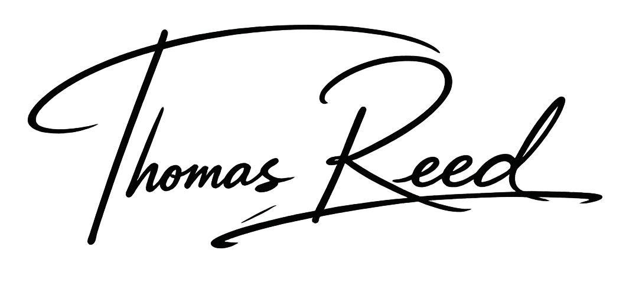  Kind Regards  Thomas Reed  Land & Planning Manager
  Scan to view our website | 

