OPI Quick Start Guide:

Installing OPI is Easy.

1. Plug in the network cable to in Internet enabled port, either directly connected to the Internet or behind a router.

2. Plug connect the supplied USB cable to OPI with the small end (mini-B) and the large flat connector to any always on USB port. OPI is designed with the intention of being placed close to your router, and many routers have a USB port available for printers or USB sticks. In most cases, this can be used to power OPI so that you do not need a seperate power adaptor for OPI.

3. Wait for two of the LEDs to turn solid green and the remaining one to start flashing. This means that OPI is ready for initialization.

4. During the order / delivery process for OPI, you should have received an email with an url to active your unit. The url is in the format of “https://setup.op-i.me/index.php?unit_id=41c189de-83e1-47a2-9a6d-a1d61929b012”. Follow that link and follow the instruction on screen to complete the setup.

Note that the master password you select is not stored anywhere and can not be emailed to you if you loose it.

OPI is designed to keep your information secure, and all personal information is stored encrypted on OPI. So you will need to provide the password on each restart to unlock OPI.

So, the above did not work... What do I do now?

If for some reasons the above process did not work, let us try to figure out why.
- Does the setup page load?
  - - If not, can you reach any other sites on the internet? If you can, then this one is hard to explain. Try again in a little while....
- The page says that I can not reach OPI.
  - This is most likely caused by a firewall. OPI tries to open and forwards ports using upnp, but not all firewall/routers are configured to accept that.
To proceed you must either:
  - Forward at least port 443 to OPI.
or
  - Access OPI from within your local network. In your local network you should be able to reach OPI on https://opi
Note that you must use https (encrypted connection) not just http.

Hopefully you will now be prompted to enter the long activation number from your order confirmation email together and the master password.
Then follow the instructions on screen.

Init process – step by step

- Master Password Selection

The first thing that needs to be done is to choose a master password for OPI. This password is used as a seed for the key that is used to encrypt all information on OPI. The password itself is not stored anywhere and can not be recovered or sent to you by email.
If you loose this password, there is no way to access your information. So be very careful and if you are not sure you can remember it, write it down and store it somewhere safe. Although OPI would be a perfect place to store such sensitive information, we do not encourage you to store your master password on OPI.
That will pose some great challenges when needed to unlock OPI....
The master password dialog box can have two different views, one including the field for the activation code if the page was not accessed from the redirect on OpenProducts setup page.

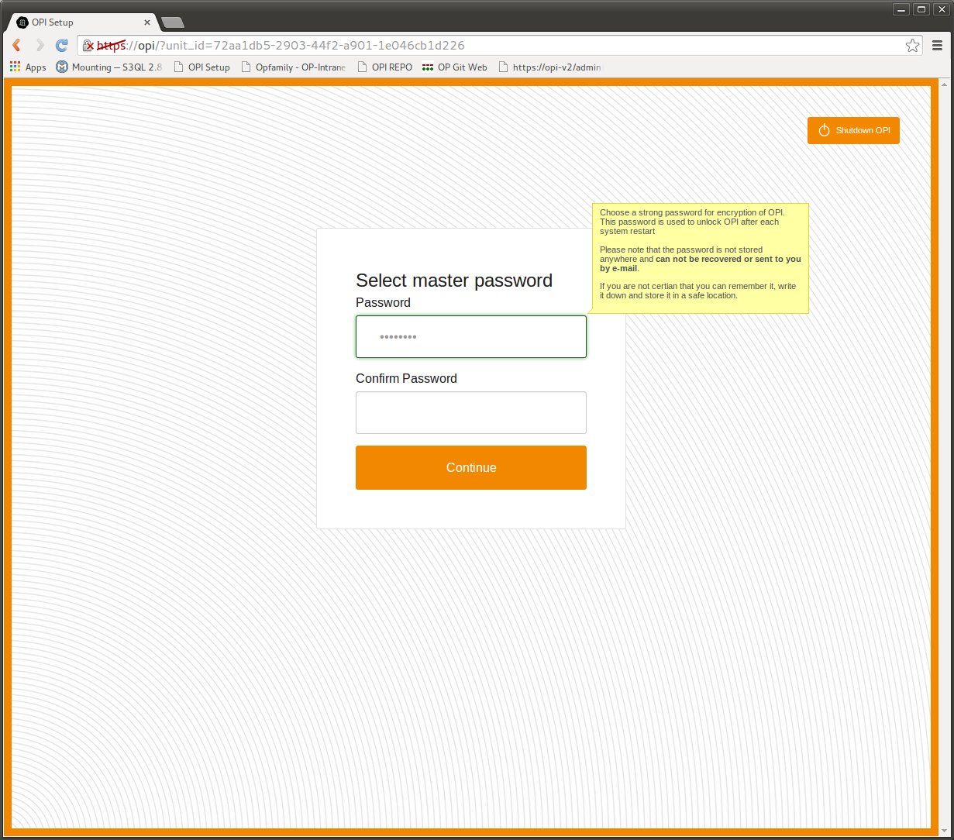

Once the master password is chosen and entered, OPI will encrypt the memory card using the supplied password.

Running this takes a while (8GB x minutes, 64GB z minutes) to please have patience while this is ongoing.
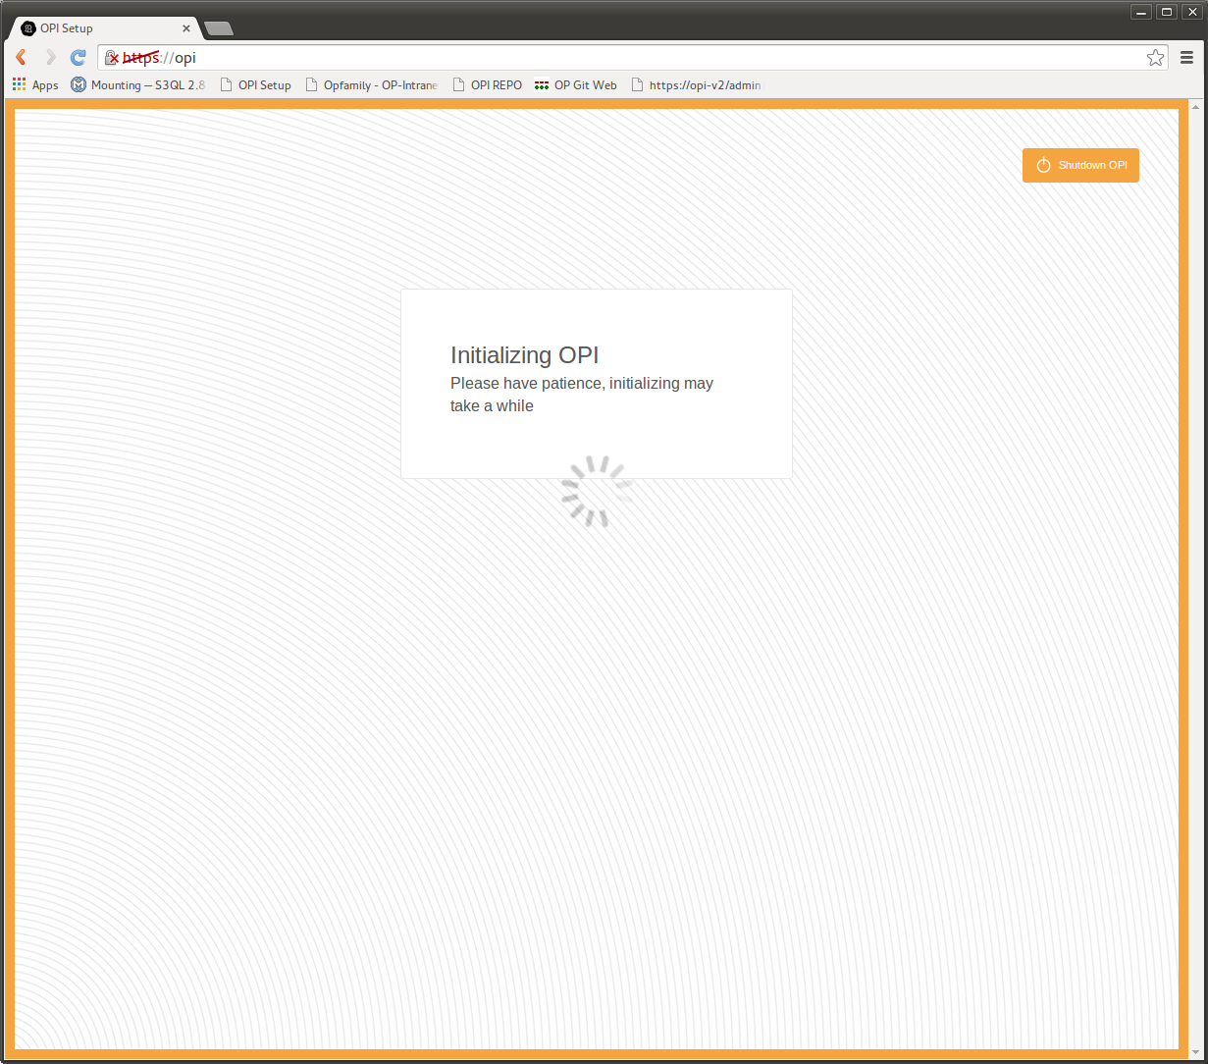

- Add First User

Once the master password has been set, the next step is to add the first user. Enter the users real name, also known in the system as “Display name”, username and password.
The first user entered will also be added to the “admin” group, given access to configure the system.

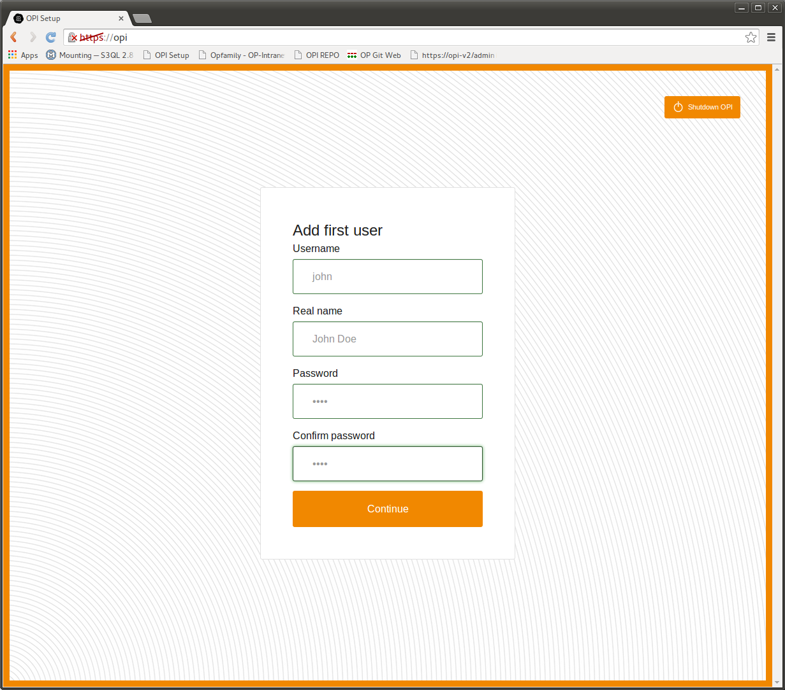

- Select Your OPI Name

In order to find and access OPI over the Internet a domain name needs to be associated with your unit. OpenProducts provides this service, free of charge for all OPIs under the domain “op-i.me”.
In this step you can select a name that prepends the domain name and makes it possible to find your unit. OPI then automatically updates this name if your IP address is changed.
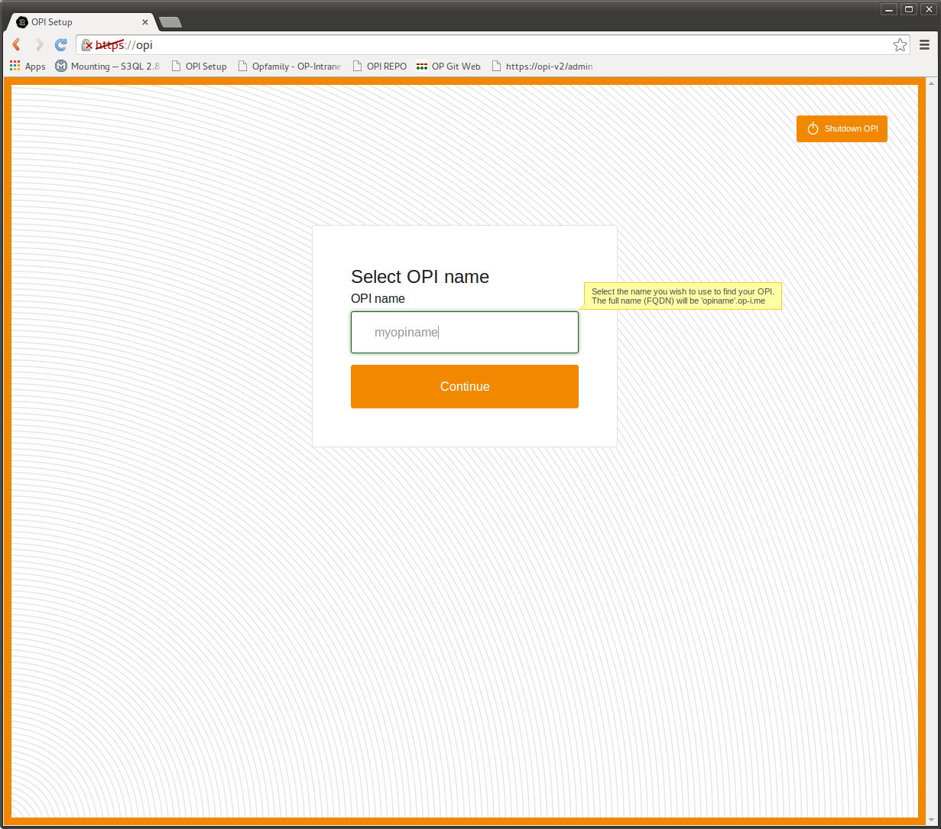
- OPI is Unlocked

All required setups is now complete and you are ready to start using your unit.

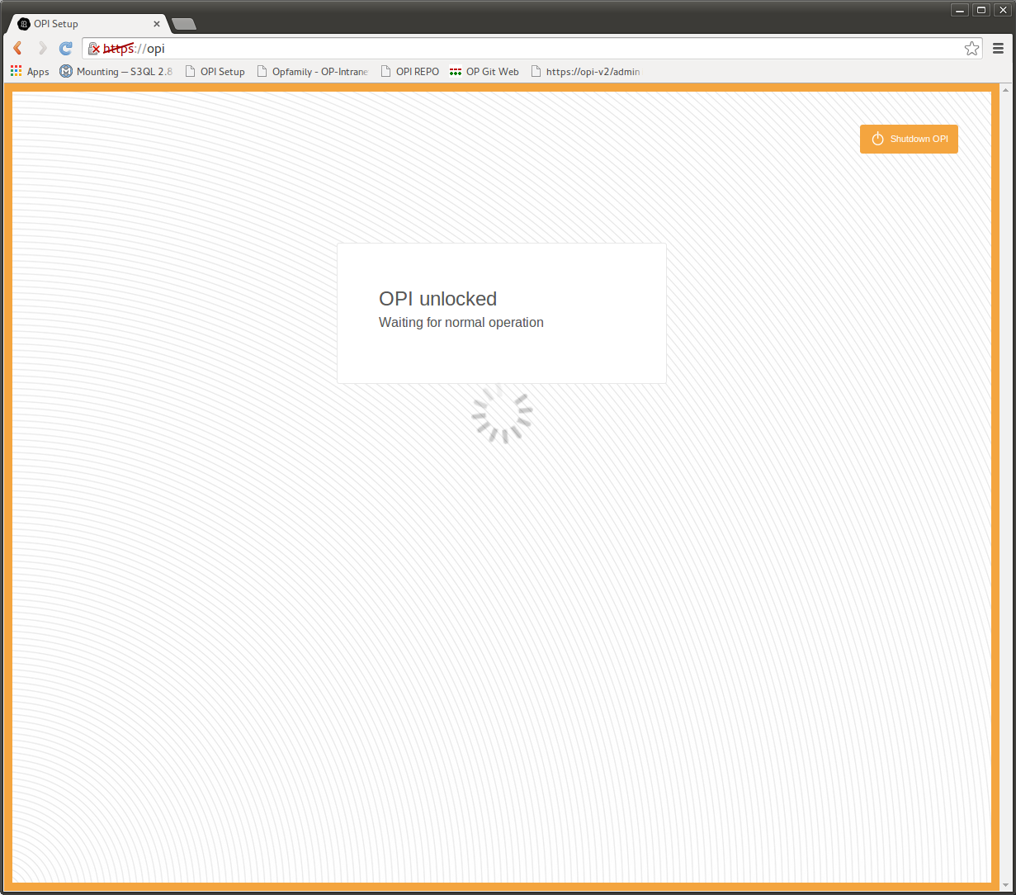
OPI has been unlocked and is starting all services and will redirect to the login page.
During this step, OPI has downloaded a certificate that has been created by OPI and signed by OpenProducts servers.

When redirecting to the login page, you will be warned that the certificate is not trusted. The process of adding the OpenProducts CA (certificate authority) differs between browsers, please see the FAQ below. This warning is expected and can be safely ignored.

- Sign In

Sign into your OPI with your newly created username and password.

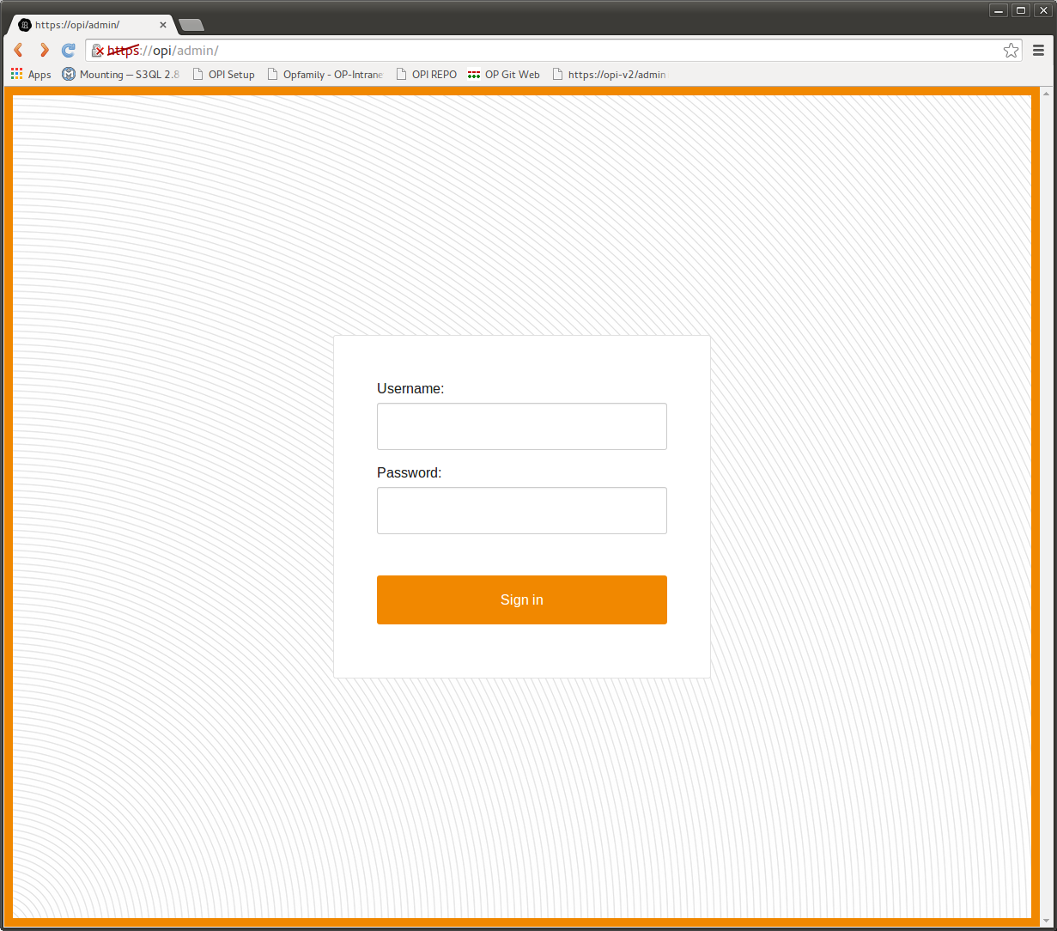
- Navigation Between Applications

In order to quickly be able to switch from one application to the next, a menu system is available in the top right corner of the web interface.

By clicking the orange boxes, a drop down menu is activated and the different applications are presented.

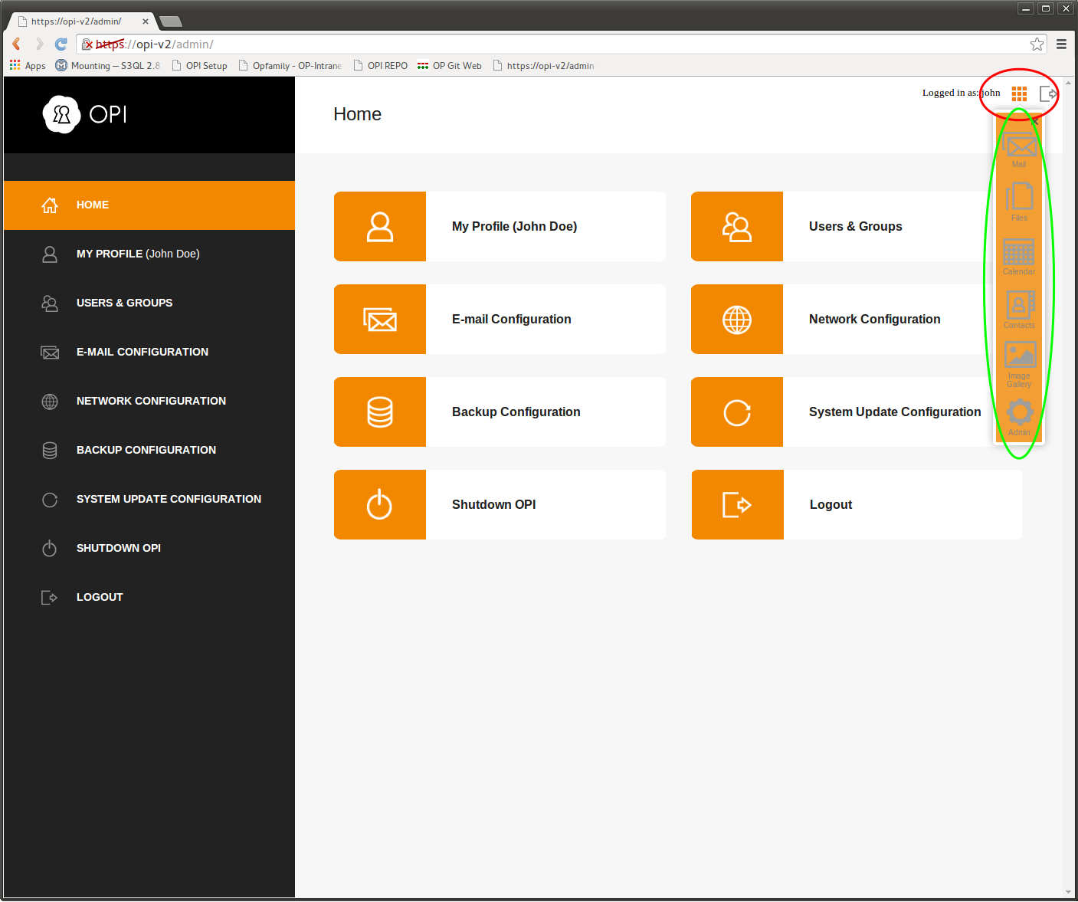
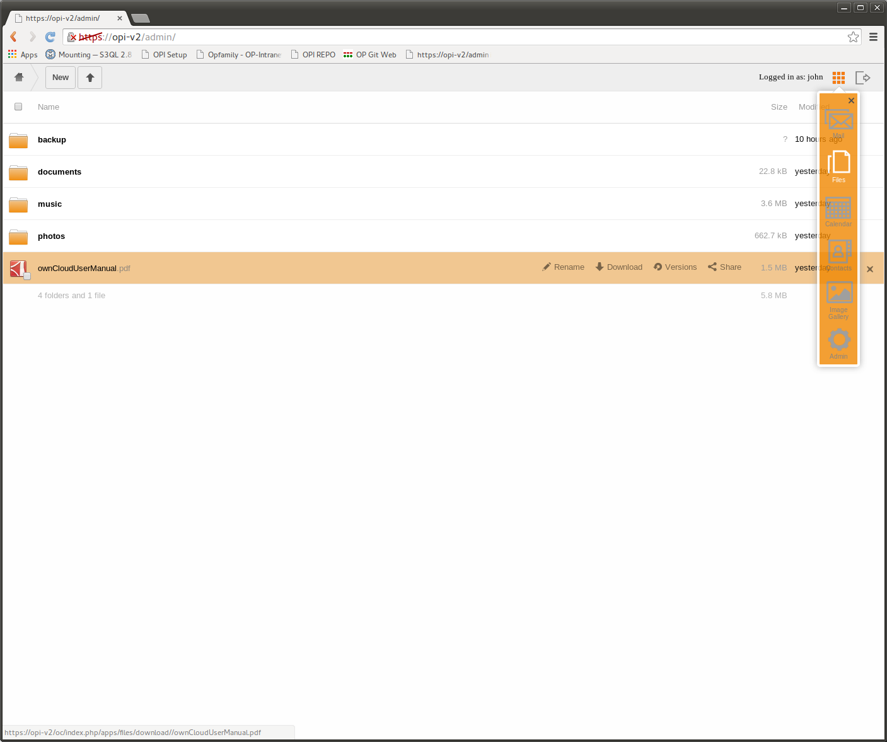
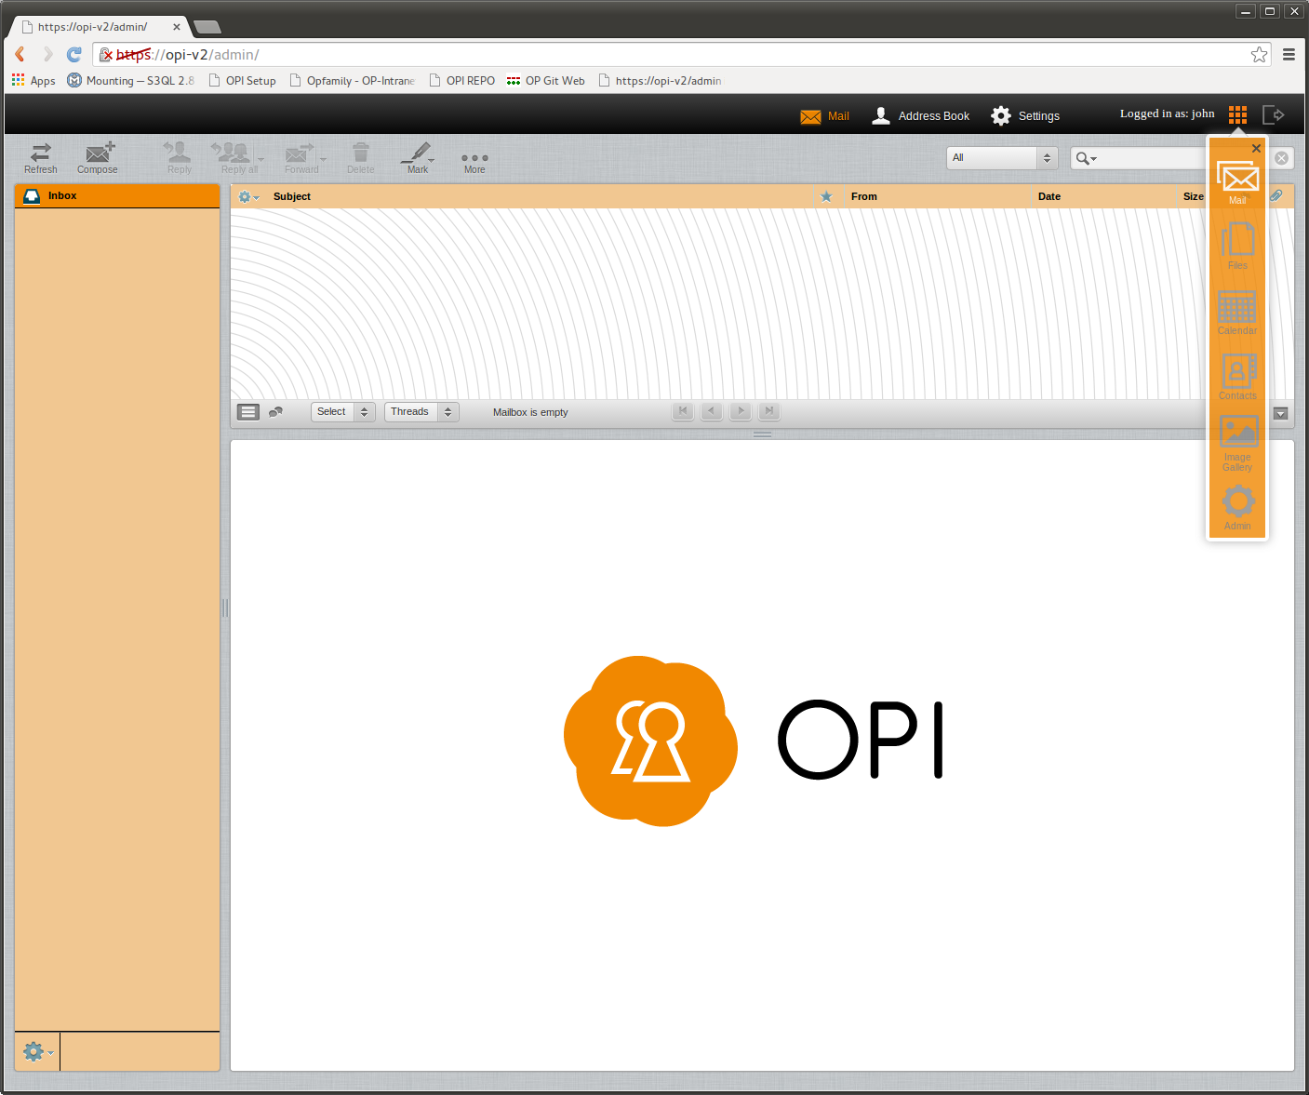
- LED Indication

There are three front LED windows on OPI.
The following table describes the meaning of the LEDs.

LED position | Color | Meaning
Right | Green | The system has detected power and is booting
Middle | Green – solid | The operating system has finished booting
Middle | Green - heartbeat | Backup is ongoing
Left | Green – solid | Normal status, everything up and running
Left | Green - heartbeat | The system is waiting for the user to input the master password
Left | Red – flashing | The lastest backup has failed. Check the web interface, Backup configuration for further error message

Recommended Extended Setup

- Enable Backup
To secure your data we recommend that you enable backup of your data. Not only does this protect you of data loss in case of theft or hardware malfunction, it also provides a time line of your data making it possible to retrieve data from previous versions even if the current data is changed.

- Login with an administrative account (the first user account created during setup is automatically created as an administrative account).
- Select “Backup configuration”
- Check the box “Enable backup”
- Select either “Remote” or “Local” target.
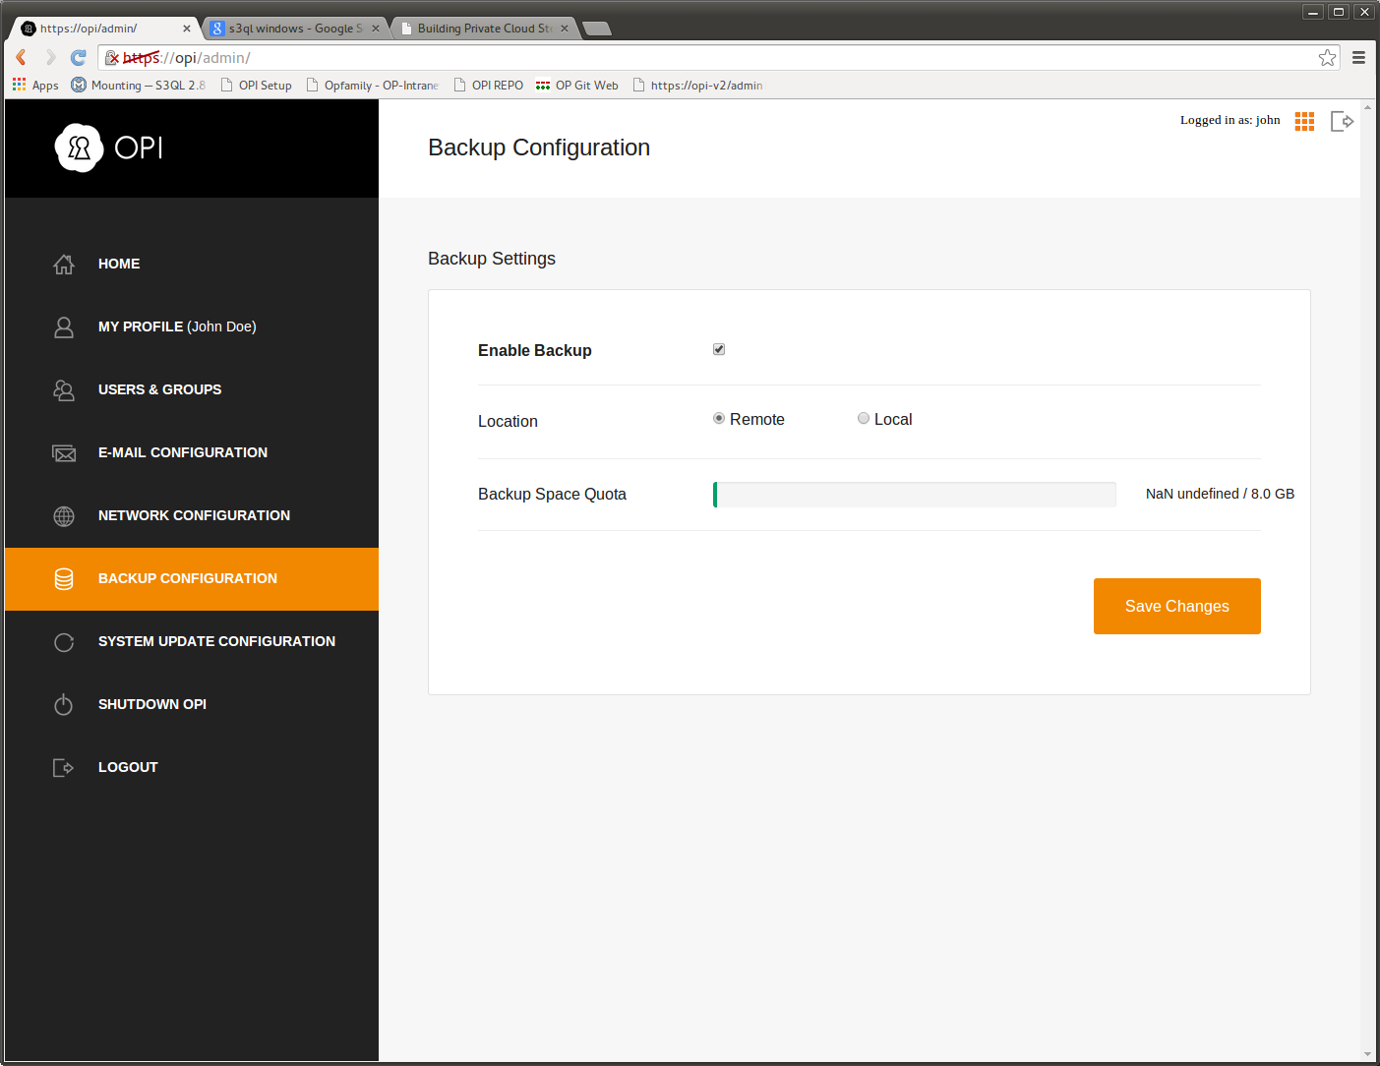
The “Remote” target is OpenProducts servers, located in Sweden. By default, all users are granted 8GB space on our servers free of charge for 3 months.
In order to use the “Local” target, a USB memory or disk needs to be inserted in the USB port on OPI. That device will then be used for backup.
Note that all backups are encrypted prior to leaving OPI, meaning that no one that does not have your master password has the possibility to decrypt your information.

- Install OPI Sync Android Application

To get the most out of your new system, for Android based devices we recommend that you install our application OPI Sync available on Google Play.
The application can be found by scanning the QR code below, or by entering this URL:
https://play.google.com/store/apps/details?id=openproducts.opisettings



In the application you specify your OPI name, username and password and then select which services you would like to synchronize.

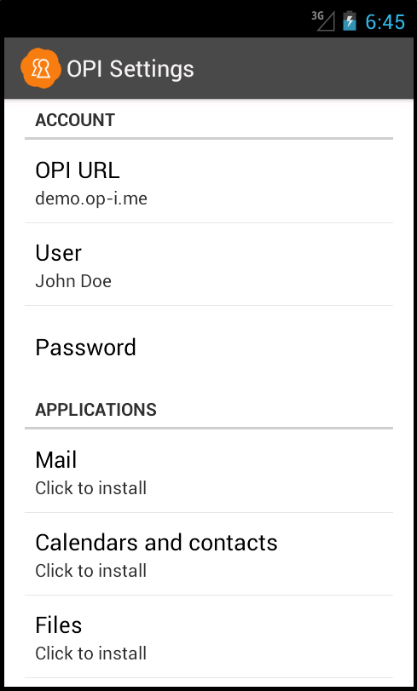
The different services are implemented as separate applications so that only the wanted features gets installed on your device.
These applications are based on open source projects and more information about these applications can be found on their websites.

- Mail: K9 - https://github.com/k9mail/k-9/wiki
- Files: Owncloud - http://owncloud.org/
- Calendar and contact sync: DavDroid - http://davdroid.bitfire.at/what-is-davdroid

Further reading
For further information and reading, please visit our fourm, www.openproducts.com/f

