Student Course Management System
Project Submission Report

Full Name | Victor Oladimeji
Email Address | oladimejivictor611@gmail.com
Department | Software Engineering
Matriculation Number | 2025/A/SENG/0149

1. What the System Does
I built this project to solve a problem I actually have every semester: keeping track of which courses I'm offsetting and how many units they add up to. SCM is a console-based Java program that does this through a simple numbered menu — I can add a course, view everything I've added, search for one by its code, check my total unit load, and save or reload that list from a text file so I don't lose it when I close the program.
It's split into three classes. Main just starts things off. CourseManager does the actual work — it runs the menu loop, keeps the list of courses in memory, and holds all the logic for adding, viewing, searching, saving and loading. Course is a small data class that just stores a course's code, title and unit value.

2. How Each Major Feature Works

2.1 Add Course
This asks for a course code, title and unit value, one at a time, and checks each one before accepting it: the code and title can't be blank, and the unit has to be a positive number. If something's wrong, I throw an IllegalArgumentException with a message that says exactly what failed, and a catch block around it prints that message instead of letting the program crash. If everything checks out, a new Course gets created and added to courseList.

2.2 View Courses
Prints every course in courseList as a formatted table, reusing Course's own toString() so I'm not duplicating formatting logic. If the list is empty it just says so instead of printing an empty table, which looked weird when I first tested it.

2.3 Search Course
Takes a course code from the user and looks for a match using recursion instead of a plain loop (more on that in Section 4). If it finds the course it prints the details; if not, it tells the user plainly that nothing matched that code.

2.4 Compute Total Units
Loops through courseList, adds up every unit value, and prints the total. Nothing fancy here — it's just a quick way to see my total registered load at a glance.

2.5 Save Courses
Writes every course to courses.txt as a comma-separated line (code, title, unit) using a BufferedWriter, so the list survives after the program closes.

2.6 Load Courses
Reads courses.txt back in with a BufferedReader, one line at a time, splits each line on the comma, and rebuilds courseList from the three fields. It clears the in-memory list first so reloading doesn't duplicate courses I'd already added in the current session.

3. Challenges Encountered and How Errors Were Handled
The part that gave me the most trouble was getting saving and loading to work properly with BufferedWriter and BufferedReader. When I first tested it, reading the file back didn't always rebuild the list correctly — a line that didn't split into exactly three comma-separated pieces (say, a trailing blank line, or a row that got written before all three fields existed) would either get silently dropped or blow up when I tried to parse the unit as an integer. I fixed it by checking data.length == 3 before building a Course from a line, so anything malformed just gets skipped instead of crashing the loader.
Beyond that specific bug, I wrapped every user-facing action in a try/catch so one bad input doesn't take down the whole program:
- Bad input when adding a course — empty code, empty title, or a unit that isn't positive — throws an IllegalArgumentException that addCourse() catches and reports back clearly.
- Non-numeric menu choices (typing a letter instead of a number) are caught in showMenu(), which just says the input was invalid and shows the menu again rather than crashing.
- File problems — no courses.txt yet on load, or a write failure on save — are caught as IOException so the program keeps running even before a save file exists.

4. Where Recursion Was Applied
I used recursion for the course search. searchCourse() hands off to a private helper, findCourseByCode(String code, int index), which checks the course sitting at index:
- If index has run past the end of courseList, it returns null — base case, nothing found.
- If the course at index matches the code I'm looking for, it returns that course — base case, found it.
- Otherwise it calls itself again with index + 1, moving one step further into the list each time — the recursive case.
It steps through the list one course at a time until it either finds a match or runs out of courses to check. A loop would do the same job, but this was a good chance to apply recursion to something concrete instead of just a textbook example.

5. Program Screenshot
The screenshot below shows a real run of the program: adding two courses (CSC301 and MTH205), viewing the course list, searching for CSC301, computing total units, and exiting.
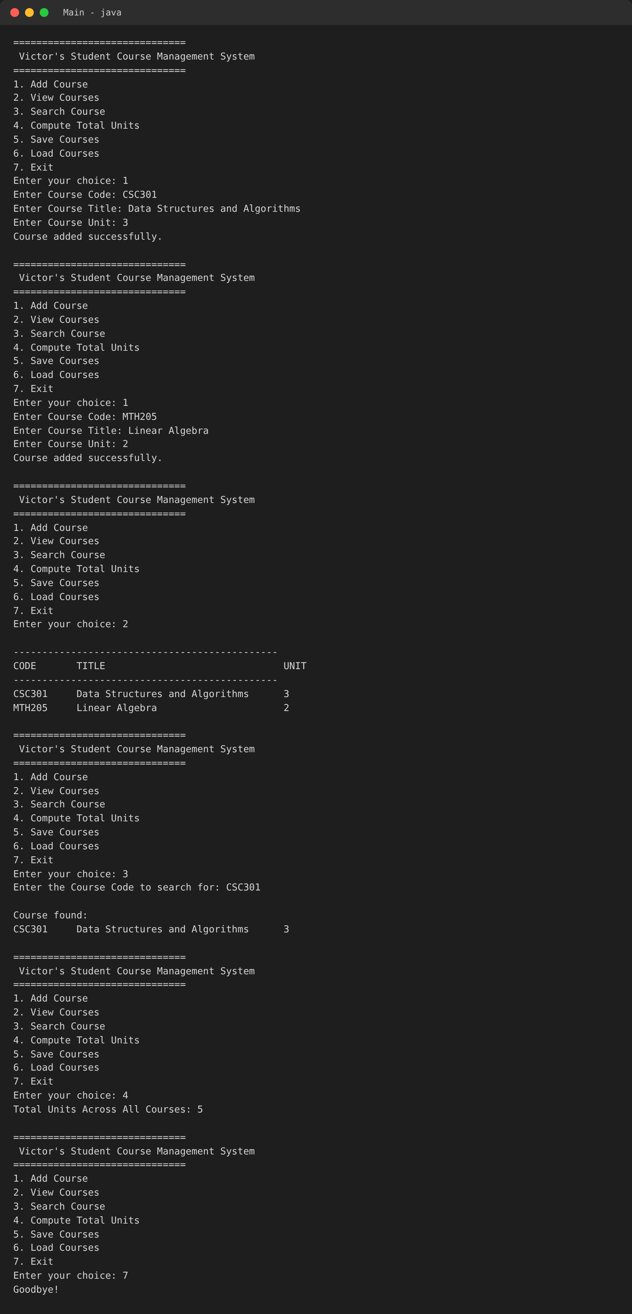
Console output captured from running Main.java.

6. Source Code

Main.java
package SCM;
public class Main {
public static void main(String[] args) {
CourseManager manager = new CourseManager();
manager.showMenu();
}
}

Course.java
package SCM;
public class Course {
private String courseCode;
private String courseTitle;
private int unit;
public Course(String courseCode, String courseTitle, int unit) {
this.courseCode = courseCode.trim().toUpperCase();
this.courseTitle = courseTitle.trim();
this.unit = unit;
}
public String getCourseCode() {
return courseCode;
}
public String getCourseTitle() {
return courseTitle;
}
public int getUnit() {
return unit;
}
public void setCourseCode(String courseCode) {
this.courseCode = courseCode.trim().toUpperCase();
}
public void setCourseTitle(String courseTitle) {
this.courseTitle = courseTitle.trim();
}
public void setUnit(int unit) {
this.unit = unit;
}
@Override
public String toString() {
return String.format("%-10s %-35s %d",
courseCode,
courseTitle,
unit);
}
}

CourseManager.java
package SCM;
import java.io.*;
import java.util.ArrayList;
import java.util.Scanner;
public class CourseManager {
private ArrayList<Course> courseList = new ArrayList<>();
private Scanner scanner = new Scanner(System.in);
public void showMenu() {
System.out.println("\n==============================");
System.out.println(" Victor's Student Course Management System");
System.out.println("==============================");
System.out.println("1. Add Course");
System.out.println("2. View Courses");
System.out.println("3. Search Course");
System.out.println("4. Compute Total Units");
System.out.println("5. Save Courses");
System.out.println("6. Load Courses");
System.out.println("7. Exit");
System.out.print("Enter your choice: ");
try {
int choice = Integer.parseInt(scanner.nextLine());
switch (choice) {
case 1:
addCourse();
break;
case 2:
viewCourses();
break;
case 3:
searchCourse();
break;
case 4:
displayTotalUnits();
break;
case 5:
saveCourses();
break;
case 6:
loadCourses();
break;
case 7:
System.out.println("Goodbye!");
return;
default:
System.out.println("Invalid choice. Please enter a number between 1 and 7.");
}
} catch (Exception e) {
System.out.println("Invalid input. Please enter a number.");
}
showMenu();
}
public void addCourse() {
try {
System.out.print("Enter Course Code: ");
String code = scanner.nextLine().trim().toUpperCase();
if(code.isEmpty()){
throw new IllegalArgumentException("Course code cannot be empty.");
}
System.out.print("Enter Course Title: ");
String title = scanner.nextLine().trim();
if(title.isEmpty()){
throw new IllegalArgumentException("Course title cannot be empty.");
}
System.out.print("Enter Course Unit: ");
int unit = Integer.parseInt(scanner.nextLine());
if(unit<=0){
throw new IllegalArgumentException("Unit must be a positive number.");
}
courseList.add(new Course(code,title,unit));
System.out.println("Course added successfully.");
}catch(Exception e){
System.out.println("Could not add course: "+e.getMessage());
}
}
public void viewCourses(){
if(courseList.isEmpty()){
System.out.println("No courses have been added yet.");
return;
}
System.out.println("\n----------------------------------------------");
System.out.printf("%-10s %-35s %s%n",
"CODE","TITLE","UNIT");
System.out.println("----------------------------------------------");
for(Course course : courseList){
System.out.println(course);
}
}
public void searchCourse(){
System.out.print("Enter the Course Code to search for: ");
String code = scanner.nextLine().trim().toUpperCase();
Course foundCourse = findCourseByCode(code,0);
if(foundCourse==null){
System.out.println("No course found with code \""+code+"\".");
}else{
System.out.println("\nCourse found:");
System.out.println(foundCourse);
}
}
private Course findCourseByCode(String code, int index){
if(index>=courseList.size())
return null;
if(courseList.get(index).getCourseCode().equalsIgnoreCase(code))
return courseList.get(index);
return findCourseByCode(code,index+1);
}
public void displayTotalUnits(){
int totalUnits=0;
for(Course course : courseList){
totalUnits+=course.getUnit();
}
System.out.println("Total Units Across All Courses: "+totalUnits);
}
public void saveCourses(){
try{
BufferedWriter writer=new BufferedWriter(new FileWriter("courses.txt"));
for(Course course : courseList){
writer.write(course.getCourseCode()+","
+course.getCourseTitle()+","
+course.getUnit());
writer.newLine();
}
writer.close();
System.out.println("Courses saved successfully to courses.txt.");
}catch(IOException e){
System.out.println("Error saving courses to file.");
}
}
public void loadCourses(){
try{
BufferedReader reader=new BufferedReader(new FileReader("courses.txt"));
courseList.clear();
String line;
while((line=reader.readLine())!=null){
String[] fields=line.split(",");
if(fields.length==3){
courseList.add(
new Course(
fields[0],
fields[1],
Integer.parseInt(fields[2])
)
);
}
}
reader.close();
System.out.println("Courses loaded successfully from courses.txt.");
}catch(IOException e){
System.out.println("No saved course file found.");
}
}
}

