Activation Function Comparison
Generated 2026-10-28 13:03. Every model uses the same data split, settings and random seed; only the hidden-layer activation function changes.

Settings
Setting | Value
Command | python activation_sweep.py --data data/dataset_20261027_143306.npz --epochs 100 --batch_size 16384 --num_workers 5 --patience 100 --max_samples 10000000
Dataset | data/dataset_20261027_143306.npz
Rows in dataset | 27471482
--max_samples | 10000000
base train / val rows | 6340169 / 1624558
base inputs -> outputs | 14 -> 2
arm train / val rows | 1617233 / 418040
arm inputs -> outputs | 27 -> 7
Activations tested | relu, leaky_relu, elu, gelu, silu, tanh, sigmoid
--epochs (max) | 100
--hidden_dim | 512
--num_layers | 4
--batch_size | 16384
--lr | 0.001
--early_stop | 0.0001
--patience | 100
--num_workers | 5
Optimizer / loss | Adam / MSE
Train/val split | 80/20 by trajectory, seed 42
Random seed (weights) | 42
Device | NVIDIA GeForce RTX 5070 Ti

Base model

Summary (sorted best to worst)
Rank | Activation | Best val MSE | Best epoch | Epochs run | Mean MAE | Mean RMSE | Mean R² | Time (min)
1 | sigmoid | 0.002388 | 98 | 100 | 0.0037 | 0.0109 | 0.9977 | 13.7
2 | elu | 0.002424 | 48 | 100 | 0.0041 | 0.0110 | 0.9977 | 16.6
3 | gelu | 0.002537 | 28 | 100 | 0.0042 | 0.0113 | 0.9976 | 15.8
4 | silu | 0.002651 | 44 | 100 | 0.0044 | 0.0116 | 0.9974 | 14.0
5 | tanh | 0.002785 | 28 | 100 | 0.0046 | 0.0119 | 0.9973 | 13.6
6 | leaky_relu | 0.002885 | 65 | 100 | 0.0053 | 0.0122 | 0.9972 | 17.4
7 | relu | 0.002965 | 22 | 100 | 0.0047 | 0.0122 | 0.9971 | 15.4

MAE per output (lower is better)
Activation | v_cmd (m/s) | w_cmd (rad/s)
sigmoid | 0.0003 | 0.0070
elu | 0.0005 | 0.0078
gelu | 0.0005 | 0.0079
silu | 0.0007 | 0.0081
tanh | 0.0008 | 0.0084
leaky_relu | 0.0006 | 0.0100
relu | 0.0007 | 0.0087

R² per output (closer to 1 is better)
Activation | v_cmd (m/s) | w_cmd (rad/s)
sigmoid | 0.9988 | 0.9966
elu | 0.9988 | 0.9966
gelu | 0.9988 | 0.9963
silu | 0.9987 | 0.9962
tanh | 0.9987 | 0.9959
leaky_relu | 0.9988 | 0.9957
relu | 0.9985 | 0.9958

Validation loss per epoch
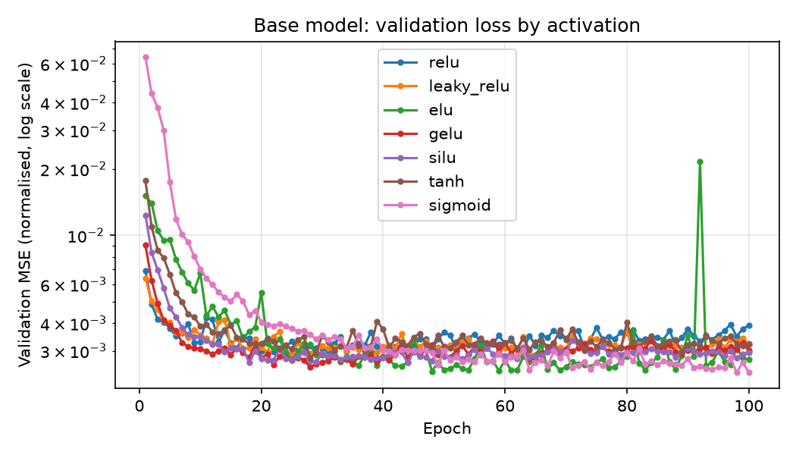
Best activation for the base model: sigmoid (val MSE 0.002388, mean R² 0.9977).

Arm model

Summary (sorted best to worst)
Rank | Activation | Best val MSE | Best epoch | Epochs run | Mean MAE | Mean RMSE | Mean R² | Time (min)
1 | silu | 0.002711 | 40 | 100 | 0.1367 | 0.3935 | 0.9973 | 4.6
2 | tanh | 0.002787 | 94 | 100 | 0.1465 | 0.4013 | 0.9972 | 4.6
3 | gelu | 0.002815 | 97 | 100 | 0.1178 | 0.3929 | 0.9972 | 4.5
4 | relu | 0.002879 | 68 | 100 | 0.1381 | 0.4019 | 0.9971 | 3.8
5 | sigmoid | 0.003277 | 99 | 100 | 0.1556 | 0.4109 | 0.9967 | 4.6
6 | leaky_relu | 0.003425 | 88 | 100 | 0.1377 | 0.4609 | 0.9965 | 3.7
7 | elu | 0.003871 | 93 | 100 | 0.1683 | 0.4435 | 0.9961 | 3.7

MAE per output (lower is better)
Activation | torque_1 (Nm) | torque_2 (Nm) | torque_3 (Nm) | torque_4 (Nm) | torque_5 (Nm) | torque_6 (Nm) | torque_7 (Nm)
silu | 0.1633 | 0.1262 | 0.2087 | 0.0950 | 0.1765 | 0.0736 | 0.1133
tanh | 0.2023 | 0.1327 | 0.2248 | 0.0857 | 0.1949 | 0.0622 | 0.1232
gelu | 0.1455 | 0.0952 | 0.1825 | 0.0749 | 0.1416 | 0.0666 | 0.1183
relu | 0.1550 | 0.1071 | 0.2007 | 0.1046 | 0.1933 | 0.0681 | 0.1376
sigmoid | 0.1849 | 0.1490 | 0.2165 | 0.1115 | 0.1770 | 0.0886 | 0.1615
leaky_relu | 0.1704 | 0.1085 | 0.2104 | 0.0847 | 0.1736 | 0.0631 | 0.1531
elu | 0.1745 | 0.1295 | 0.2708 | 0.0918 | 0.2301 | 0.0703 | 0.2109

R² per output (closer to 1 is better)
Activation | torque_1 (Nm) | torque_2 (Nm) | torque_3 (Nm) | torque_4 (Nm) | torque_5 (Nm) | torque_6 (Nm) | torque_7 (Nm)
silu | 0.9964 | 0.9961 | 0.9991 | 0.9971 | 0.9978 | 0.9946 | 0.9998
tanh | 0.9958 | 0.9967 | 0.9992 | 0.9969 | 0.9977 | 0.9943 | 0.9998
gelu | 0.9952 | 0.9977 | 0.9994 | 0.9974 | 0.9984 | 0.9925 | 0.9995
relu | 0.9963 | 0.9976 | 0.9993 | 0.9964 | 0.9980 | 0.9926 | 0.9995
sigmoid | 0.9970 | 0.9950 | 0.9991 | 0.9940 | 0.9980 | 0.9941 | 0.9998
leaky_relu | 0.9941 | 0.9965 | 0.9992 | 0.9959 | 0.9968 | 0.9939 | 0.9994
elu | 0.9951 | 0.9961 | 0.9991 | 0.9963 | 0.9977 | 0.9889 | 0.9996

Validation loss per epoch
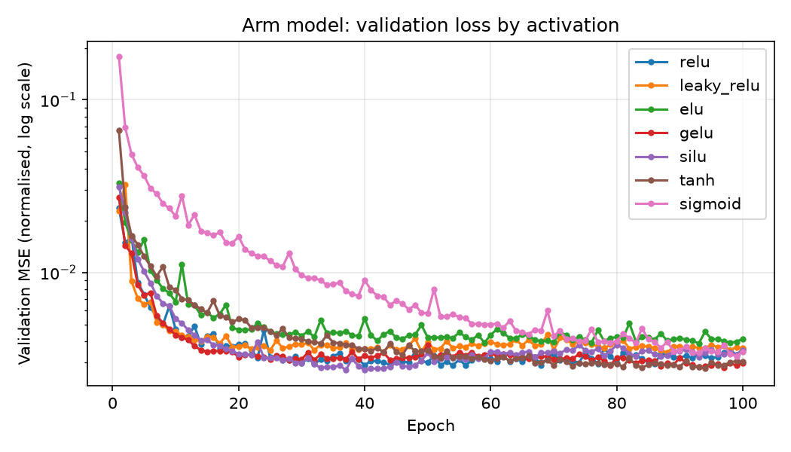
Best activation for the arm model: silu (val MSE 0.002711, mean R² 0.9973).

How to read this
Best val MSE: error on the held-out 20% of trajectories, in normalised units (1.0 = no better than predicting the average). Lower is better.
MAE / RMSE: average and root-mean-square error in real units (m/s, rad/s or Nm). RMSE punishes large mistakes more.
R²: fraction of the expert's behaviour the model explains (1 = perfect, 0 = useless).

