Activation Function Comparison
Generated 2026-10-28 00:56. Every model uses the same data split, settings and random seed; only the hidden-layer activation function changes.

Settings
Setting | Value
Command | python activation_sweep.py --data data/dataset_20261027_143306.npz --epochs 50 --batch_size 16384 --num_workers 7 --patience 15 --early_stop 0.0001
Dataset | data/dataset_20261027_143306.npz
Rows in dataset | 27471482
--max_samples | all
base train / val rows | 17419179 / 4461142
base inputs -> outputs | 14 -> 2
arm train / val rows | 4443802 / 1147359
arm inputs -> outputs | 27 -> 7
Activations tested | relu, leaky_relu, elu, gelu, silu, tanh, sigmoid
--epochs (max) | 50
--hidden_dim | 512
--num_layers | 4
--batch_size | 16384
--lr | 0.001
--early_stop | 0.0001
--patience | 15
--num_workers | 7
Optimizer / loss | Adam / MSE
Train/val split | 80/20 by trajectory, seed 42
Random seed (weights) | 42
Device | NVIDIA GeForce RTX 5070 Ti

Base model

Summary (sorted best to worst)
Rank | Activation | Best val MSE | Best epoch | Epochs run | Mean MAE | Mean RMSE | Mean R² | Time (min)
1 | elu | 0.002379 | 25 | 31 | 0.0041 | 0.0110 | 0.9977 | 9.0
2 | sigmoid | 0.002409 | 33 | 39 | 0.0036 | 0.0110 | 0.9977 | 13.4
3 | silu | 0.002535 | 19 | 34 | 0.0045 | 0.0114 | 0.9975 | 11.0
4 | gelu | 0.002548 | 8 | 21 | 0.0043 | 0.0114 | 0.9975 | 7.6
5 | tanh | 0.002644 | 9 | 24 | 0.0045 | 0.0116 | 0.9974 | 8.8
6 | leaky_relu | 0.002692 | 23 | 38 | 0.0051 | 0.0118 | 0.9974 | 11.1
7 | relu | 0.002735 | 17 | 22 | 0.0050 | 0.0119 | 0.9974 | 8.0

MAE per output (lower is better)
Activation | v_cmd (m/s) | w_cmd (rad/s)
elu | 0.0003 | 0.0079
sigmoid | 0.0004 | 0.0067
silu | 0.0005 | 0.0086
gelu | 0.0007 | 0.0078
tanh | 0.0009 | 0.0081
leaky_relu | 0.0007 | 0.0096
relu | 0.0006 | 0.0095

R² per output (closer to 1 is better)
Activation | v_cmd (m/s) | w_cmd (rad/s)
elu | 0.9989 | 0.9965
sigmoid | 0.9988 | 0.9966
silu | 0.9989 | 0.9962
gelu | 0.9988 | 0.9963
tanh | 0.9987 | 0.9961
leaky_relu | 0.9989 | 0.9959
relu | 0.9988 | 0.9959

Validation loss per epoch
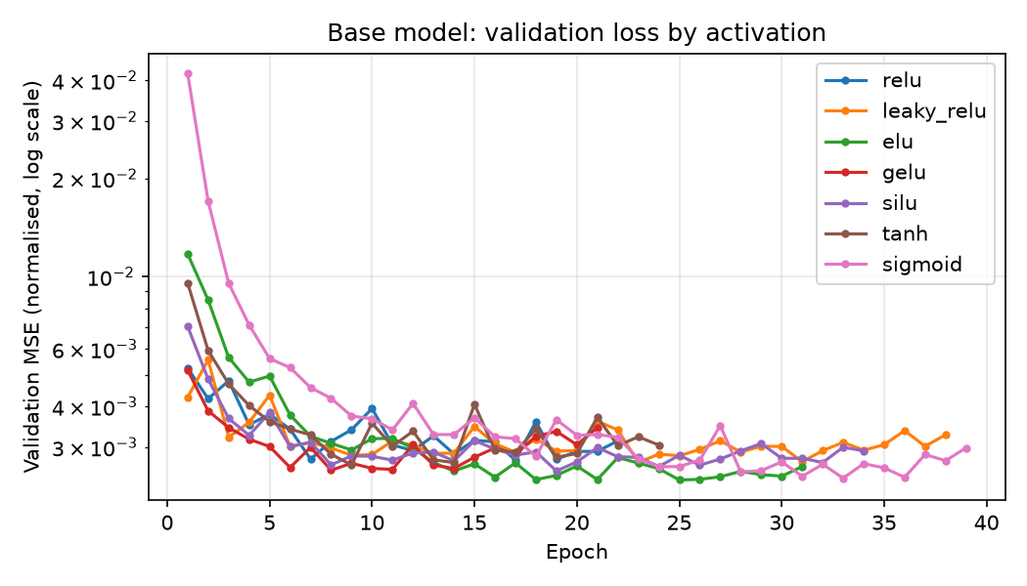
Best activation for the base model: elu (val MSE 0.002379, mean R² 0.9977).

Arm model

Summary (sorted best to worst)
Rank | Activation | Best val MSE | Best epoch | Epochs run | Mean MAE | Mean RMSE | Mean R² | Time (min)
1 | tanh | 0.002477 | 33 | 38 | 0.1289 | 0.3768 | 0.9975 | 3.6
2 | elu | 0.002795 | 46 | 46 | 0.1414 | 0.3959 | 0.9972 | 3.8
3 | sigmoid | 0.002832 | 45 | 50 | 0.1529 | 0.3902 | 0.9971 | 4.6
4 | relu | 0.002851 | 34 | 37 | 0.1653 | 0.4036 | 0.9971 | 3.2
5 | silu | 0.003035 | 12 | 25 | 0.1682 | 0.4338 | 0.9969 | 2.4
6 | leaky_relu | 0.003327 | 20 | 24 | 0.1718 | 0.4484 | 0.9966 | 2.0
7 | gelu | 0.003582 | 10 | 21 | 0.1483 | 0.4751 | 0.9964 | 1.8

MAE per output (lower is better)
Activation | torque_1 (Nm) | torque_2 (Nm) | torque_3 (Nm) | torque_4 (Nm) | torque_5 (Nm) | torque_6 (Nm) | torque_7 (Nm)
tanh | 0.1753 | 0.0959 | 0.1738 | 0.0859 | 0.2007 | 0.0592 | 0.1113
elu | 0.1410 | 0.1403 | 0.2371 | 0.0956 | 0.1636 | 0.0806 | 0.1313
sigmoid | 0.1957 | 0.1414 | 0.1889 | 0.1237 | 0.2015 | 0.0737 | 0.1456
relu | 0.1816 | 0.0974 | 0.2625 | 0.0978 | 0.1864 | 0.0944 | 0.2372
silu | 0.1795 | 0.1317 | 0.3148 | 0.1184 | 0.1761 | 0.0782 | 0.1789
leaky_relu | 0.2243 | 0.0997 | 0.2823 | 0.1003 | 0.2086 | 0.0654 | 0.2218
gelu | 0.1853 | 0.1282 | 0.2267 | 0.0972 | 0.2045 | 0.0746 | 0.1215

R² per output (closer to 1 is better)
Activation | torque_1 (Nm) | torque_2 (Nm) | torque_3 (Nm) | torque_4 (Nm) | torque_5 (Nm) | torque_6 (Nm) | torque_7 (Nm)
tanh | 0.9970 | 0.9974 | 0.9993 | 0.9965 | 0.9979 | 0.9947 | 0.9998
elu | 0.9977 | 0.9967 | 0.9991 | 0.9956 | 0.9977 | 0.9938 | 0.9997
sigmoid | 0.9973 | 0.9953 | 0.9992 | 0.9950 | 0.9980 | 0.9955 | 0.9998
relu | 0.9965 | 0.9976 | 0.9993 | 0.9950 | 0.9983 | 0.9938 | 0.9994
silu | 0.9966 | 0.9959 | 0.9987 | 0.9959 | 0.9974 | 0.9943 | 0.9997
leaky_relu | 0.9922 | 0.9978 | 0.9993 | 0.9968 | 0.9980 | 0.9930 | 0.9992
gelu | 0.9949 | 0.9959 | 0.9988 | 0.9960 | 0.9966 | 0.9929 | 0.9995

Validation loss per epoch
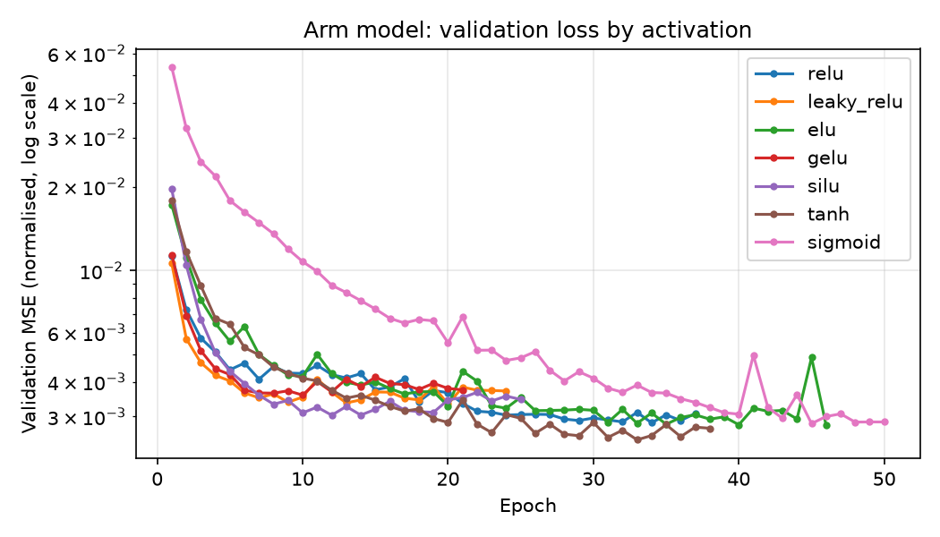
Best activation for the arm model: tanh (val MSE 0.002477, mean R² 0.9975).

How to read this
Best val MSE: error on the held-out 20% of trajectories, in normalised units (1.0 = no better than predicting the average). Lower is better.
MAE / RMSE: average and root-mean-square error in real units (m/s, rad/s or Nm). RMSE punishes large mistakes more.
R²: fraction of the expert's behaviour the model explains (1 = perfect, 0 = useless).

