Call Recorder

Table of contents

Introduction 2

Software requirements 2

Installation and Configuration of Ozeki Phone System XE 2

Project development 4

Implementation 4

Model 4

RealClient 5

ProgramSettings 6

SettingsHelper 6

ConnectorContext 6

RecordingContext 6

View 7

AboutBox 7

BaseWindow 7

ConnectToServerWindow 7

MainWindow 8

OptionsWindow 9

Presenter 9

ConnectToServerPresenter 9

OptionsWindowPresenter 9

MainWindowPresenter 9

Util 10

SimpleIOCContainer 10

# Introduction

The basic task of the Call Recorder sample program, connected to Ozeki Phone System XE, is to record calls, which are made through the PBX. There is an opportunity to record more than one calls simultaneously. The purpose of this documentation is to show step-by-step how an application like this can be developed.

The system will be developed under Windows Operating System and with the help of Visual Studio.

# Software requirements

Microsoft Windows

Microsoft Visual Studio

Ozeki Phone System XE

# Installation and Configuration of Ozeki Phone System XE

In order to connect to the server, Ozeki Phone System XE has to be installed. A Setup Guide can be found here: <http://www.ozekiphone.com/how-to-install-and-configurate-your-ozeki-phone-system-xe-172.html>, the installation package can be downloaded from the following page: <http://www.ozekiphone.com/download-21.html>. After the installation, the main page of the PBX can be accessed on the <http://localhost:7777/Home> address.

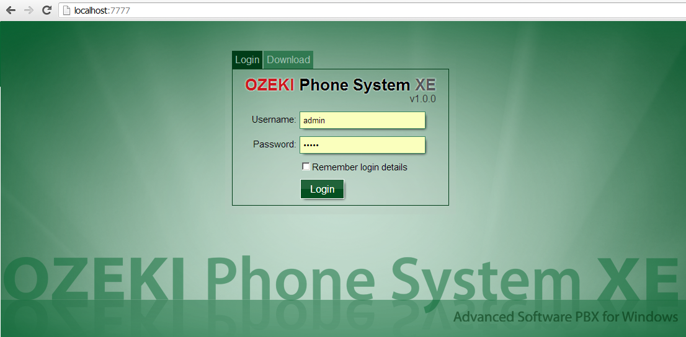

For the first login attempt, use the username and password, which was provided during the installation process.

New user can be added to the system with the Add user button. It can be found under the Office users menu item in the Connections menu.

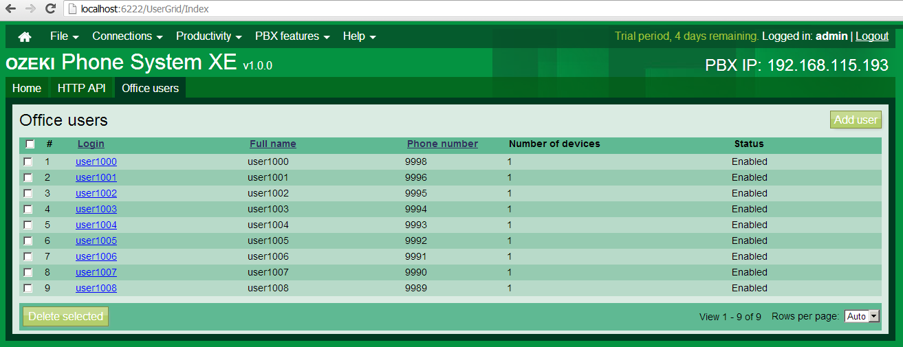

The username and password specified here can be used to connect to the system, in the **OPSClient LoginAsync** method.

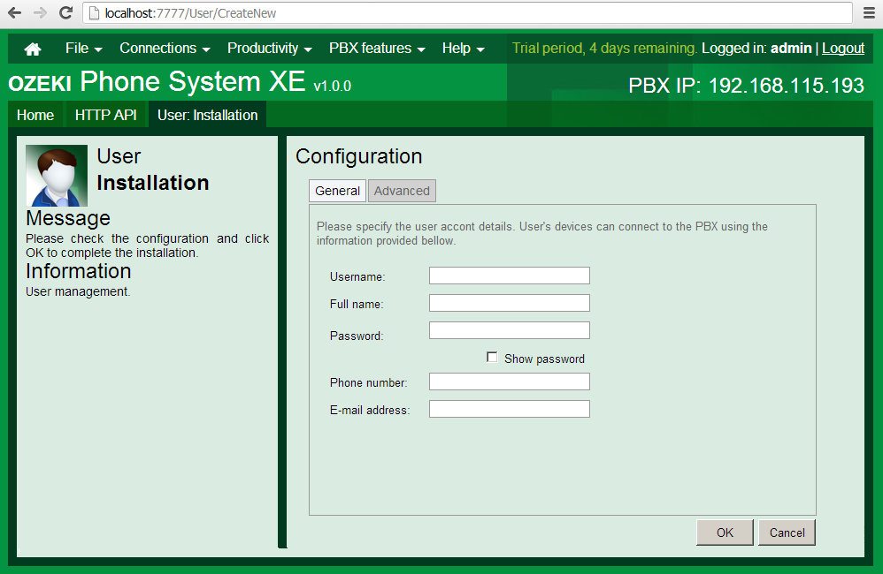

# Project development

1. Let us create a new Windows Forms Application project with the help of File/New/Project menu item.
2. Let us add the OPSSDK.dll file to the project references in the Solution Explorer by clicking on Add Reference… menu item. This will ensure the connection interface to Ozeki Phone System XE.

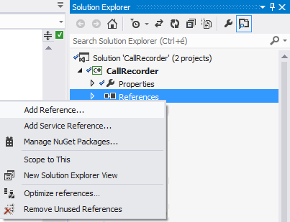

# Implementation

During the development of the application, we followed the Model-View-Presenter software designing pattern. This is useful because the display interface can be easily changed.

## Model

The files that include the application logics were added to the Model namespace.

### RealClient

With the help of the **Login** method, we can connect to Ozeki Phone System XE and try to login with the default username and password in an asynchronous way.

publicvoid Login(stringserver_address, string username, string password)

{

ops_client = newOpsClient();

ops_client.ErrorOccurred += OPSClientOnErrorOccurred;

ops_client.LoginAsync(server_address, username, password, Completed);

}

In case of successful connection, we subscribe to the below events of the **OpsClient**:

ops_client.SessionCreated += OPSClientOnSessionCreated;

ops_client.SessionCompleted += OPSClientOnSessionCompleted;

In case of unsuccessful connection attempt the taskmanager of the OpsClientErrorOccured runs.

The **SessionCreated** event signals if there is a new incoming call in the system. The status changes of the new call can be handled in the **SessionStateChanged** event. In our sample program the **RealClient** only forwards the event towards the **MainWindowPresenter**. This class will query the Extensions and Outside lines, which can be located in the system. We can execute the Extensions and Outside lines both in a synchronous and asynchronous way. In the sample, we use the asynchronous way and here is how the call looks like:

ops_client.GetExtensionInfosAsync(completed);

After the call is made, we can divide the **ExtensionInfo**s according to the **ExtensionType** property. The **ExtensionInfo** can be either an extension or an outside line.

When a call is ended, the event of the **OpsClientSessionCompleted** runs, which activates the **RealClientSessionComleted** event, on which the presenter will subscribe.

### ProgramSettings

The program settings are stored in this class.

- Recordable extensions (**RecordableExtensions**)

- Recordable outside lines (**RecordableOutsideLines**)

- Saving place of the recordable files(**RecordingPath**)

- File format of the recording (**RecordingFileFormat**)

### SettingsHelper

This class is closely related to **ProgramSettings**. It fetches a settingsmanager via the IoC container. Through the settings manager it gets or sets the provided settings. If there are no settings then it creates them with default values.

### ConnectorContext

This is a Help Class, which will be used in the **RecordingContext**. It is for reaching the **MediaConnector** and **AudioMixerMediaHandler** that have to be disposed.

### RecordingContext

We create a **RecordingContext** object to each call, which will have the following dependencies: the recordable session, the file format of the record, the name of the recorded subdirectory that will be the same as the phone number of the recordable entity. According to the file format, we instantiate either the **MP3StreamRecorder** or the **WaveStreamRecorder**. The record can be started with the **StartRecording** method, for which you need to specify the subdirectory as a paramter where the recorded file should be made. After the record has started, this code snippet will ensure the connection to the recorder:

var media_connector = new MediaConnector();

var mixer = new AudioMixerMediaHandler();

lock (sync)

{

Connectors.Add(session, new ConnectorContext(media_connector, mixer));

}

media_connector.Connect(mixer, receiver);

session.ConnectAudioReceiver(CallParty.Callee, mixer);

session.ConnectAudioReceiver(CallParty.Caller, mixer);

The **AudioMixerMeidaHandler** is required to avoid cracking sounds on the recording. The Mixer that is instantiated here and the **MediaConnector** have to be disposed later on.

ConnectorContext connector_context;

lock (sync)

{

connector_context = Connectors[session];

Connectors.Remove(session);

}

session.DisconnectAudioReceiver(CallParty.Callee, connector_context.Mixer);

session.DisconnectAudioReceiver(CallParty.Caller, connector_context.Mixer);

connector_context.Connector.Disconnect(connector_context.Mixer, receiver);

connector_context.Connector.Dispose();

connector_context.Mixer.Dispose();

This is what the code snippet, which is invited by the **StopRecording**, is used for.

## View

The graphical interfaces and a unique controller were placed in this namespace. The **ExtendedListView** has to be introduced otherwise the display would flicker in the list view and for creating a better looking display as well.

### AboutBox

This is the about of the application.

### BaseWindow

**BaseWindow** is the parent of **ConnectToServerWindow, OptionsWindow** and **MainWindow**. This interface implements basic features like error message, information message display, window closing or waiting.

### ConnectToServerWindow

This windows makes it possible to connect to Ozeki Phone System XE. In order to connect, the followings have to be provided: the IP address of the computer (ex.: 192.168.115.193:8802) on which Ozeki Phone System XE runs, username (Ozeki Phone System office user) and password. When starting the Call Recorder, this window appears automatically but the opportunity is given to connect to a provider later on.

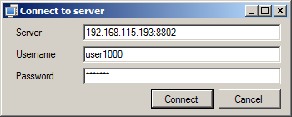

### MainWindow

This is the main window of the application. Here, on the left side, the Extensions and Outside lines that are in the system can be seen in a list view. Under the Recording details tab there are the following things: the selected entity is under recording or not, are there any files that belong to it, how long does all the calls last altogether, how big is the file size. Moreover, there is the type of the entity, to which directory will the saves be placed and in what file format. On the Recorded files tab, the recorded files can be retraced. We can play or delete the recorded files if there is no need for them.



### OptionsWindow

Here, the recording place and format of the file can be modified.



## Presenter

These files are responsible for connecting the model and the view.

### ConnectToServerPresenter

One dependency of the **ConnectToServerPresenter** is an **IConnectToServer** interface, which is implemented by the **ConnectToServerWindow**. We connect to the server with this view. The other dependency is the **IOPSClient**, which is implemented by the **RealClient** class. The connection is done via the client interface (**IOPSClient**) and also the user interface is notified about the connection process. In case of unsuccessful connection attempt an error message appears, anyway we close the GUI.

### OptionsWindowPresenter

It’s only dependency is the **IOptionsWindow** interface, through which an error message can be displayed if it is required. We have access to the settings container via the IoC container.

### MainWindowPresenter

The **MainWindowPresenter** also has two dependencies, from which the **IOPSClient** is completely the same as the object being used by the **ConnectToServerPresenter**. Since, the **IOPSClient** is added to the IoC container as a singleton class. We will talk about the IoC container later on. The other dependency is the **IMainWindow** interface, which is implemented by the **MainWindow**. Here, the **IMainWindow** interface also notifies the user interface (UI) if any change needs to be done in the display.

The build up of the selected file names to be recorded include the caller, calle, when the call started and the call duration. However, when the file list is displayed, the time of the file modification and creation is used to display the start and duration of the call.

This presenter will subscribe for the **SessionCreated** and the **SessionCompleted**, which are the two events of the **IOPSClient**.

client.SessionCreated += ClientOnSessionCreated;

client.SessionCompleted += ClientOnSessionCompleted;

If a call arrives to the system then regarding the entities, which are selected for recording, a recording process will start. After the call ends, the recording ends as well.

## Util

In this namespace, the dialogue windows that are responsible for displaying the messages, constants, delegates and the IoC container can be found.

### SimpleIOCContainer

The IoC (inversion of control) container is a singleton class, which is suitable for storing dependencies:

SimpleIOCContainer.Instance.AddDependency<IOPSClient>(() =>new RealClient());

The following code is for dependency resolving:

SimpleIOCContainer.Instance.Resolve<IOPSClient>();

It makes dependency replacement available at the same place so changing to the usage of test classes will be easier.