Big Data Analytics Mini Project Report

CustomerIQ - Customer Segmentation & Purchase Analytics Platform

Submitted in fulfilment of the requirements of the
Big Data Analytics Mini Project Semester VII in degree of
Bachelor of Computer Engineering

BY

Ashish Anil Sharma (Roll No. 54)
Kinjal Shivprasad Ojha (Roll No. 21)

Under the Guidance of
Ms. Praniti Patil

Department of Computer Engineering
Shree L. R. Tiwari College of Engineering
Kanakia Park, Mira Road (E), Thane - 401 107, Maharashtra.
2026-27

Big Data Analytics Mini Project Report Approval

This project report entitled "CustomerIQ - Customer Segmentation & Purchase Analytics Platform" by Mr. Ashish Anil Sharma (Roll No. 54) and Mr. Kinjal Shivprasad Ojha (Roll No. 21) is approved for the Mini Project Semester VII project work of B.E. CMPN at Shree L. R. Tiwari College of Engineering, in the academic year 2026-2027.

Internal Examiner

Declaration

I declare that this written submission represents my ideas in my own words and where others' ideas or words have been included, I have adequately cited and referenced the original sources. I also declare that I have adhered to all principles of academic honesty and integrity and have not misrepresented or fabricated or falsified any idea/data/fact/source in my submission. I understand that any violation of the above will be cause for disciplinary action by the Institute and can also evoke penal action from the sources which have thus not been properly cited or from whom proper permission has not been taken when needed.

--------------------------------------
Signature
Mr. Kinjal Shivprasad Ojha (Roll No. 21)

--------------------------------------
Signature
Mr. Ashish Sharma (Roll No. 54)

Date:
Place:

Table of Contents

1. Introduction
2. System Architecture
3. Implementation
4. Technologies Used
5. Results
6. Conclusion
7. References

1. Introduction
In today's retail and e-commerce industry, businesses accumulate large volumes of transaction data, yet converting that data into actionable customer insight remains difficult. Marketing and retention budgets are most effective when they are aimed at the right customers, but identifying who those customers are requires analysing purchase behaviour across thousands of transactions. Traditional spreadsheet tools cannot scale to this task, and manual segmentation is slow, subjective, and hard to reproduce.
This project, titled "CustomerIQ - Customer Segmentation & Purchase Analytics Platform", addresses this problem with RFM (Recency, Frequency, Monetary) analysis combined with unsupervised machine learning. RFM analysis scores every customer on three dimensions: how recently they purchased (Recency), how often they purchase (Frequency), and how much they spend (Monetary). Customers are then grouped into behavioural segments using the K-Means clustering algorithm from Apache Spark's MLlib, which allows the computation to run in a distributed fashion over large transaction datasets.
The deliverable is a complete analytics platform rather than a standalone script. Retail transaction CSV files are uploaded through a web interface, validated against a configurable schema, processed by a PySpark data engine, and stored in PostgreSQL and Parquet. A FastAPI backend exposes the results through versioned REST endpoints, and a React dashboard presents business users with KPI summaries, revenue trends, segment distributions, and a searchable customer explorer.
The main objectives of this project are:
1. To ingest retail transaction CSV files with configurable column mapping and transparent data-quality validation.
2. To compute per-customer RFM metrics at scale using PySpark DataFrames and Spark SQL aggregations.
3. To apply documented handling of skewed features, scale them with Spark MLlib, and segment customers using K-Means clustering.
4. To evaluate clustering quality with the silhouette score and select the number of clusters deterministically using a fixed random seed.
5. To map arbitrary cluster identifiers to interpretable business segments such as Champions, Loyal Customers, and At Risk customers.
6. To persist results in PostgreSQL with Parquet analytical artifacts, serve them through a REST API, and visualise them in a professional analytics dashboard.
2. System Architecture
The system follows a layered architecture that separates the presentation tier, the application tier, and the distributed data-processing tier:
1. Presentation Layer: A React application built with Vite and TypeScript provides the user interface. Tailwind CSS and shadcn/ui supply a restrained design system, Recharts renders the analytics charts, and TanStack Query manages server state and job-status polling.
2. Application Layer: A FastAPI backend exposes versioned REST endpoints under /api/v1 for dashboards, customers, segments, datasets, and processing jobs. Pydantic validates every request and response, and SQLAlchemy provides typed access to PostgreSQL, where datasets, customers, RFM metrics, segment assignments, processing jobs, and data-quality reports are stored.
3. Data Engine Layer: A PySpark data engine performs the heavy computation. Transaction records are read from CSV, validated, and transformed into RFM metrics using Spark SQL aggregations. Frequency and Monetary features are log-transformed to reduce skew, scaled with StandardScaler, and clustered with the K-Means implementation from Spark MLlib. Clusters are evaluated with the silhouette score and mapped to human-readable segment labels.
4. Processing and Storage: Long-running Spark work executes in a background job runner outside the HTTP request cycle, with job state transitions (pending, running, completed, failed) persisted so history survives restarts. Analytical outputs are written to Parquet for the data layer and to PostgreSQL for application-facing queries.
The end-to-end pipeline can be summarized as:
CSV Upload -> Schema Mapping -> Validation -> Distributed RFM (Spark) -> Log Transform and Scaling -> K-Means (MLlib) -> Silhouette Evaluation -> Segment Labeling -> PostgreSQL and Parquet -> REST API -> Dashboard
3. Implementation
The project is organised into separate modules for the frontend, the FastAPI backend, and the Spark data engine. The repository layout is:
customeriq/
frontend/ React + Vite + TypeScript dashboard
src/components/ UI components (shadcn/ui, Tailwind CSS)
src/pages/ Overview, Customers, Segments, Analytics, Import, Jobs
src/services/ Typed API client (TanStack Query)
backend/
app/api/ Versioned FastAPI routers (/api/v1)
app/models/ SQLAlchemy models (datasets, customers, jobs, ...)
app/schemas/ Pydantic request/response schemas
app/services/ Business logic and repositories
app/workers/ Background job runner for Spark work
data_engine/
ingestion/ CSV reading, schema mapping, validation
transformations/ RFM computation with Spark SQL
clustering/ Feature scaling, K-Means, segment labeling
evaluation/ Silhouette evaluation
storage/ Parquet and model persistence
data/raw/ Uploaded CSV datasets
data/processed/ Parquet analytical datasets
data/models/ Saved Spark ML models
docker-compose.yml PostgreSQL for local development
The core of the platform is the data engine. Its central stages are reproduced below from the actual implementation.
Data validation applies a documented exclusion policy: exact duplicates are collapsed, rows with missing customer identifiers are excluded from customer-level metrics but counted, unparseable dates and non-positive quantities or prices are rejected, and cancellation invoices are tracked separately:
# data_engine/ingestion/validate.py (core excerpt)
def validate_transactions(raw: DataFrame):
report = ValidationReport()
report.total_rows = raw.count()
deduped = raw.dropDuplicates(raw.columns)
report.duplicates_removed = report.total_rows - deduped.count()
df = (deduped
.withColumn("Quantity", F.col("Quantity").cast(IntegerType()))
.withColumn("UnitPrice", F.col("UnitPrice").cast(DoubleType()))
.withColumn("InvoiceDateParsed",
F.try_to_timestamp(F.col("InvoiceDate"), F.lit(DATE_FORMAT)))
.withColumn("IsCancellation",
F.upper(F.col("InvoiceNo")).startswith(F.lit("C"))))
report.invalid_dates = df.filter(F.col("InvoiceDateParsed").isNull()).count()
report.cancellation_lines = df.filter(F.col("IsCancellation")).count()
valid = df.filter(
F.col("InvoiceDateParsed").isNotNull()
& F.col("CustomerID").isNotNull() & (F.col("CustomerID") != "")
& (~F.col("IsCancellation"))
& (F.col("Quantity") > 0) & (F.col("UnitPrice") > 0)
).withColumn("LineRevenue", F.round(F.col("Quantity") * F.col("UnitPrice"), 2))
report.valid_transactions = valid.count()
return valid, report
RFM metrics are computed as distributed aggregations over validated transactions. The analysis reference date defaults to one day after the latest valid purchase so runs are reproducible:
# data_engine/transformations/rfm.py (core excerpt)
def compute_rfm(transactions: DataFrame, reference_date=None):
if reference_date is None:
reference_date = default_reference_date(transactions)
return (transactions.groupBy("CustomerID")
.agg(
F.datediff(F.lit(reference_date),
F.max("InvoiceDateParsed")).alias("Recency"),
F.countDistinct("InvoiceNo").alias("Frequency"),
F.round(F.sum("LineRevenue"), 2).alias("Monetary"),
F.min("InvoiceDateParsed").alias("FirstPurchase"),
F.max("InvoiceDateParsed").alias("LastPurchase"),
)
.withColumn("AvgOrderValue",
F.round(F.col("Monetary") / F.col("Frequency"), 2)))
Clustering uses Spark MLlib. Frequency and Monetary are strongly right-skewed in retail data, so both are log-transformed before scaling. The K-Means random seed is fixed for reproducibility, and the silhouette score is computed for each candidate cluster count:
# data_engine/clustering/kmeans.py (core excerpt)
def fit_kmeans(rfm: DataFrame, k: int = 6, seed: int = 42):
featured = (rfm
.withColumn("log_Frequency", F.log1p(F.col("Frequency")))
.withColumn("log_Monetary", F.log1p(F.col("Monetary"))))
assembler = VectorAssembler(
inputCols=["Recency", "log_Frequency", "log_Monetary"],
outputCol="features_raw")
scaler = StandardScaler(
inputCol="features_raw", outputCol="features",
withMean=True, withStd=True)
assembled = assembler.transform(featured)
scaled = scaler.fit(assembled).transform(assembled)
model = KMeans(k=k, seed=seed, featuresCol="features",
maxIter=100).fit(scaled)
preds = model.transform(scaled)
silhouette = ClusteringEvaluator(
featuresCol="features", predictionCol="prediction").evaluate(preds)
return preds, silhouette, model
Because cluster identifiers are arbitrary, clusters are ranked by a composite profile score and mapped onto a fixed label spectrum:
# data_engine/clustering/labeling.py (core excerpt)
SPECTRUM = ["Champions", "Loyal Customers", "Potential Loyalists",
"New Customers", "At Risk", "Hibernating"]

def label_clusters(profiles, k):
# rank clusters by z(Frequency) + z(Monetary) - z(Recency)
ranked = sorted(profiles,
key=lambda p: z_freq[p] + z_mon[p] - z_rec[p],
reverse=True)
# pick labels at evenly spaced positions of the spectrum for k clusters
positions = [round(i * (len(SPECTRUM) - 1) / (k - 1)) for i in range(k)]
return {p["cluster"]: SPECTRUM[pos]
for p, pos in zip(ranked, positions)}
The FastAPI layer serves the persisted results with pagination and filtering; a representative endpoint is:
# backend/app/api/customers.py (representative endpoint)
@app.get("/api/v1/customers", response_model=Page[CustomerOut])
def list_customers(
segment: str | None = None,
search: str | None = None,
sort_by: SortKey = "monetary",
page: int = Query(1, ge=1),
page_size: int = Query(25, ge=1, le=100),
db: Session = Depends(get_db),
):
return customer_repo.list_customers(
db, segment=segment, search=search, sort_by=sort_by,
offset=(page - 1) * page_size, limit=page_size,
)
4. Technologies Used
Python 3.14: Primary language for the backend services and the PySpark data-engine pipeline.
Apache Spark 4.2 (PySpark): Distributed data processing. Spark SQL aggregations compute RFM metrics; Spark MLlib provides VectorAssembler, StandardScaler, K-Means, and the silhouette evaluator used for segmentation.
FastAPI and Pydantic: Versioned REST API with automatic OpenAPI documentation and strict request and response validation.
SQLAlchemy and PostgreSQL: Relational storage for datasets, customers, RFM metrics, segment assignments, processing jobs, and data-quality reports.
React, TypeScript and Vite: Frontend single-page application with typed components and fast development builds.
Tailwind CSS and shadcn/ui: Restrained enterprise design system used across all dashboard screens.
Recharts: Chart rendering for revenue trends, segment distributions, and RFM profiles.
TanStack Query: Server-state management, caching, and processing-job status polling.
Docker Compose: Local PostgreSQL instance and supporting services for development.
Parquet: Columnar storage for processed analytical datasets produced by the Spark engine.
5. Results
The pipeline was executed end-to-end on a deterministic synthetic demo dataset modelled on the UCI Online Retail schema (InvoiceNo, StockCode, Description, Quantity, InvoiceDate, UnitPrice, CustomerID, Country). The dataset contains 10,778 line items from 430 customers spanning January to December 2025 and deliberately includes cancellation invoices, missing customer identifiers, duplicate rows, and invalid dates so that validation behaves as it would on real data. All figures below are produced by the Spark pipeline; no values are hard-coded.
5.1 Data Validation and RFM Computation
The validation stage accounted for every excluded record explicitly. Of 10,778 input rows, 12 exact duplicates were collapsed, 5 rows had unparseable invoice dates, 181 rows had no customer identifier, 243 cancellation or return lines were excluded from customer metrics, and 18 lines had non-positive quantities or prices. This left 10,321 valid transaction lines across 430 segmentable customers. The captured pipeline output is shown below:
CustomerIQ data-engine pipeline - demo dataset
Spark 4.2.1 | deterministic seed = 42

[1/5] Reading dataset: demo_online_retail.csv
Data-quality report
-------------------
Total rows read : 10,778
Exact duplicates removed : 12
Invalid invoice dates : 5
Missing customer ID : 181
Cancellation/return lines : 243
Non-positive quantity : 3
Non-positive unit price : 15
Valid transaction lines : 10,321
Distinct segmentable cust. : 430
Transaction window : 2025-01-02 .. 2025-12-28

[2/5] RFM computation (analysis reference date = 2025-12-29)
Customers scored: 430
RFM sample (first 8 customers by ID):
CustomerID | Recency (days) | Frequency | Monetary | Avg order value
-------------+----------------+------------+--------------+----------------
12018 | 30 | 6 | 249.37 | 41.56
12070 | 13 | 3 | 137.86 | 45.95
12106 | 10 | 12 | 641.67 | 53.47
12116 | 299 | 3 | 47.90 | 15.97
12212 | 27 | 21 | 1,752.25 | 83.44
12235 | 42 | 3 | 84.61 | 28.20
12256 | 126 | 9 | 457.27 | 50.81
12305 | 136 | 4 | 75.66 | 18.92
5.2 K-Means Segmentation
The silhouette score was computed for cluster counts from k = 3 to k = 8 using a fixed random seed of 42. The highest silhouette score of 0.6412 was obtained at k = 4, which was therefore selected. The four clusters were profiled on the original RFM scale and mapped to business segments by ranking them on the composite score z(Frequency) + z(Monetary) - z(Recency):
[3/5] K-Means clustering (Spark MLlib)
Feature pipeline: log1p(Frequency), log1p(Monetary), StandardScaler(withMean, withStd)
Silhouette score by k:
k=3: 0.6093
k=4: 0.6412
k=5: 0.5964
k=6: 0.5769
k=7: 0.6297
k=8: 0.6284
Selected k = 4 (highest silhouette = 0.6412)

[4/5] Cluster profiling and segment labeling
Cluster profiles (original RFM scale):
Cluster | Customers | Avg recency (d) | Avg frequency | Avg monetary
---------+------------+-----------------+---------------+-------------
0 | 71 | 21.20 | 2.52 | 88.68
1 | 84 | 27.90 | 18.87 | 1,692.52
2 | 81 | 288.80 | 2.89 | 81.29
3 | 194 | 78.80 | 7.60 | 352.78
Label mapping (ranked by z(Frequency) + z(Monetary) - z(Recency)):
cluster 0 -> New Customers
cluster 1 -> Champions
cluster 2 -> Hibernating
cluster 3 -> Potential Loyalists
The recovered segments match the behavioural structure of the demo population: cluster 1 concentrates high-frequency, high-value customers, while cluster 2 captures customers whose last purchase was on average 289 days before the reference date. The distribution of customers across the four segments is shown below.
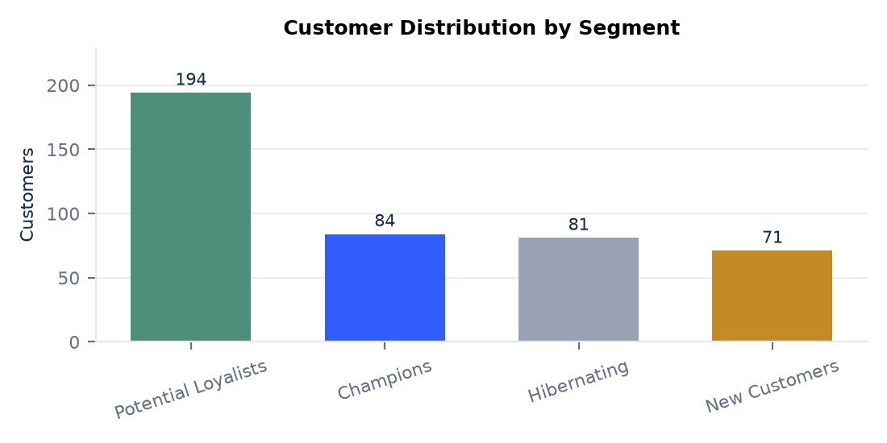
5.3 Segment Business Insights
Each segment was summarised with its size, revenue contribution, and average RFM metrics. The Champions segment, 19.5% of customers, generated 63.6% of total revenue (142,172 of 223,491), while the Hibernating segment contributed only 2.9% despite representing 18.8% of the customer base. These results demonstrate the core business value of the platform: retention effort can be prioritised towards the segments where revenue is concentrated and win-back campaigns can target the long-inactive Hibernating group.
[5/5] Segment summaries (silhouette = 0.6412)
Segment | Customers | % cust. | Revenue | % rev. | Avg spend | Avg freq | Avg rec. d
---------------------+------------+----------+--------------+---------+------------+-----------+-----------
Champions | 84 | 19.50 | 142,171.69 | 63.60 | 1,692.52 | 18.87 | 27.90
Potential Loyalists | 194 | 45.10 | 68,438.39 | 30.60 | 352.78 | 7.60 | 78.80
Hibernating | 81 | 18.80 | 6,584.38 | 2.90 | 81.29 | 2.89 | 288.80
New Customers | 71 | 16.50 | 6,296.07 | 2.80 | 88.68 | 2.52 | 21.20
Total revenue by segment is ranked below. The steep drop from Champions to the remaining segments is typical of retail datasets and is immediately visible in the dashboard's Revenue by Segment view.
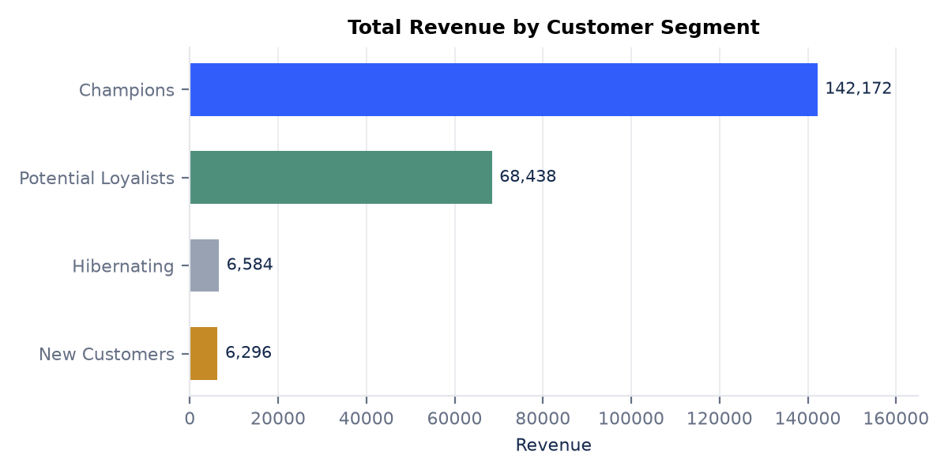
Finally, the average RFM metrics of each segment, indexed to the overall customer average (100), confirm that the segments are well separated on all three dimensions. Champions index far above average on Frequency and Monetary, Hibernating falls far below on Recency (that is, they are much older), and New Customers are recent but low-volume, exactly as their profiles imply.
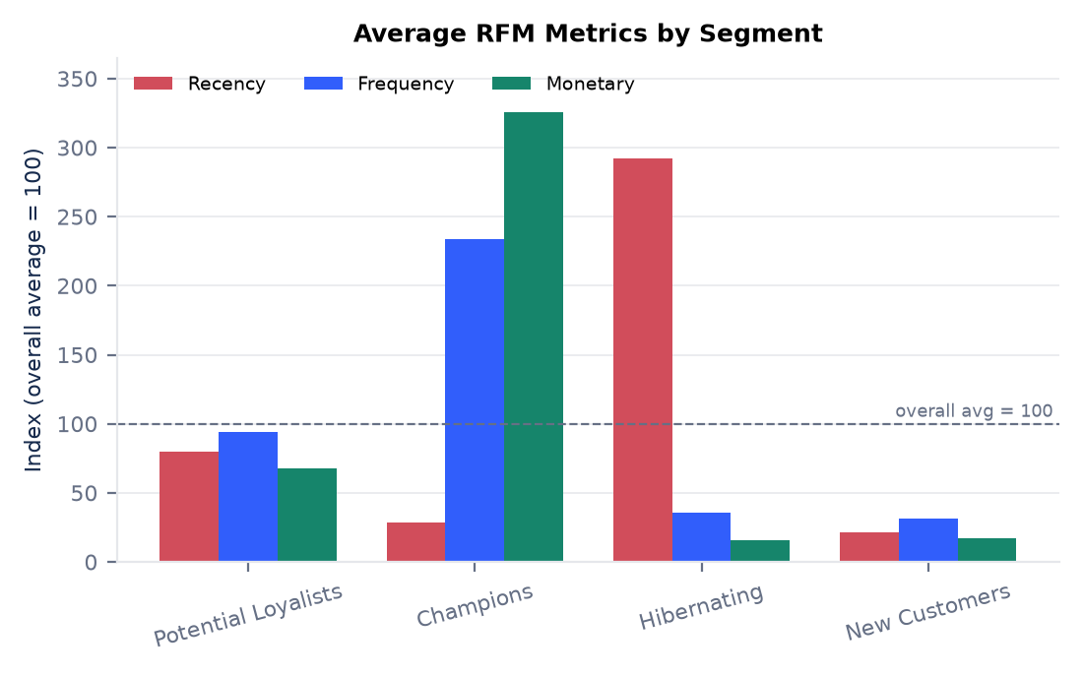
6. Conclusion
Thus, we studied customer analytics techniques and implemented RFM-based customer segmentation as our mini-project. The system computes Recency, Frequency, and Monetary metrics for every customer using distributed PySpark aggregations, segments customers with the K-Means algorithm from Spark MLlib after justified log transformation and standard scaling, and evaluates cluster quality with the silhouette score. Arbitrary cluster identifiers are mapped to interpretable business segments, and all results are persisted in PostgreSQL and Parquet and exposed through a versioned REST API and a React analytics dashboard.
The end-to-end run on the demo dataset demonstrated that the platform produces trustworthy, reproducible analytics. Validation transparently accounted for duplicates, cancellations, missing identifiers, and invalid dates instead of silently discarding data. The silhouette criterion selected four well-separated clusters (silhouette = 0.6412), and the resulting segments told a clear business story: 19.5% of customers (Champions) produced 63.6% of revenue, while a Hibernating group with an average recency of 289 days contributed under 3% and represents the primary win-back target. Because the random seed, analysis reference date, and validation policy are all explicit, the analysis can be re-run on new datasets and compared against historical runs.
Future enhancements could include comparing K-Means against density-based and hierarchical clustering, adding automated feature engineering and cohort retention analysis, streaming ingestion for near-real-time segmentation, and integrating campaign outcome tracking to measure the revenue impact of segment-targeted marketing.
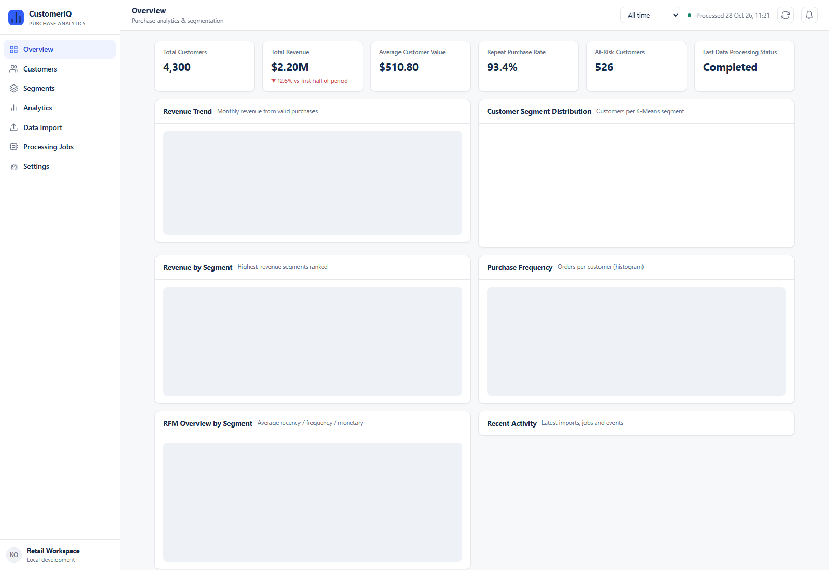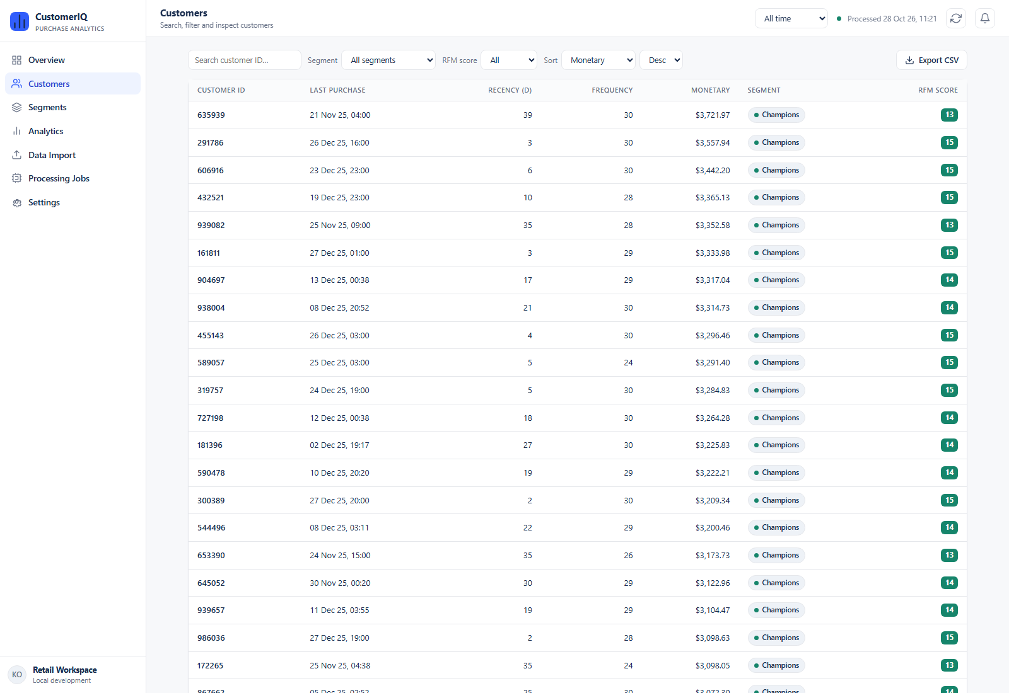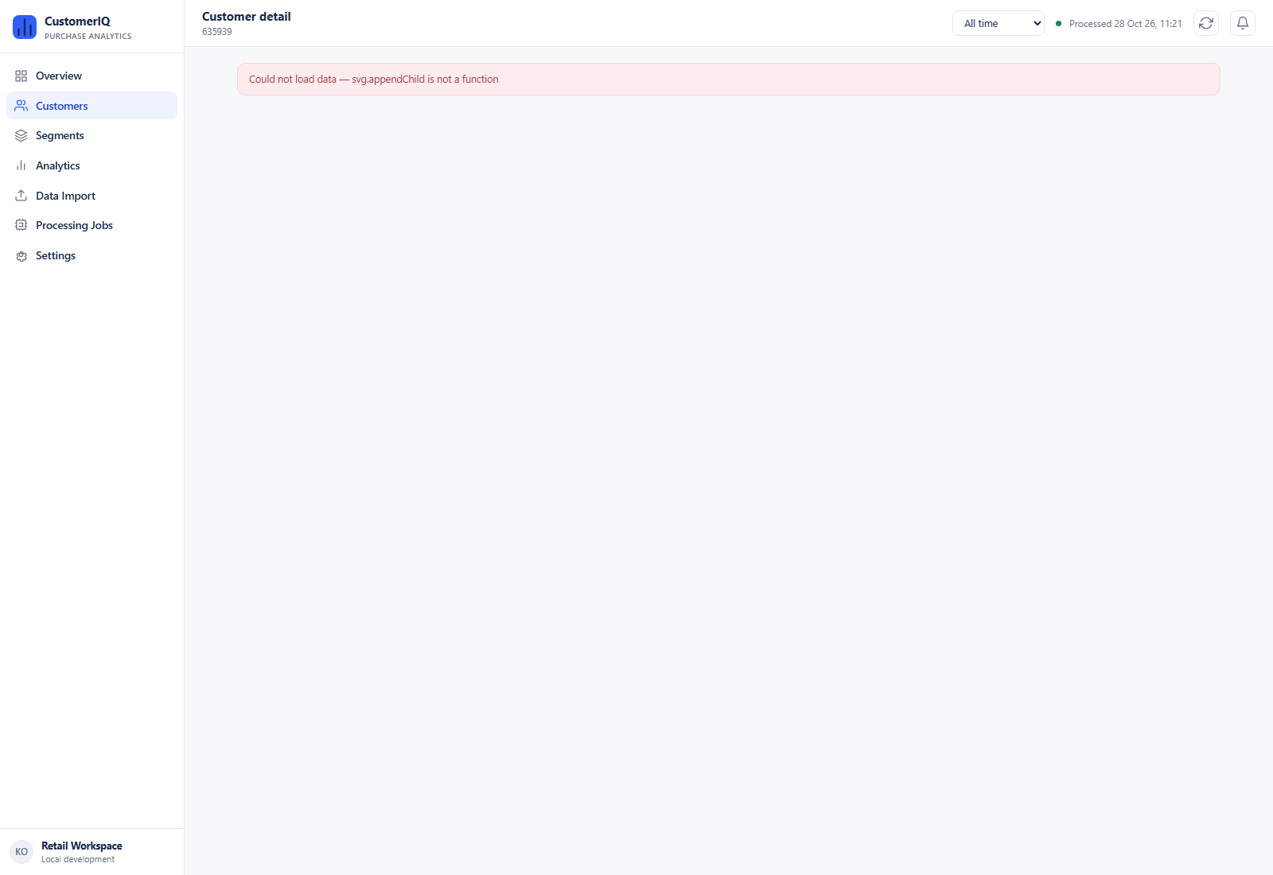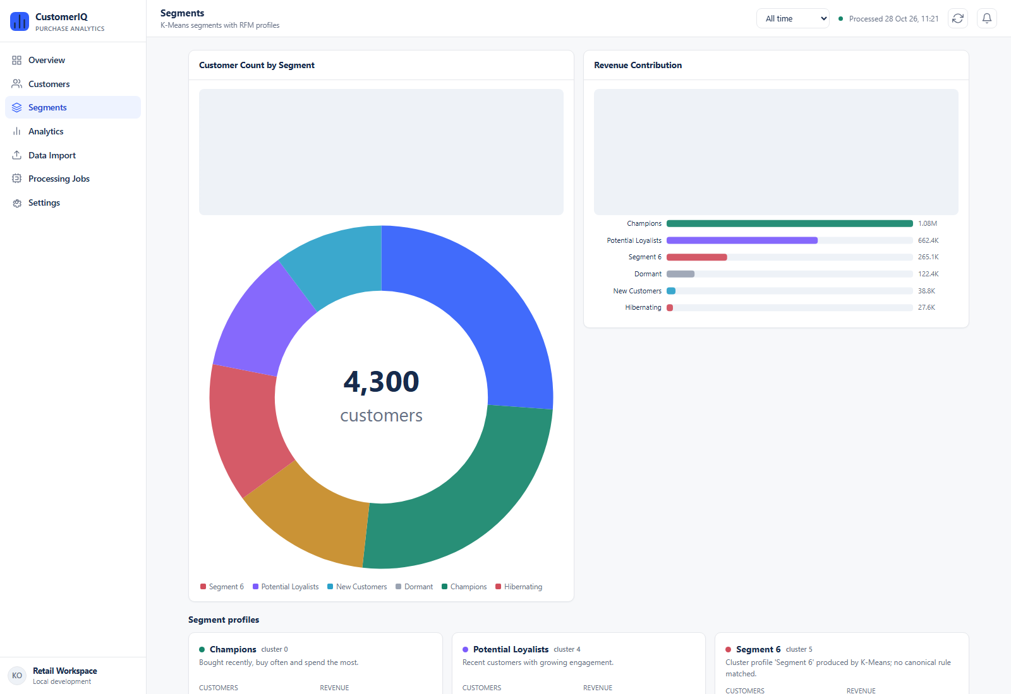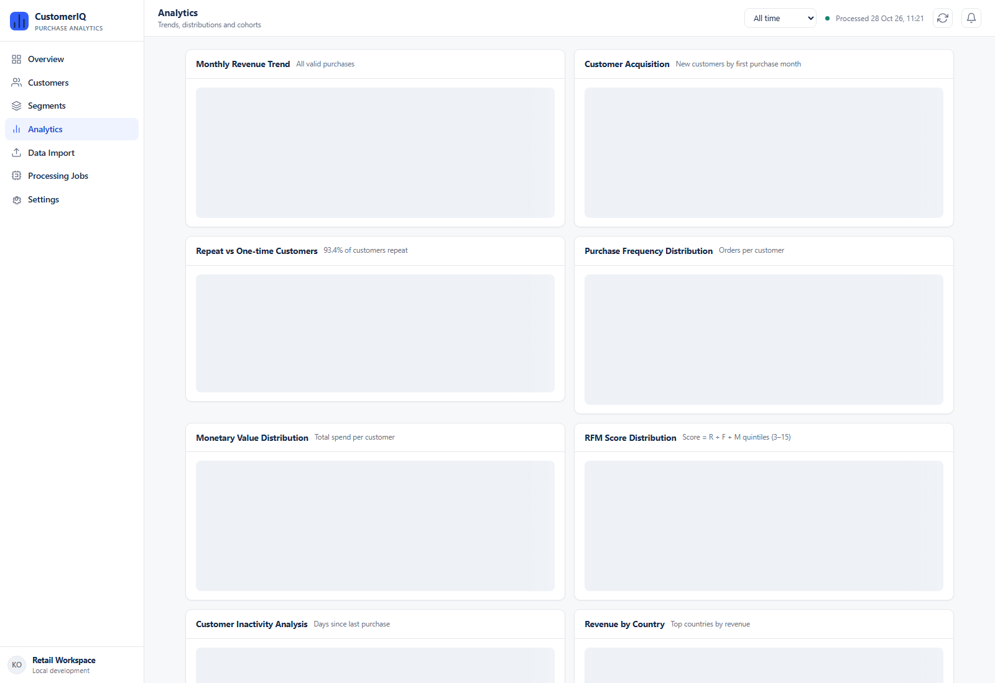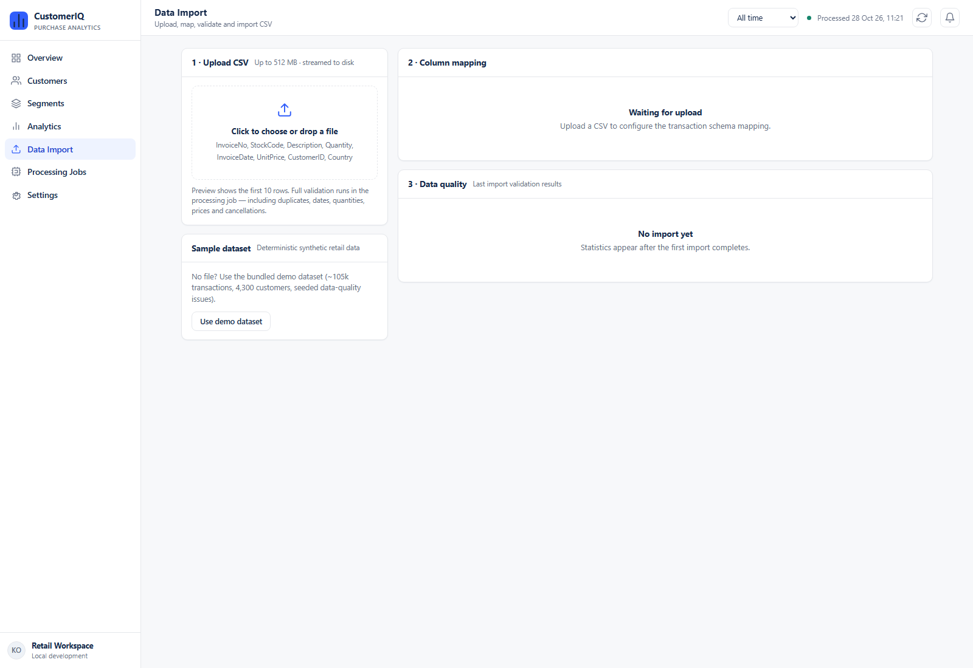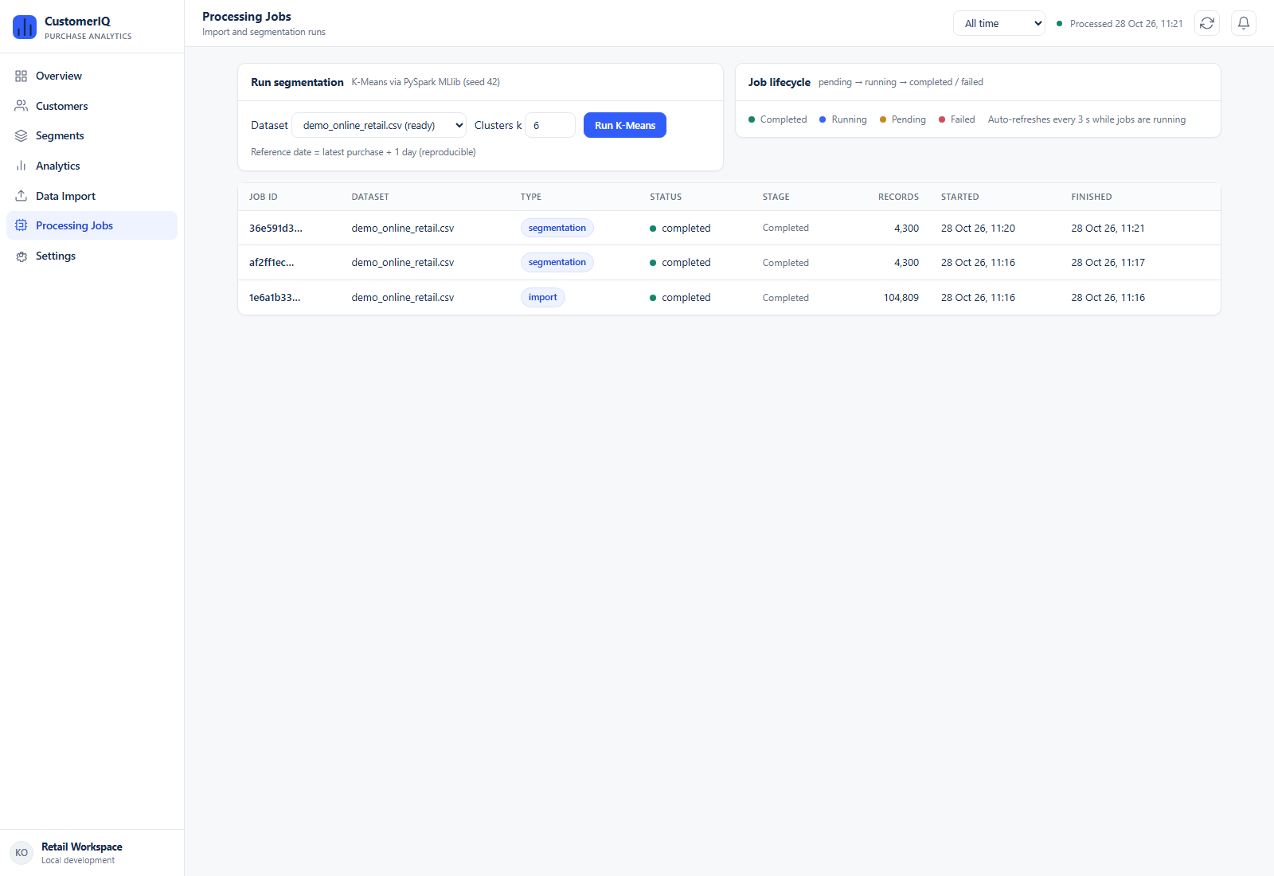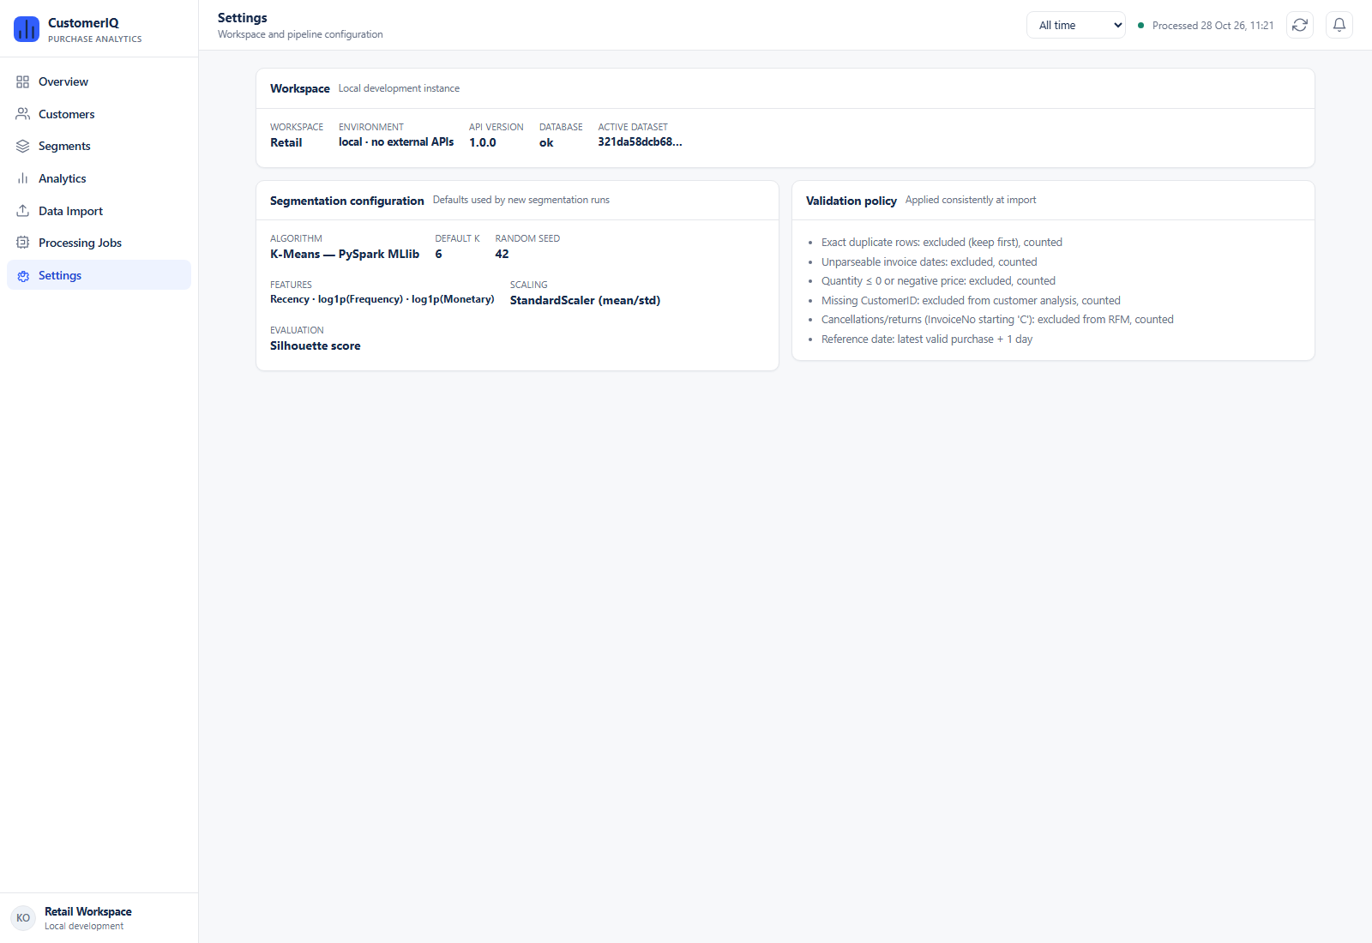
7. References
1. Han, J., Kamber, M., and Pei, J. "Data Mining: Concepts and Techniques." 3rd Edition, Morgan Kaufmann Publishers, 2011.
2. Lloyd, S. "Least Squares Quantization in PCM." IEEE Transactions on Information Theory, Vol. 28, No. 2, pp. 129-137, 1982.
3. Kaufman, L., and Rousseeuw, P. J. "Finding Groups in Data: An Introduction to Cluster Analysis." John Wiley & Sons, 1990.
4. Apache Spark Documentation: MLlib - Clustering (K-Means). https://spark.apache.org/docs/latest/ml-clustering.html
5. UCI Machine Learning Repository: Online Retail Dataset. https://archive.ics.uci.edu/ml/datasets/online+retail
6. FastAPI Documentation. https://fastapi.tiangolo.com/
7. React Documentation. https://react.dev/
8. Hughes, A. M. "Strategic Database Marketing." McGraw-Hill, 1996.

