**Q.1 Write a program to insert element into the stack and display the element.**

#include<stdio.h>

#include<conio.h>

#define SIZE 4

int top = -1,inp_array[SIZE];

void push();

void show();

int main()

{

int choice;

while(1)

{

printf("\nperform operation on the stack:");

printf("\n1.push the element\n2.show\n3.end");

printf("\n\n Enter the choice:"0;

scanf("%d",&choice);

{

case 1:

push();

break;

case 2:

show();

case 3:

exit(0);

default:

printf("\nInvalid choice!!");

}

}

getch();

}

void push()

{

int x;

if(top == SIZE -1)

{

printf("\n overflow!!");

}

else

{

printf("\nEnter the element to be added onto the stack:");

scanf("%d",&x);

topp=top+1;

inp_array[top]=x;

}

}

void show()

{

if(top == -1)

{

printf("\nunderflow!!");

}else{

printf("\nElement present in the stack:\n");

for(i=top;i>=0;--i)

Printf(“%d”;inp_array[iI);

}

}

**Output :**

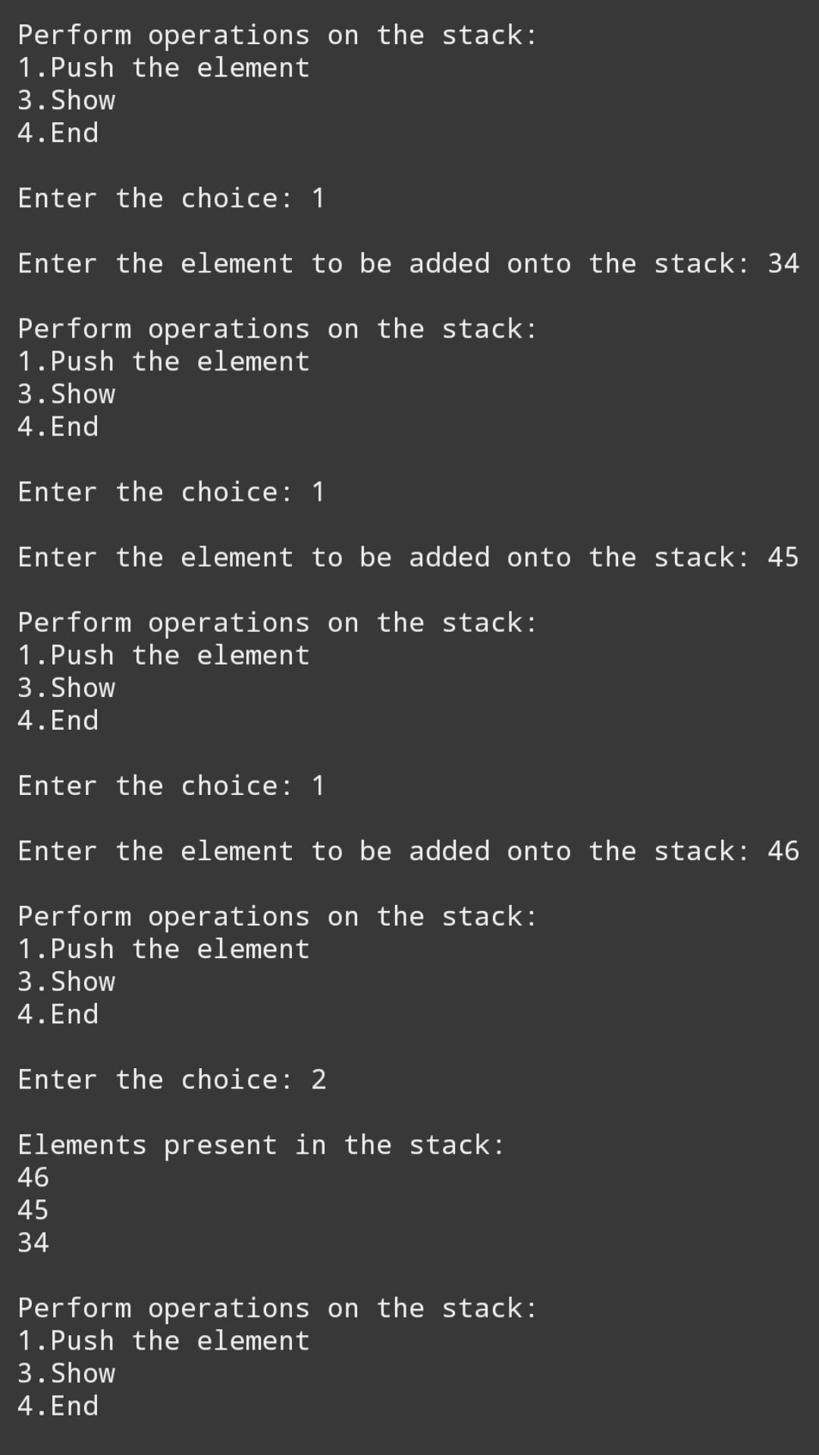

**Q.2write a program to delete an element into the staa=ck and display the element.**

#include<stdio.h>

#include<stdlib.h>

#define SIZE 4

int top=-1,inp_array[SIZE];

void push();

void pop();

int main()

{

int choice;

while(1)

{

printf("\nperform operation on the stack:");

printf("\n1.push the element\n2.pop the element\n3.end");

printf("\n\nEnter the choice:");

scanf("%d",&choice);

switch(choice)

{

case 1:

push();

break;

case 2:

pop();

break;

case 3:

exit(0);

default:

printf("\nInvalid choice!!");

}

}

getch();

}

void push()

{

int x;

if(top == SIZE - 1)

{

if

{

printf("\n overflow!!");

}

else

{

printf("\nEnter the element to be added onto the stack:");

scanf("%d",&x);

top = top + 1;

inp_array[top]=x;

}

}

void pop()

{

if(top == -1)

{

printf("\nUnderflow!!");

}

else

{

printf("\n popped element : %d", inp_array[top]);

top = top - 1;

}

}

**output :**

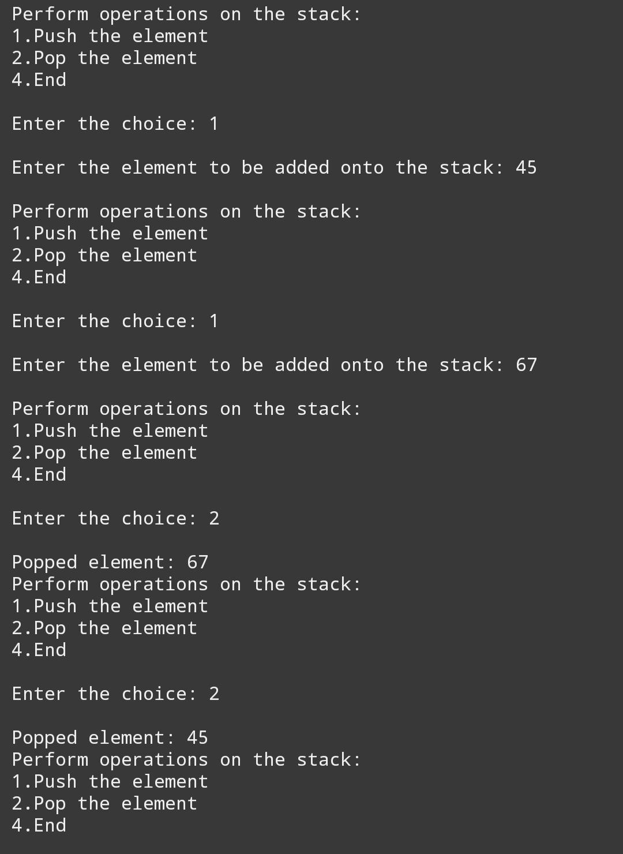

**Q.3 write a program to insert element into the queue and display the element.**

#include<stdio.h>

#include<stdlib.h>

#define SIZE 4

int inp_arr[SIZE];

int Rear = -1;

int Front = -1;

int main()

{

int choice;

while(1)

{

printf("1.enQeue operation\n");

printf("2.exit\n");

printf("Enter the choice:");

scanf("%d",&choice);

switch(choice)

{

case 1:

enQueue();

break;

case 2:

exit(0);

default:

printf("Invalid choice\n");

}

}

return 0;

}

void enQueue()

int insert_item;

if(Rear == SIZE - 1)

{

printf("overflow\n");

}

else

{

if(Front == -1)

Front=0;

printf("Element to be inserted in the queue:");

scanf("%d",&insert_item);

}

}

**output :**

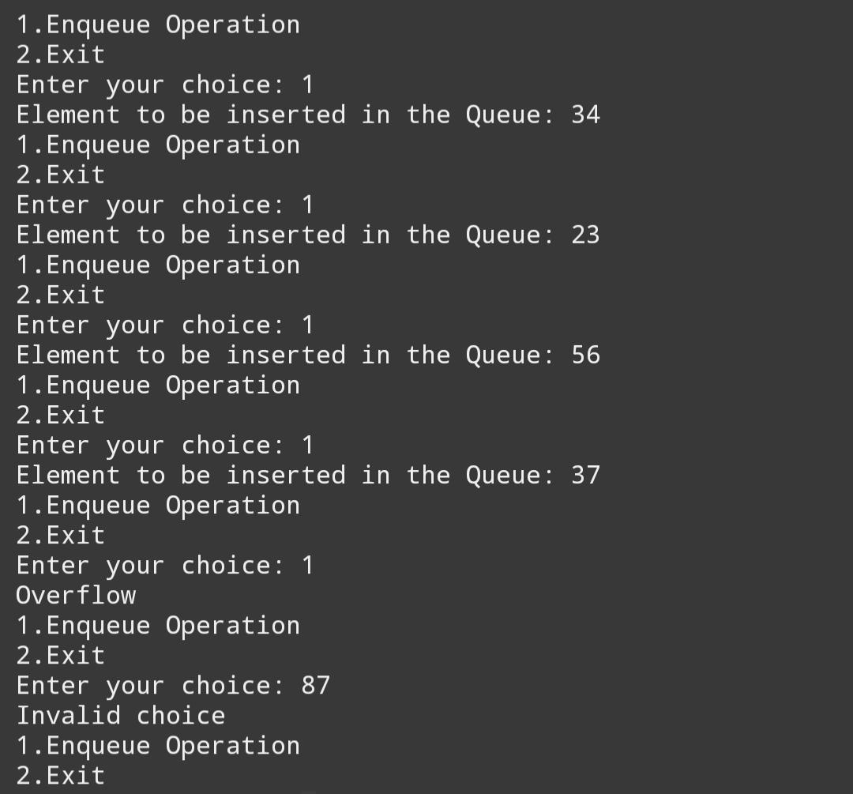

**Q.4 write a program to delete element into the queue and display the element.**

#include<stdio.h>

#include<stdlib.h>

#define SIZE 4

int inp_arr[SIZE];

int Rear = -1;

int Front = -1;

int main()

{

int choice;

while(1)

{

printf("1.enQueue operation\n");

printf("2.deQueue operaton\n");

printf("Exit\n");

printf("Eneter the choice:")

scanf("%d",&choice);

switch(choice)

{

case 1:

enQeue();

break;

case 2:

deQeue();

break;

case 3:

exit(0);

default:

printf("Invalid choice\n");

}

}

return 0;

}

void enQueue()

int insert_item;

if(Rear == SIZE - 1)

printf("overflow\n");

else

{

if(Front == -1)

Front=0;

printf("Element to be inserted in the queue:");

scanf("%d",&insert_item);

}

}

void deQeue()

{

if(Front == -1 || Front > Rear)

{

printf("Underflow\n");

return;

}

else

{

printf("Element deleted from the qeue : %d\n",inp_arr[Front]);

Front = Front + 1;

}

}

**output :**

