# Deep Learning – Case Study

**Age and Gender prediction using CNN**

**Name:** Kinjal R Omkar

**Enrollment Number:** 19012012003

**Batch:** DL2

## Introduction

This case study is designed to Classify the Age and Gender prediction. It uses the Sequential and cnn model for the images.

This case study can be used Using CNN, model is trained to an extent that accuracy of Age and Gender

.

## Tools and Technologies

|  |  |
| --- | --- |
| **Tools and Libraries** | **Usage** |
| **Keras** | This library is used for building the network architecture. It allows us to use several layers,  callbacks, and InceptionResNetV2 model. |
| **Sequential** | A Sequential model is appropriate for a plain stack of layers where each layer has exactly one input tensor and one output tensor. |
| **Matplotlib** | Matplotlib is a plotting library for the Python programming language and its numerical mathematics extension NumPy. |
| **Kaggle** | Used as a platform to execute code as well as  manage datasets and model weights |

1. **Model Explanation and Architecture**

Sequential data pops up absolutely everywhere, and I will talk about some particularly popular use cases for sequence modeling, including:

• Language models (prediction of the next word given a seed string, as you see in keyboard apps on mobile phones)

• Machine translation (automatic translation between different languages)

• Computational biology, for example in the functional modeling of DNA and protein sequences (predicting which regions of biological sequences are functional and what that function could be)

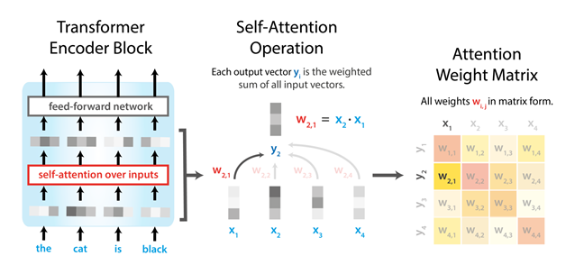

## Working

## At first, I added necessary liberties, we propose a model that uses CNN architecture to predict the age group and gender of human’s faces from unfiltered real-world environments. CNN approach addresses the age and gender labels as a set of discrete annotations and train the classifiers that predict the human’s age group and gender.

## demonstrate that pretraining on large-scale datasets allows an effective training of our age and gender CNN model which enable the classifiers to generalize on the test images and then avoid overfitting.

## Finally, showing prediction.

## Code

<https://github.com/manavshah123/Traffic-Signs-Classification>

** Code and Report is available in the GitHub repository.

## Output

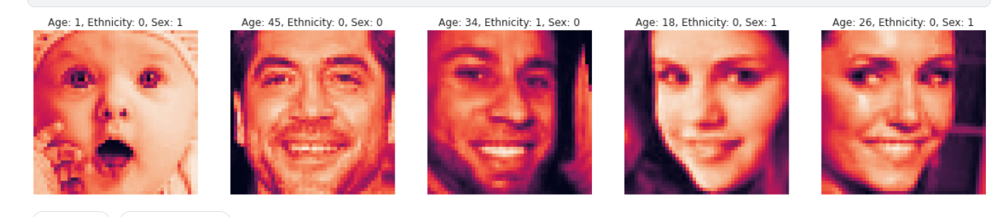

**Prediction: -**



