PHARMACEUTICAL MANAGEMENT SYSTEM

Project report in partial fulfillment of the requirement of Software Engineering Lab
In
COMPUTER SCIENCE & ENGINEERING DEPT.

Submitted By

<<Student_1 Name>> Department of Computer Science,
University Roll No. XXXXXXXXX UEM, Kolkata
Section: _____, Class Roll No.: ___

<<Student_2 Name>> Department of Computer Science,
University Roll No. XXXXXXXXX UEM, Kolkata
Section: _____, Class Roll No.: ___

<<Student_3 Name>> Department of Computer Science,
University Roll No. XXXXXXXXX UEM, Kolkata
Section: _____, Class Roll No.: ___




UNIVERSITY OF ENGINEERING & MANAGEMENT, KOLKATA
University Area, Plot No. III – B/5, New Town, Action Area – III, Kolkata – 700 156
Table of Contents
Table of Contents ii
Revision History ii
1. Introduction 1
1.1 Purpose 1
1.2 Document Conventions 1
1.3 Intended Audience and Reading Suggestions 1
1.4 Project Scope 1
1.5 References 1
2. Overall Description 2
2.1 Product Perspective 2
2.2 Product Features 2
2.3 User Classes and Characteristics 2
2.4 Operating Environment 2
2.5 Design and Implementation Constraints 2
2.6 User Documentation 2
2.7 Assumptions and Dependencies 3
3. System Features 3
3.1 System Feature 1 3
3.2 System Feature 2 (and so on) 4
4. External Interface Requirements 4
4.1 User Interfaces 4
4.2 Hardware Interfaces 4
4.3 Software Interfaces 4
4.4 Communications Interfaces 4
5. Other Nonfunctional Requirements 5
5.1 Performance Requirements 5
5.2 Safety Requirements 5
5.3 Security Requirements 5
5.4 Software Quality Attributes 5
6. Other Requirements 5
Appendix A: Glossary 5
Appendix B: Analysis Models and Design Documents 6
Appendix C: Issues List 6
7. Future Scope
8. Bibliography

Introduction

Purpose
<Identify the product whose software requirements are specified in this document, including the revision or release number. Describe the scope of the product that is covered by this SRS, particularly if this SRS describes only part of the system or a single subsystem.>

Document Conventions
<Describe any standards or typographical conventions that were followed when writing this SRS, such as fonts or highlighting that have special significance. For example, state whether priorities for higher-level requirements are assumed to be inherited by detailed requirements, or whether every requirement statement is to have its own priority.>

Intended Audience and Reading Suggestions
<Describe the different types of reader that the document is intended for, such as developers, project managers, marketing staff, users, testers, and documentation writers. Describe what the rest of this SRS contains and how it is organized. Suggest a sequence for reading the document, beginning with the overview sections and proceeding through the sections that are most pertinent to each reader type.>

Project Scope
<Provide a short description of the software being specified and its purpose, including relevant benefits, objectives, and goals. Relate the software to corporate goals or business strategies. If a separate vision and scope document is available, refer to it rather than duplicating its contents here. An SRS that specifies the next release of an evolving product should contain its own scope statement as a subset of the long-term strategic product vision.>

References
<List any other documents or Web addresses to which this SRS refers. These may include user interface style guides, contracts, standards, system requirements specifications, use case documents, or a vision and scope document. Provide enough information so that the reader could access a copy of each reference, including title, author, version number, date, and source or location.>

Overall Description

Product Perspective
<Describe the context and origin of the product being specified in this SRS. For example, state whether this product is a follow-on member of a product family, a replacement for certain existing systems, or a new, self-contained product. If the SRS defines a component of a larger system, relate the requirements of the larger system to the functionality of this software and identify interfaces between the two. A simple diagram that shows the major components of the overall system, subsystem interconnections, and external interfaces can be helpful.>

Product Features
<Summarize the major features the product contains or the significant functions that it performs or lets the user perform. Details will be provided in Section 3, so only a high level summary is needed here. Organize the functions to make them understandable to any reader of the SRS. A picture of the major groups of related requirements and how they relate, such as a top level data flow diagram or a class diagram, is often effective.>

User Classes and Characteristics
This product utilizes three classes of users as described below: -
- Administrator: An Administrator is a user type which will manage and integrate the whole product. Being the highest security level and to protect data access and manipulation, administrators cannot be added to the system through the UI. However, an administrator can login to the system and view the admin dashboard through the universal login system. An Administrator has full rights to the following actions:
  - Add/Edit/Delete Chemicals
  - Add/Edit/Delete Medicines
  - Set/Unset Medicines for sale
  - Add/Edit/Delete Medicine Composition
  - Trigger Medicine manufacture process and control quantity
  - View Vendor/Customer Transactions
- Vendors: Vendors are generic users with no direct modification rights. However, their access level is slightly higher than that of Customers. Vendors can register themselves to the system by filling up the registration form. Vendors should login to view the list of chemicals to supply. They can just select and set quantity of chemicals to sell.
- Customers: Customers are generic users too. Customers can register themselves to the system by filling up the registration form. However, customers can list available medicines by just visiting the homepage. To buy medicine(s), they need to log in with their credentials.

Operating Environment
- MySQL DB
- Client/Server system
- Operating System: Windows, OSX, Linux
- JS Enabled Web Browser

Design and Implementation Constraints
This project uses MySQL/MariaDB Database. Hence, the queries are solely written on SQL and are expected to run on any other distributions of SQL like MS SQL, SQL Server etc. Though it is unexpected to port this system to a NoSQL or a document-based DB system, primarily due to the existing DB structure. In such a case, the composite tables to link different tables should be avoided.
Keeping in mind the security considerations, Administrator cannot be directly added through the UI. However, by carefully modifying the server-side code in the register page, one can add Administrators. This is done, keeping in mind the consistency in the password hashing algorithm. If Administrators are added directly in the DB with a password, that might not match the hashing done throughout the system, therefore blocking the user from logging in.
This project was developed using Visual Studio Code with PHP IntelliSense. Throughout the code, 2 spaces indentation was maintained. Lines are no more than 80 characters.

User Documentation
Little or no user documentation is expected to be delivered along with this project. Most of the project will be self-explanatory, backed up with suitable prompts throughout the UI.
Administrators might need additional specialization using the software, which can be achieved through training and evaluation

Assumptions and Dependencies
It is assumed that an Administrator of the system has the sole authority to manage the whole application. Being the highest access level, an Administrator can control all the production of medicines within the application, even if they are/aren’t produced physically in the organization.
This project is known to have no dependencies. It can run as a stand-alone software as long as enough resources are available and the file system has enough permissions to read/write.

System Features
The following System features are organized by the different user classes explained in Section 2.3

Administrator
3.1.1 Description and Priority
The administrator has the highest privilege and the highest priority in the system. An administrator can integrate the whole manufacturing process in a pharmaceutical organization through the system. The project provides a UI to the Administrator to manage the Chemicals and Medicines Inventory and control production.
3.1.2 Stimulus/Response Sequences
User Actions | System Response
Add a chemical | The system will accept input through a form and save the chemical data in the DB
Edit a chemical | The system will dynamically create a form using the current chemical data from the DB. Editing and submitting the form will lead to overwriting of the chemical data in the DB.
Delete a Chemical | The system will delete the chemical from the DB.
Add a medicine | The system will accept input through a form and save the medicine data in the DB
Edit a chemical | The system will dynamically create a form using the current medicine data from the DB. Editing and submitting the form will lead to overwriting of the medicine data in the DB.
Delete a Chemical | The system will delete the medicine from the DB.
Add composition | The system will accept input through a form and save the composition data in the DB. Also, the medicine price can be set through here
Edit Composition | The system will dynamically create a form using the current composition data from the DB. Editing and submitting the form will lead to overwriting of the composition data in the DB.
Delete Composition | The system will delete the composition from the DB.
Manufacture | The system prompts the administrator with the current availability of the chemicals required to manufacture a certain medicine. If the chemicals aren’t available sufficiently, then the administrator cannot proceed with production.
View Transaction | The system will list all the vendor and customer transactions along with the total debit/credit
3.1.3 Functional Requirements
REQ-1: A user should be signed in as an Administration to use all the above features.
REQ-2: The chemical and medicine should be added before adding a composition linking them
REQ-3: Medicines using a chemical in its composition should be deleted before the chemical can be deleted.
REQ-4: Images should be reuploaded in edit forms
REQ-5: The chemical quantity required to produce a medicine should be available sufficiently to manufacture.

Vendor
3.1.1 Description and Priority
The vendor is a generic user with no direct privileges to edit the DB. Vendors can only list, view and sell chemicals stored in the DB.
3.1.2 Stimulus/Response Sequences
User Actions | System Response
List chemicals | All the chemicals stored in the DB will be listed along with the current quantity in the inventory
Sell a chemical | A vendor can select the quantity of chemical to sell
3.1.3 Functional Requirements
REQ-1: A user should be signed in as a Vendor to list and sell chemicals.
REQ-2: A vendor can sell maximum of 10 units of a chemical in a single transaction.

Customer
3.1.1 Description and Priority
The customer is a generic user with no direct privileges to edit the DB. Customers can only list, view and buy medicines stored in the DB.
3.1.2 Stimulus/Response Sequences
User Actions | System Response
List medicines | All the medicines stored in the DB will be listed along with the current quantity in the inventory.  Note: Any end user can list medicines even without registering/logging in in the system.
Buy a medicine | A customer can select the quantity of medicines to buy
3.1.3 Functional Requirements
REQ-1: A user should be signed in as a Customer to buy chemicals

External Interface Requirements

User Interfaces
The UI of the total project is based on Material design through the usage of Materialize CSS framework. Distinctive shades of blue is used throughout the project to specify different states of interfaces. Full screen backdrop Modals are used to provide error messages display.

Hardware Interfaces
Standard Input devices like Keyboard and Mouse pointing device along with output Display device (monitor) with a minimum resolution of 1024×768 should be use. This project doesn’t directly interface with any specialized hardware.

Software Interfaces
This project is a web application and was developed and debugged throughout using the Chrome Web Browser (v 90.0.4430.72). So, this project is intended to run in a web browser (preferably a chromium-based browser). However, using the project through ElectronJS might have undesirable behavior.
PHPMyAdmin using MySQL/MariaDB was used throughout the development process for the backend server and DB requirements.

Communications Interfaces
This project is indented to run of a web browser with JS enabled. Disabling JS is not recommended as it might lead to non-functioning components. The User Interface is served on the web over HTTP. All the electronic forms follow the HTTP standard POST request to send information to the server. The forms which include some file uploads are encoded as multipart/form-data.

Other Nonfunctional Requirements

Performance Requirements
This project works almost in real-time due to less to almost no complex system overheads. Data transferred over local HTTP is fast enough not to include any pre-loaders. However, images might need additional time to load depending on their size or hardware/software read/write times. Reading and Writing on the DB is real-time enabled by optimized queries and indexed fields.

Safety Requirements
Ideally, one Administrator should be logged in to the system, which can modify crucial DB entries. Multiple Administrators accessing the same data might be protected by the DB’s internally locking system. Other safety measures should include protecting the user’s DB from multiple email entries, which ideally should be incorporated with error prompts in the UI.

Security Requirements
Data should be protected with the utmost priority, and user credentials is one of the data leakages sources. Hence, passwords of the users should be hashed before saving in the DB, to protect from logging in as in imposter by the DB admin or DB user(s).

Software Quality Attributes
This product has a great degree of reliability, robustness and accuracy. Data has been presented in a simple way to the user, which facilitates easy and quick usage. Also, this application is in line with WAI-ARIA, that makes it more accessible (though aria-* labels aren’t explicitly declared, modern HTML5 can already use the ARIA from attributed specified in the tags). Additionally, this software is highly maintainable due to the modular coding approach.

Other Requirements
Most of the features in this project are re-usable. This includes the authentication system, Database CRUD applications, sidebar navigation etc.
New sections pertinent to this system might include a session-based cart system and payment gateways integrations, auto-generated mailing system etc.
Other requirements for developing this application:
- Text Editor – For coding the application
- Materialize CSS – Material Design themes and responsive CSS for the website
- StarUML – Preparing the design documents
Appendix A: Glossary
Glossary of Terms used in this SRS Documentation:
- Administrator – The user intended to work with the backend of the system. Manages and controls the DB and medicine production.
- Customers – The user intended to work with a part of the frontend. Customers can buy medicines from the firm.
- Organization – The term ‘organization’ has been used interchangeably with ‘firm’, ‘company’, and ‘pharmaceutical company’ which collectively stands as the group of people that use the backend of the system.
- Project – The term ‘project’ has been used interchangeably with ‘product’, ‘software’, ‘system’ and ‘application’ which collectively stands as the outcome of development.
- User – End user i.e., the customer, unless otherwise specified.
- Vendors – The user intended to work with a part of the frontend. Vendors can sell medicines to the firm.
Acronym used in this SRS Documentation:
- ARIA – Accessible Rich Internet Application
- DB – Database
- HTML – Hyper Text markup Language
- JS – JavaScript
- NoSQL – Not Only SQL
- PHP – Hypertext Preprocessor
- SQL – Structured Query Language
- UI – User Interface

Appendix B: Analysis Models and Design Documents
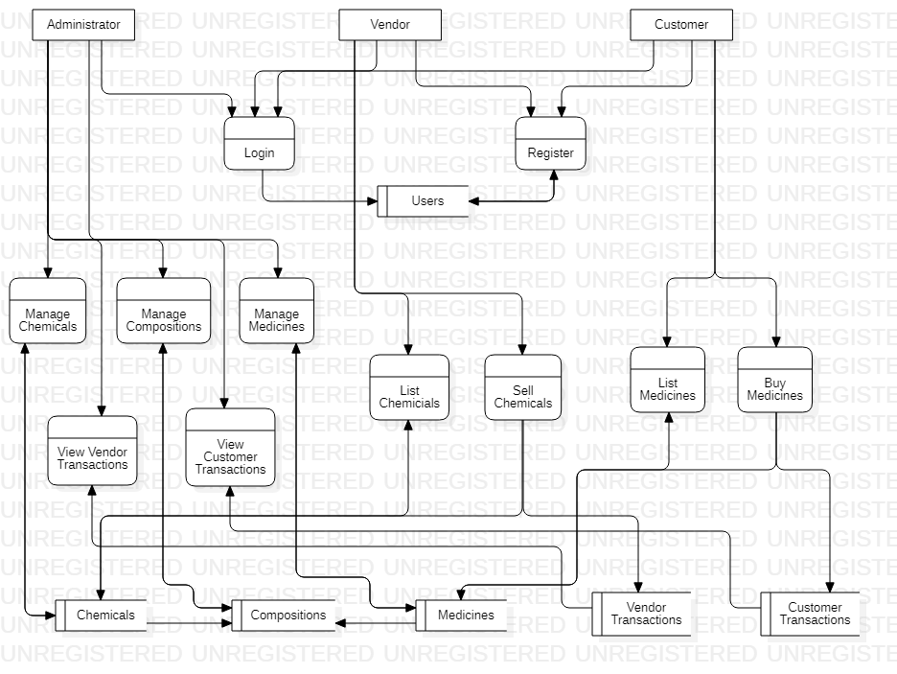
Figure 1 Data flow Diagram
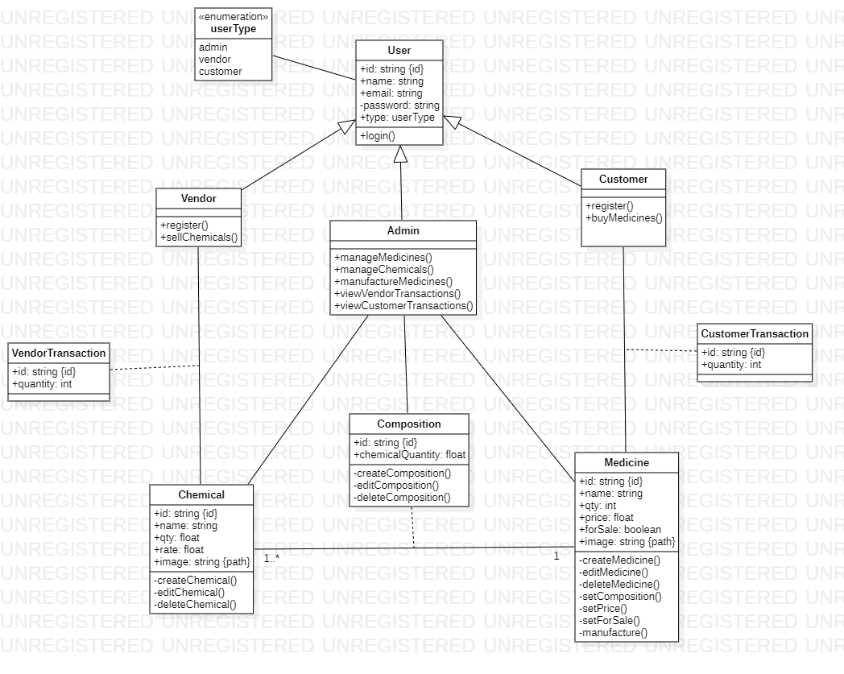
Figure 2 Class Diagram
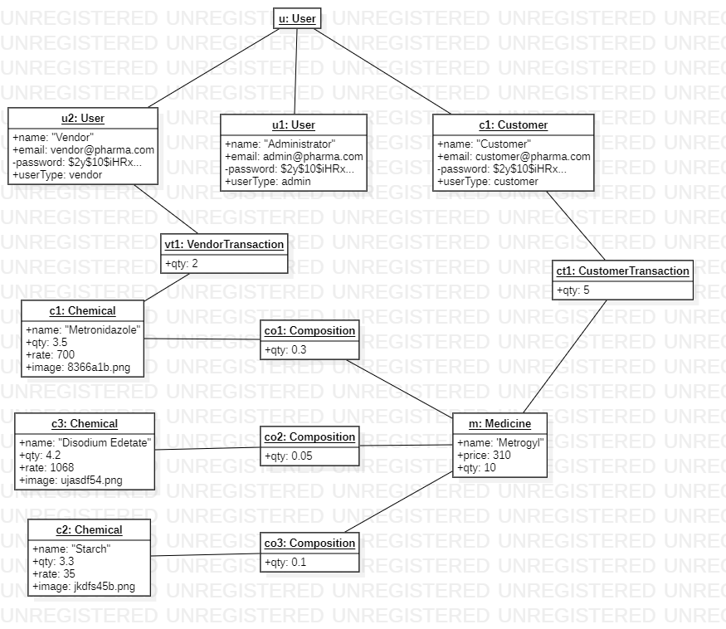
Figure 3 Object Diagram
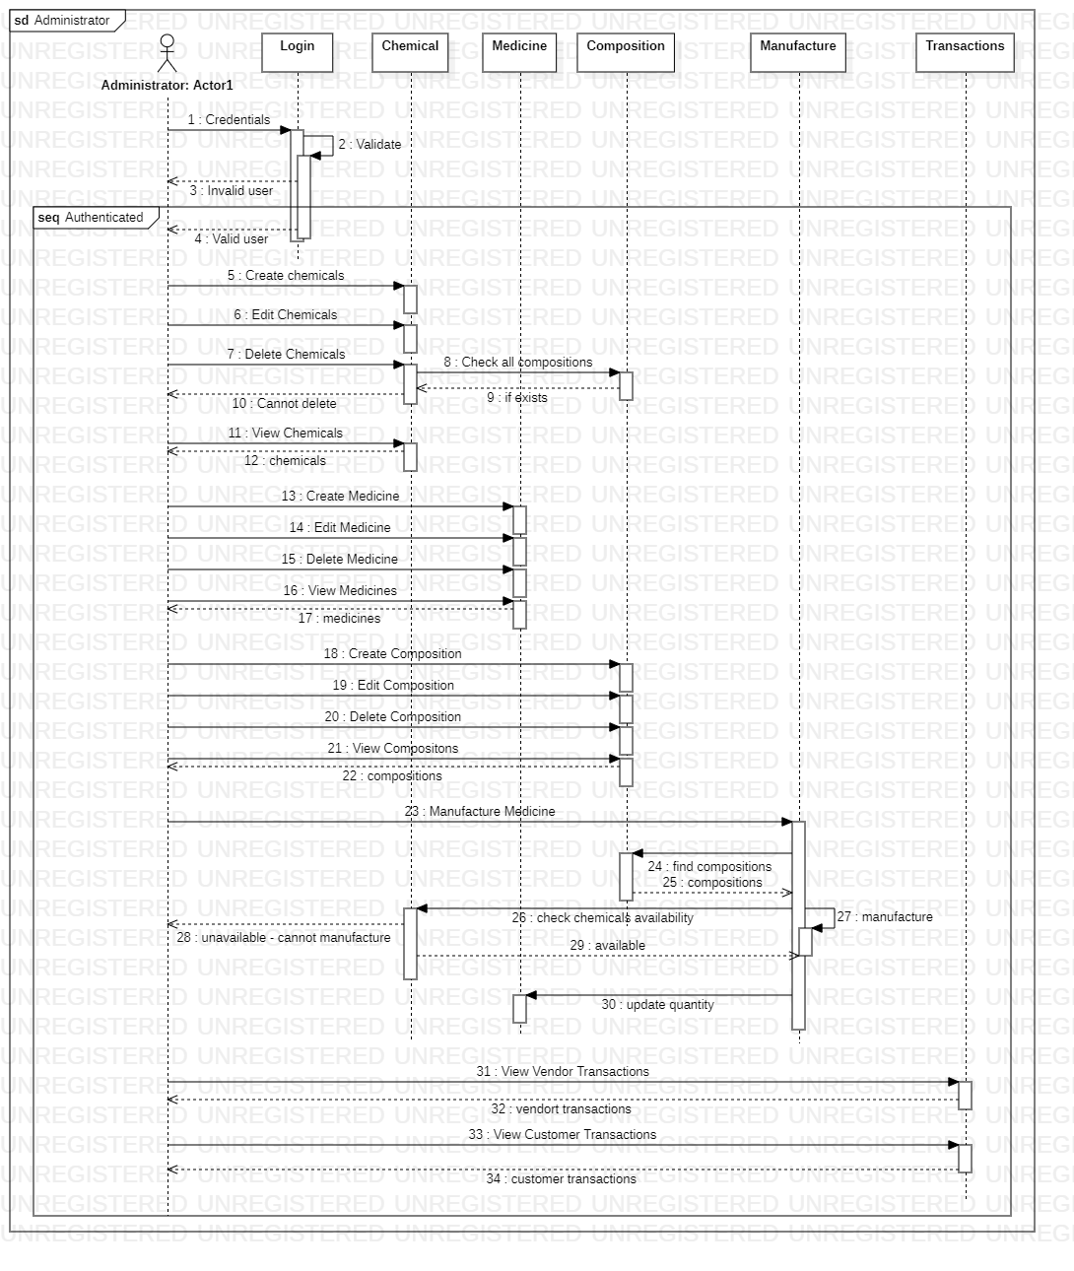
Figure 4 Sequence Diagram – Administrator
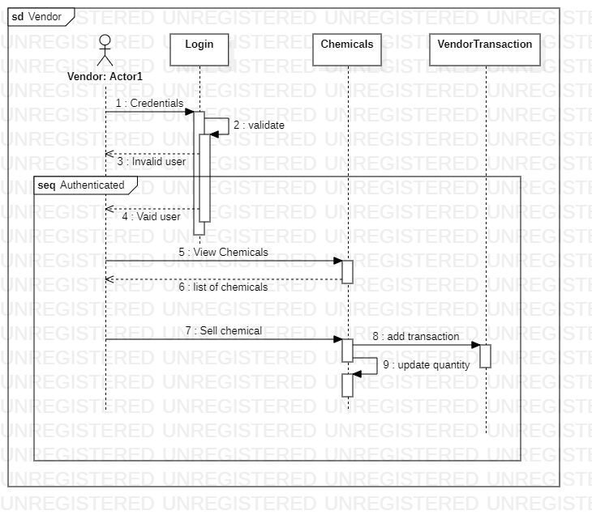
Figure 5 Sequence Diagram – Vendor
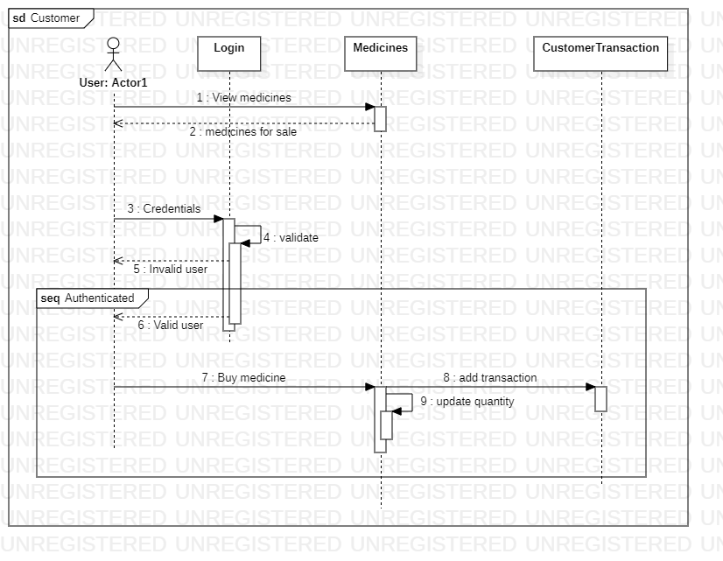
Figure 6 Sequence Diagram – Customer
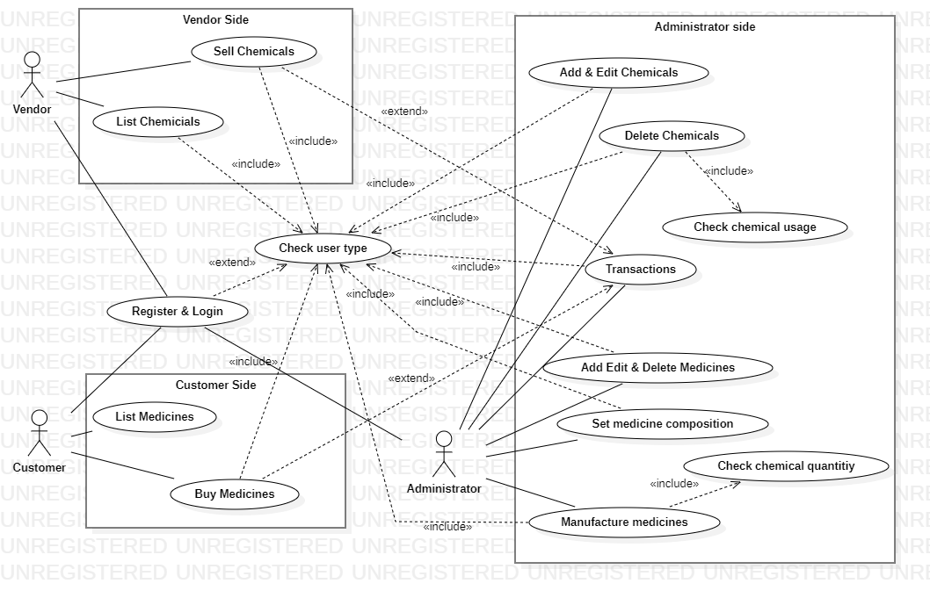
Figure 7 Use case Diagram
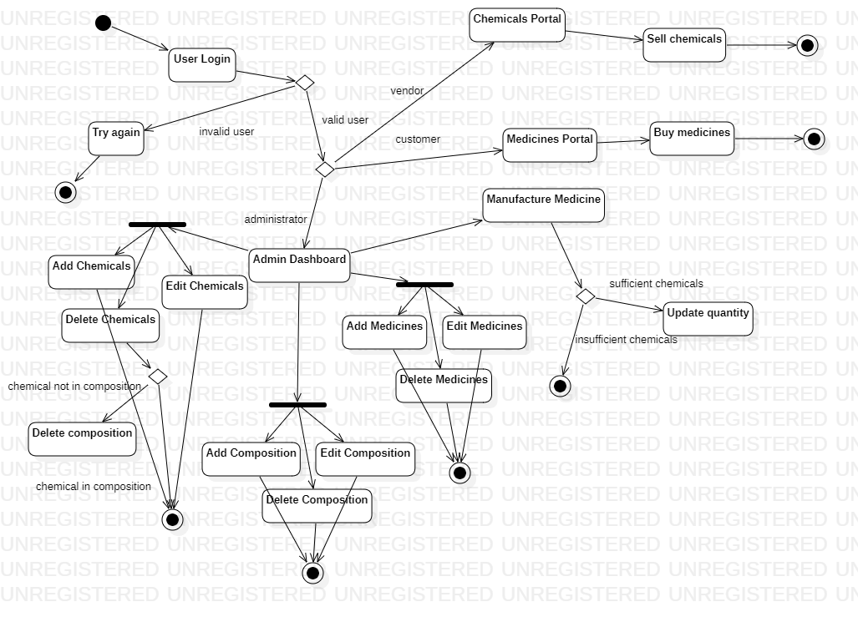
Figure 8 Activity Diagram
Appendix C: Implementation
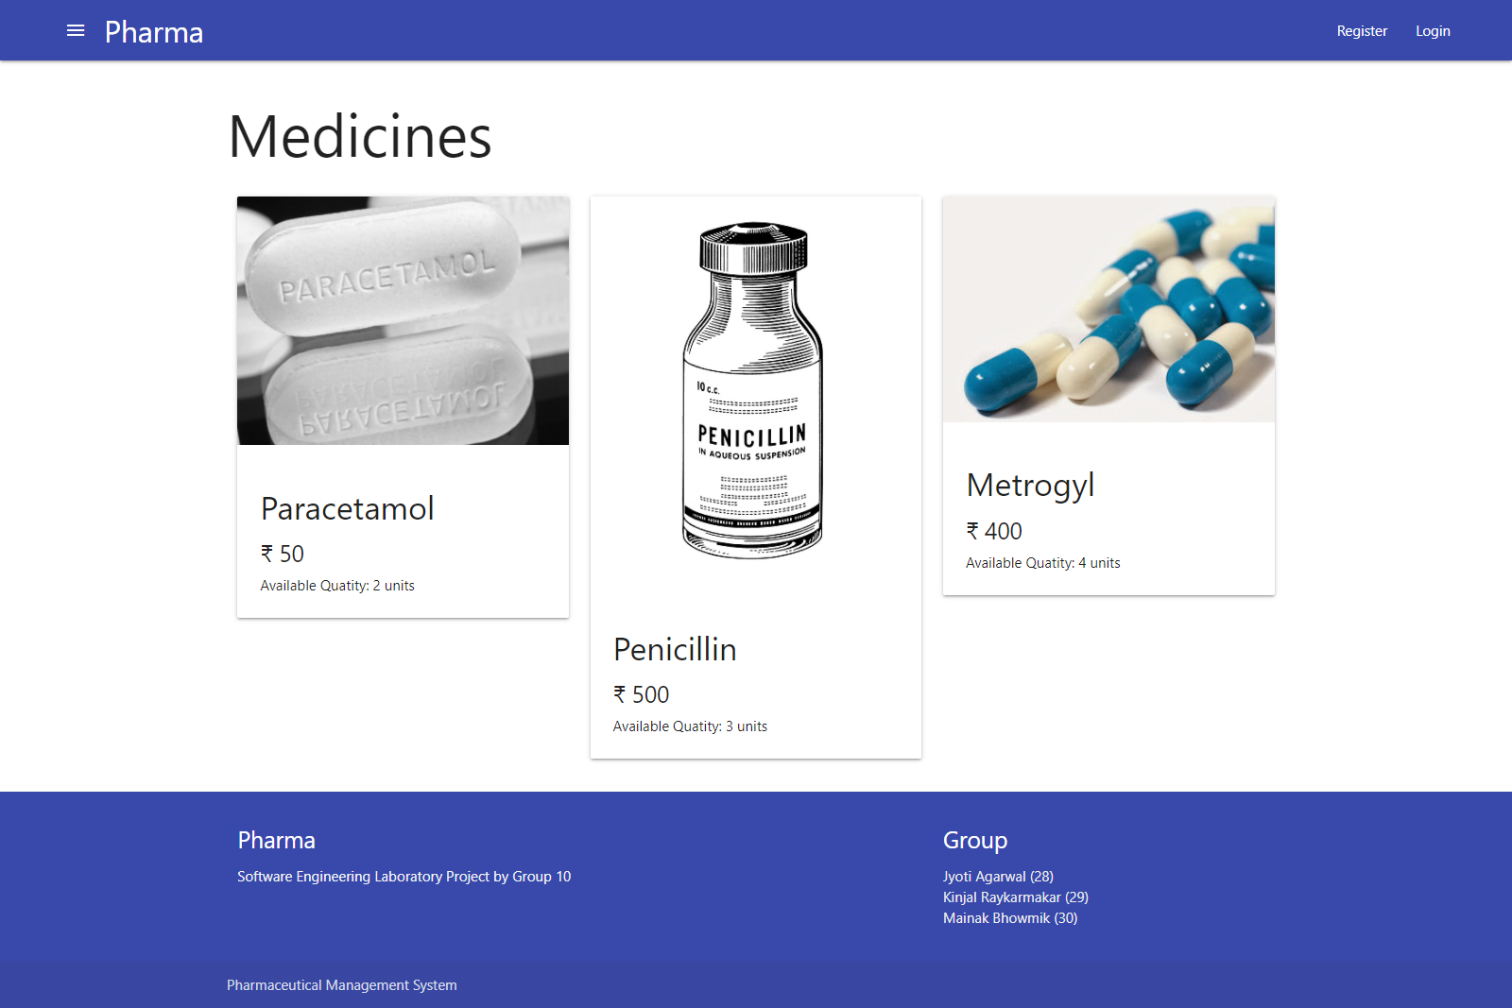
Figure 9 Index Page


Figure 9 Register Page

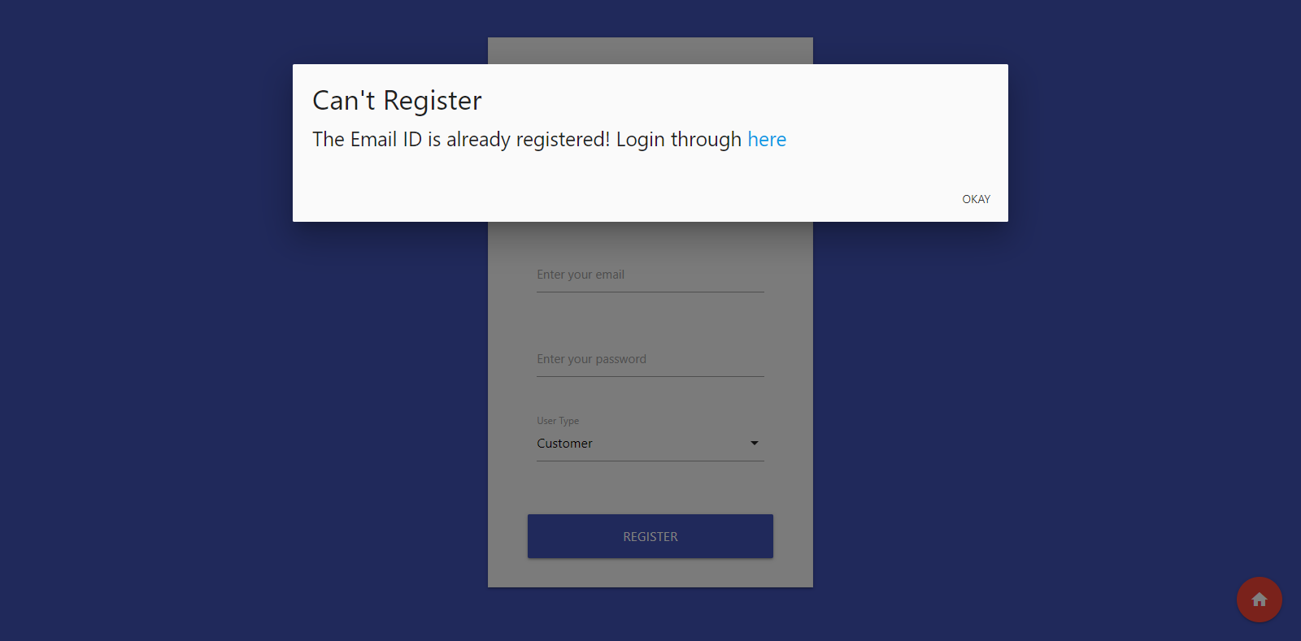
Figure 10 Error Prompt: Trying to register with existing email id


Figure 11 Login Page
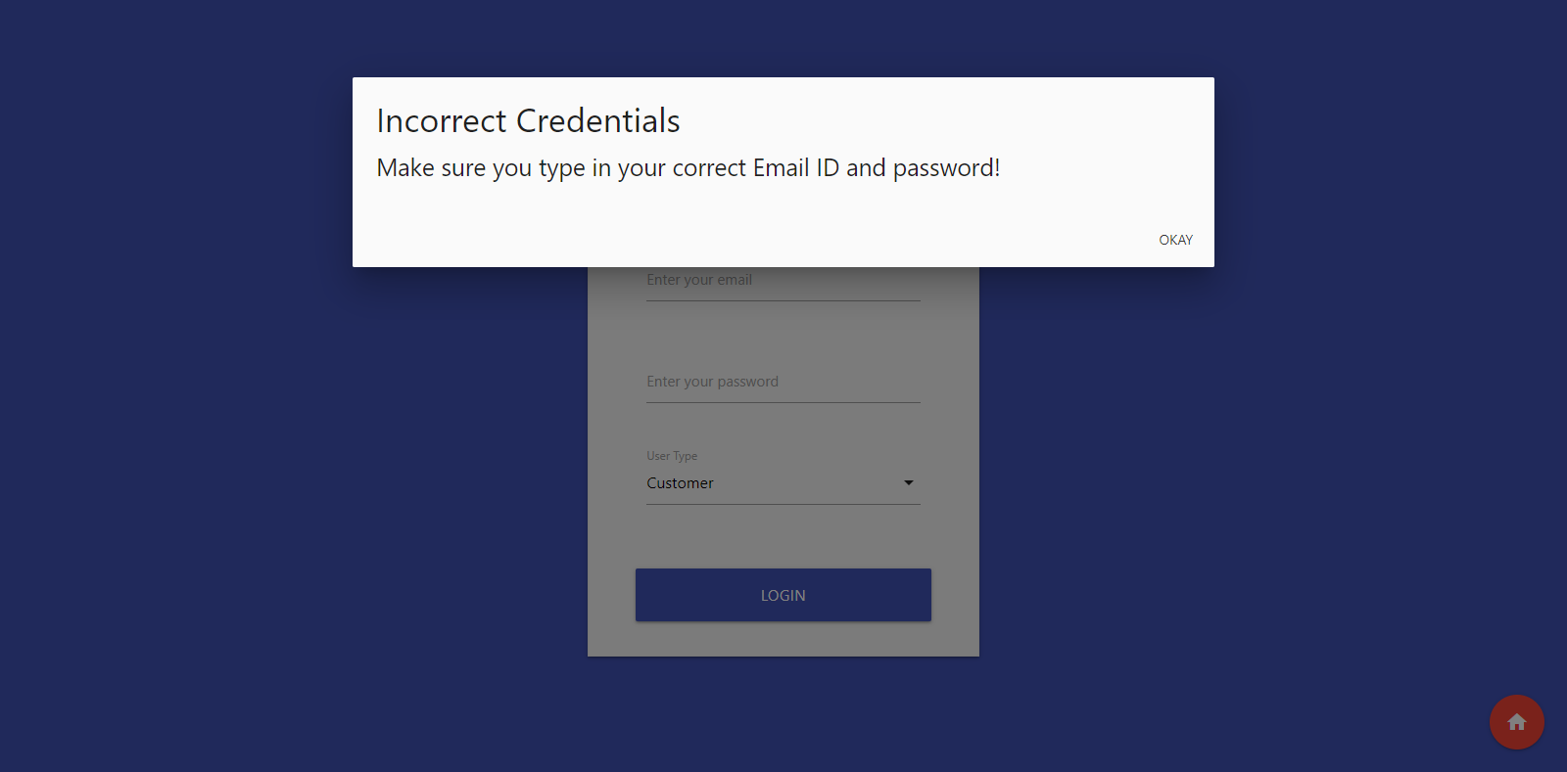
Figure 12 Error Prompt: Trying to logging in with incorrect credentials

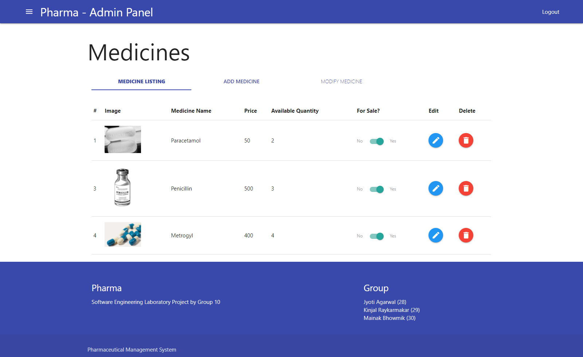
Figure 13 Admin Dashboard + Medicine Listing
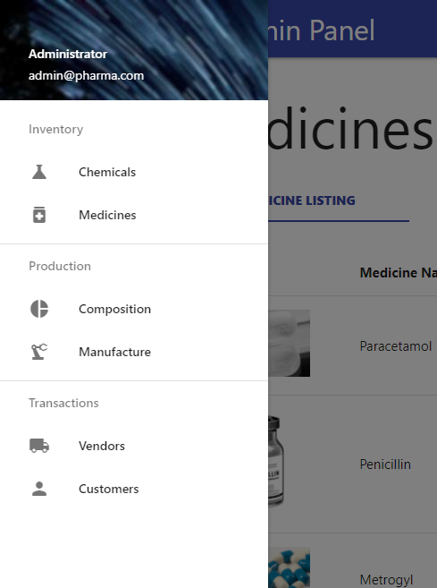
Figure 14 Sidebar for navigation
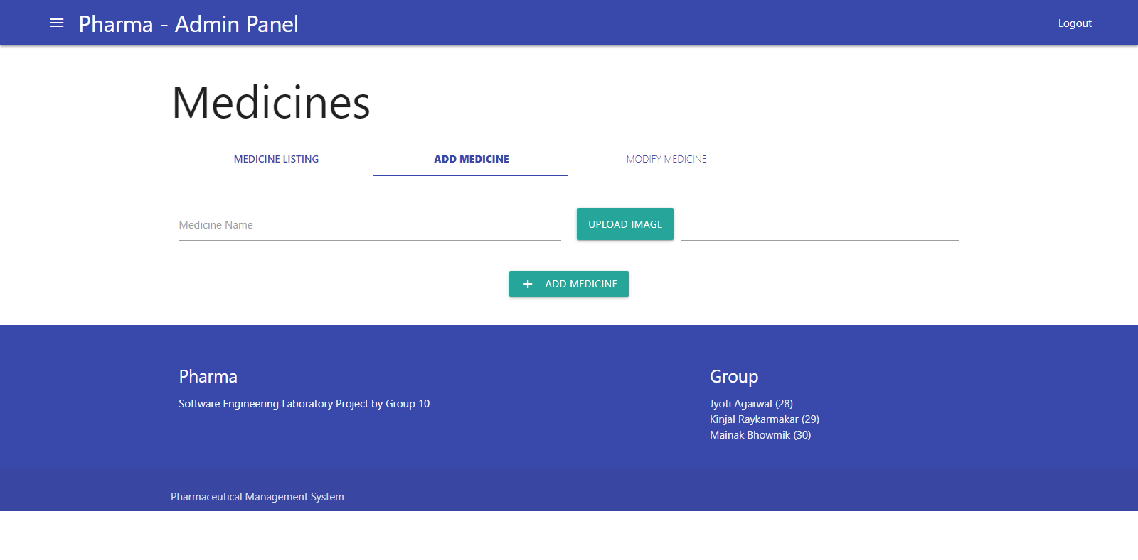
Figure 15 Add Medicine page

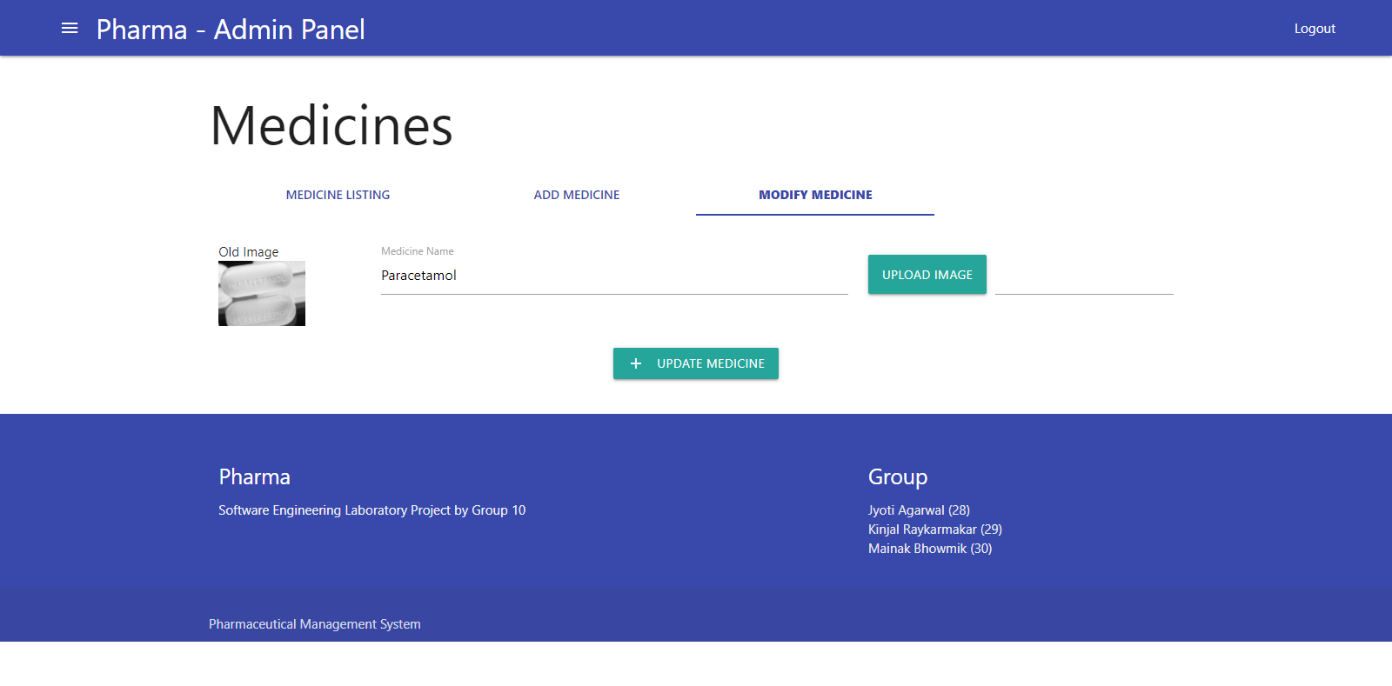
Figure 16 Modify Medicine Page
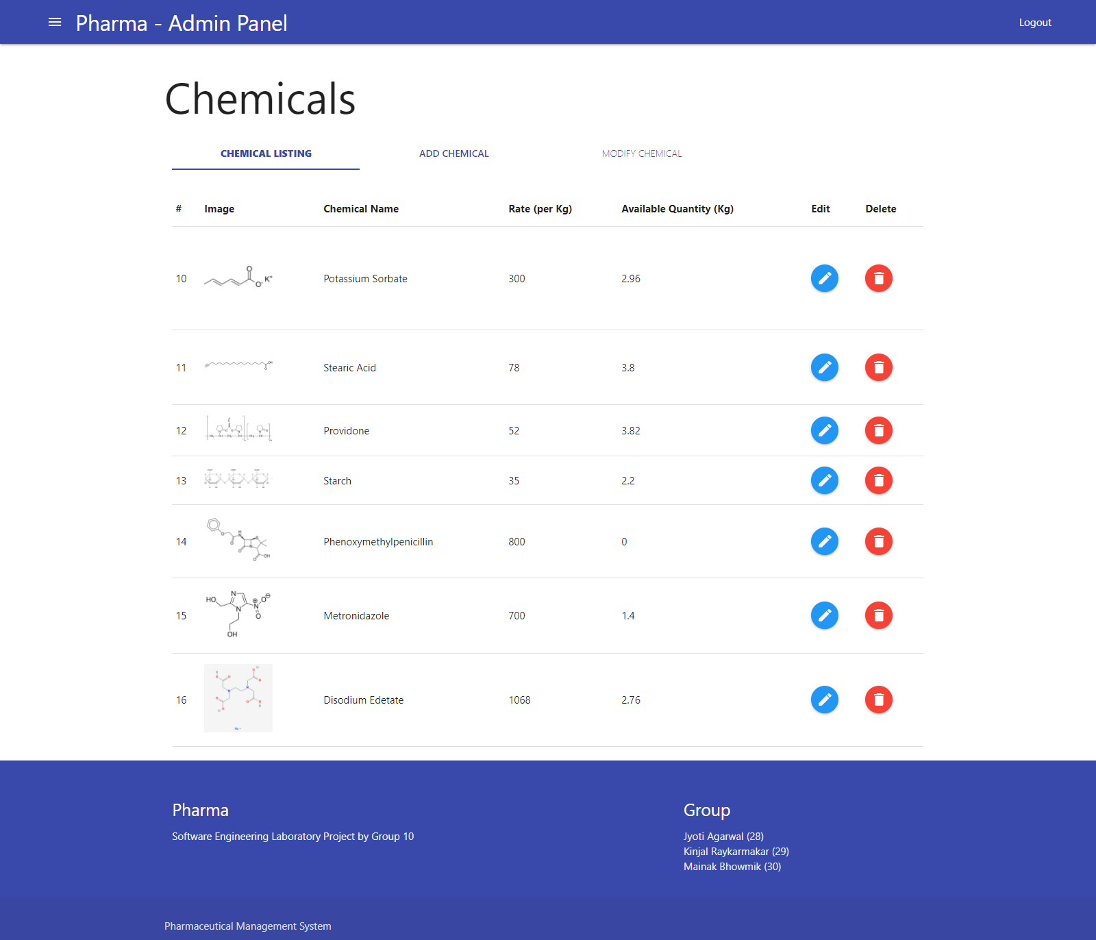
Figure 17 Chemical Listing Page
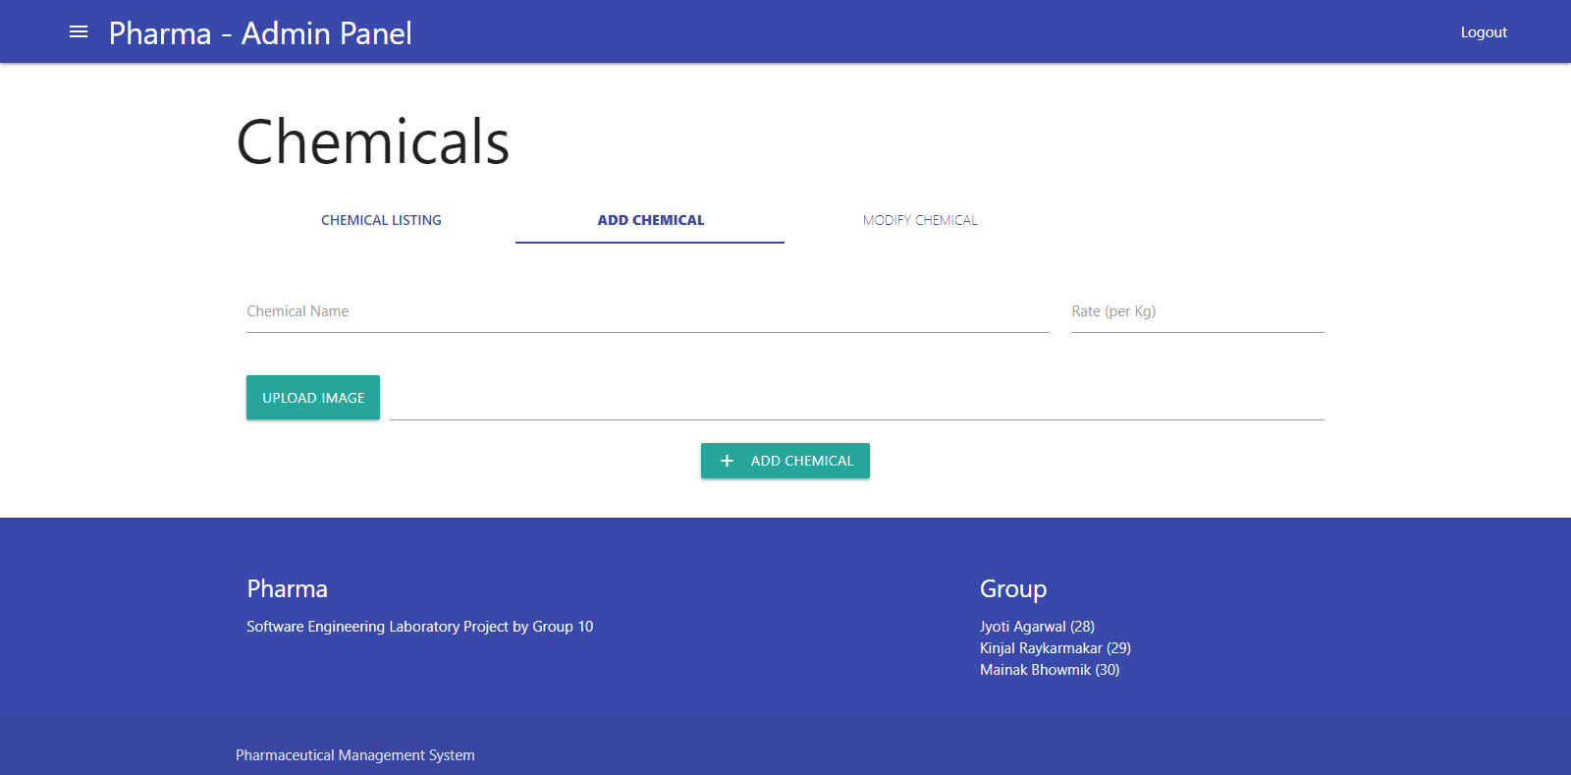
Figure 18 Add Chemical Page

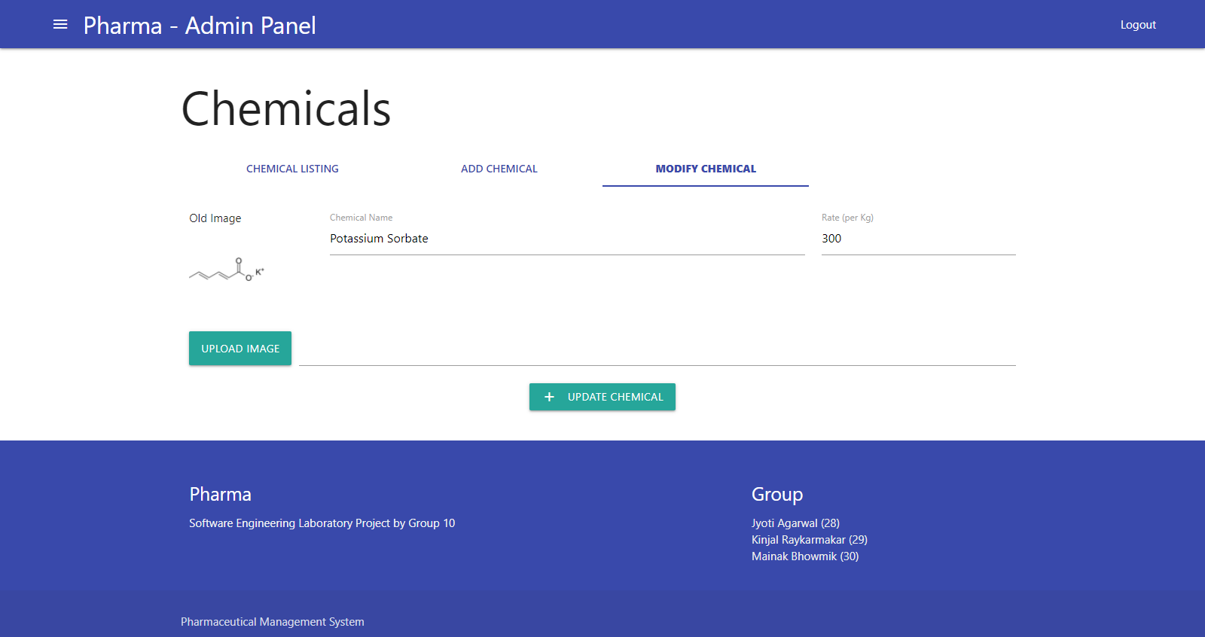
Figure 19 Modify Chemical Page
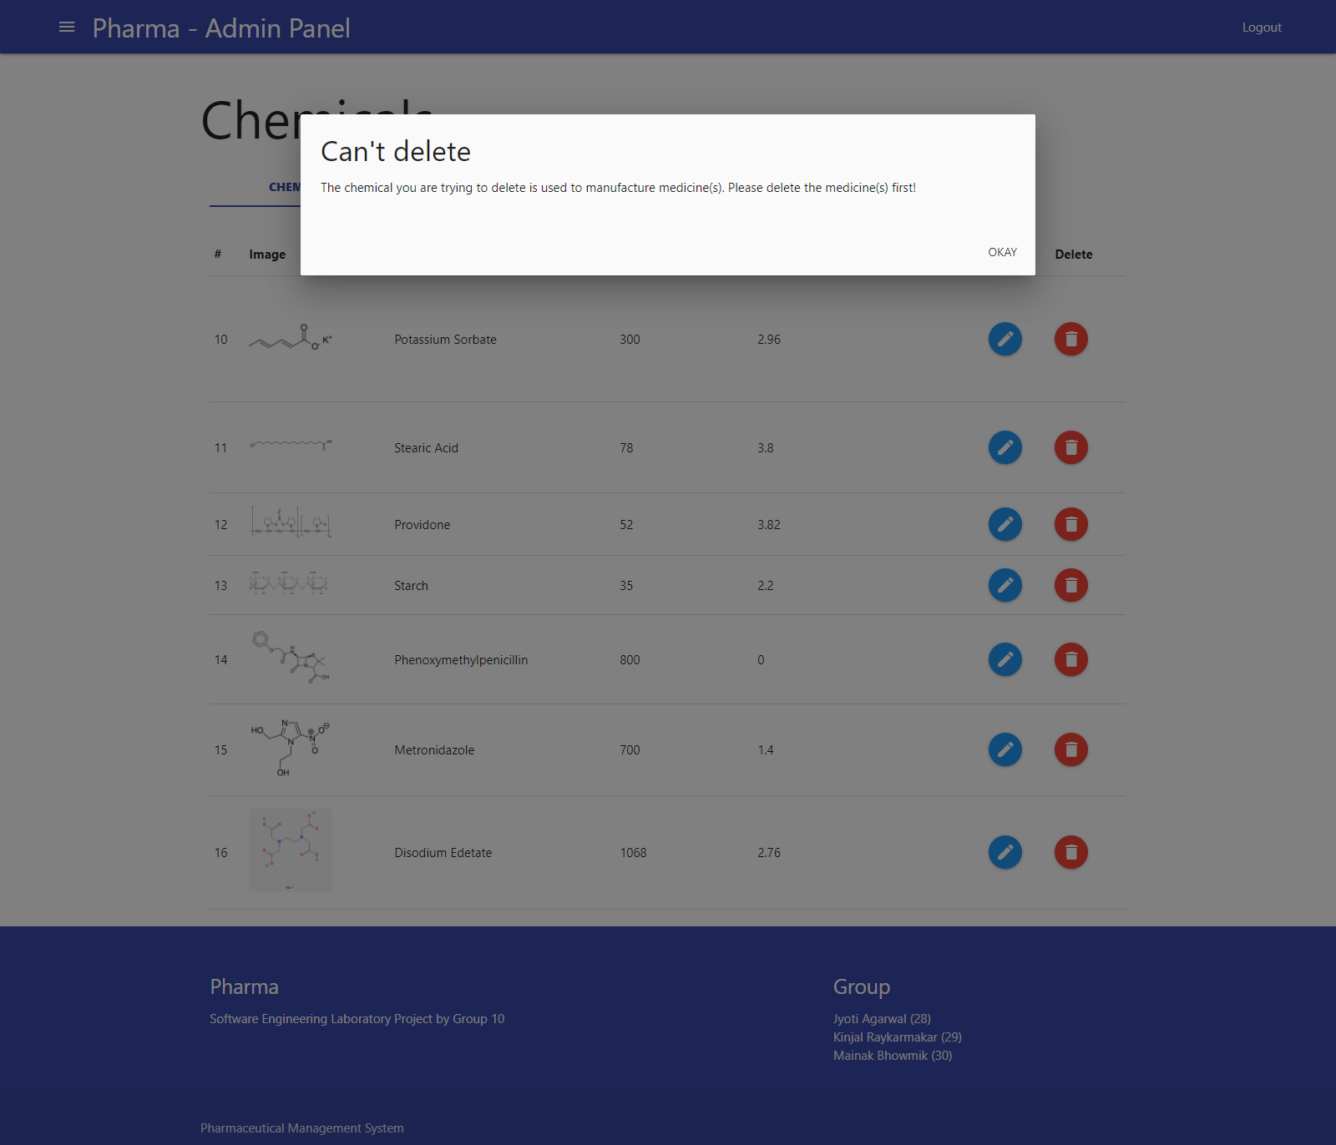
Figure 20 Error Prompt: Trying to delete a medicine which is used in a medicine
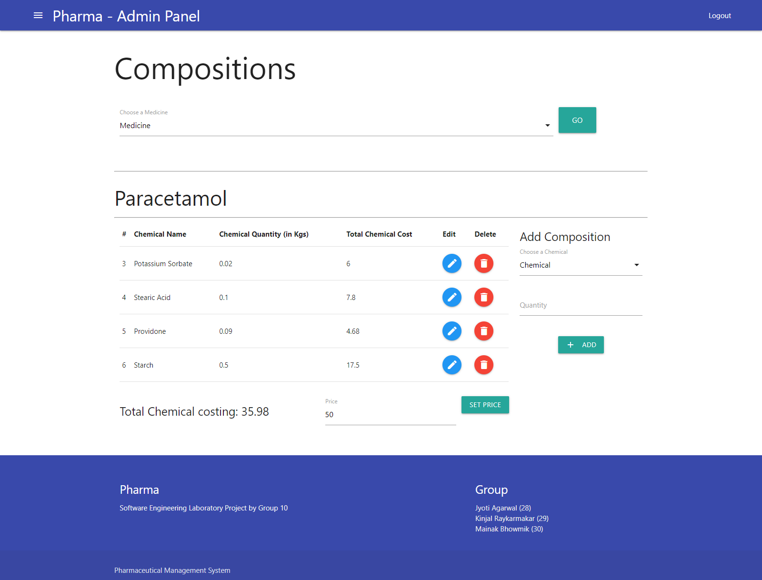
Figure 21 Medicine Composition Page – Including Add/Modify Composition and Medicine price setting
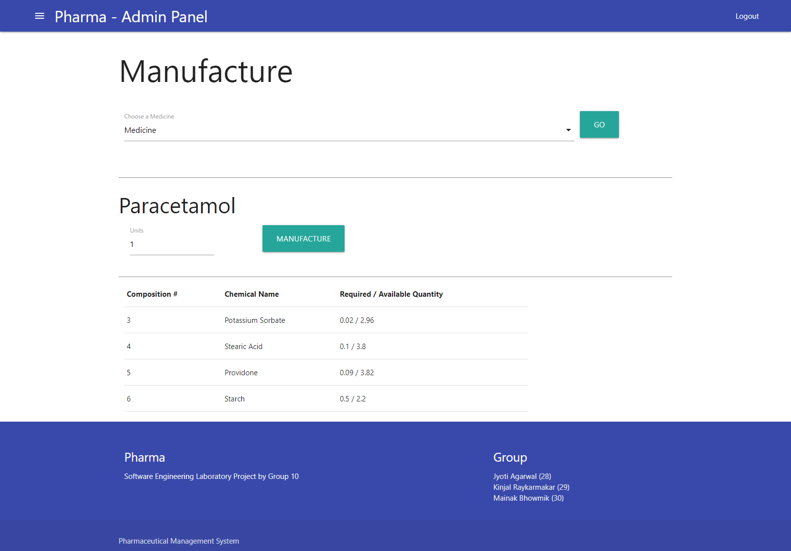
Figure 22 Medicine Manufacture page
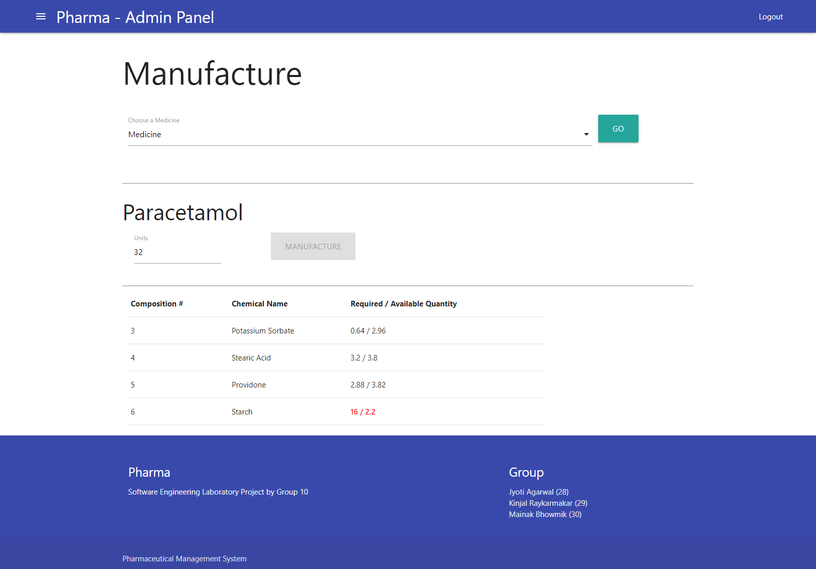
Figure 23 Trying to manufacture medicine with insufficient chemical quantity

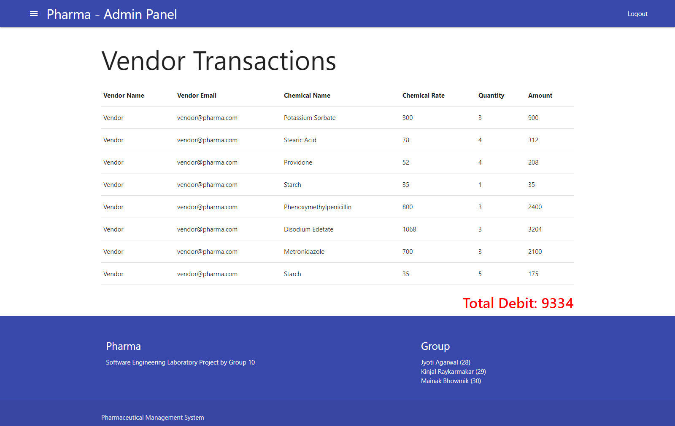
Figure 24 Listing Vendor Transactions
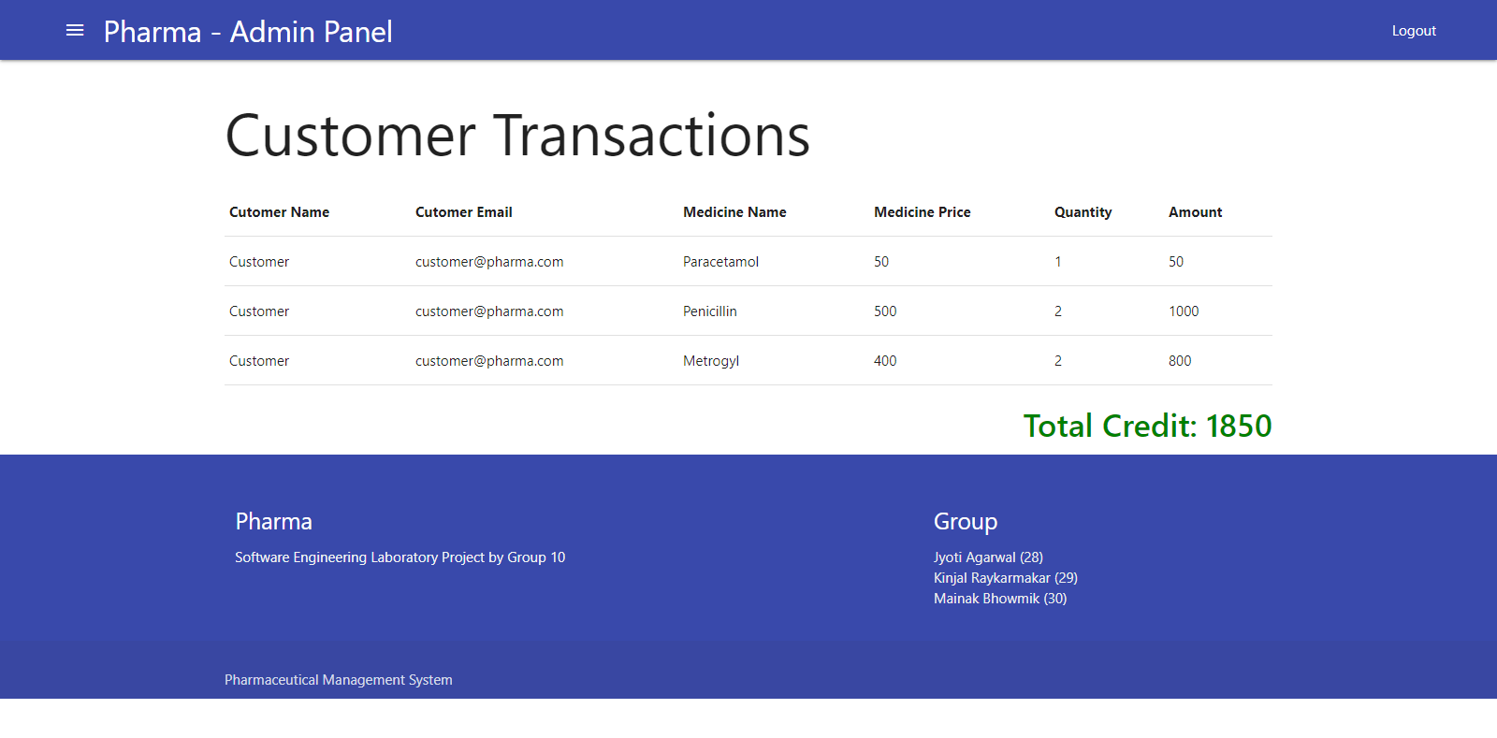
Figure 25 Listing Customer Transactions

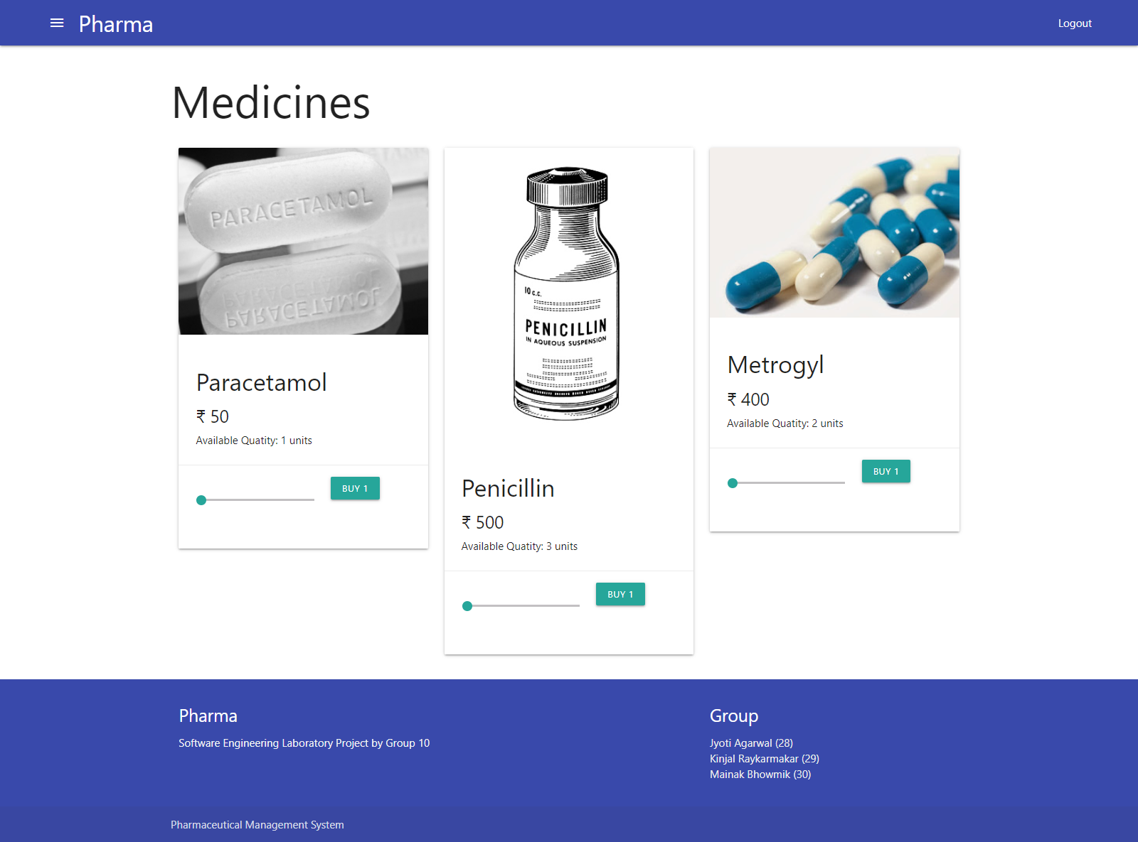
Figure 26 Index Page - Logged in as customer
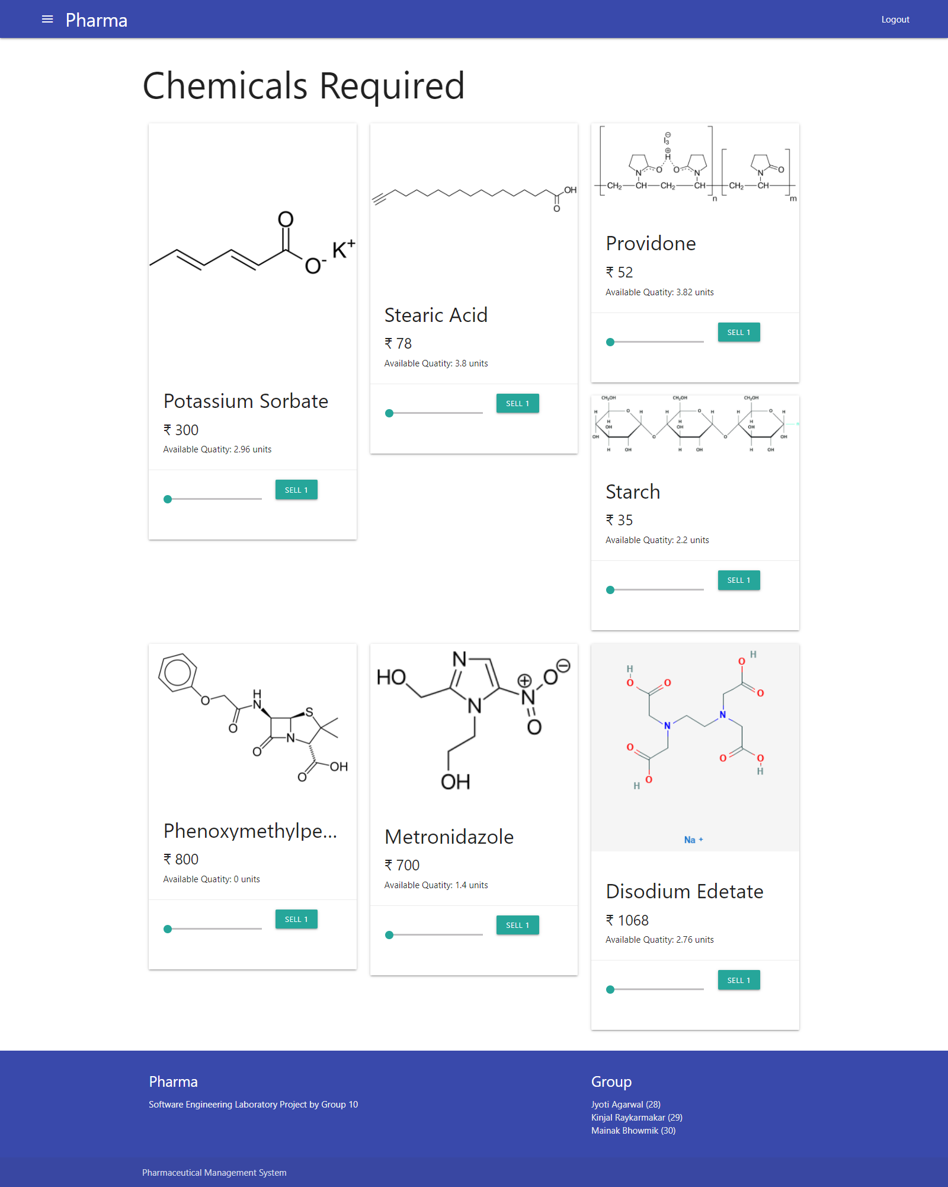
Figure 27 Vendor’s page
Appendix D: Testing
Throughout the development process, each module was unit tested as well as integration tested to make remove any bugs or design issues. The following sections were overall tested
- Links: All the internal links and anchor links were tested to work as expected.
- Forms: All the forms were tested with various test cases to check the working of front-end form validations.
- Session: Setting and resting session variables at times of login/register and logout respectively were thoroughly tested.
- UI/UX: All buttons’ clicks were tested to have the ripple effect in-line with the Material Design.
- Database: Multiple test queries were run to make sure the database maintains data integrity and optimal response times.

Future Scope

Bibliography

