WireGuard Installation Guide
This guide explains how to download and install WireGuard on Windows, macOS, and Linux systems in a simple step-by-step format.

1. Download the WireGuard App
- Open your web browser.
- Go to the official WireGuard website https://www.wireguard.com/install/
- Choose your operating system: Windows, macOS, or Linux.
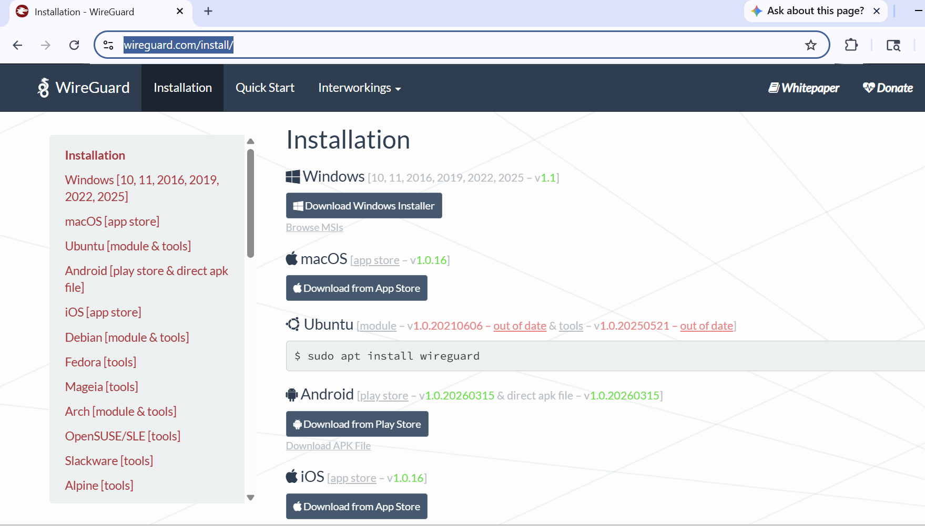
- Download the installer or follow the installation instructions for your system.

2. Install WireGuard on Windows
- Open the downloaded WireGuard installer file.
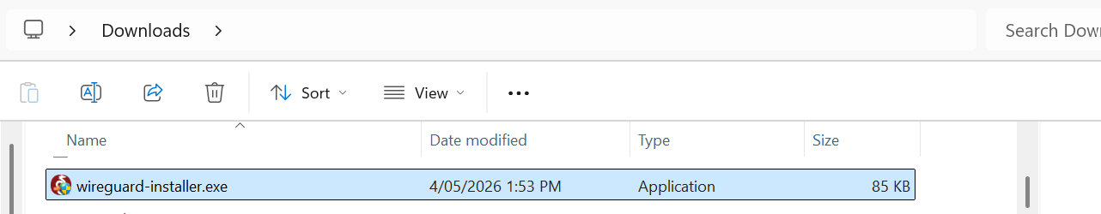
- If Windows asks for permission, click Yes.
- Follow the installation wizard.
- Click Install.
- Wait for the installation to finish.

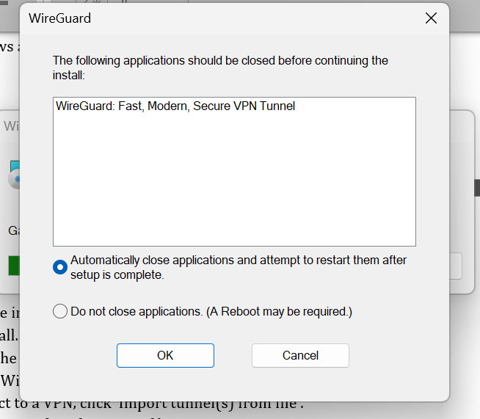

- Open the WireGuard application.
- To connect to a VPN, click ‘Import tunnel(s) from file’.
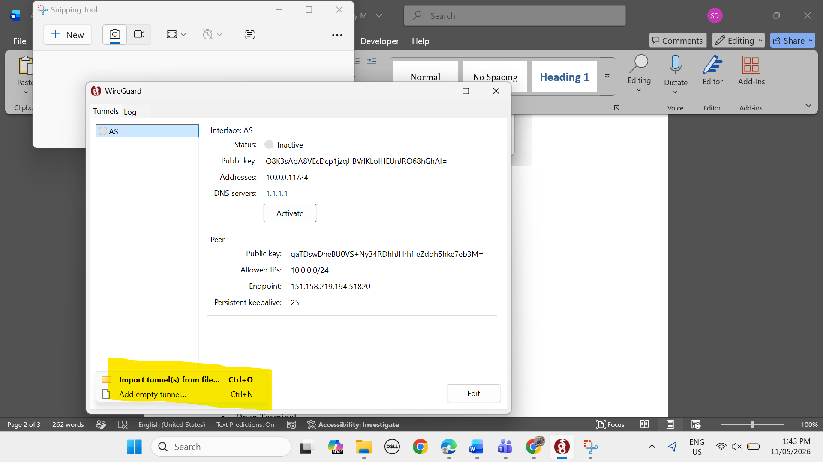

- Select your .conf configuration file.
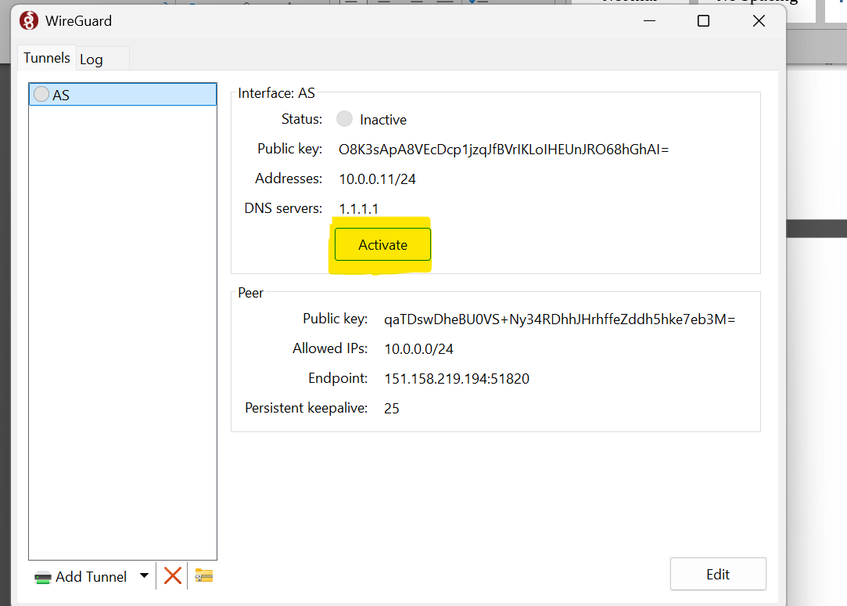
- Click Activate to start the VPN.

3. Install WireGuard on macOS
- Go to the downloads and select the exe. File that you downloaded.
- Click Get or Install.
- Open the WireGuard application after installation.
- Click ‘Import tunnel(s) from file’.
- Choose your .conf VPN configuration file that you downloaded from the website.
- Click Activate to connect.

4. Install WireGuard on Linux (Ubuntu/Debian)
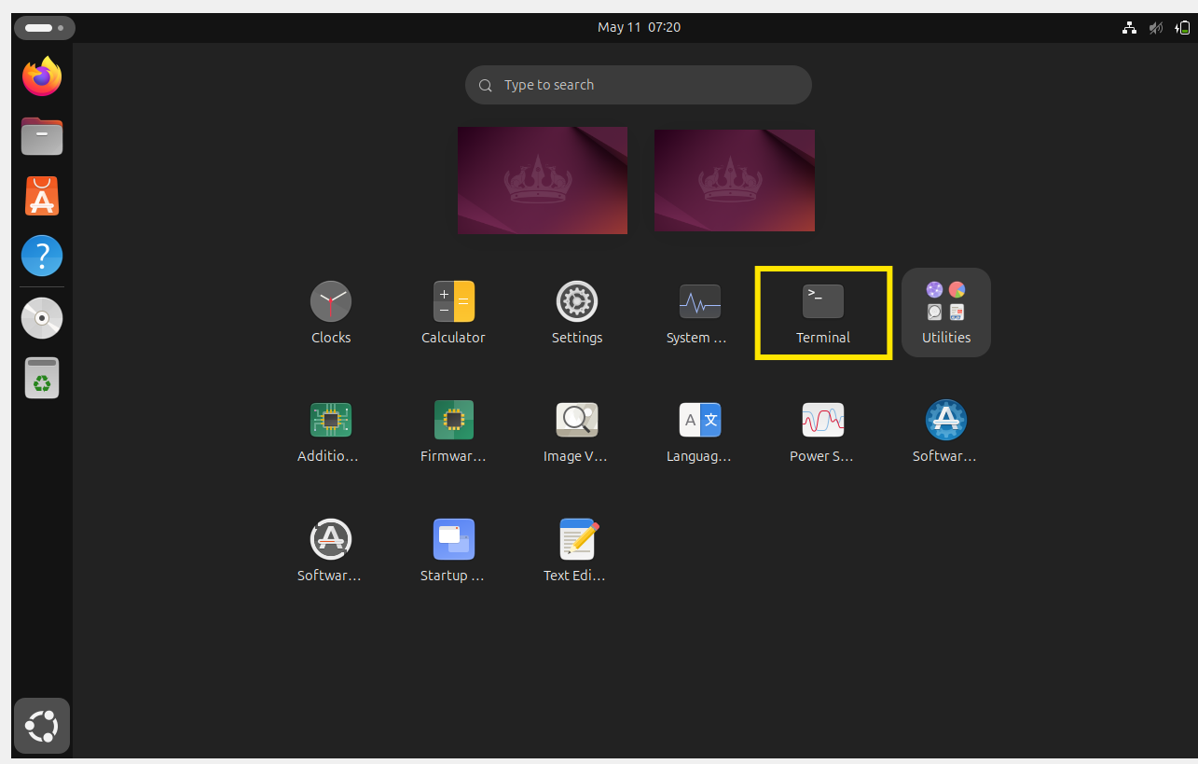
- Open Terminal.

- Update package list using:
sudo apt update
- Install WireGuard using:
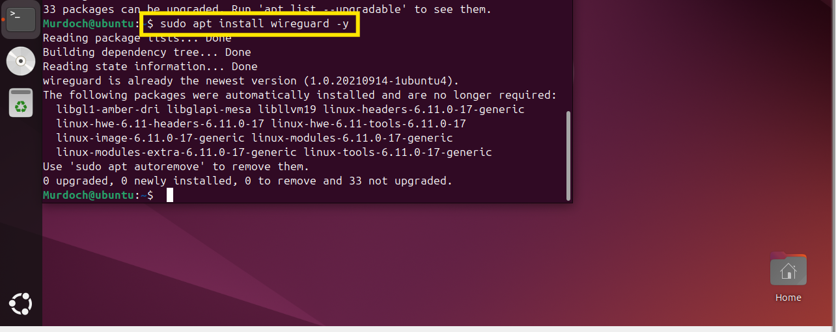
sudo apt install wireguard -y

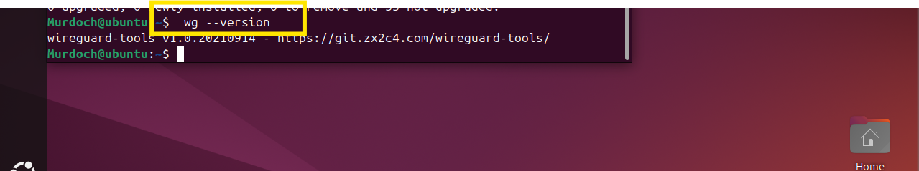
- Check installation using: wg –version

- To start WireGuard later, use your VPN configuration file.

5. Understanding the Configuration File
- A WireGuard VPN connection requires a .conf file.
- This file contains VPN settings, keys, and server information.
- Each student or user should have their own unique configuration file.
- Do not share private keys with others.

6. Example WireGuard Configuration
- [Interface]
- PrivateKey = your_private_key
- Address = 10.0.0.4/24

- [Peer]
- PublicKey = server_public_key
- Endpoint = server_public_ip:51820
- AllowedIPs = 10.0.0.0/24

