
Gyalpozhing College of Information Technology
Royal University of Bhutan
Kabjisa, Chamjekha, Thimphu
School of Future Computing
Bachelor of Computer Science
CSC410 Final Year Capstone Project
Autumn 2026

Onchain Wallet Profiler

Submitted by:
Karma Tshering 12230016
Kezang Wangmo 12230020
Kinley Namgay 12230022
Sonam Deki 12230045
Thinley Dhendup 12230057

Supervisor: Mr. Sherab Tharchen Dorji

Table of Contents
Chapter 1. Introduction 3
1.1 Project Background 3
1.2 Problem Statement 3
1.3 Aim 3
1.4 Goal 4
1.5 Objectives 4
1.6 Scope 4
1.6.1 System Scope 4
1.6.2 User Scope 6
1.6.3 Constraints / Feasibility 6
1.7 Requirements 7
1.7.1 Functional Requirements 7
1.7.2 Non-functional Requirements 8
1.7.3 System Requirements 9
1.8 Literature Review 9
Chapter 2. Methodology 13
2.1 Methodology of the Study 13
2.1.1 Project Initiation 13
2.1.2 Validation Strategy 13
2.2 System Description 13
2.2.1 System Architecture 13
2.2.2 Workflow 14
2.2.3 Use Case Diagram 15
2.3 Work Plan 16
2.3.1 Roles and Responsibilities 16
2.3.2 Gantt Chart 17
Bibliography 18

Chapter 1. Introduction

1.1 Project Background
Public blockchain networks generate high-volume, time-ordered data, including transactions, token transfers, contract calls, balances, timestamps, counterparties, and protocol interactions. Although these records are transparent, analysing a wallet manually is difficult because the data is distributed across many transactions and smart contracts.
The proposed Onchain Wallet Profiler will retrieve permitted Ethereum wallet data through the approved Nansen API. The backend will validate and normalize the returned records, calculate behavioural features, identify known protocol interactions, and apply documented classification and anomaly-detection rules. The results will be presented as a visual Wallet Identity Card.
The system is intended for investors and traders performing wallet due diligence and for security specialists reviewing unusual onchain behaviour. It will highlight observable patterns and explain the evidence behind each result. It will not identify the real-world owner of a wallet, prove criminal activity, or provide financial advice.

1.2 Problem Statement
Ethereum wallet records are public, but their volume and technical structure make them difficult to interpret quickly. Investors, traders, and security specialists often need to examine transaction frequency, asset movement, counterparties, protocol usage, trading behaviour, and timing patterns before deciding whether a wallet requires further review.
Existing data services can provide individual records, but users still need a clear and consistent way to combine them into behavioural profiles and suspicious-activity indicators. The proposed system will address this problem by transforming permitted Nansen data into explainable features, rule-based wallet profiles, and non-definitive anomaly alerts. Each result will show its supporting evidence, data limitations, and analysis time so that users can make informed decisions without treating an automated score as proof of misconduct.

1.3 Aim
To develop a secure and responsive Ethereum wallet-profiling web application that uses permitted Nansen API data to generate explainable behavioural profiles and suspicious-activity indicators for investors, traders, and security specialists.

1.4 Goal
To develop a Wallet Identity Card that helps investors, traders, and security specialists assess an Ethereum wallet by presenting its behavioural profiles, unusual activity indicators, supporting transaction evidence, and data limitations.

1.5 Objectives
- To validate Ethereum wallet addresses and securely submit valid addresses for analysis.
- To retrieve, paginate, normalize, and organize permitted Nansen transaction, balance, counterparty, trading, and contract-interaction data within a defined analysis period.
- To calculate wallet behaviour indicators such as transaction frequency, active periods, transfer volume, trading activity, protocol interactions, counterparty concentration, and repeated timing patterns.
- To design rule-based classification methods that assign wallets to one or more profiles, such as Active Trader, DeFi Participant, and Long-Term Holder.
- To develop an anomaly-detection method that identifies unusual wallet behaviour.
- To explain each profile and anomaly result by showing the calculated indicators and blockchain records that contributed to it.
- To identify frequently used protocols using available labels or verified smart-contract mappings.
- To generate a Wallet Identity Card containing wallet profiles, supporting evidence, an activity heatmap, protocol usage, anomaly indicators, the analysed period, and known data limitations.
- To test the accuracy of data calculations and classification rules and evaluate the application’s usability, performance, security, and reliability.

1.6 Scope

1.6.1 System Scope
- Wallet address input and validation for Ethereum wallets.
- Collection of permitted wallet data from Nansen API and other relevant publicly available data sources.
- Retrieval and organization of available real-time and historical wallet information, subject to API availability, API credit limits, and data-source limitations.
- Analysis of wallet transactions, balances, token movements, protocol interactions, and fund flows.
- Feature extraction from wallet activity to identify relevant behavioural and transaction patterns.
- Development of a Proof of Concept (PoC) demonstrating the feasibility of wallet behavioural and risk analysis.
- Application of a rule-based scoring system to evaluate wallet behaviour using predefined and transparent criteria.
- Calculation of a wallet risk score based on identified risk indicators and defined scoring rules.
- Analysis of indicators relevant to Anti-Money Laundering (AML) and compliance, without making definitive claims that a wallet is involved in illegal activity.
- Identification of behavioural risk indicators such as unusual activity patterns, rapid movement of funds, repetitive transactions, concentrated counterparties, and other predefined signals.
- Analysis and visualization of fund flows to help users understand the movement of assets between wallets and relevant addresses.
- Identification and display of frequently used protocols when reliable labels or maintained contract-to-protocol mappings are available.
- Generation of a Wallet Identity Card containing key wallet activity, behavioural characteristics, and risk-related information.
- Presentation of supporting evidence and explanations for the assigned behavioural classification and risk score.
- Visualization of wallet activity and risk-related information through charts, timelines, heatmaps, and other suitable visualizations.
- Handling API credit limitations, pagination, missing data, unavailable records, and limitations of external data sources.
- Providing results as analytical indicators rather than definitive judgments, financial advice, or legal/compliance determinations.

1.6.2 User Scope
The primary users of the system are investors and traders who want to analyze Ethereum wallet activity and understand wallet behaviour and associated risk indicators.
The system will allow investors and traders to:
- Enter and validate an Ethereum wallet address.
- View relevant real-time and historical wallet activity, where available.
- Analyze transactions, token movements, balances, and protocol interactions.
- Understand fund flows associated with a wallet.
- View the wallet's behavioural patterns and classification.
- View the Wallet Identity Card summarizing important wallet characteristics.
- View the wallet risk score and the factors contributing to the score.
- Understand the reasoning behind the behavioural classification and risk score through transparent rules and supporting activity.
- Use wallet behavioural and risk insights to support their investment and trading research and decision-making.

1.6.3 Constraints / Feasibility
- API access and resource limits: The system depends on authorized access to the API, available endpoints, API credits, and applicable usage restrictions. The amount of data that can be retrieved and analyzed may be limited by the available API credits and rate limits.
- Data source limitations: The system may use Nansen data together with other relevant publicly available data sources. However, data coverage, accuracy, availability, update frequency, and consistency may vary between sources.
- Real-time data limitations: Although the system aims to provide current or near-real-time wallet information where available, real-time analysis may be affected by API response time, data-source update frequency, API limits, and network conditions.
- Rule-based classification: Behavioural classification and risk scoring will be based on predefined and transparent rules or scoring criteria. Since wallet behaviour can be complex and may change over time, the resulting classifications and scores should be treated as analytical estimates rather than absolute conclusions.
- Risk scoring limitations: The wallet risk score represents risk indicators identified from the selected observable data and rules. It should not be interpreted as a definitive measure of criminal activity, money laundering, creditworthiness, investment risk, or legal/compliance status.
- AML and ethical considerations: The system may identify AML-related risk indicators such as unusual fund movements, rapid transactions, or concentrated counterparties. These indicators do not establish that a wallet is involved in money laundering or other illegal activities.
- Wallet identity and privacy: The system analyzes publicly observable blockchain wallet activity and should not claim to identify or reveal the real-world identity of the wallet owner unless such information is legitimately available from a reliable public source.
- Data interpretation: The generated behavioural profile, risk score, and Wallet Identity Card depend on the quality, completeness, and availability of the underlying data. Missing or inaccurate data may affect the resulting analysis.
- Financial decision-making: The system provides analytical information to support investors and traders in their research and decision-making. It does not provide financial advice, guaranteed predictions, or recommendations to buy, sell, or hold assets.

1.7 Requirements

1.7.1 Functional Requirements
- Wallet Input: The user can enter an ethereum wallet address for analysis.
- Address Validation: The system validates whether the submitted address follows the expected wallet address format.
- Analysis Period Selection: The system should allow users to select a supported historical period for wallet analysis.
- Data Retrieval: The system retrieves authorised transaction and balance records for the wallet and declared date range, handling pagination and incomplete responses.
- Data Integration: The system should combine relevant data from the selected sources into a consistent dataset for wallet analysis.
- Data Processing: The system should validate, normalize, aggregate, and identify duplicate or incomplete records before calculating behavioural features.
- Data Completeness Detection: The system should detect incomplete, unavailable, or delayed data and inform the user when such limitations may affect the analysis.
- Feature Extraction: The system derives behavioural indicators from the retrieved records.
- Profile Classification: The system assigns zero or more profiles using versioned, documented rules and displays the evidence and confidence band for each result.
- Risk Scoring: The system should calculate a transparent behavioural risk score based on defined wallet activity and interaction indicators.
- Risk Explanation: The system should display the main factors and supporting evidence contributing to the profile and risk score.
- Behavioural Anomaly Indicator: The system calculates a descriptive anomaly score from disclosed signals and displays a disclaimer that it is not a fraud, sanction, credit, security, or investment-risk rating.
- Activity Heatmap: The system visualises wallet activity across selected time periods.
- Protocol Analysis: The system ranks protocol interactions when reliable Nansen labels or approved contract mappings are available; unattributed interactions remain explicitly marked as unknown.
- Wallet Identity Card: The system generate a visual summary containing the wallet profile, risk score, key behavioural indicators, activity heatmap, and protocol interactions.
- Historical Activity and Provenance: The user can inspect summarized evidence, analysis dates, data sources, completeness warnings, and the rule version that produced the profile.

1.7.2 Non-functional Requirements
- Usability: The interface should be understandable to investors and traders with different levels of blockchain knowledge.
- Performance: Wallet analysis should return results within a reasonable period for the supported history size.
- Reliability: The system should handle missing, delayed, or failed data requests gracefully.
- Security: User input, API credentials, and backend services should be protected against unauthorized access and misuse.
- Scalability: The architecture should support increasing numbers of wallet analyses within the limits of the selected data services.
- Maintainability: Data processing, classification rules, risk-scoring rules, and protocol mappings should be modular and easy to update.
- Accuracy: Calculated metrics should be consistent with the source data and clearly explain their limitations.
- Accessibility: Visualizations should include readable labels and alternatives where practical.
- Compatibility: The web interface should function across commonly used modern browsers and screen sizes.

1.7.3 System Requirements
The system will consist of :
- Frontend: React.js + Tailwind CSS
- Charts: Recharts
- Backend: FastAPI + Python
- Data processing: Pandas
- Database: PostgreSQL
- Blockchain data: Nansen API + additional approved API
- Testing: Postman and Pytest
- Version control: GitHub
- Deployment: Vercel + Render

1.8 Literature Review
Blockchain networks such as Ethereum provide large amounts of publicly accessible information, which includes transactions, token transfers, balances, timestamps, and smart contract interactions. While this transparency makes every blockchain activity observable, the quantity and technical nature of said available information can make individual wallets difficult to interpret. Existing blockchain explorers, portfolio trackers, and intelligence platforms attempt to address this issue in different ways through organization of raw blockchain data into transaction histories, portfolio summaries, protocol positions, wallet labels, and risk indicators.
The proposed OnChain Wallet Profiler takes references from these existing systems but focuses specifically on presenting wallet behaviour in a simplified and explainable form. Therefore, related systems such as Arkham Intelligence, Etherscan, DeBank, Zerion and Chainalysis provide useful references for determining which information should be displayed, how it can be visually organized, and what limitations remain in currently available platforms.
- Arkham Intelligence
Arkham Intelligence provides an example of wallet and entity profiling. Its Profiler organizes blockchain information into five main areas which are Portfolio, Historical Performance, Counterparties, Borrows and Loans, and Transactions. The portfolio section of its Profiler displays an entity or wallet’s total holdings and individual token holdings, while the Portfolio Archive allows users to inspect historical balances and token portfolios. This organization of functions shows the importance of bringing several pieces of wallet information together within a single profile. Instead of presenting only a list of transactions, Arkham provides a broader presentation of an address or entity through the combination of holdings, historical behaviour, counterparties, borrowing activity, and transaction records. Arkham Intelligence demonstrates that users can benefit from having the most important wallet information wrapped into a centralized profile rather than requiring navigation through completely unrelated pages. The proposed system follows a similar high-level design principle by gathering the most relevant behavioral indicators into a single summary.
However, the proposed OnChain Wallet Profiler has a different objective. Instead of attempting extensive entity intelligence, it intends to classify patterns such as Active Trader, DeFi Participant, and Long-Term Holder and show the evidence that contributed to these classifications.
- Etherscan
Etherscan represents a different category of related system. Rather than functioning primarily as a wallet-intelligence platform, it operates as a blockchain explorer and analytics platform for Ethereum and other EVM-compatible networks. When examining an externally owned address, Etherscan provides several categorizations of activity, including normal transactions, internal transactions, ERC-20 token transfers, NFT transfers, and analytics relating to balances and transaction activity. This makes Etherscan extremely useful for inspection and verification of individual blockchain records in detail. The strength of this design is transparency and detail. A user can inspect individual transactions and determine accurately when assets were transferred, which addresses were involved, and which token movements occurred. However, this also presents an important limitation for behavioural profiling: transaction records do not automatically explain what the overall transaction history means. For example, a wallet may contain hundreds of token transfers and contract interactions. Although Etherscan enables the user to inspect those records individually, the user may still need to manually determine whether the wallet behaves primarily as a trader, DeFi participant, long-term holder, or another type of actor.
This represents an important design motivation for the proposed system. Rather than replacing the detailed transaction data offered by blockchain explorers, the OnChain Wallet Profiler intends to provide an additional layer of interpretation that will make it easier to understand.
- DeBank
DeBank provides a useful reference especially for DeFi portfolio and protocol analysis. Its API allows wallet information to be retrieved across supported chains, including token holdings, total balances, transaction histories, and positions held within different protocols. One of DeBank’s particularly relevant features is the ability to retrieve the protocols used by an address. Protocol information can include the protocol name, chain, portfolio information, total value of assets, and debt values. Its transaction history data can also identify which project or protocol was interacted with during a particular transaction. This provides an important design lesson for the proposed OnChain Wallet Profiler. A raw smart contract address is difficult for many users to interpret. Attributing interactions according to recognizable protocols provides much better context. The project can therefore adopt the useful design principle of organizing blockchain activity according to protocols as demonstrated by DeBank while applying it specifically to behavioural interpretation.
- Zerion
Zerion is also another strong example of a portfolio-oriented approach at wallet visualization. Its wallet portfolio functionality aggregates a wallet’s assets and presents information such as overall portfolio value, distribution across chains, distribution by position type and changes in portfolio value. Zerion also places significant emphasis on DeFi positions. Its system can identify positions such as lending, staking, liquidity provision, locked assets, and rewards and associate those positions with the relevant protocols. Additionally, it also presents transactions in a more interpreted form, such as swaps, borrowing, receiving, and other activity categories. This is relevant to the proposed profiler because it shows the importance of presenting blockchain data in forms that describe the meaning of an interaction rather than only its technical representation. Zerion also demonstrates how complex blockchain information can be summarized through a dashboard. Instead of requiring users to understand every smart-contract call, the interface focuses on assets, positions, historical changes, and recognizable activities.
The proposed system adopts a similar principle of simplification while mainly focusing on behavioural interpretation. Rather than primarily answering what assets and DeFi positions does this wallet currently have, the proposed system attempts to answer what patterns of behaviour this wallet demonstrates.
Wallet Risk and Behavioural Anomaly Analysis
Risk-oriented blockchain intelligence systems provide another important reference. For example, Chainalysis describes wallet screening as analysing blockchain addresses using attribution and risk information to measure exposure to categories such as scams, sanctioned entities, mixers, or stolen funds. Its approach can consider both direct relationships and indirect connections through intermediary addresses. The proposed Onchain Wallet Profiler attempts to use a more limited behavioural anomaly indicator based on observable patterns such as unusually concentrated counterparties, transaction bursts, or highly repetitive timing.

Chapter 2. Methodology

2.1 Methodology of the Study
The project will use Agile because it requires repeated design, integration, testing, and improvement. Work will be divided into initiation, design, planning, implementation, review, and refinement.
- Design: Create the application architecture, data model, classification rules, user interface, and Wallet Identity Card concept.
- Planning and estimation: Prioritize features such as address input, transaction retrieval, feature extraction, profile classification, visualization, and testing.
- Implementation: Develop the interface, backend services, Nansen data integration, analytical pipeline, and visualizations.
- Review and iteration: Evaluate outputs against representative wallets, collect feedback, identify classification or visualization problems, and refine the system.
Development will use short sprints. Early sprints will build wallet lookup and data retrieval. Later sprints will add feature calculation, classification, the Wallet Identity Card, testing, and deployment.

2.1.1 Project Initiation
Define the wallet-analysis problem, stakeholders, target users, data requirements, and initial user stories.

2.1.2 Validation Strategy
Validation will cover data correctness, classification rules, and usability. Calculations will be checked against sample API records and selected explorer data. Rules will be tested with normal and unusual wallets, including inactive, new, high-volume, and incomplete cases. Accuracy scores will be reported only if Nansen provides enough verified test data.

2.2 System Description

2.2.1 System Architecture
The architecture has five layers: Frontend, Backend/API, Analytics and Profiling, Database/Cache, and Data Sources. Users enter an Ethereum wallet address through the Frontend. The Backend retrieves and manages wallet data from the Nansen API. The Analytics layer extracts features, identifies protocols, and assigns wallet profiles. The Database/Cache stores processed results and mappings. Nansen provides the indexed Ethereum data, so the system will not operate a blockchain node or index the full network.
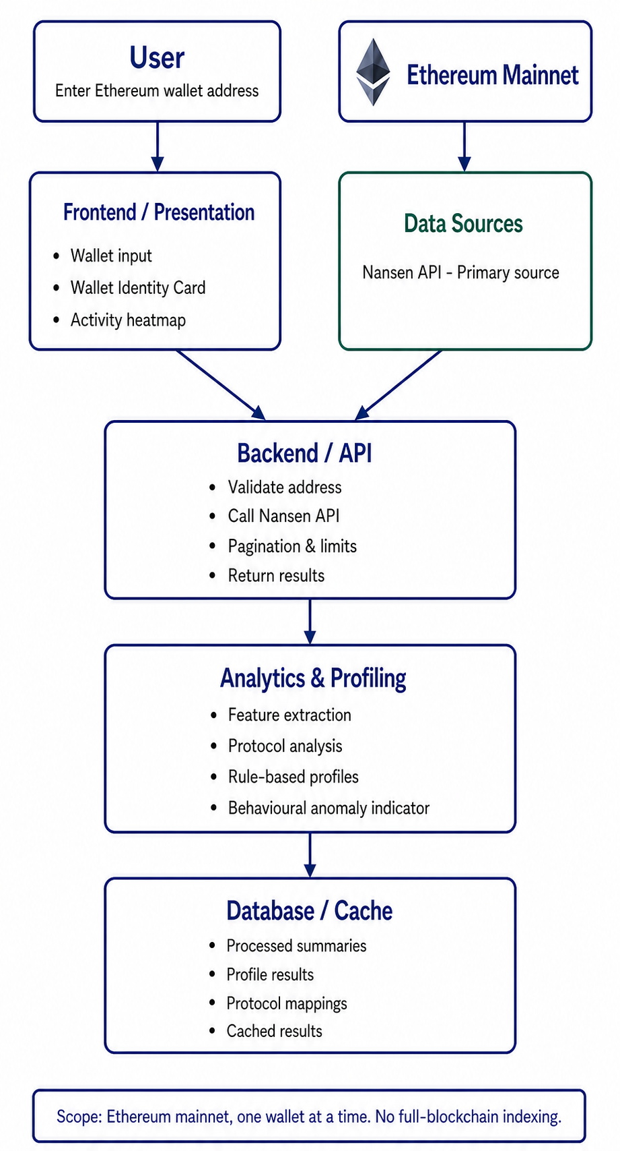

2.2.2 Wallet Profiling and Risk Calculation Method
How wallet data becomes profiles
1. Collect and prepare the data: For one Ethereum wallet and a chosen period, collect available transactions, times, transfers, DEX trades, balances, counterparties, and contract interactions. Convert different API formats into common fields, remove duplicates, and record the data source and date range.
2. Calculate the variables: Count transactions, active days, DEX trades, DeFi interactions, and verified protocols. Also calculate trade share and counterparty concentration when enough data is available.
Example: If 40 of 100 distinct transactions are verified DEX trades, the DEX trade ratio is 40%. We do not calculate a ratio when its required records or total count are missing.
3. Apply profile rules: Each profile has its own team-defined thresholds. Meeting a threshold earns points; the total becomes a profile match score from 0 to 100. A wallet may match both Active Trader and DeFi Participant. We will confirm a profile only when its score reaches the assignment threshold and the required data is present. A long-term holder needs at least 90 days of usable history.
4. Explain the result: The Wallet Identity Card shows each assigned profile, its score, the values and thresholds behind it, and supporting transactions. The score means rule match, not probability. If essential data is missing or incomplete, show 'Could not assess' instead of a misleading score.
How the security risk indicator is calculated
1. Check unusual patterns: Use separate rules for bursts of transactions within ten minutes, rapid movement of received funds, concentrated counterparties, a large rise in daily transfer volume and very regular transaction timing. Use a risky-address label only when reliable label data is available. Each supported signal earns points when its rule is met.
2. Calculate and display the indicator: Divide the points earned by the maximum points for signals that could be checked, then show a low, moderate or high unusual-activity band. Give specific reasons, such as “nine transactions in ten minutes”, and state which signals were not checked and how much of the requested period was covered.
3. State the limits: The indicator prompts further review; it does not prove crime or unsafe trading. If data is missing or analysis stops early for a large wallet, show partial results and withhold final scores. Test and refine the initial thresholds with representative wallets.

2.2.3 Workflow
The system will validate the submitted Ethereum wallet address and retrieve permitted wallet data from the Nansen API and other approved sources where applicable. The retrieved records will be validated, normalized, deduplicated, and organized within the selected analysis period. The system will then calculate behavioural indicators such as transaction frequency, active periods, transfer volume, protocol interaction, counterparty concentration, and timing patterns. Verified labels or contract mappings will be used to identify known protocol interactions. The Analytics and Profiling layer will apply documented rules to assign one or more behavioural profiles, identify behavioural anomalies, and calculate the defined behavioural risk score. The system will retain the indicators and transaction evidence contributing to each result. Finally the results will be presented through the Wallet Identity Card, including behavioural profiles, risk and anomaly indicators, supporting evidence,activity heatmap, protocol usage, analysis period, confidence information, and known data limitations.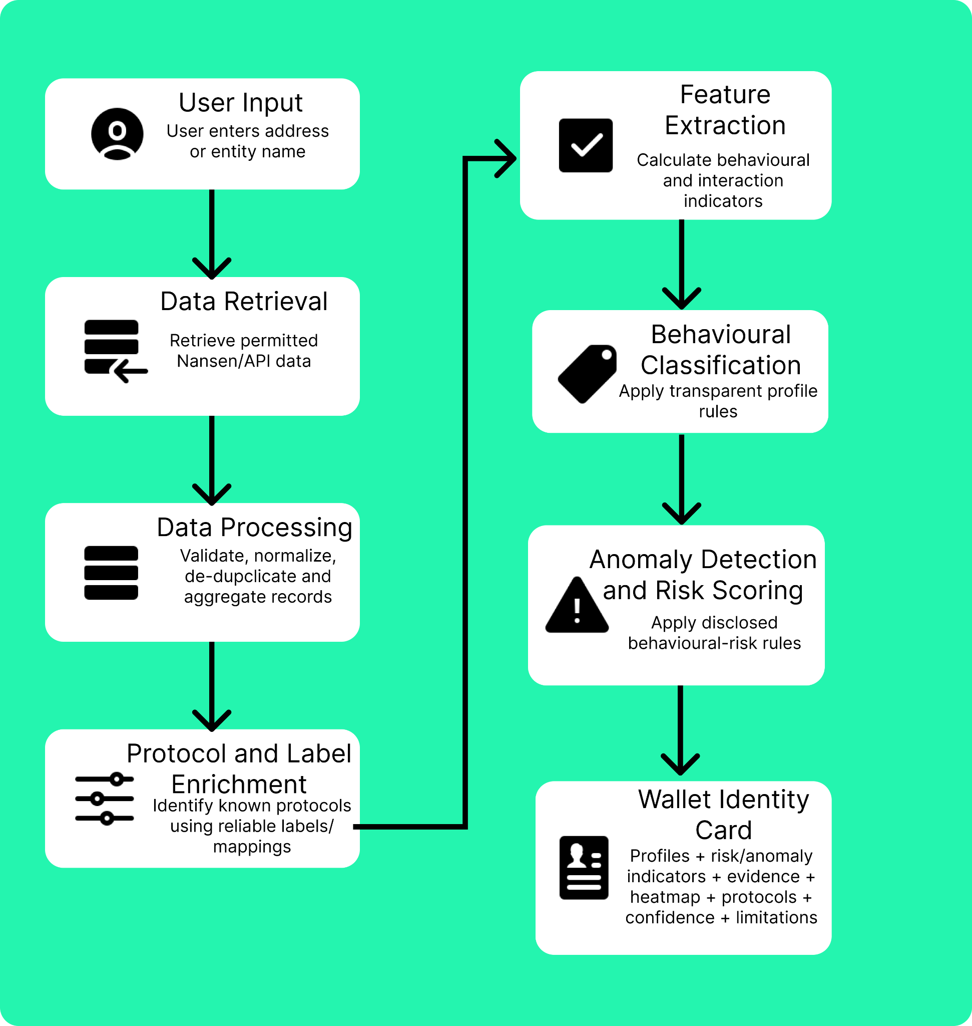

2.2.4 Use Case Diagram
The use case diagram shows how users interact with the Onchain Wallet Profiler. All investors, traders, and security specialists are represented by one User actor because they have access to the same functions.
The user enters a wallet address to start the analysis. The system validates the address, retrieves wallet data from Nansen or another approved blockchain data provider, prepares the data, calculates wallet activity indicators, creates wallet profiles, finds the protocols used, and checks for unusual activity. The results are combined into a Wallet Identity Card.
The user can then view the wallet profile, activity heatmap, protocols used, supporting evidence, and unusual-activity warnings. The “<<include>>” relationships represent functions that are required during wallet analysis, while the <<exclude>> relationships represent optional details that users can choose to view.

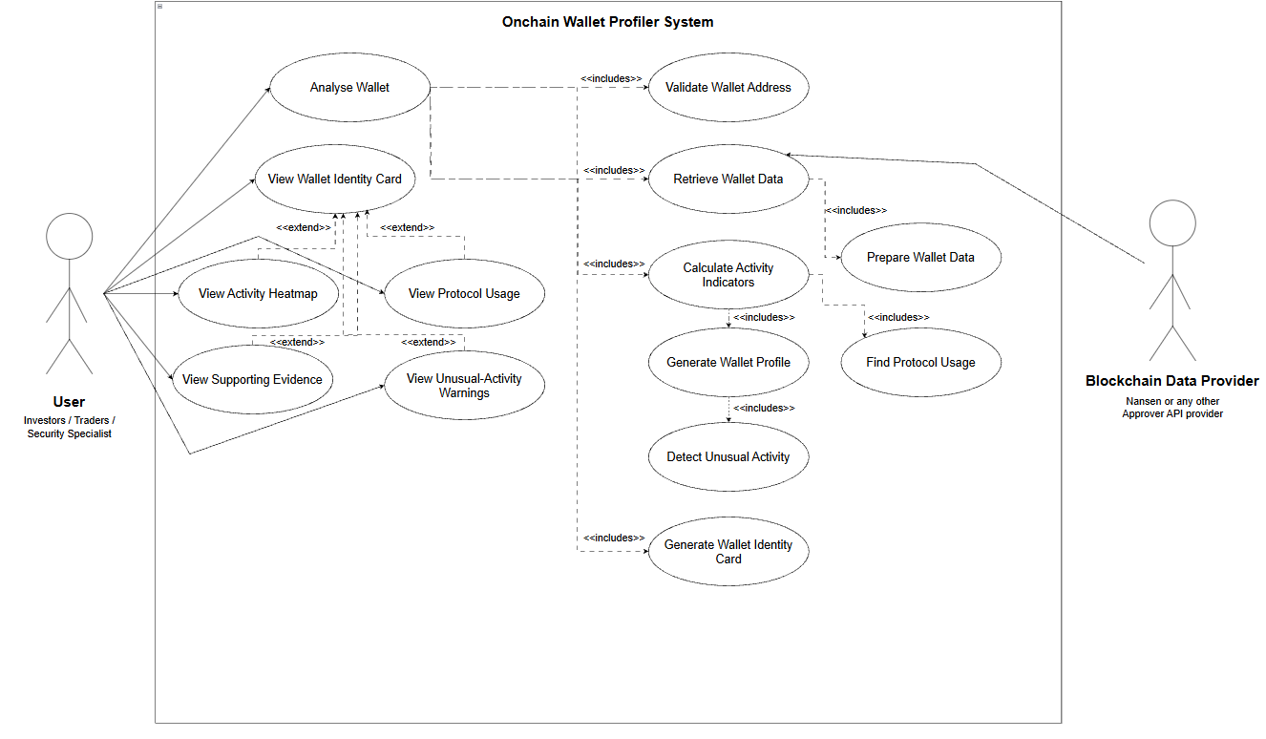

2.3 Work Plan

2.3.1 Roles and Responsibilities
- Scrum Master & Project Leader: Kinley Namgay. Facilitates Scrum events, including Sprint Planning, Daily Scrum, Sprint Review, and Sprint Retrospective. Coordinates project activities among team members and supports communication with the client and project supervisor. Monitors project milestones, sprint progress, assigned tasks, dependencies, risks, and deadlines using the project management tool. Identifies blockers and coordinates with the team to resolve them. Ensures that project activities remain aligned with the agreed scope and schedule.
- UI/UX Designer: Kezang Wangmo. Leads the design of user flows, wireframes, mock-ups, and interactive prototypes for the project. Ensures that the interfaces are user-friendly, responsive, accessible, and appropriate for the different user groups of the system.
- Front end Developer: Thinley Dhendup. Leads the development and maintenance of frontend components and their integration with backend services. Incorporates stakeholder feedback and usability findings to continuously improve the overall user experience.
- Backend Developer: Karma Tshering. Leads the design and development of the backend architecture, database structure, APIs, and other required security measures. Ensures the integrity, consistency, reliability, and secure handling of wallet addresses, API responses, derived wallet features, profile results, protocol mappings, cached data, and analysis records. Collaborates with the frontend and integration leads to ensure that system components communicate and function correctly.
- Documentation and Quality Assurance: Sonam Deki. Leads the planning and coordination of software testing activities, including the preparation of test scenarios, test cases, test data, and testing records. Coordinates functional, integration, system, and user acceptance testing and tracks identified defects until they are resolved. Verifies that implemented features satisfy the defined requirements and acceptance criteria. Maintains meeting minutes, stakeholder feedback, requirement changes, and supporting project records. Coordinates the preparation and consistency of project reports and ensures that documented requirements remain aligned with the client's expectations for the project.

2.3.2 Gantt Chart
This Gantt chart will include a dated plans for API access, design, development, integration, testing, security review, documentation, and deployment. Dates will be added after the academic deadline and API-access date are confirmed.
https://docs.google.com/spreadsheets/d/1SSO1G_qhgPVXvqxbZqLJlaYiCBALmRyZ/edit?gid=1253219820#gid=1253219820

Bibliography

Ethereum.org. (n.d.). Ethereum.org.https://ethereum.org/developers/docs/smart-contracts
Ethereum.org. (2026). Transactions. Ethereum.org. https://ethereum.org/developers/docs/transactions
Arkham Intelligence. (n.d.). Profiler. https://codex.arkm.com/the-intelligence-platform/profiler
Etherscan. (n.d.). Etherscan Documentation. https://docs.etherscan.io/introduction
DeBank. (n.d.). DeBank Cloud API. https://docs.cloud.debank.com/en/readme/api-pro-reference/user
Zerion. (n.d.). DeFi Positions API. Zerion.https://zerion.io/api/endpoints/defi-positions
Zerion. (n.d.). Wallet Portfolio API. Zerion.https://zerion.io/api/endpoints/wallet-portfolio
Zerion. (n.d.). API for wallets. Zerion.https://zerion.io/api/wallets
Chainalysis. (n.d.). Wallet screening. Chainalysis. https://www.chainalysis.com/glossary/wallet-screening

