report
Group2
2024-11-12
## Loading required package: Rcpp
## This is rstanarm version 2.32.1
## - See https://mc-stan.org/rstanarm/articles/priors for changes to default priors!
## - Default priors may change, so it's safest to specify priors, even if equivalent to the defaults.
## - For execution on a local, multicore CPU with excess RAM we recommend calling
## options(mc.cores = parallel::detectCores())
##
## Attaching package: 'dplyr'
## The following objects are masked from 'package:stats':
##
## filter, lag
## The following objects are masked from 'package:base':
##
## intersect, setdiff, setequal, union
## Loading required package: Matrix
CLMM
0.1 CLM Model Formula The Cumulative Link Mixed Model (CLMM), used in ordinal regression, extends the Cumulative Link Model (CLM) by including random effects, often to account for group-level variance. The general formula for the cumulative link mixed model is:
$$P\left(Y≤j∣X,u\right)=g^{−1}\left(θ_{j}−Xβ−u\right)$$
where:
0.2 Why We Choose CLMM? We chose to use CLMM instead of LMER due to several advantages of the CLMM approach:
No normality assumption: CLMM does not require residuals to follow a normal distribution, which is a typical assumption in LMER. No homoscedasticity assumption: CLMM does not assume homoscedasticity, allowing for greater flexibility with varying residual variances. Suitability for ordered and discrete data: CLMM is specifically designed to handle ordered and discrete dependent variables, making it a better fit for our dataset.
##
## Attaching package: 'ordinal'
## The following object is masked from 'package:dplyr':
##
## slice
Link | ceb_click | ceb_knock | spn_click | spn_knock
logit | 886.82 | 907.44 | 512.65 | 777.42
probit | 888.13 | 913.67 | 516.32 | 759.19
cloglog | 887.92 | 901.23 | 507.38 | 759.19
## Warning in rho$updateU(rho): Non finite negative log-likelihood
## at iteration 278
## Warning in rho$updateU(rho): Non finite negative log-likelihood
## at iteration 278
## Warning in rho$updateU(rho): Non finite negative log-likelihood
## at iteration 278
## Warning in rho$updateU(rho): Non finite negative log-likelihood
## at iteration 278
## Warning in rho$updateU(rho): Non finite negative log-likelihood
## at iteration 278
## Warning in rho$updateU(rho): Non finite negative log-likelihood
## at iteration 278
## Warning in rho$updateU(rho): Non finite negative log-likelihood
## at iteration 278
## Warning in rho$updateU(rho): Non finite negative log-likelihood
## at iteration 278
## Warning in rho$updateU(rho): Non finite negative log-likelihood
## at iteration 278
## Warning in rho$updateU(rho): Non finite negative log-likelihood
## at iteration 278
## Warning in rho$updateU(rho): Non finite negative log-likelihood
## at iteration 278
## Warning in rho$updateU(rho): Non finite negative log-likelihood
## at iteration 278
## Warning in rho$updateU(rho): Non finite negative log-likelihood
## at iteration 278
## Warning in rho$updateU(rho): Non finite negative log-likelihood
## at iteration 278
## Warning in rho$updateU(rho): Non finite negative log-likelihood
## at iteration 278
## Warning in rho$updateU(rho): Non finite negative log-likelihood
## at iteration 278
## Warning in rho$updateU(rho): Non finite negative log-likelihood
## at iteration 278
## Warning in rho$updateU(rho): Non finite negative log-likelihood
## at iteration 278
## Warning in rho$updateU(rho): Non finite negative log-likelihood
## at iteration 278
## Warning in rho$updateU(rho): Non finite negative log-likelihood
## at iteration 278
## Warning in rho$updateU(rho): Non finite negative log-likelihood
## at iteration 278
## Warning in rho$updateU(rho): Non finite negative log-likelihood
## at iteration 278
## Warning in rho$updateU(rho): Non finite negative log-likelihood
## at iteration 278
## Warning in rho$updateU(rho): Non finite negative log-likelihood
## at iteration 278
## Warning in rho$updateU(rho): Non finite negative log-likelihood
## at iteration 278
## Warning: clmm2 may not have converged:
## optimizer 'ucminf' terminated with max|gradient|: 0.295810502034117
## Warning: clmm2 may not have converged:
## optimizer 'ucminf' terminated with max|gradient|: 2.06124645559744e-05
##the rating standard deviation-likelihood 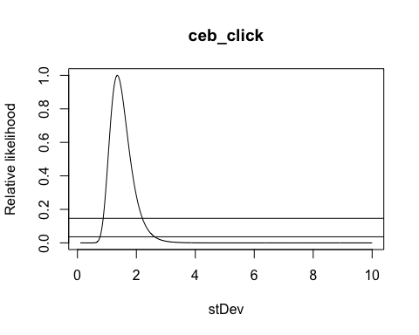
## Warning: clmm2 may not have converged:
## optimizer 'ucminf' terminated with max|gradient|: 149.596871617463
## Warning in rho$updateU(rho): Non finite negative log-likelihood
## at iteration 120
## Warning in rho$updateU(rho): Non finite negative log-likelihood
## at iteration 120
## Warning in rho$updateU(rho): Non finite negative log-likelihood
## at iteration 120
## Warning in rho$updateU(rho): Non finite negative log-likelihood
## at iteration 120
## Warning in rho$updateU(rho): Non finite negative log-likelihood
## at iteration 120
## Warning in rho$updateU(rho): Non finite negative log-likelihood
## at iteration 120
## Warning in rho$updateU(rho): Non finite negative log-likelihood
## at iteration 120
## Warning in rho$updateU(rho): Non finite negative log-likelihood
## at iteration 120
## Warning in rho$updateU(rho): Non finite negative log-likelihood
## at iteration 120
## Warning in rho$updateU(rho): Non finite negative log-likelihood
## at iteration 120
## Warning in rho$updateU(rho): Non finite negative log-likelihood
## at iteration 120
## Warning in rho$updateU(rho): Non finite negative log-likelihood
## at iteration 120
## Warning in rho$updateU(rho): Non finite negative log-likelihood
## at iteration 120
## Warning in rho$updateU(rho): Non finite negative log-likelihood
## at iteration 120
## Warning in rho$updateU(rho): Non finite negative log-likelihood
## at iteration 120
## Warning in rho$updateU(rho): Non finite negative log-likelihood
## at iteration 120
## Warning in rho$updateU(rho): Non finite negative log-likelihood
## at iteration 120
## Warning in rho$updateU(rho): Non finite negative log-likelihood
## at iteration 120
## Warning in rho$updateU(rho): Non finite negative log-likelihood
## at iteration 120
## Warning in rho$updateU(rho): Non finite negative log-likelihood
## at iteration 120
## Warning in rho$updateU(rho): Non finite negative log-likelihood
## at iteration 120
## Warning in rho$updateU(rho): Non finite negative log-likelihood
## at iteration 120
## Warning in rho$updateU(rho): Non finite negative log-likelihood
## at iteration 120
## Warning: clmm2 may not have converged:
## optimizer 'ucminf' terminated with max|gradient|: 260.587341674568
## Warning: clmm2 may not have converged:
## optimizer 'ucminf' terminated with max|gradient|: 61.8084887981036
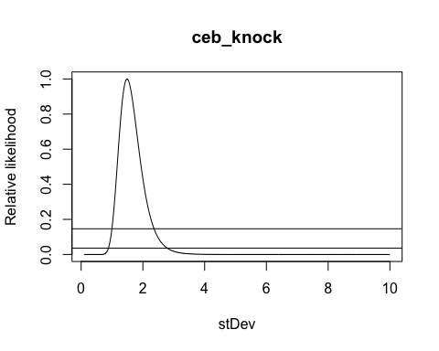
## Warning: clmm2 may not have converged:
## optimizer 'ucminf' terminated with max|gradient|: 551.470097198537
## Warning: clmm2 may not have converged:
## optimizer 'ucminf' terminated with max|gradient|: 1391.52671706485
## Warning: clmm2 may not have converged:
## optimizer 'ucminf' terminated with max|gradient|: 219.275816988663
## Warning: clmm2 may not have converged:
## optimizer 'ucminf' terminated with max|gradient|: 817.743989435702
## Warning: clmm2 may not have converged:
## optimizer 'ucminf' terminated with max|gradient|: 643.482701525327
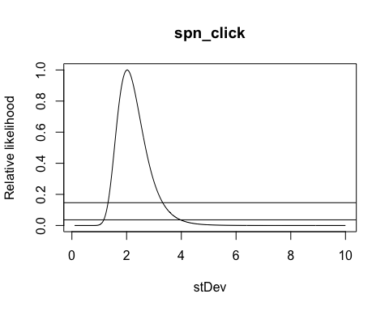
## Warning: clmm2 may not have converged:
## optimizer 'ucminf' terminated with max|gradient|: 18.8621082259005
## Warning: clmm2 may not have converged:
## optimizer 'ucminf' terminated with max|gradient|: 9.57986666919231
## Warning: clmm2 may not have converged:
## optimizer 'ucminf' terminated with max|gradient|: 29.2048297809738
## Warning: clmm2 may not have converged:
## optimizer 'ucminf' terminated with max|gradient|: 269.787609137996
## Warning: clmm2 may not have converged:
## optimizer 'ucminf' terminated with max|gradient|: 39.7848019117221
## Warning: clmm2 may not have converged:
## optimizer 'ucminf' terminated with max|gradient|: 261.796035329009
## Warning in rho$updateU(rho): Non finite negative log-likelihood
## at iteration 196
## Warning in rho$updateU(rho): Non finite negative log-likelihood
## at iteration 196
## Warning in rho$updateU(rho): Non finite negative log-likelihood
## at iteration 196
## Warning in rho$updateU(rho): Non finite negative log-likelihood
## at iteration 196
## Warning in rho$updateU(rho): Non finite negative log-likelihood
## at iteration 196
## Warning in rho$updateU(rho): Non finite negative log-likelihood
## at iteration 196
## Warning in rho$updateU(rho): Non finite negative log-likelihood
## at iteration 196
## Warning in rho$updateU(rho): Non finite negative log-likelihood
## at iteration 196
## Warning in rho$updateU(rho): Non finite negative log-likelihood
## at iteration 196
## Warning in rho$updateU(rho): Non finite negative log-likelihood
## at iteration 196
## Warning in rho$updateU(rho): Non finite negative log-likelihood
## at iteration 196
## Warning in rho$updateU(rho): Non finite negative log-likelihood
## at iteration 196
## Warning in rho$updateU(rho): Non finite negative log-likelihood
## at iteration 196
## Warning in rho$updateU(rho): Non finite negative log-likelihood
## at iteration 196
## Warning in rho$updateU(rho): Non finite negative log-likelihood
## at iteration 196
## Warning in rho$updateU(rho): Non finite negative log-likelihood
## at iteration 196
## Warning in rho$updateU(rho): Non finite negative log-likelihood
## at iteration 196
## Warning in rho$updateU(rho): Non finite negative log-likelihood
## at iteration 196
## Warning in rho$updateU(rho): Non finite negative log-likelihood
## at iteration 196
## Warning in rho$updateU(rho): Non finite negative log-likelihood
## at iteration 196
## Warning in rho$updateU(rho): Non finite negative log-likelihood
## at iteration 196
## Warning in rho$updateU(rho): Non finite negative log-likelihood
## at iteration 196
## Warning in rho$updateU(rho): Non finite negative log-likelihood
## at iteration 196
## Warning in rho$updateU(rho): Non finite negative log-likelihood
## at iteration 196
## Warning in rho$updateU(rho): Non finite negative log-likelihood
## at iteration 196
## Warning in rho$updateU(rho): Non finite negative log-likelihood
## at iteration 196
## Warning in rho$updateU(rho): Non finite negative log-likelihood
## at iteration 196
## Warning: clmm2 may not have converged:
## optimizer 'ucminf' terminated with max|gradient|: 257.1937957924
## Warning: clmm2 may not have converged:
## optimizer 'ucminf' terminated with max|gradient|: 253.29092429484
## Warning in rho$updateU(rho): Non finite negative log-likelihood
## at iteration 196
## Warning in rho$updateU(rho): Non finite negative log-likelihood
## at iteration 196
## Warning in rho$updateU(rho): Non finite negative log-likelihood
## at iteration 196
## Warning in rho$updateU(rho): Non finite negative log-likelihood
## at iteration 196
## Warning in rho$updateU(rho): Non finite negative log-likelihood
## at iteration 196
## Warning in rho$updateU(rho): Non finite negative log-likelihood
## at iteration 196
## Warning in rho$updateU(rho): Non finite negative log-likelihood
## at iteration 196
## Warning in rho$updateU(rho): Non finite negative log-likelihood
## at iteration 196
## Warning in rho$updateU(rho): Non finite negative log-likelihood
## at iteration 196
## Warning in rho$updateU(rho): Non finite negative log-likelihood
## at iteration 196
## Warning in rho$updateU(rho): Non finite negative log-likelihood
## at iteration 196
## Warning in rho$updateU(rho): Non finite negative log-likelihood
## at iteration 196
## Warning in rho$updateU(rho): Non finite negative log-likelihood
## at iteration 196
## Warning in rho$updateU(rho): Non finite negative log-likelihood
## at iteration 196
## Warning in rho$updateU(rho): Non finite negative log-likelihood
## at iteration 196
## Warning in rho$updateU(rho): Non finite negative log-likelihood
## at iteration 196
## Warning in rho$updateU(rho): Non finite negative log-likelihood
## at iteration 196
## Warning in rho$updateU(rho): Non finite negative log-likelihood
## at iteration 196
## Warning in rho$updateU(rho): Non finite negative log-likelihood
## at iteration 196
## Warning in rho$updateU(rho): Non finite negative log-likelihood
## at iteration 196
## Warning in rho$updateU(rho): Non finite negative log-likelihood
## at iteration 196
## Warning in rho$updateU(rho): Non finite negative log-likelihood
## at iteration 196
## Warning in rho$updateU(rho): Non finite negative log-likelihood
## at iteration 196
## Warning in rho$updateU(rho): Non finite negative log-likelihood
## at iteration 196
## Warning in rho$updateU(rho): Non finite negative log-likelihood
## at iteration 196
## Warning in rho$updateU(rho): Non finite negative log-likelihood
## at iteration 196
## Warning in rho$updateU(rho): Non finite negative log-likelihood
## at iteration 196
## Warning: clmm2 may not have converged:
## optimizer 'ucminf' terminated with max|gradient|: 249.449539876739
## Warning: clmm2 may not have converged:
## optimizer 'ucminf' terminated with max|gradient|: 852.268757750223
## Warning: clmm2 may not have converged:
## optimizer 'ucminf' terminated with max|gradient|: 242.220583920881
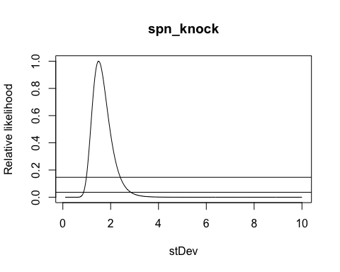
## Cumulative Link Mixed Model fitted with the Laplace approximation
##
## Call:
## clmm2(location = rating ~ vk, random = speaker, data = ceb_click,
## Hess = TRUE)
##
## Random effects:
## Var Std.Dev
## speaker 1.830104 1.352814
##
## Location coefficients:
## Estimate Std. Error z value Pr(>|z|)
## vkik 0.8267 0.3261 2.5354 0.01123321
## vkuk 0.7426 0.3162 2.3483 0.01885733
##
## No scale coefficients
##
## Threshold coefficients:
## Estimate Std. Error z value
## 1|2 -0.6760 0.4520 -1.4957
## 2|3 0.2503 0.4473 0.5597
## 3|4 0.7271 0.4487 1.6205
## 4|5 1.1988 0.4530 2.6463
## 5|6 1.7343 0.4614 3.7591
## 6|7 2.4271 0.4755 5.1045
## 7|8 3.3977 0.5055 6.7215
## 8|9 4.5220 0.5813 7.7791
## 9|10 5.5343 0.7391 7.4877
##
## log-likelihood: -431.4085
## AIC: 886.8171
## Condition number of Hessian: 572.0302
Random Effects:
speaker: The model includes random effects for “speaker” to account for variations across individual speakers. Variance (Var): The variance of the random effect for “speaker” is 1.8301, indicating the level of variability in the ratings due to individual differences among speakers. Standard Deviation (Std.Dev): The standard deviation for “speaker” is 1.3528. Location Coefficients (Fixed Effects):
The model estimates the effects of the variable “vk” on “rating,” where vkik and vkuk are levels within “vk.” Estimate: The estimated effect size of “vkik” on “rating” is 0.8267, and for “vkuk” it’s 0.7426. Both indicate positive associations with rating. Standard Error: The standard errors for “vkik” (0.3261) and “vkuk” (0.3162) suggest the precision of these estimates. Z value & p-value: For vkik, z = 2.5354, p = 0.0112, and for vkuk, z = 2.3483, p = 0.0189. Both coefficients are statistically significant, indicating that these predictors have a significant effect on the rating. Threshold Coefficients:
Thresholds represent cut points between ordinal categories, where each threshold (e.g., 1|2, 2|3, etc.) shows where one rating category transitions into the next.
##The influence to the rating of each speaker 