Team Members

Ahad Rahman – 6411247

Thit Lwin Win Thant – 6540122

Kaung Khant Lin – 6540131

Thust Thongsricharoen – 6714508

# Practice 2.1

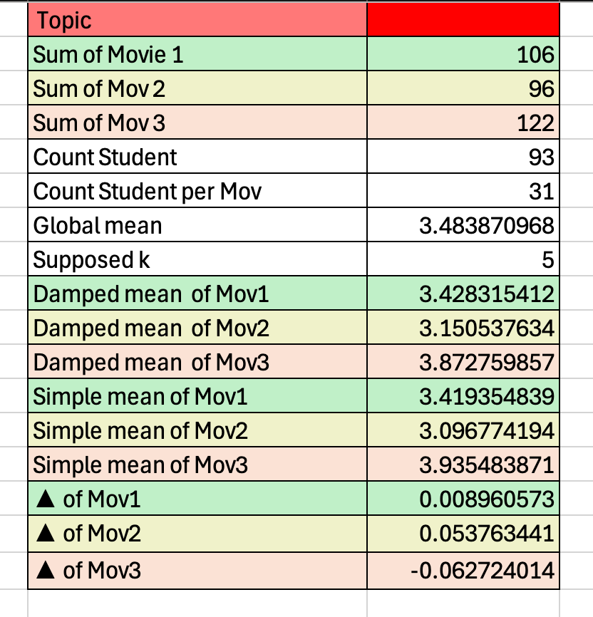

We use damp_mean(i) =

$$\frac{Σ_{u}r_{ui}+kμ}{n+k}$$

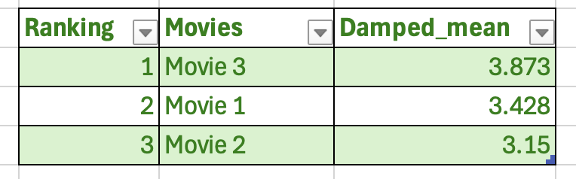

# Practice 2.2

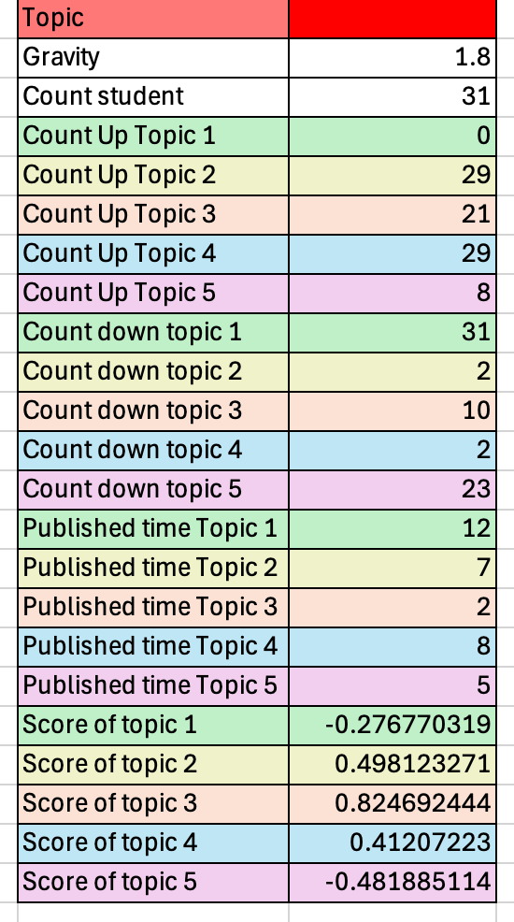

We use Hacker News Ranking Algorithm to get Scores. $$Score=\frac{\left(P-1\right)}{{(T+2)}^{G}}$$

