Lab Report
Event-Driven Cybersecurity Pipeline with Kafka and Tracing
Course: AI-Enhanced Cybersecurity (HIT)
Lab: Lab 5 Accelerated AI - MITRE ATT&CK Classification Pipeline
Student: Sharon Weisman ID: 208660456
Rom Ben Yakar ID: 207295437

1. Objective
The goal of this lab was to build and run a small event-driven cybersecurity analysis pipeline and understand why it is structured the way it is. The pipeline ingests synthetic Windows security events, sends them through a Kafka message queue, classifies each event against the MITRE ATT&CK framework in a separate consumer stage, stores the results to a CSV file, and finally analyzes those results offline. Distributed tracing with Jaeger is used to follow a single event end-to-end through the pipeline. The lab is deliberately not about model accuracy - the focus is on pipeline architecture, decoupling, scalability, and observability.
Note: although the README title refers to "Lab 3.1", this submission is based on the lab5 Accelerated AI folder and implements the Kafka + Jaeger MITRE classification pipeline described there.

2. Environment and How the Pipeline Was Run
The whole stack is defined in compose.yml and was started with:
docker compose up -d
Four services come up on the shared pipeline-net bridge network:
Service | Image | Role | URL / Port
kafka | confluentinc/cp-kafka:7.5.0 | Message queue (KRaft, no Zookeeper) | kafka:9092 / 29092
redpanda-console | redpandadata/console | Kafka topic and message viewer | http://localhost:8080
jaeger | jaegertracing/all-in-one | Distributed tracing UI (OTLP in) | http://localhost:16686
jupyter | jupyter/scipy-notebook | Runs the three pipeline notebooks | http://localhost:8888
Inside JupyterLab, the three notebooks were run in order. The producer and consumer were left running in parallel so that events flowed continuously while they were inspected in Redpanda Console and Jaeger:
- 1. Producer.ipynb - generates events and publishes them to the raw-events topic.
- 2. Consumer_Classifier.ipynb - consumes from raw-events, classifies each event, and appends a row to classified_packets.csv.
- 3. Statistics (extended).ipynb - loads the CSV and plots the results once enough data has accumulated.

3. Pipeline Architecture
The pipeline is a three-stage, queue-decoupled design. Each stage only knows about the queue or file directly in front of it, not about the internal implementation of the other stages:
[ Producer ] --> Kafka topic raw-events --> [ Consumer / Classifier ] --> classified_packets.csv --> [ Statistics ]
All processing stages also emit OpenTelemetry spans to Jaeger, which provides an end-to-end timeline for individual events.
A key design choice in the starter code is that the OpenTelemetry trace ID is derived from the event UUID. The producer uses this value as the trace ID, and the consumer rebuilds the exact same trace ID from event_id. Because both stages share the trace ID, Jaeger can stitch the producer span and the consumer spans into a single end-to-end trace for each event, even though the notebooks run as separate processes.

4. MITRE ATT&CK Classification Logic
The classifier in the consumer is intentionally simple and rule-based. It inspects the event type and selected fields and maps each event to one MITRE tactic and one technique:
Event condition | Tactic | Technique
process_start, command line contains EncodedCommand | TA0002 Execution | T1059.001 PowerShell
process_start, command line contains cmd.exe | TA0002 Execution | T1059.003 Windows Cmd Shell
process_start, any other process | TA0002 Execution | T1059 Command/Scripting Interpreter
user_login, logon result = failure | TA0006 Credential Access | T1110 Brute Force
user_login, logon result = success | TA0001 Initial Access | T1078 Valid Accounts
Each step of this work is wrapped in its own span: consume_event, classify_event, and write_csv. The resulting tactic and technique are attached to the span as attributes, so the classification decision is visible inside the trace itself.

5. Inspecting Kafka (Redpanda Console) and Traces (Jaeger)
Redpanda Console (http://localhost:8080). After starting the producer, the raw-events topic appears under Topics. Opening it shows JSON messages arriving with the expected fields: event_id, timestamp, user, host, source_ip, event_type, and the relevant process or logon fields. The message count climbs while the producer runs, confirming that events are buffered in the queue independently of whether the consumer is currently reading them. Comparing a message in the console to the matching row in the CSV confirms that the consumer preserved the same event_id.
Jaeger (http://localhost:16686). Selecting the services in the dropdown shows windows-log-producer and packet-classifier. Opening a trace shows a single event journey: produce_event -> kafka_produce from the producer, followed by consume_event -> classify_event -> write_csv from the consumer, all under the same trace ID. The span timings make it easy to see which stage takes the longest and how much time the event spent waiting in Kafka between production and consumption.

6. Results and Statistics
The analysis below was produced from the accumulated classified_packets.csv, which contains 2,169 classified events generated across several producer sessions on 2026-01-15 (roughly 07:00-20:24 UTC). Because the producer was started and stopped a few times, the events fall into bursts rather than one continuous stream - this is visible as the gaps in Figure 1.
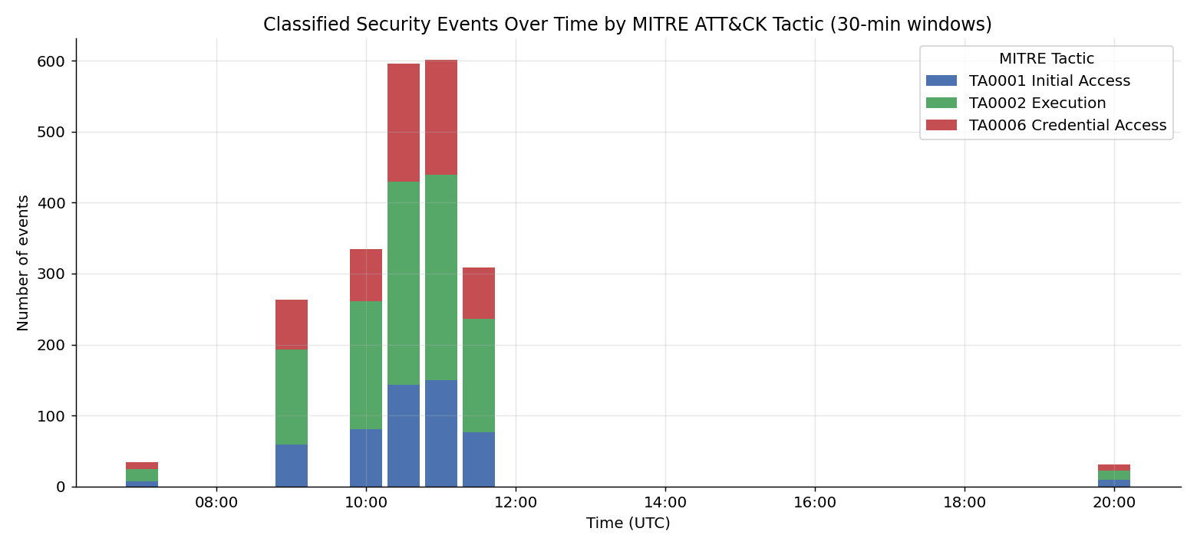
Figure 1 - Classified events over time, grouped into 30-minute windows and stacked by MITRE tactic.
Dimension | Breakdown
Total events | 2,169
Event type | user_login: 1,088 process_start: 1,081
Tactic | TA0002 Execution: 1,081 TA0006 Credential Access: 563 TA0001 Initial Access: 525
Technique | T1110: 563 T1078: 525 T1059.001: 383 T1059: 375 T1059.003: 323
Hosts | win-02: 733 win-03: 719 win-01: 717
Users | admin: 557 alice: 551 charlie: 543 bob: 518
The two event types are almost perfectly balanced because the producer chooses the type randomly. As a result, Execution (every process_start) makes up about half of all events, while the two login outcomes split the rest. Activity is spread evenly across the three hosts and four users, as expected from uniform random generation. There is no single hot host or noisy user in this synthetic dataset.

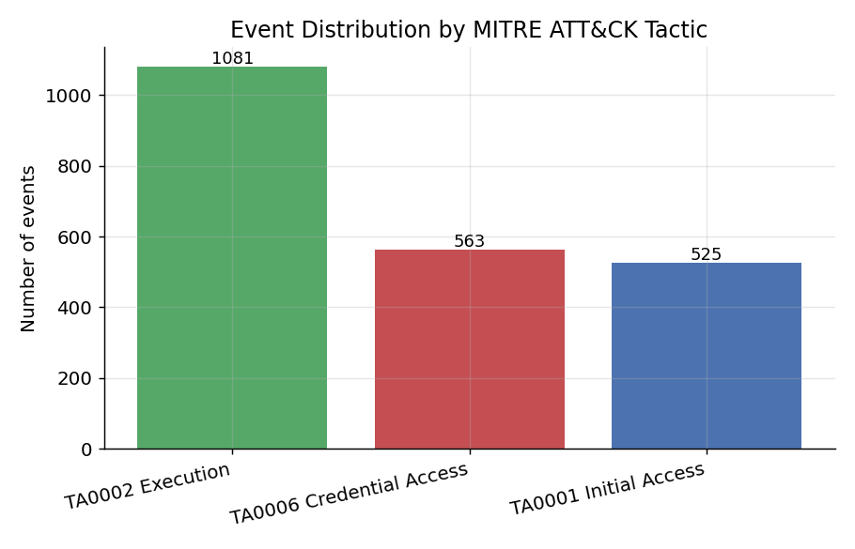
Figure 2 - Total events per MITRE tactic.
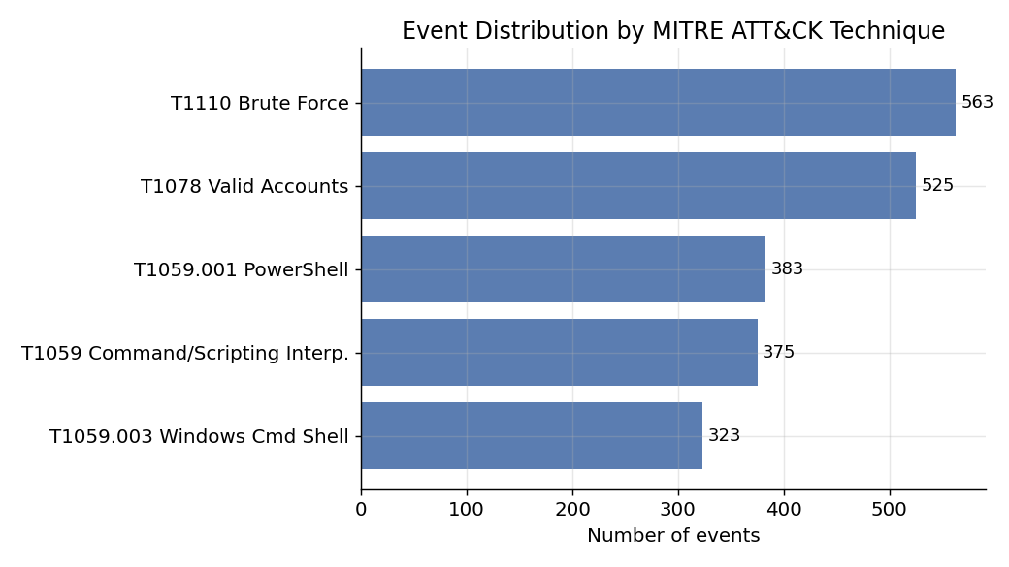
Figure 3 - Total events per MITRE technique.
As an extra experiment suggested by the Statistics notebook, the data was also aggregated by host. Figure 4 confirms that the tactic mix is essentially similar across all hosts. This is the correct result for this generator and a useful sanity check. In a real environment, an uneven split would be exactly the kind of anomaly worth investigating.
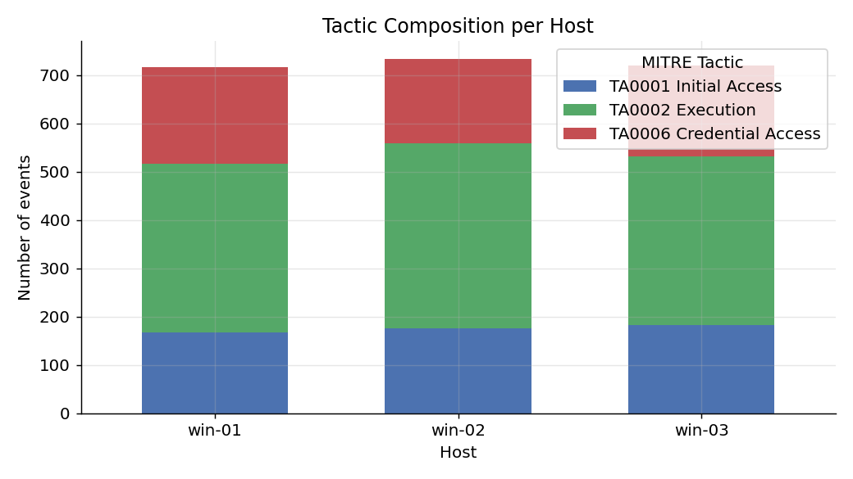
Figure 4 - Tactic composition per host (extra aggregation).

7. Conceptual Questions
Q1. Why is Kafka used instead of direct function calls?
A direct function call couples the producer and the classifier into one process: the producer would have to wait for classification to finish before generating the next event, and if the classifier crashed, the producer would crash or block with it. Kafka breaks that coupling by putting a durable queue between the two stages. The producer appends events to the raw-events topic and moves on - it does not need to know who reads them. This gives security pipelines buffering, fault tolerance, asynchrony, and scalability. With direct calls, one slow or failed stage can take down the whole chain.
Q2. What happens if the consumer is slower than the producer?
Events accumulate in the Kafka topic instead of being lost. This is consumer lag: the difference between the latest offset written by the producer and the offset committed by the consumer. The queue acts as a shock absorber, so temporary bursts can be handled gracefully and the consumer can catch up later. The danger is a persistent lag: latency grows, and eventually old data may be deleted according to Kafka retention before it is processed. The fix is to scale the consumer horizontally and partition the topic so multiple consumers in the same group can process events in parallel.
Q3. How does tracing help debug pipeline behavior?
Logs usually describe what happened inside one component, but tracing follows one event across multiple asynchronous processes. In this lab, every event has a shared trace ID derived from its UUID, so the spans produce_event, kafka_produce, consume_event, classify_event, and write_csv line up as one timeline in Jaeger. This makes it possible to see the order of stages, stage latency, queue waiting time, and the exact point of failure or slowdown. Span attributes such as tactic, technique, host, and user also expose the classification decision inside the trace.
Q4. Which pipeline stages could be scaled independently?
The consumer/classifier is the most natural stage to scale. By adding more consumer instances to the packet-classifier group and adding partitions to the Kafka topic, classification throughput can increase while Kafka balances partitions across consumers. The producer can also be scaled by adding more event sources writing to the same topic. The statistics stage is offline and independent, so it can be run on demand or replaced without affecting ingestion. Kafka itself scales by adding brokers and partitions. The current CSV sink is the main weak point because concurrent writers would contend on the same file; a real system would replace it with a database, object storage, or SIEM index.
Q5. How would this pipeline change in a real SOC system?
The architecture would stay conceptually similar, but every component would be hardened and scaled. Events would come from real telemetry such as EDR agents, Windows Event Logs, Sysmon, network sensors, and log forwarders. Kafka would run as a multi-broker, replicated, partitioned cluster with authentication, encryption, schema enforcement, retention policies, and dead-letter handling. The CSV sink would be replaced by a scalable store such as a data lake, Elasticsearch, Splunk, or another SIEM-backed index. The simple rule-based classifier would become a combination of detection rules, correlation logic, enrichment, and possibly trained ML models. Tracing and metrics would feed operational monitoring and alerting. The core idea remains the same: decoupled stages connected by a durable queue and observed end-to-end with distributed tracing.

8. Conclusion
Running this lab made the value of a queue-based design concrete. The producer and consumer ran as independent processes, communicated only through Kafka, and could be started, stopped, and restarted without losing data - something a direct function call approach would not provide. Redpanda Console showed exactly what data flowed through the topic, while Jaeger showed how each event moved through the stages and how long each step took. The MITRE ATT&CK classification, though intentionally simple, demonstrated how raw telemetry can be normalized into structured security meaning, and the statistics step closed the loop from raw events to interpretable results. The main takeaway is that in cybersecurity systems, the pipeline - how data is ingested, decoupled, processed, stored, and observed - matters as much as any individual detection model.

