DCU School of Computing
Assignment Submission
Student Name(s): | Shaun Kinsella
Student Number(s): | 14740175
Programme: | BSc in Computer Applications
Project Title: | Lexical & Syntax Analyser
Module code: | CA4003
Lecturer: | Dr David Sinclair
Project Due Date: | 12/11/18

Declaration
I declare that this material, which I now submit for assessment, is entirely my own work and has not been taken from the work of others, save and to the extent that such work has been cited and acknowledged within the text of my work. I understand that plagiarism, collusion, and copying is a grave and serious offence in the university and accept the penalties that would be imposed should I engage in plagiarism, collusion, or copying. I have read and understood the Assignment Regulations set out in the module documentation. I have identified and included the source of all facts, ideas, opinions, viewpoints of others in the assignment references. Direct quotations from books, journal articles, internet sources, module text, or any other source whatsoever are acknowledged and the source cited are identified in the assignment references.
I have not copied or paraphrased an extract of any length from any source without identifying the source and using quotation marks as appropriate. Any images, audio recordings, video or other materials have likewise been originated and produced by me or are fully acknowledged and identified.
This assignment, or any part of it, has not been previously submitted by me or any other person for assessment on this or any other course of study. I have read and understood the referencing guidelines found at http://www.library.dcu.ie/citing&refguide08.pdf and/or recommended in the assignment guidelines.
I understand that I may be required to discuss with the module lecturer/s the contents of this submission.
I/me/my incorporates we/us/our in the case of group work, which is signed by all of us.

Signed:___Shaun Kinsella___

Section 1 :: Options

Here the options for the Javacc parser can set such as case sensitivity, the specification for CAL states its case insensitive. I’ve also added several debug options to help step through the test cases as the parser breaks them up into tokens.

Section 2 :: User Code

The parser class which initialises the parser when compiled from a JJ to Java class file, this will read in .cal extension files, when provided as an argument on the command line. The class must begin with “PARSER_BEGIN(CalParser)” and end with “PARSER_END(CalParser)” . The parser is started by calling “parser.prog()”, this will then process the tokens and production rules provided below and will throw exceptions if incorrect CAL source code is read in. Otherwise it will report a success.

Section 3 :: Token Definitions

Here is where we declare our language’s specified tokens and whether to ignore them or not such as new lines, comments and white space, which we specify with the kind “SKIP”. The tokens we wish to scan and process are specified by the “TOKEN” kind. Here we specify what constitutes what counts as an integer, in this case an integer can be 0 or any positive or negative number not beginning with 0 as given by the regex rules in <DIGIT> and <NUMBER>.

Another example would be the <IDENTIFIER> token, as the language requires identifiers to start with a character, then may be followed by a sequence of characters/numbers or underscore. It may not start with a number or underscore however.

Section 4 :: Grammar & Production Rules

Here is where the token stream is analysed against the production rules of the Cal language to make sure that syntactically the source code provided is valid.

(Something about prod rules in general)

Left Hand Recursion

Starting off with the given prod rules, there were two cases of left hand recursion that had to be fixed, firstly indirect recursion from expression() and fragment(), and then direct recursion from condition().

Expression() => Fragment() => Expression()

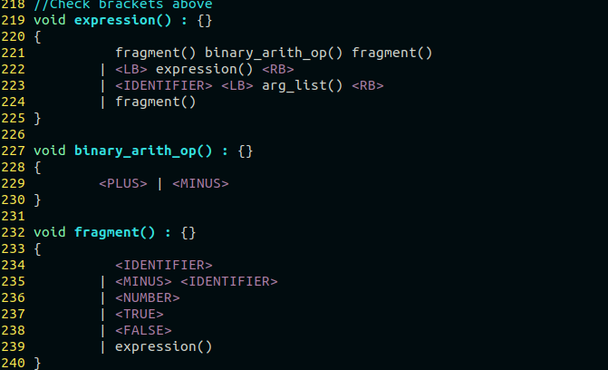

As we can see above, expression may match fragment on its own, which in turn can call expression, with no way of terminating. Removing expression() from fragment() temporarily solves this by removing the indirect recursion.

Condition() => Condition()
The left recursion here is more direct.
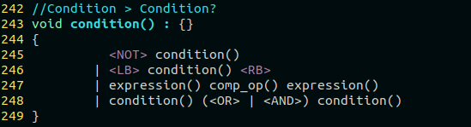
Factoring out the common left hand term of condition() on line 248 and rewriting the production rule into two smaller ones gives us :

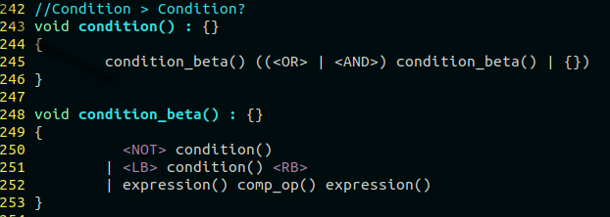
As we can note that a condition on its own is simply an “expression() comp_op() expression()”, we can write condition as “A condition_beta() followed by an option <OR> or <AND> condition or nothing/epsilon .” Nothing is worrying about the negated condition or a condition in parentheses as they are not left hand recursive. Fixing those two cases of recursion however leaves us with a few choice conflicts.

Choice Conflicts

Nemp_parameter_list()
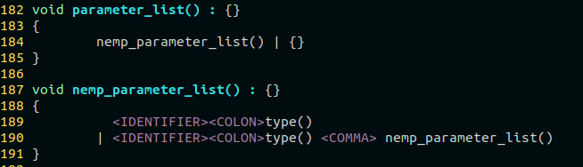
For the non-empty parameter_list production rule, we have a choice conflict as <IDENTIFIER> <COLON>type() is common to both line 189 and 190, meaning a lookahead of 3 would be required to see if it is a parameter list containing more than one parameter. As this would be terrible for compiler performance (and my assignment marks), we will rewrite the rule to:
<IDENTIFIER><COLON>type() (<COMMA> nemp_parameter_list())?

So a non-empty parameter list will always have <IDENTIFIER> <COLON>type() but the comma and all that follows will be optional (zero or one). Further, we can rewrite parameter_list() to encapsulate non-empty parameter list and remove the redundant production rule, giving us:

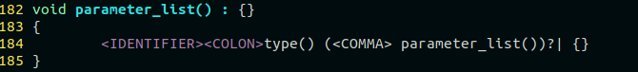
So in a single parameter_list() rule, “One or more parameters or nothing” , simplifying it all down.

The above is also true for arg_list() and nemp_arg_list() so we will rewrite them to simplify and get rid of one more choice conflict

Statement()
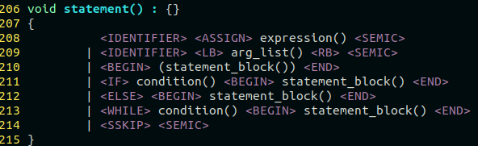
We have a choice conflict between an expression assignment and a function being called with arguments as seen on line 208 and 209, so we will remove the ambiguous choice by introducing another statement production rule, statement_beta(), letting statement become <IDENTIFIER>statement_beta()

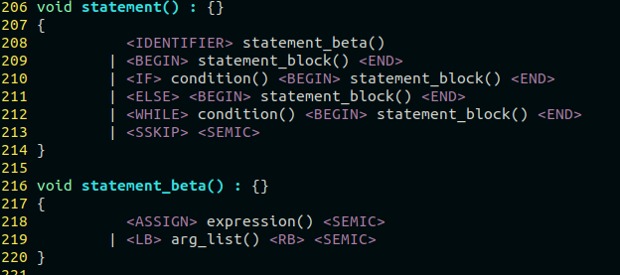

Expression()
Once again we must visit the expression() prod rule, this time for choice conflicts.
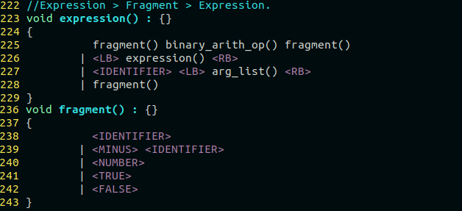
We can once again see that expression has a choice conflict between a lone fragment or a fragments having binary arithmetic operators. So it will be rewritten as:
fragment() ( binary_arith_op() fragment())*

This still leaves us with an “indirect” choice conflict as a fragment() may begin with an <IDENTIFIER> as may a function being called. So we will remove the arg_list() from line 226 in expression() and instead make it optional in fragment() as below.
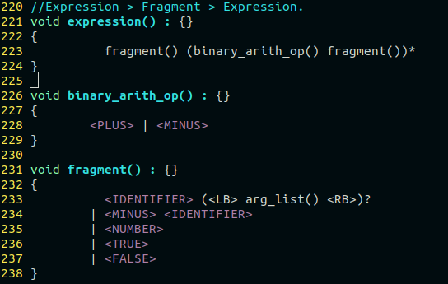
Unfortunately I could not escape a choice conflict for condition() and condition_beta(). Initially I thought production rules were correct until I introduced more than two conditions chained together by <AND> or <OR>. So I changed condition_beta() to include the kleene closure of a chained condition.
condition_beta() ((<OR> | <AND>) condition_beta())*

This results in javacc complaining of a nested expansion choice conflict in which the compiler has difficulty telling if more chained conditions follow the current one. Attempting to rewrite this without a lookahead resulted in my parser losing the ability to deal with <OR> or <AND> altogether and would require a large rewrite. There is a possibility that the parser will choose the correct derivation without the lookahead but it would be impossible to guarantee. So condition_beta() becomes

condition_beta() (LOOKAHEAD(2)(<OR> | <AND>) condition_beta())*

This resolves all my choice conflicts to date. Running my parser against the given test cases parses correctly and I have added some extra checks in terms of badly formed comments, missing brackets from return statements, function calls, chained conditions, nested brackets. Any test that is meant to fail is prefixed with fail_*.cal. The javacc_script.sh compiles the jj and java files, and calling test_script.sh runs all test inputs against the parser.

